Classification

- Load the MNIST dataset from the sklearn.datasets. It provides various libraries to work with.
- Load the dataset (MNIST), which contains handwritten numbers which is labelled!
- Split the dataset into test and training data.(10000, 60000)

Training a Binary Classifier
The Stochastic Gradient Descent (SGD) Classifier is a linear model for classification that uses SGD optimization to find the best parameters for a decision boundary. It is particularly useful when dealing with large datasets because it updates parameters incrementally, making it faster and more memory-efficient than batch gradient descent.
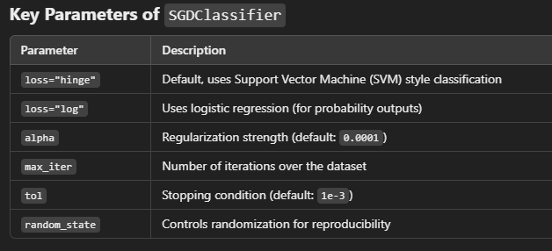

How Does SGD Work?
- Initialize Model Parameters: The algorithm starts with random weights and bias.
- Pick a Random Training Sample: Instead of computing the gradient using the entire dataset (as in batch gradient descent), SGD picks one random training example per iteration.
- Compute the Gradient: It calculates the gradient (derivative) of the loss function with respect to the parameters.
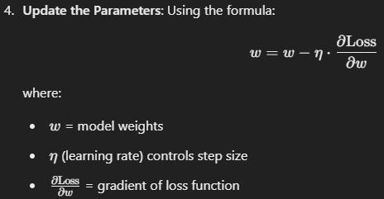
- Repeat Until Convergence: It repeats the process for multiple epochs until the loss function stops improving.

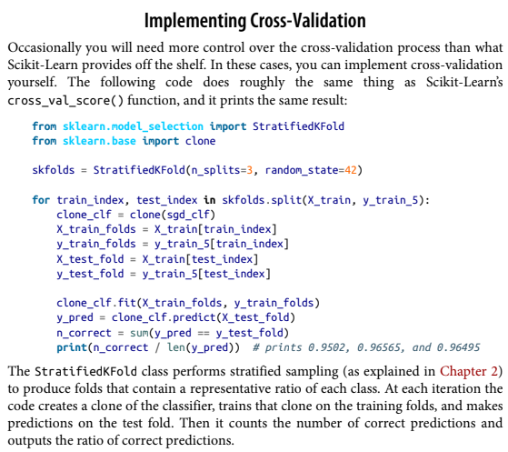
Confusion Matrix

A much better way to evaluate the performance of a classifier is to look at the confu‐
sion matrix. The general idea is to count the number of times instances of class A are
classified as class B. For example, to know the number of times the classifier confused
images of 5s with 3s, you would look in the fifth row and third column of the confu‐
sion matrix.
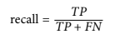
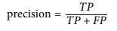
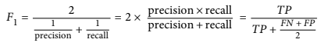
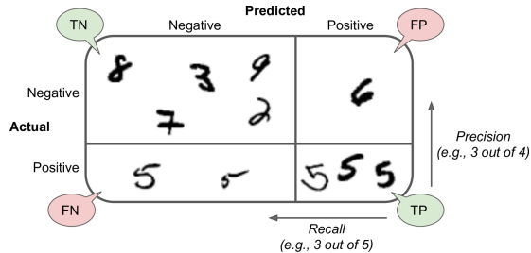

Precision:
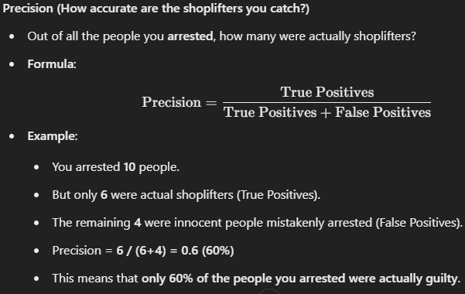
Recall:
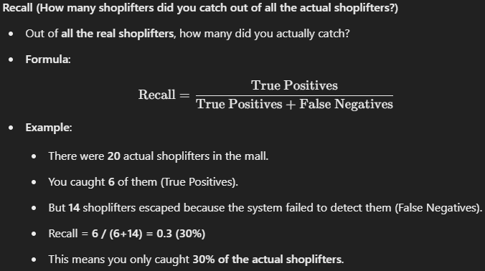

Balancing Precision and Recall (Trade-off)

If you focus only on Precision:
- You arrest only when you are very sure someone is a shoplifter.
- Fewer false arrests, but you might miss a lot of real shoplifters.
If you focus only on Recall:
- You arrest everyone who looks even slightly suspicious.
- You catch most shoplifters but also arrest a lot of innocent people.

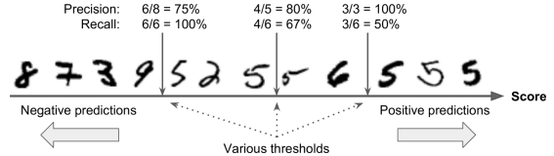

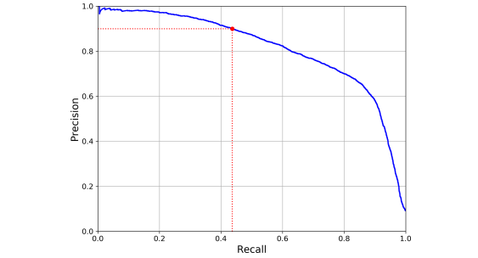
You can see that precision really starts to fall sharply around 80% recall. You will
probably want to select a precision/recall trade-off just before that drop—for exam‐
ple, at around 60% recall. But of course, the choice depends on your project.

You can always put a threshold for the same i.e., how much minimum precision you want

The ROC Curve

The receiver operating characteristic (ROC) curve is another common tool used with
binary classifiers. It is very similar to the precision/recall curve, but instead of plot‐
ting precision versus recall, the ROC curve plots the true positive rate (another name
for recall) against the false positive rate (FPR). The FPR is the ratio of negative instan‐
ces that are incorrectly classified as positive. It is equal to 1 – the true negative rate
(TNR), which is the ratio of negative instances that are correctly classified as negative.
The TNR is also called specificity. Hence, the ROC curve plots sensitivity (recall) ver‐
sus 1 – specificity.

Let’s now train a RandomForestClassifier and compare its ROC curve and ROC
AUC score to those of the SGDClassifier. First, you need to get scores for each
instance in the training set.

Multiclass Classifier

Whereas binary classifiers distinguish between two classes, multiclass classifiers (also
called multinomial classifiers) can distinguish between more than two classes.
Scikit-Learn detects when you try to use a binary classification algorithm for a multi‐
class classification task, and it automatically runs OvR or OvO, depending on the
algorithm.

MultiOutput Classification

It is simply a generalization of multilabel classification where each label can be multiclass. Let’s build a system that removes noise from images. It will take as
input a noisy digit image, and it will (hopefully) output a clean digit image, represented as an array of pixel intensities, just like the MNIST images.

