Project Name: Yahoo’s Make My Trip

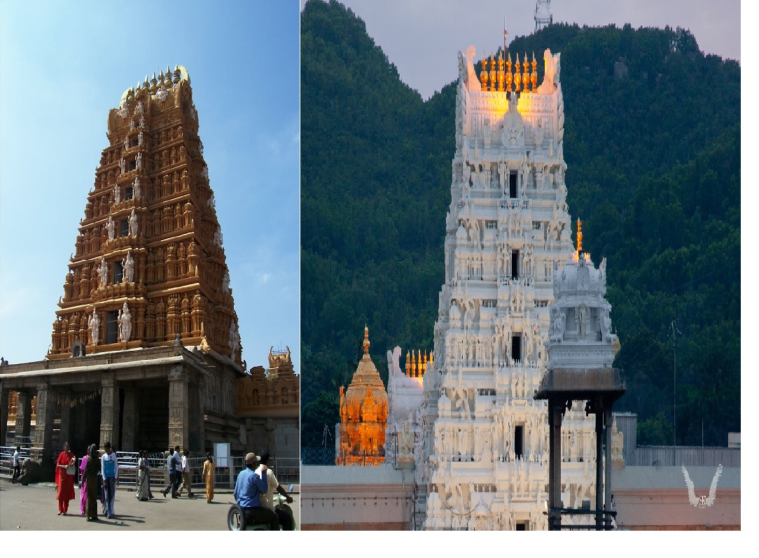

Overview:

Yasho’s MakeMyTrip is an Indian online travel company that provides services to book tickets in a package (i.e famous Temples in Karnataka and Andhra Pradesh)

Goals:

Create a Navigation bar with all the elements:

Logo

Home Page

Packages

Gallery

Review

Contact

________________________________________________________

i)Home Page- Logo

Popular Temples in Karnataka & Andhra Pradesh(Images needs to be Scrolled)

OR

Revisit our heritage & favorite iconic temple of different architectural styles in our own motherland.

ii)Book –

Book Now contains all information about

Where to go

Number of people (how many)

Arrivals

Leaving

iii)Packages

Different temples in Karnataka & AP to visit .

iv)Gallery

Images and information about each famous temple.

v)Review-

About the place and their user’s experiences

vi)Contact Us-

Contact details in the form of page.

Languages used:(Other languages will be used further on)

HTML

CSS