**Practical No : 07**

**Aim**: Construction of OBST

**Output** :

**Task 1 :**

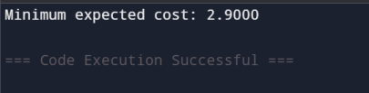

**Task 2 :**

**https://www.geeksforgeeks.org/problems/optimal-binary-search-tree2214/1**