**Assignment Title:** (A) Study of Open Source NOSQL Database: MongoDB , Installation of MongoDB

(B) Create database in MongoDB , create a collection named student, Insert 5 records with field (Student_ Id, Name, Address, contact_no , subjects and percentage).

1. Insert 1 more document in collection with additional field of hobbies.
2. Display information of all students
3. Display details of students who have secured more than 70 percentage
4. Update percentage of student whose Student _ Id is 5
5. Delete document of ‘Rohan’ from database
6. Demonstrate use of Save() Method

**CODE:**

use mydatabase

db.createCollection("student") db.student.insertMany([

{"Student_Id": 1, "Name": "Sakshi", "Address": "Nashik", "contact_no":

"1234567890", "subjects": ["Math", "Science"], "percentage": 85},

{"Student_Id": 2, "Name": "Gauri", "Address": "Pune", "contact_no":

"9876543210", "subjects": ["History", "English"], "percentage": 78},

{"Student_Id": 3, "Name": "Shubham", "Address": "Mumbai", "contact_no": "4567890123", "subjects": ["Geography", "Art"], "percentage": 60},

{"Student_Id": 4, "Name": "Yash", "Address": "Nagpur", "contact_no": "7890123456", "subjects": ["Physics", "Chemistry"], "percentage": 92},

{"Student_Id": 5, "Name": "Rohan", "Address": "Delhi", "contact_no":

"2345678901", "subjects": ["Biology", "Computer Science"], "percentage":

70}

])

db.student.insertOne({"Student_Id": 6, "Name": "Shourya", "Address": "Chh. SambhajiNagar", "contact_no": "8901234567", "subjects": ["Economics", "Psychology"], "percentage": 80, "hobbies": ["Photography",

"Hiking"]}) db.student.find({}) db.student.find({"percentage": {$gt: 70}}) db.student.updateOne({"Student_Id": 5}, {$set: {"percentage": 75}})

db.student.find({"Student_Id": 5}) db.student.deleteOne({"Name": "Rohan"}) db.students.save({Student_Id:1,Name:"Sakshi"}) db.student.replaceOne({"Name": "Shourya"}, {"Student_Id": 6, "Name":

"Suhani", "Address": "987 Cedar St", "contact_no": "8901234567", "subjects": ["Economics", "Psychology"], "percentage": 80, "hobbies": ["Photography", "Hiking"]})

db.student.find({"Student_Id": 6})

**OUTPUT:**

1. Insert 1 more document in collection with additional field of hobbies:

O/P:

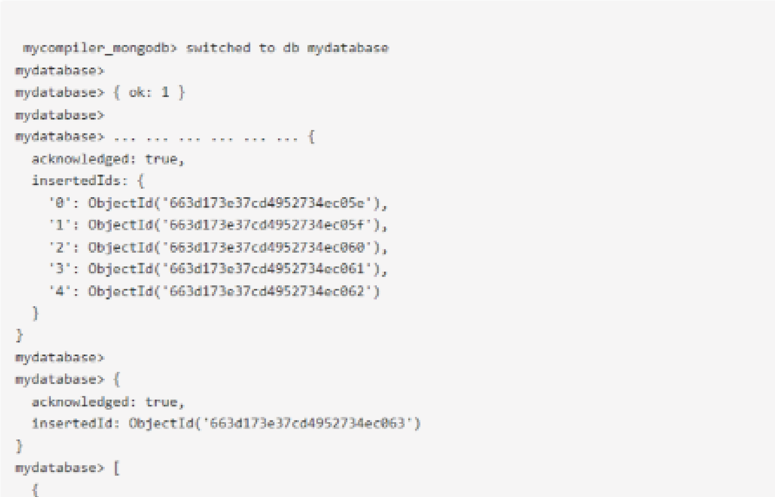

1. Display information of all students: O/P:

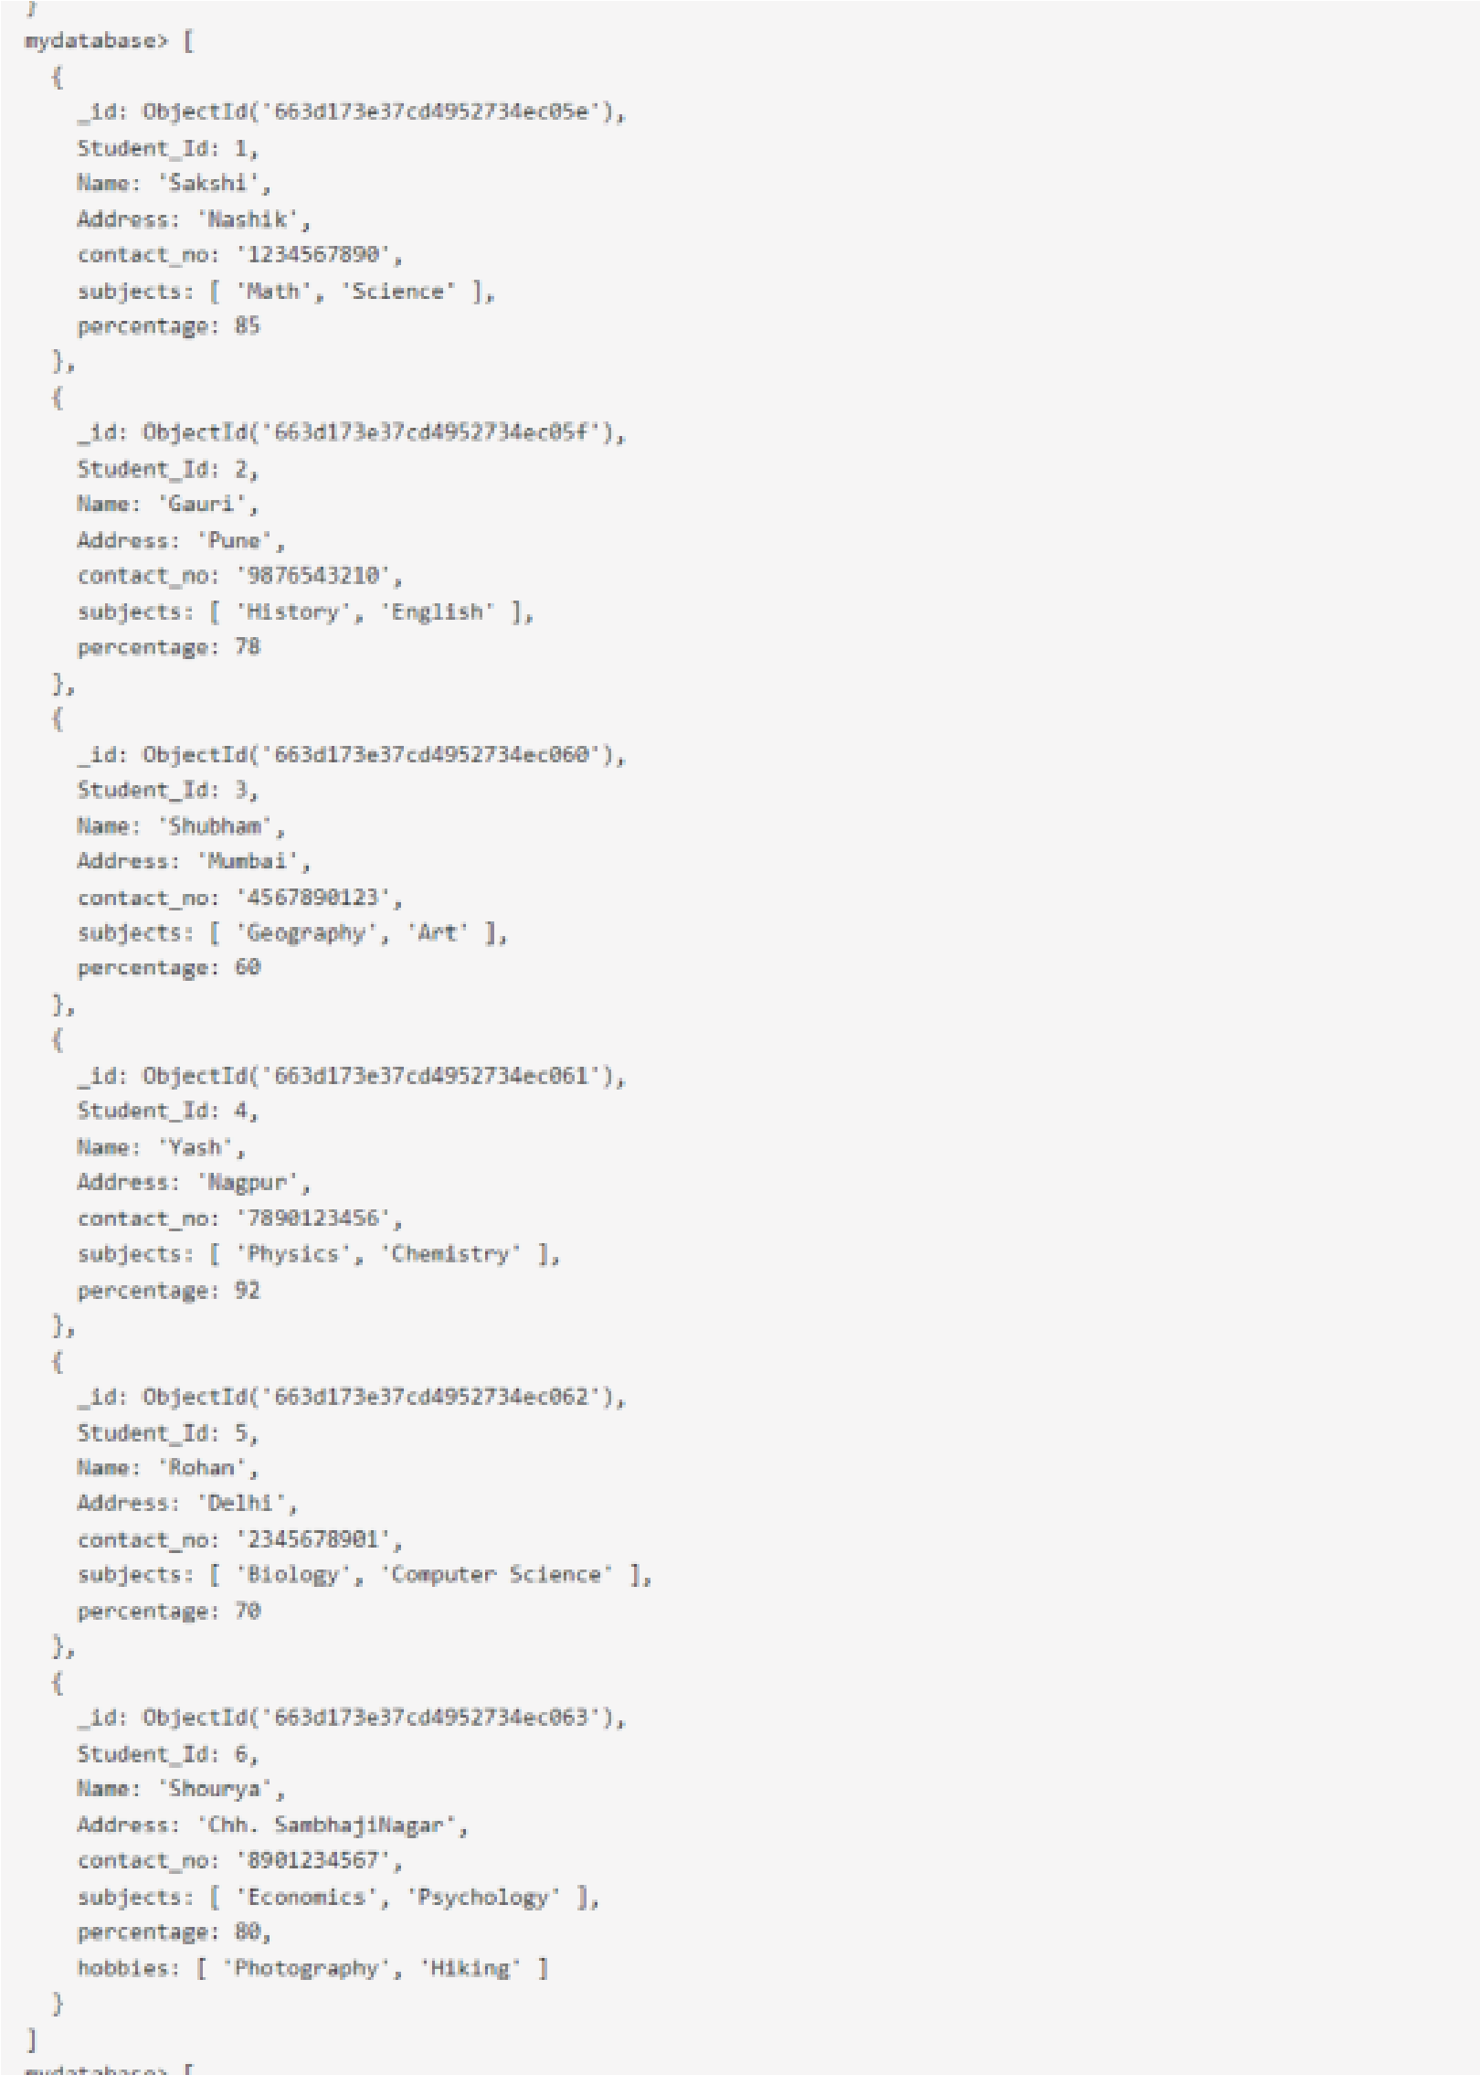

1. Display details of students who have secured more than 70 percentage:

O/P:

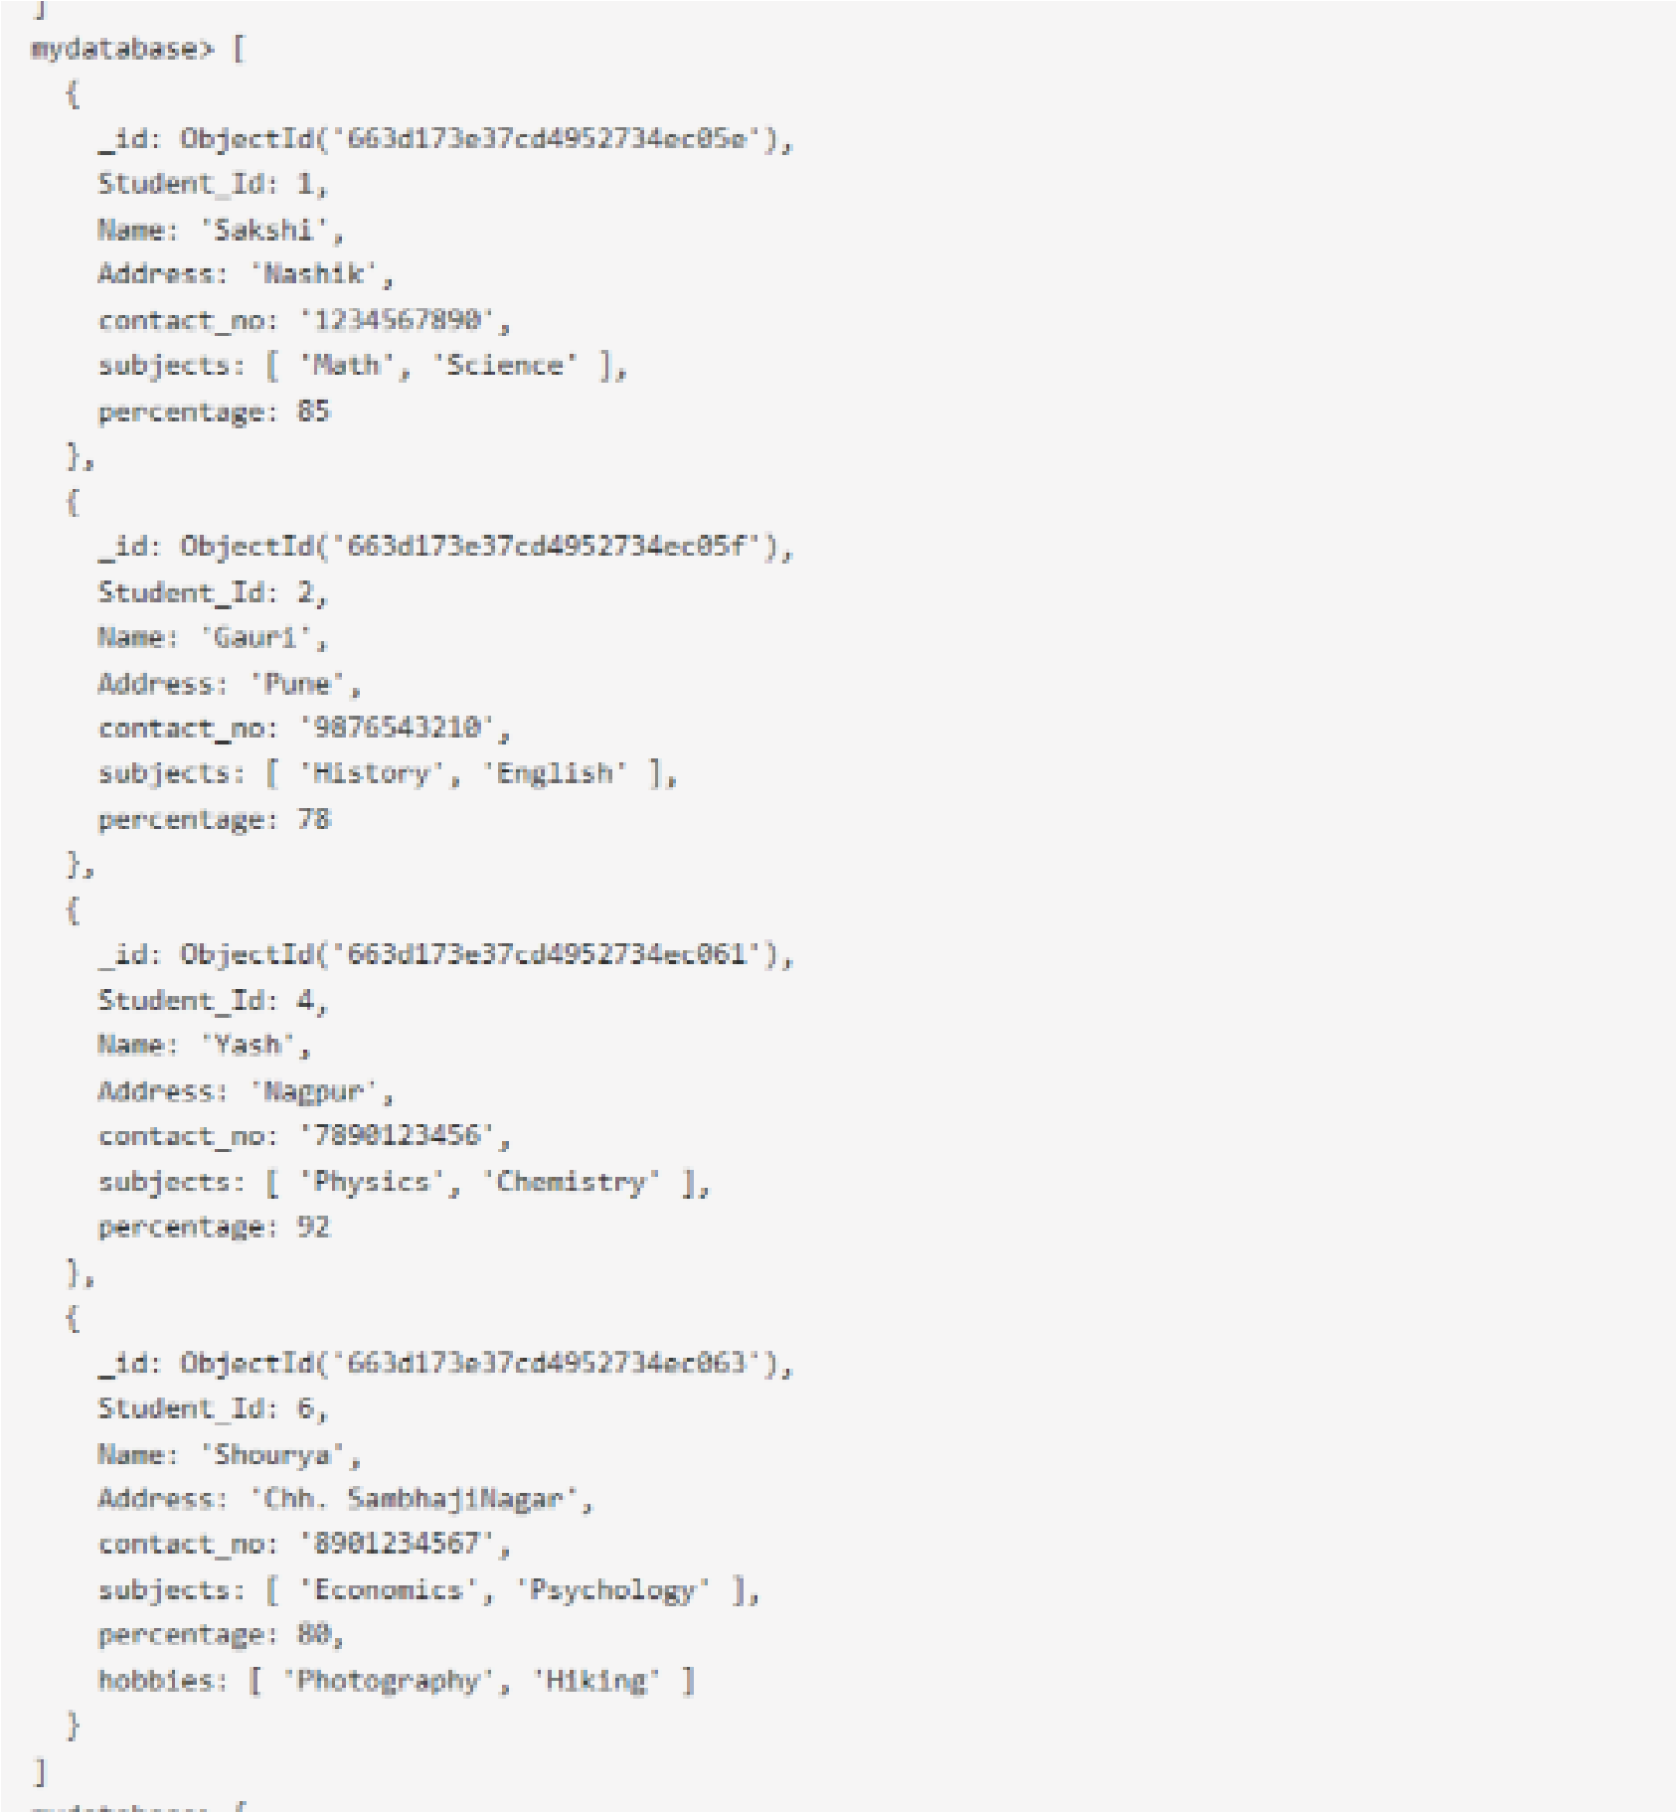

1. Update percentage of student whose Student _ Id is 5: O/P:

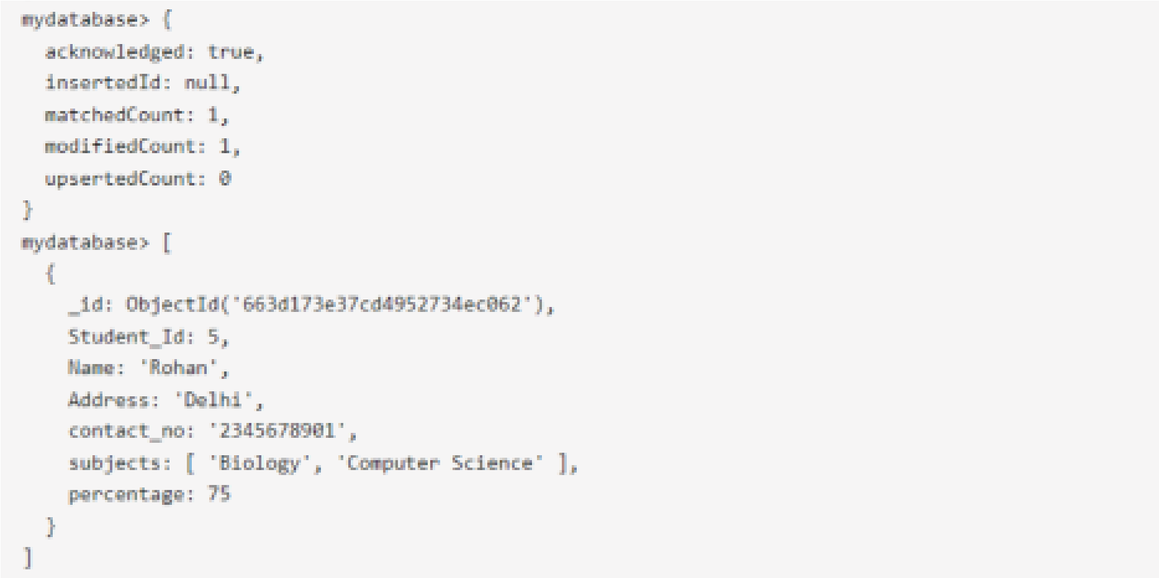

1. Delete document of ‘Rohan’ from database: O/P: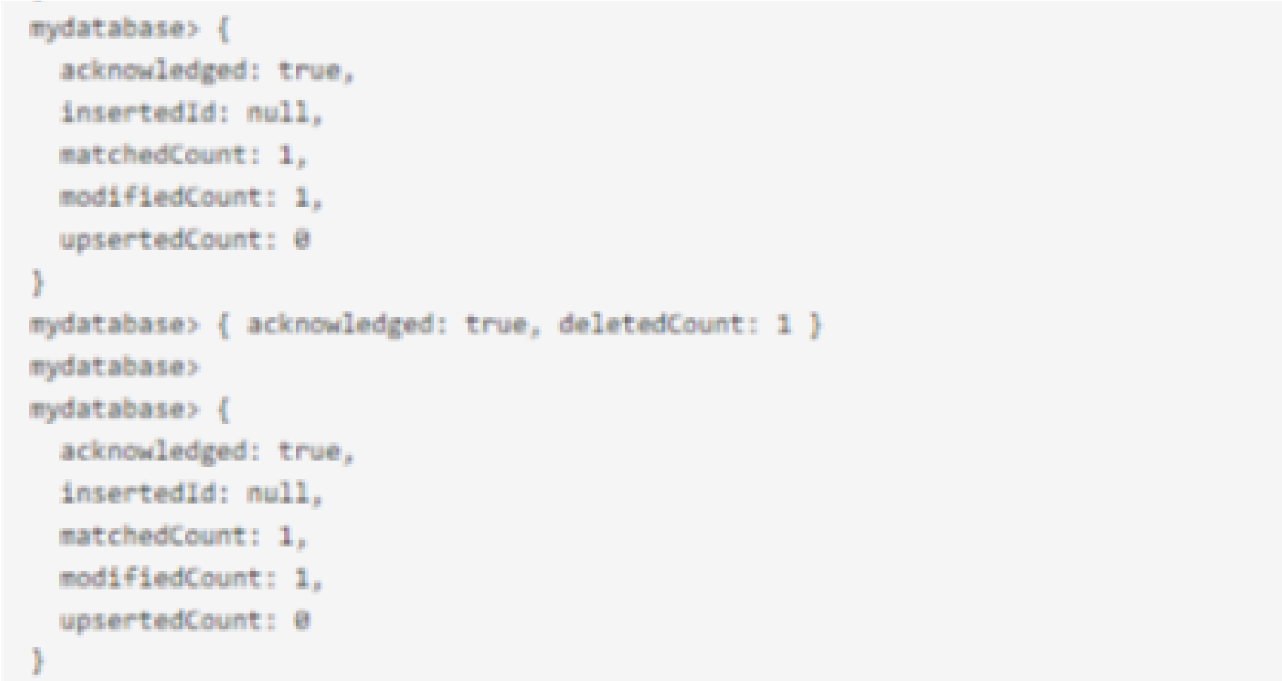
2. Demonstrate use of Save() Method:

In MongoDB, save() has been deprecated and replaced by replaceOne(), updateOne(), or updateMany() based on the use case.

O/P: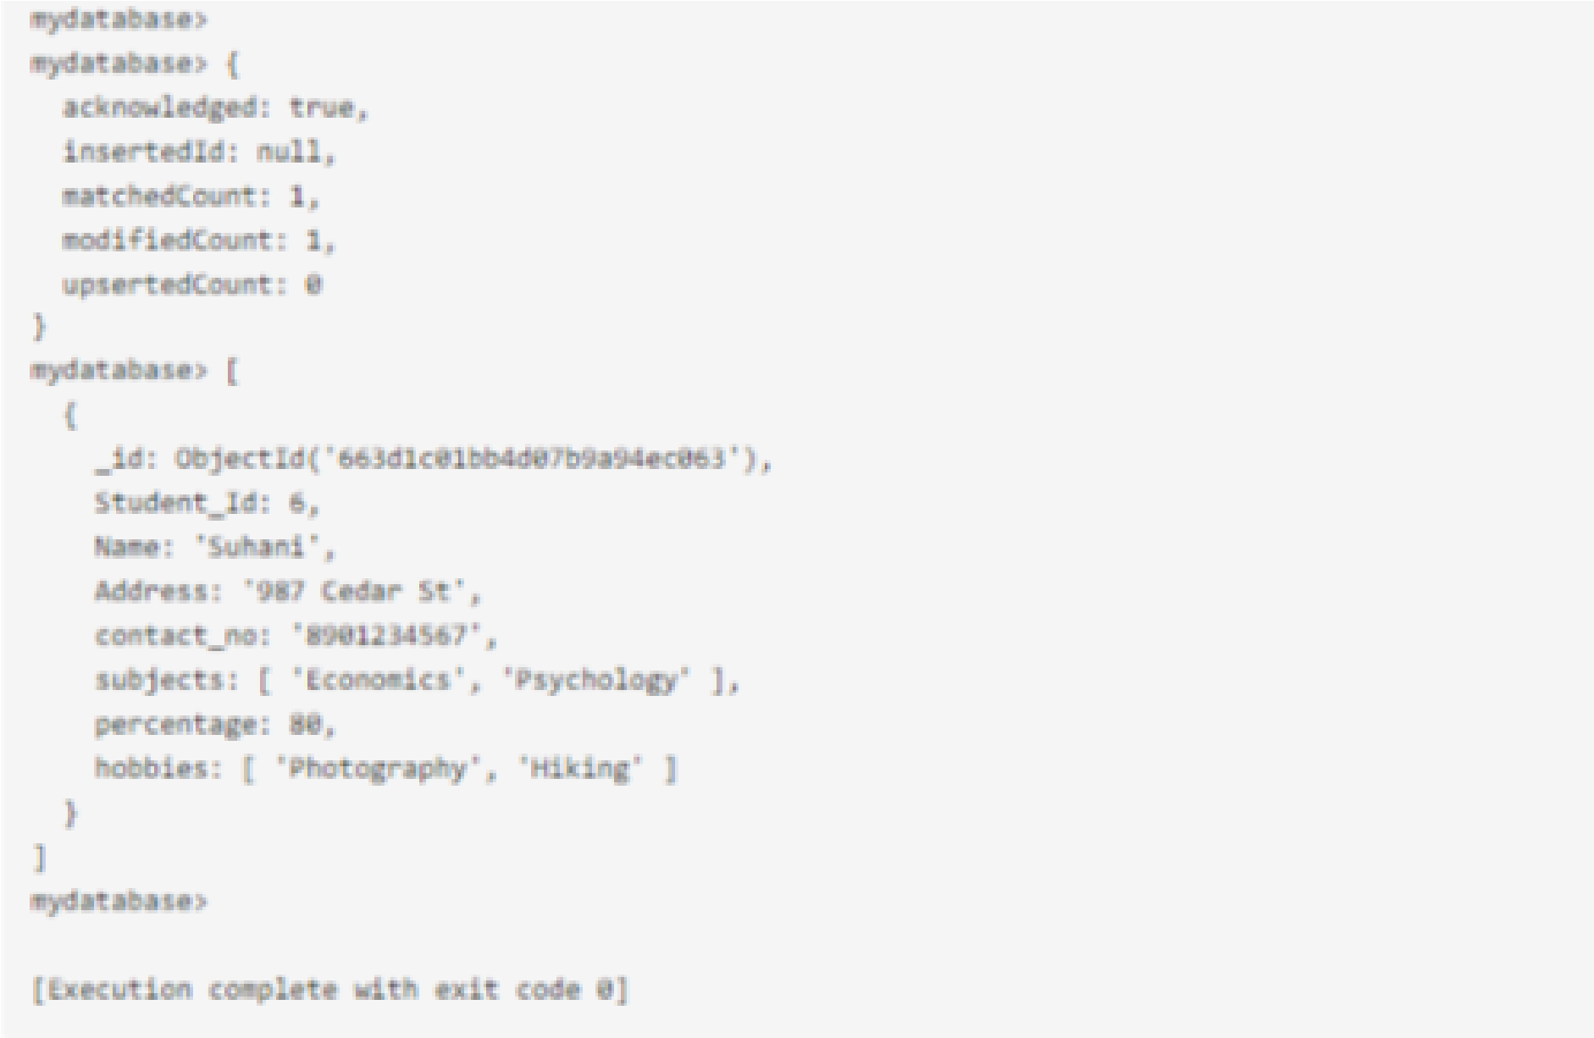

**Complete Output:**

