Member 3 - Mobile Screen Evidence
Implemented donor search, matching, notification and chat features shown in the actual mobile screen layout.

Figure 1: Member 3 Home / Emergency Blood Request screen
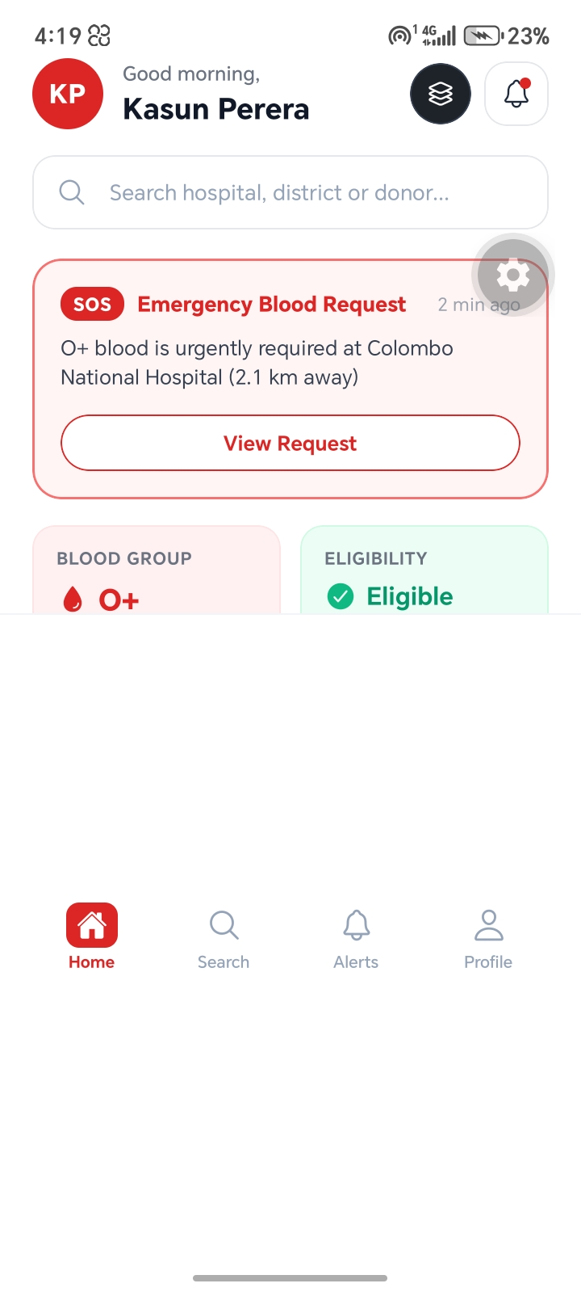

Figure 2: Member 3 Matching Donors screen
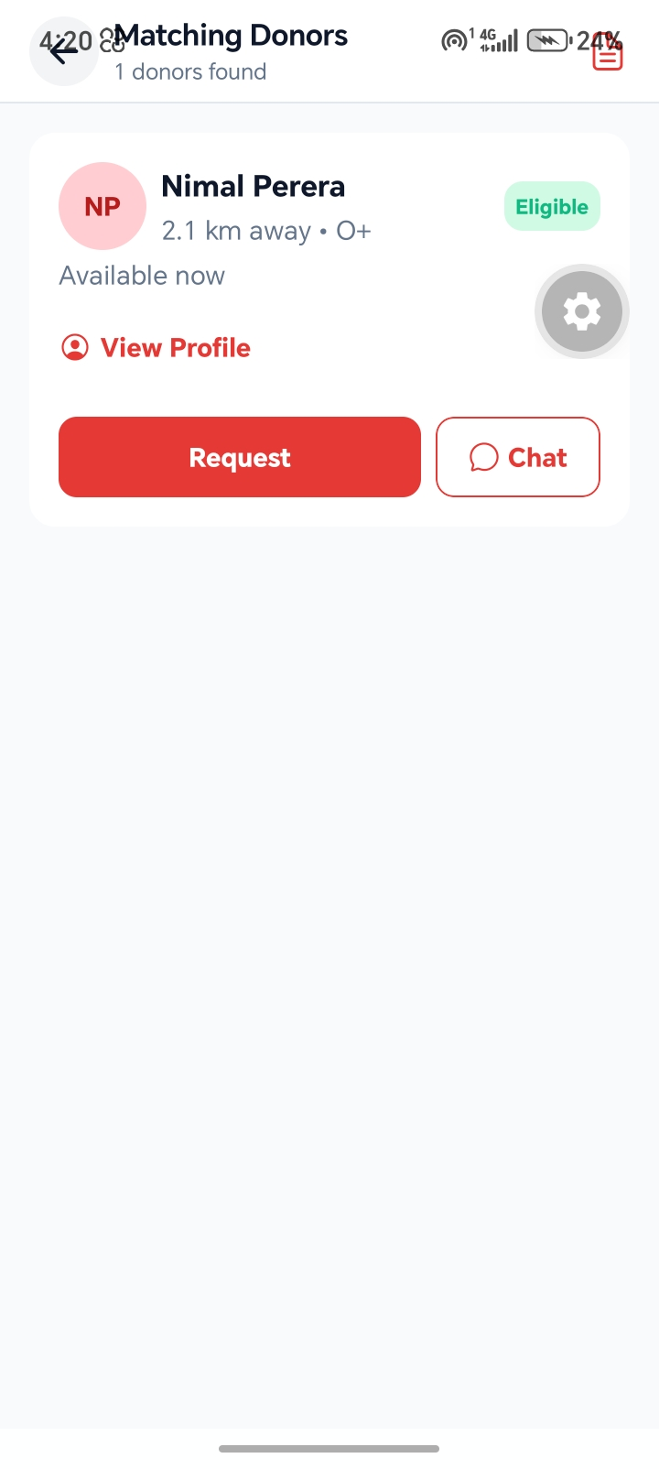

Figure 3: Member 3 Chat screen with quick replies
