Commands Utilities

This assignment expects the participant to identify specific command(s) OR perform the given action using one or commands as per the given question. You are requested to maintain the answers (i.e command(s) as per given question) for all questions below.

Mandatory Questions

1. Which command is used to know the current working directory?

🡺The command is used to know the current working directory is “print working directory (pwd)”.

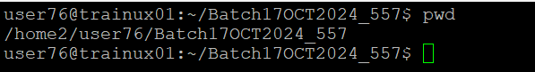

2. How would you find out its contents?

🡺To find out the contents of the current directory, the command “ll” is used.

3. Identify the commands with inputs to do the following

a. create a directory d1

🡺Use “mkdir d1” to create a directory.



b. create a subdirectory d2 in d1

🡺Use “mkdir d1/d2” to create a subdirectory d2 inside d1.



c. change to directory d2

🡺Use “cd d1/d2” to change to the directory d2.



d. create an empty file “f1.txt”

🡺Use “touch f1.txt” to create an empty file named f1.txt.



e. display the contents of “f1.txt”

🡺 cat f1.txt to display the contents of f1.txt.



f. view the contents of d1 from current directory d2

🡺Use “ls” to view contents of the current directory d2.



4. Use the ls command with its options. How will you identify directories from the listing?

🡺To identify directories, use the “-l” with the option “ls” command.

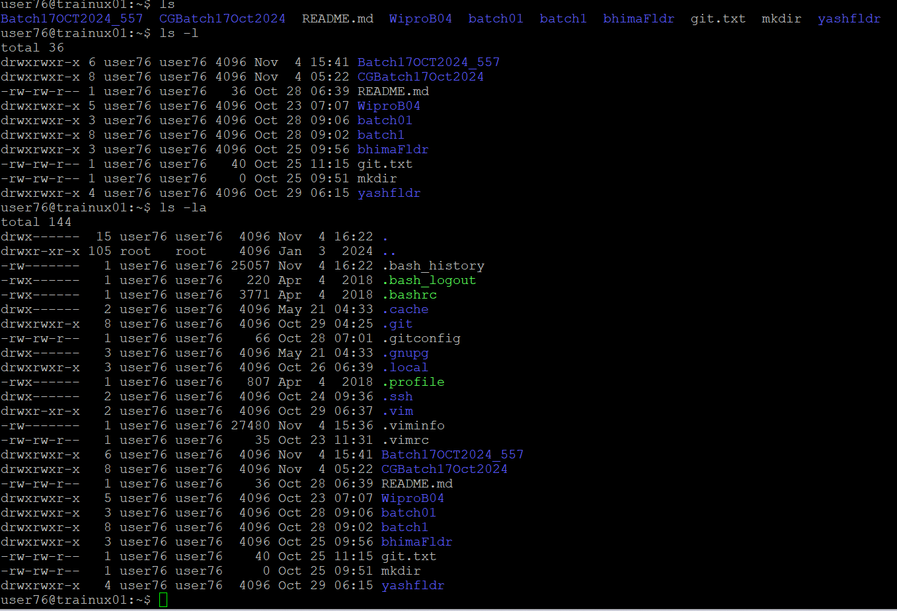

5. Use ls to do the following

a. List files with single character names.

🡺To list files with single character names “ls ?” command is used.

b. List hidden files also. [ Note : Hidden files are files having name started with a “.” ]

🡺To list hidden files “ls-la” command can be used.

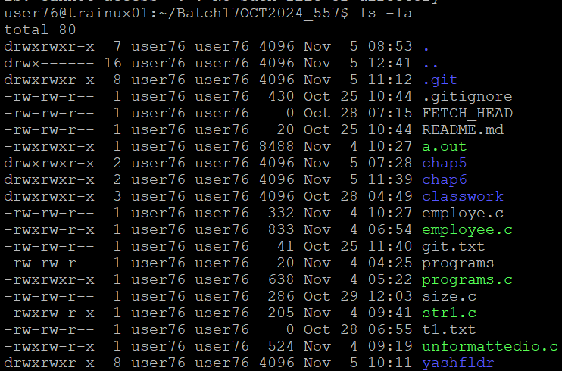

c. Suppose there are files tb1.1, tb2.1, tb3.1, ….tb10.1. Write command to list all the files [Hint: use wild card characters]

🡺Suppose there are files tb1.1, tb2.1,tb3.1 … tb10.1. To list all the files “ls tb*.1” command is used.



6. Write the command to list all files in descending order of their size.

🡺 To list all files in descending order of their size “ls -lS” command can be used.

7. Suppose there are files temp1, temp2, temp3. Write command to remove the files without listing them explicitly

🡺 Suppose there are files temp1, temp2, temp3. “rem temp*” command is used to remove the files without listing them explicitly.

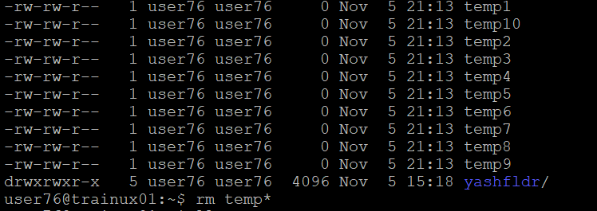

8. Which command is used to list top few lines in the file?

🡺 “head file_name” command is used to list top few lines in the file.

9. Create a directory “testdir”

🡺 To create a directory “testdir”, the command “mkdir testdir” can be used.



10. Use cp command to do the following

a. Copy the file tb1.1 (created above) in the same directory.

🡺 To copy the file tb1.1 (created above) in the same directory, “cp tb1.1 tb1_copy.1” is used.

b. Write a command to copy all the files i.e tb1.1,tb2.1,tb3.1,…..tb10.1 in a new directory –“new”

🡺 To copy all the files i.e. tb1.1, tb2.1, tb3.1,…..tb10.1 in a new directory –“new” ,

the commands:

“mkdir new

cp tb*.1 new/”

c. Create a subdirectory in new in named“new1”.

🡺 To create a subdirectory in new in named “new1”, “mkdir new/new1” command is used.

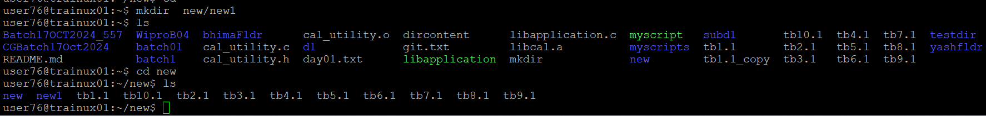

d. Write a command to copy selectively only tb2.1, tb6.1, tb7.1 and tb10.1 in the directory new1.

🡺 To copy only tb2.1, tb6.1, tb7.1 and tb10.1 in the directory new1, the command used is “cp tb2.1 tb6.1 tb7.1 tb10.1 new/new1”.

e. Write a command to copy the entire directory “new” to a directory “newprogs”. [Note : use the –R option of “cp” command ]

🡺 To copy the entire directory “new” to a directory “newprogs”. The command used is

“mkdir newprogs

cp -R new newprogs/”.



11. Find out the difference between

a. “mv” & “cp”

🡺

|  |  |
| --- | --- |
| “mv” Command | “cp” Command |
| The “mv” command is used when a file or a directory is supposed to be moved from one location to the another. The original will be removed in this case. | The “cp” command is used when the contents of a file or a directory is supposed to be copied from one location to another location. In this case the original will be remained untouched. |

b. “rm”, “rmdir”

🡺

|  |  |
| --- | --- |
| “rm” Command | “rmdir” Command |
| The “rm” command is used to remove the entire file or directory erasing all the contents inside the file as well. The non-empty directories can be removed as well using the “-r” command attached. | The “rmdir” command is used to remove only the empty directories. When a directory is not empty then rmdir can not remove the certain directory. |

c. “mkdir” and “mkdir -p”

🡺

|  |  |
| --- | --- |
| “mkdir” Command | “mkdir -p” |
| The “mkdir” command is used to create a directory. The directory gets created only if there exists a parent directory. | The “mkdir -p” command is used to create a directory even if it does not have a parent as the command creates the parent directory itself. |

12. Use a single command rmdir once to remove “testdir” and all its sub directories and files created above.

🡺 To remove “testdir” and all its sub directories and files created above, the command used is “rm -r testdir”.

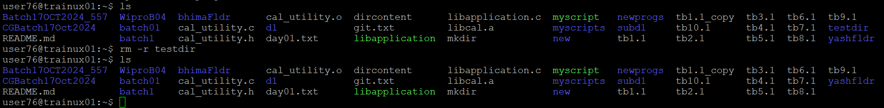

13. Which command is used to get the manual information of a command?

🡺 The command which is used to get the manual information of a command is “man command_name”.

Ex: man gcc

14. If you are not able to change to a directory what could be the likely cause?

🡺 If you are not able to change to a directory it could be likely because

* 1. The directory does not exist.
  2. Insufficient permissions to access the directory.
  3. The path provided is incorrect.

15. Explain the differences among the following commands:

a. cd /

🡺 Changes to the root directory.

b. cd ..

🡺 Moves up one level to the parent directory.

c. cd

🡺 Changes to the user's home directory.

d. cd ../..

🡺 Moves up two levels to the grandparent directory.

