Experiment: Study of Raspberry-Pi, Beagle board, Arduino, and different operating systems for Raspberry Pi/Beagle board/Arduino. Understanding the process of OS installation on Raspberry Pi/Beagle board/Arduino

Lab setup: Raspberry Pi -3, SD Card, SD card formatter, Raspbian OS latest image, 5 Volts 2 Amperes adapter, VGA /HDMI cable converter

Step by Step Execution:

1. Download the latest image of Raspbian OS from [Raspberry Pi OS – Raspberry Pi](https://www.raspberrypi.com/software/)
2. Install Raspberry Pi Imager from the same link.
3. Format the existing SD card using Raspberry Pi Imager and copy the downloaded Raspbian OS with the same tool
4. Post to successful writing of OS over SD card, remove SD card safely from the reader
5. Insert SD card in raspberry pi 3 slot
6. Connect the HDMI port of raspberry pi 3 to monitor using VGA /HDMI cable converter
7. Power on the Raspberry pi 3 using adapter
8. Observe booting process
9. After the successful login set up the time, network and serial port configurations using raspi-config command in terminal

Experiment: Open-source prototype platform- Raspberry-Pi/Beagle board/Arduino -Simple program digital read/write using LED and Switch -Analog read/write using sensor and actuators.

Lab setup: Arduino Uno/ Nano, LED, 220 Ohm resistors, LM 35 sensor, Arduino IDE

Step by Step Execution:

1. Connect LED to GPIO pins of Arduino UNO/Nano with 220 Ohm resistor Ref Link [LED Interface Arduino Uno](https://www.bing.com/images/search?view=detailV2&ccid=hR4qsjfs&id=7A0DC4AA098373281BED64C1713C3627FE2B9B1D&thid=OIP.hR4qsjfs-httuZ9tvto6-QHaKr&mediaurl=https%3a%2f%2f1.bp.blogspot.com%2f-7mXR6vJD_uc%2fVLA-N7ZtUdI%2fAAAAAAAAM3s%2fhhXKp5HUMlc%2fs1600%2fLedBlink_bb.png&exph=1323&expw=918&q=led+blink+arduino&simid=608021851839686634&FORM=IRPRST&ck=7B0A02AB67A079B1E5E6FD7487131952&selectedIndex=6)

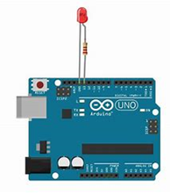

1. Connect LM 35 sensor to Arduino Uno/ Nano as shown below. Refer link [LM 35 Arduino Uno Interface](https://beatyourbit.files.wordpress.com/2018/01/lm35-arduino-2.png)

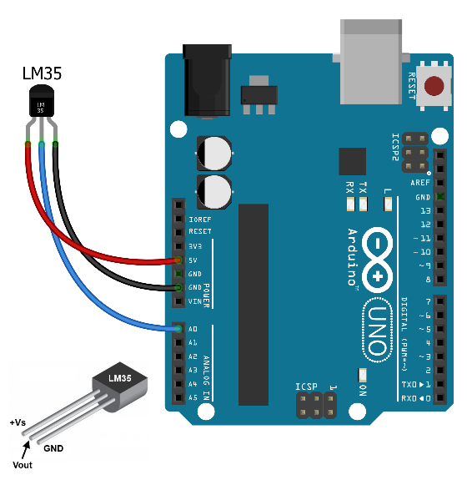

1. Using AnalogRead() function in Arduino start reading temperature from LM35 sensor and display the temperature in degree Celsius over serial port on PC
2. Set the threshold of 36-degree Celsius temperature in programming and turn on LED if temperature crosses the threshold value.

Experiment: Interfacing sensors and actuators with Arduino/Raspberry-pi

Lab setup: ESP8266 Node-MCU, DHT11, 10 K Pull Up resistor, USB to Serial cable, Ardunio IDE with ESP8266 libraries

Step by Step Execution:

1. Connect DHT 11 to ESP8266 Node MCU as shown in the below figure. Reference Link [ESP8266 - DHT 11 Interface](https://miro.medium.com/max/5166/1*gIMRuDbEumGs8rN7nu8chg.png)

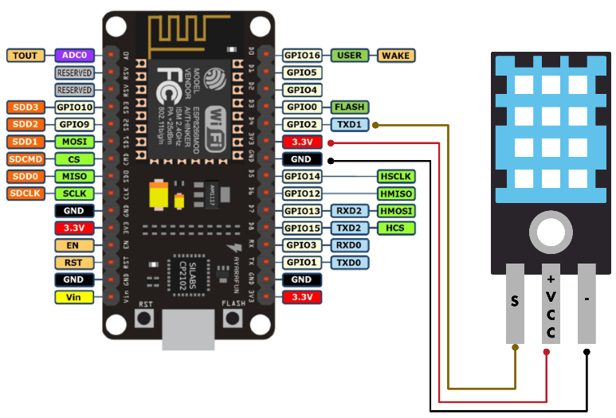

1. Install DHT 11 Arduino Libraries in Arduino IDE
2. Create ESP8266 as access point using SOFTAP() function
3. Add HTML script of Web page for displaying temperature and humidity
4. Read the temperature and humidity values from DHT11, parse the string in separate fields
5. Once system is boot up, check its local IP address over serial port
6. Connect to the access point hosted by ESP8266 and log into HTTP portal of IP address to observe the temperature and humidity