**Sensor Fabrication Fault Detection**

1. **Problem Statement:**

The inputs of various sensors for different wafers have been provided. In [electronics](https://en.wikipedia.org/wiki/Electronics), a wafer (also called a slice or substrate) is a thin slice of [semiconductor](https://en.wikipedia.org/wiki/Semiconductor) used for the [fabrication](https://en.wikipedia.org/wiki/Semiconductor_device_fabrication) of [integrated circuits](https://en.wikipedia.org/wiki/Integrated_circuit). The goal is to build a machine learning model which predicts whether a wafer needs to be replaced or not(i.e., whether it is working or not) based on the inputs from various sensors. There are two classes: +1 and -1.

* +1 means that the wafer is in a working condition and it doesn’t need to be replaced.
* -1 means that the wafer is faulty and it needs to be replaced.

1. **Architecture Diagrams:**
   1. **Functional Architecture**

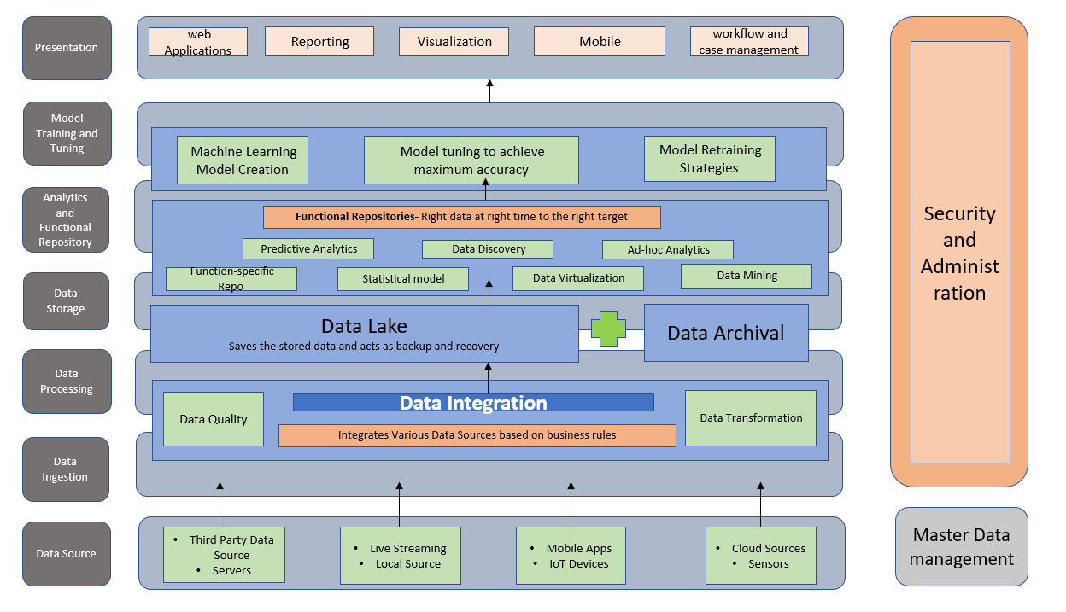

* 1. **Technical Stack**

