Comparative Study of Valmiki’s *Ramayana* and Tulsidas’s *Ramcharitmanas*

NAME :- Yash Dharmendra Parmar

ROLL NO. :- 23102B0037

BRANCH :- CMPN B

SUBJECT :- EXPLORING INDIAN ARTS

**Acknowledgment**

I would like to express my sincere gratitude to my professor for guiding me throughout this comparative study of Valmiki's *Ramayana* and Tulsidas's *Ramcharitmanas*. This project would not have been possible without the constant support and encouragement of my family, friends, and teachers, who motivated me at every step. I am also deeply thankful to the scholars, writers, and filmmakers whose interpretations of these timeless epics contributed significantly to my research. Their works provided invaluable insights and deepened my understanding of the subject matter.

### Table of Contents

1. **Introduction**..............................................................................4  
   1.1 Overview of Ramayana and Its Significance in Indian Culture  
   1.2 Introduction to Valmiki’s Ramayana and Tulsidas’s Ramcharitmanas  
   1.3 Purpose of the Comparative Study
2. **Chapter 1: Historical and Cultural Context**....................................8  
   2.1 Valmiki’s Ramayana  
   2.2 Tulsidas’s Ramcharitmanas
3. **Chapter 2: Structure and Organization**............................................10  
   3.1 Valmiki’s Ramayana  
   3.2 Tulsidas’s Ramcharitmanas
4. **Chapter 3: Language and Style**.......................................................11  
   4.1 Valmiki’s Ramayana  
   4.2 Tulsidas’s Ramcharitmanas
5. **Chapter 4: Philosophical Themes**..................................................12  
   5.1 Valmiki’s Ramayana  
   5.2 Tulsidas’s Ramcharitmanas
6. **Chapter 5: Portrayal of Major Characters**.....................................13  
   6.1 Rama  
   6.2 Sita  
   6.3 Hanuman
7. **Chapter 6: Depiction of Major Events**...........................................19  
   7.1 Valmiki’s Ramayana  
   7.2 Tulsidas’s Ramcharitmanas
8. **Chapter 7: Influence and Popularity**..............................................21  
   8.1 Valmiki’s Ramayana  
   8.2 Tulsidas’s Ramcharitmanas
9. **Conclusion**...................................................................................23  
   9.1 Summary of Key Differences and Similarities  
   9.2 Discussion on Coexistence and Complementarity  
   9.3 Reflection on Enduring Legacy
10. **References**..................................................................................24

### ****Introduction****

#### ****The Ramayana: A Brief Overview and Its Cultural Significance****

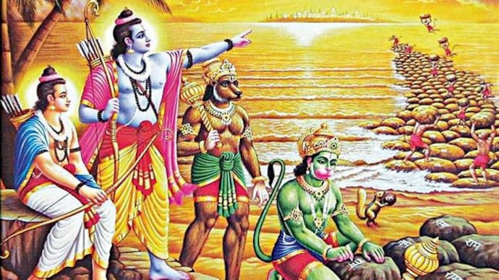

The Ramayana, one of the two great epics of ancient India alongside the Mahabharata, holds an unparalleled position in Indian culture, religion, and philosophy. Attributed to the sage Valmiki, this monumental work is not merely a story of the heroic Prince Rama but a profound exploration of dharma (righteousness), devotion, and the human condition. Across centuries, the Ramayana has transcended the boundaries of a literary epic to become a source of moral and ethical guidance for millions. Its characters—Rama, Sita, Lakshmana, Hanuman, and Ravana—are household names, representing ideals and lessons for life.

The epic narrative of Ramayana recounts the life of Rama, the prince of Ayodhya, who is exiled to the forest for fourteen years. The story revolves around his struggle to uphold dharma, the abduction of his wife Sita by the demon king Ravana, and the eventual rescue of Sita with the help of his devoted ally, Hanuman. At its core, the Ramayana is a tale of good versus evil, righteousness versus injustice, but it is also a multi-layered work that explores complex themes of loyalty, love, duty, sacrifice, and redemption.

Throughout the centuries, the Ramayana has inspired various retellings, adaptations, and interpretations in numerous languages and formats—oral traditions, plays, dance forms like Kathakali and Bharatanatyam, and even modern films and television series. The cultural reach of the Ramayana extends beyond India, influencing Southeast Asian countries such as Indonesia, Thailand, and Cambodia, where it has been assimilated into local traditions.

In India, the Ramayana is not just a story but a living tradition. The epic is recited, dramatized, and sung in festivals like Ramlila, celebrated particularly during Dussehra, which culminates in the burning of Ravana's effigy symbolizing the triumph of good over evil. The Ramayana has shaped the social, moral, and ethical framework of Indian society and continues to serve as a timeless guide on how to live a life in accordance with the values of dharma, or righteousness.

#### ****Valmiki’s**** Ramayana****: The Adi Kavya (The First Epic)****

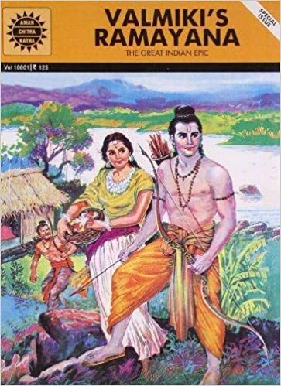

Valmiki’s Ramayana is regarded as the earliest and most authoritative version of the Rama story, often referred to as the Adi Kavya or the "first epic." Composed in classical Sanskrit, Valmiki’s Ramayana dates back to approximately 500 BCE and consists of around 24,000 verses organized into seven books, or Kandas. The narrative structure of Valmiki’s Ramayana follows a linear progression of events, beginning with the birth of Rama and culminating in his return to Ayodhya after defeating Ravana.

Valmiki is revered as the “Adi Kavi” or the “first poet,” and his Ramayana is considered a masterpiece of classical Sanskrit literature. The text is written in a refined and sophisticated style, with intricate poetic devices, vivid imagery, and a deep philosophical undercurrent. While the Ramayana primarily celebrates Rama as the ideal man (Maryada Purushottam) who adheres to the principles of dharma, it also delves into the complexities of human emotions and moral dilemmas.

Valmiki’s portrayal of Rama is of a mortal prince who, though endowed with divine qualities, faces trials and tribulations that test his adherence to duty, justice, and virtue. His struggle to uphold dharma in the face of personal loss, temptation, and adversity serves as a powerful model for readers and listeners. The Ramayana also offers a profound meditation on the nature of relationships—whether between husband and wife (Rama and Sita), brothers (Rama and Lakshmana), or friends (Rama and Hanuman)—and the sacrifices one must make to honor those relationships.

Valmiki’s Ramayana has had a lasting influence on Indian literature, philosophy, and culture. Its characters, themes, and moral teachings continue to resonate in modern times, and its Sanskrit verses are still recited in religious ceremonies and academic settings. The epic's universality lies in its exploration of timeless themes that transcend time, space, and cultural boundaries, making it a cornerstone of India’s spiritual and literary heritage.

#### ****Tulsidas’s**** Ramcharitmanas****: The Bhakti Movement and the Vernacular Retelling****

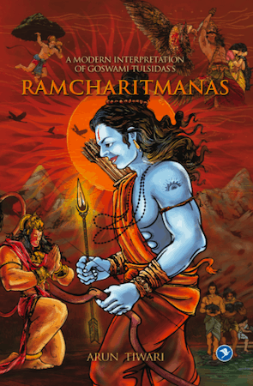

Fast forward to the 16th century, a time when India was experiencing significant socio-political upheavals due to the rise of Islamic rule in Northern India and the increasing gap between the Sanskrit-educated elite and the common populace. It was in this context that Tulsidas, a poet-saint of the Bhakti movement, composed the Ramcharitmanas in Awadhi, a dialect of Hindi. Unlike the classical Sanskrit of Valmiki’s Ramayana, which was largely inaccessible to the common people of the time, Tulsidas chose the vernacular to make the story of Rama more accessible to the masses.

The Ramcharitmanas, often referred to as “Tulsidas’s Ramayana,” is much more than a retelling of Valmiki’s epic. Composed in Chaupai and Doha poetic forms, the Ramcharitmanas is infused with a devotional spirit that reflects Tulsidas’s deep commitment to the Bhakti tradition. While Valmiki’s Ramayana portrays Rama as an ideal human being, Tulsidas’s version elevates him to the status of the supreme divine entity, an incarnation of Vishnu who has come to earth to vanquish evil and establish righteousness. This shift in focus from the human to the divine reflects the Bhakti movement’s emphasis on personal devotion (bhakti) to God as the path to salvation.

Tulsidas’s portrayal of Rama, Sita, Lakshmana, and Hanuman in the Ramcharitmanas is deeply rooted in the Bhakti ethos. Rama is not just the ideal king or warrior; he is the epitome of divine grace and love, and his actions are seen as lila (divine play) rather than mere worldly events. Sita is the divine consort, and her relationship with Rama symbolizes the union of the soul with God. Hanuman, in particular, emerges as the ultimate devotee, embodying the ideal of selfless service and surrender to the Lord.

Tulsidas’s Ramcharitmanas rapidly gained immense popularity in North India, particularly among the rural and devotional communities. It became a part of the living tradition of devotional singing and storytelling, especially during the festival of Ramlila, where scenes from the Ramayana are enacted in folk performances. The Ramcharitmanas is still widely recited in temples and homes, and its verses are sung in religious gatherings. Tulsidas’s version of the Ramayana has become an integral part of the religious and cultural fabric of India, particularly in regions where Hindi and related dialects are spoken.

#### ****Purpose of the Comparative Study****

The Ramayana, in its various forms, has had a profound and lasting impact on Indian culture, religion, and philosophy. While Valmiki’s Ramayana is the original and authoritative version of the story, Tulsidas’s Ramcharitmanas has become equally influential, particularly in North India. Both texts present the same core narrative, but they do so through different linguistic, cultural, and philosophical lenses.

This comparative study aims to explore the key differences and similarities between Valmiki’s Ramayana and Tulsidas’s Ramcharitmanas. By examining their historical contexts, narrative structures, philosophical themes, and cultural significance, this study will shed light on how each version of the Ramayana reflects the values and beliefs of its time. The study will also explore how both texts have influenced the development of Hinduism, particularly with regard to the concepts of dharma and bhakti.

Ultimately, this comparative analysis will not only highlight the unique contributions of Valmiki and Tulsidas to Indian literature but also demonstrate the enduring relevance of the Ramayana in shaping the moral and spiritual consciousness of millions of people across generations.

**Chapter 1: Historical and Cultural Context**

**Valmiki’s *Ramayana***

* **Date of Composition (Approx. 500 BCE):** Valmiki’s *Ramayana* is believed to have been composed during a period between 500 BCE and 100 BCE, placing it in ancient India’s Vedic period. This was a time when Sanskrit was the dominant language of intellectual, spiritual, and cultural expression.
* **Valmiki as the “Adi Kavi” (First Poet):** Valmiki holds the revered title of "Adi Kavi" because his *Ramayana* is considered the first Sanskrit poem. It set the template for future epics, blending mythology, philosophy, and cultural values in a poetic format.
* **Sanskrit as the Language of Intellectual and Religious Discourse:** Sanskrit, the language in which the *Ramayana* was written, was the liturgical and scholarly language of the time. Its grammar, refinement, and complexity reflected the intellectual and philosophical sophistication of ancient Indian culture. Sanskrit's prestige solidified the *Ramayana* as a work of high literary merit and religious importance.
* **Influence on Hindu Philosophy and Other Ancient Epics:** The *Ramayana* not only influenced later Hindu epics like the *Mahabharata* but also shaped the philosophical concepts of dharma (duty), karma (action), and the moral obligations of a ruler. Its portrayal of Rama as the “Maryada Purushottama” (the perfect man) became a standard for kings and commoners alike. The epic influenced Hindu philosophy and has parallels with other epics, like the *Iliad* and the *Odyssey*, focusing on heroism, morality, and divine-human interaction.

**Tulsidas’s *Ramcharitmanas***

* **Date of Composition (16th Century CE):** Tulsidas wrote *Ramcharitmanas* in the 16th century during the Mughal era. The socio-political environment of the time, with the Bhakti movement on the rise, deeply influenced his work. Unlike Valmiki’s time, the medieval period saw the dominance of vernacular languages over classical Sanskrit.
* **Tulsidas’s Life and the Bhakti Movement:** Tulsidas was a central figure in the Bhakti movement, which emphasized personal devotion to God over ritualistic practices. His work, *Ramcharitmanas*, was an expression of his deep devotion to Lord Rama. The Bhakti movement aimed to make spiritual practices more accessible to the masses, breaking away from caste-based exclusivity in religious rites.
* **Awadhi as a Vernacular Language and Its Accessibility:** Tulsidas composed *Ramcharitmanas* in Awadhi, a dialect of Hindi spoken by common people in North India. This made the story of Rama accessible to a broader audience, especially those who couldn’t understand Sanskrit, further popularizing the worship of Rama.
* **Impact on Medieval Hinduism and Popularizing Rama’s Worship:** Through his *Ramcharitmanas*, Tulsidas revolutionized the way Lord Rama was perceived. The Bhakti lens, which stressed devotion over the rigid adherence to dharma, made the text spiritually significant for devotees. The *Ramcharitmanas* played a key role in fostering widespread devotion to Rama in temples, homes, and public spaces, such as the *Ramlila* performances.

**Chapter 2: Structure and Organization**

**Valmiki’s *Ramayana***

* **Divided into Seven Kandas (Books):** Valmiki’s *Ramayana* is divided into seven books, known as *Kandas*: Bala, Ayodhya, Aranya, Kishkindha, Sundara, Yuddha, and Uttara Kanda. These sections follow a linear chronological narrative, detailing the life of Rama from his birth to his coronation after defeating Ravana.
* **Original Text Contains Around 24,000 Verses:** With approximately 24,000 shlokas (verses), Valmiki’s *Ramayana* is an extensive work that leaves room for detailed descriptions of events, dialogues, and moral lessons.
* **Focus on Events and Dialogue:** The narrative style of Valmiki is more descriptive, with greater emphasis on the actions of the characters, their dialogues, and the events surrounding them. This makes the *Ramayana* more of a historical chronicle.

**Tulsidas’s *Ramcharitmanas***

* **Also Divided into Seven Kandas but with Variations:** Tulsidas retains the seven-Kanda structure but renames and reorganizes them. For example, the *Yuddha Kanda* in Valmiki becomes *Lanka Kanda* in *Ramcharitmanas*. Tulsidas’s Kandas emphasize the spiritual and emotional journeys of the characters.
* **Written in Chaupai and Doha Poetic Forms:** The verses are structured in *Chaupai* (quatrains) and *Doha* (couplets), forms more suited to singing and recitation. These poetic forms were popular in folk traditions, allowing *Ramcharitmanas* to resonate with people at religious gatherings.
* **Contains Approximately 12,000 Verses:** Tulsidas’s text is shorter, focusing less on descriptive events and more on devotional expression and emotional depth. Its content was streamlined to align with the Bhakti movement’s focus on devotion.
* **More Devotional, Focused on Spiritual Teachings and Bhakti:** While Valmiki’s *Ramayana* revolves around dharma, Tulsidas’s text emphasizes Bhakti (devotion to God). Events are interpreted as expressions of divine will, with characters like Rama and Hanuman representing the path to salvation through devotion.

**Chapter 3: Language and Style**

**Valmiki’s *Ramayana***

* **Written in Classical Sanskrit:** The Sanskrit used in the *Ramayana* is classical, reflecting the high linguistic and literary standards of the time. Sanskrit’s intricate grammar and vocabulary allow for complex sentence structures and rich expressions.
* **Use of Vivid Imagery, Similes, and Metaphors:** Valmiki’s poetry is known for its rich use of imagery and metaphor, often using nature and celestial elements to describe scenes. For instance, Rama’s beauty is often compared to the moon, while battles are depicted with the ferocity of natural disasters.
* **A Literary Masterpiece in Poetic Devices:** The text is considered a benchmark in Sanskrit literature, renowned for its skilled use of poetic devices like alliteration, assonance, and meter. This makes the text both intellectually engaging and aesthetically pleasing.

**Tulsidas’s *Ramcharitmanas***

* **Written in Awadhi:** Tulsidas composed his work in Awadhi, a more accessible dialect of Hindi. The language is straightforward, making the text comprehensible to people with no formal education in Sanskrit.
* **Simpler and More Accessible Language for the Masses:** Awadhi’s simplicity allowed the devotional themes to be absorbed more easily by the common people. It wasn’t just a literary work but also a devotional manual that could be chanted or sung.
* **Poetic Devices Tailored for a Devotional Audience:** Tulsidas employs metaphor, simile, and local idioms that reflect the daily lives of his audience. His emphasis is on evoking emotion, particularly feelings of devotion, reverence, and awe toward Rama and his divine acts.

**Chapter 4: Philosophical Themes**

Valmiki’s *Ramayana*

* Dharma (Duty) as a Central Theme: Valmiki’s *Ramayana* is a text centered on dharma—moral and social obligations. Each character’s actions are evaluated based on how they uphold their dharma. Rama is an epitome of a dharmic ruler and son, who sacrifices his happiness for the sake of duty.
* Rama as a Human Prince with Divine Attributes: In Valmiki’s text, Rama is primarily a human, albeit with divine attributes. His adherence to dharma is emphasized, and his godliness is more subtle, making his virtues more relatable to humans.
* Explores Moral Dilemmas: Key episodes such as Rama’s exile, Sita’s abduction, and her *Agni Pariksha* (trial by fire) highlight the moral dilemmas that the characters face. These dilemmas are used to teach lessons about righteousness, justice, and the consequences of one’s actions.

Tulsidas’s *Ramcharitmanas*

* Strong Bhakti (Devotional) Orientation: Tulsidas’s text is infused with the philosophy of Bhakti, advocating the path of surrender to God as the ultimate means of liberation. Unlike Valmiki, who emphasizes dharma, Tulsidas underscores the importance of loving devotion.
* Rama Portrayed as a Divine Incarnation of Vishnu: In *Ramcharitmanas*, Rama’s divinity is much more explicit. He is not just a prince but an avatar of Vishnu, born to vanquish evil and establish dharma. His godliness is central to the narrative, and he is worshipped as the supreme deity.
* Emphasis on Surrender and Devotion: While Valmiki’s Rama teaches adherence to dharma, Tulsidas’s Rama demands devotion and surrender. The highest ideal is not just righteousness but complete devotion and trust in Rama’s divinity.

**Chapter 5: Portrayal of Major Characters**

Rama:

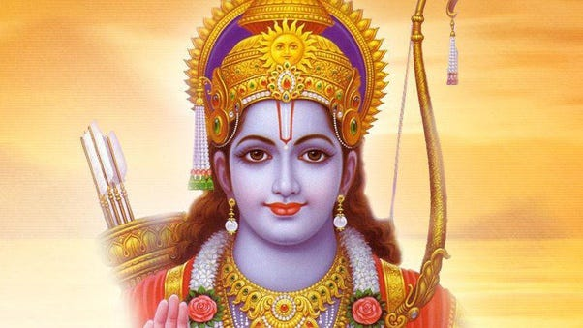

**Valmiki’s Rama**

* **Embodiment of Dharma: In Valmiki's *Ramayana*, Rama is revered as the ideal embodiment of dharma (righteousness) and duty. He represents the quintessential values of a king, son, husband, and warrior, seamlessly blending moral integrity with the responsibilities of leadership. His adherence to dharma is reflected in his commitment to his father’s wishes and his willingness to accept exile to uphold the honor of his family and kingdom. This unwavering devotion to righteousness makes him a model of virtuous behavior, demonstrating that even a divine being must navigate the challenges of human existence.**
* **Human Qualities: What sets Valmiki’s Rama apart is his deeply human portrayal, allowing him to resonate with readers on an emotional level. He is not a distant deity but a character imbued with a range of human emotions, including sorrow, doubt, and anger. For instance, when Sita is abducted by Ravana, Rama's grief is palpable, revealing his vulnerability and the profound love he harbors for her. This moment encapsulates his humanity, as he grapples with despair and a sense of loss that transcends his divine nature.**
* **Moral Dilemmas and Vulnerability: Throughout the narrative, Rama faces numerous moral dilemmas that challenge his understanding of duty and righteousness. His banishment of Sita, despite his deep love for her, highlights the conflict between personal affection and public duty. This moment of sorrow not only illustrates his emotional depth but also emphasizes the burdens of kingship and the expectations placed upon him. Valmiki’s Rama is relatable in his struggle to balance his divine responsibilities with the human experiences of love, loss, and regret. This balance between divinity and humanity adds layers of complexity to his character, inviting readers to explore the nuances of ethical decision-making and the emotional toll of adhering to one's principles.**
* **Complex Characterization: Valmiki’s portrayal of Rama ultimately showcases a multi-faceted character who is both divine and human. He navigates the trials of life with a sense of duty that resonates with the moral complexities of human existence, making him a compelling figure in literature. His journey illustrates the profound nature of dharma, demonstrating that righteousness often requires sacrifice and difficult choices.**

**Tulsidas’s Rama**

* **Divine Nature and Bhakti Devotion: In contrast, Tulsidas’s *Ramcharitmanas* presents Rama primarily as a divine figure, deeply aligned with Bhakti (devotional) principles. Here, Rama is venerated as an incarnation of Vishnu and is regarded as the supreme deity, transcending the human condition. This portrayal emphasizes his divinity, making him an object of worship rather than a relatable figure to be emulated. Tulsidas’s Rama is a source of divine grace, embodying the qualities of a protector and savior for his devotees.**
* **De-emphasized Human Attributes: Tulsidas downplays Rama’s human attributes, focusing instead on his omnipotent nature. His actions are portrayed as manifestations of divine will, reflecting the belief that Rama’s decisions and emotions are beyond human complexities. For example, Rama’s responses to challenges are not depicted as struggles with doubt or fear but rather as expressions of his divine purpose. This shift in focus elevates him to a status that emphasizes faith and devotion, allowing devotees to connect with him on a spiritual plane.**
* **Protector and Source of Grace: In *Ramcharitmanas*, Rama is celebrated as a protector who intervenes in the lives of his devotees, showcasing his role as the ultimate source of divine grace. His divine actions are seen as exemplifications of love and compassion, drawing devotees into a deeper spiritual connection. For Tulsidas, Rama's narrative serves to inspire faith among the Bhaktas, reinforcing the idea that divine intervention is accessible to all who seek it.**
* **Transcendence of Moral Complexity: Tulsidas’s Rama transcends the moral complexities faced by Valmiki’s character. Rather than embodying the struggles inherent to human life, Tulsidas presents him as a figure of unwavering righteousness, whose divine nature absolves him of moral ambiguity. This portrayal aligns with the Bhakti movement's emphasis on personal devotion and faith, positioning Rama not just as a historical or literary figure but as the ultimate form of God that Bhaktas can worship and revere.**

**Sita:**

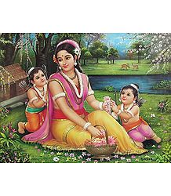

* **Valmiki’s Sita:** Valmiki’s Sita is a multi-faceted character who displays remarkable resilience, purity, and strength. She undergoes severe trials, such as her abduction by Ravana and her subsequent *Agni Pariksha* (trial by fire), to prove her chastity. Valmiki’s Sita is a symbol of ideal womanhood but also possesses depth and agency. Her portrayal is not just as Rama’s devoted wife, but as a woman of strong will who endures significant hardship without losing her dignity or purity. Her decision to remain in exile after her banishment by Rama demonstrates her independent strength. Sita’s role in the *Ramayana* highlights the theme of dharma from a woman’s perspective—her unwavering support for her husband and her own adherence to righteousness.
* **Tulsidas’s Sita:** In *Ramcharitmanas*, Sita is more of a devotional figure. Tulsidas emphasizes her role as the ideal, devoted wife and a symbol of feminine virtue. She is portrayed as a spiritual equal to Rama, embodying devotion and surrender, essential qualities of the Bhakti tradition. Her suffering and trials, including the *Agni Pariksha*, are seen as tests of her unwavering devotion to Rama, rather than as personal hardships. Sita’s portrayal in Tulsidas’s work is less about her personal agency and more about her embodiment of Bhakti ideals. She is a divine consort whose entire existence revolves around her relationship with Rama, symbolizing the perfect devotee.

**Hanuman:**

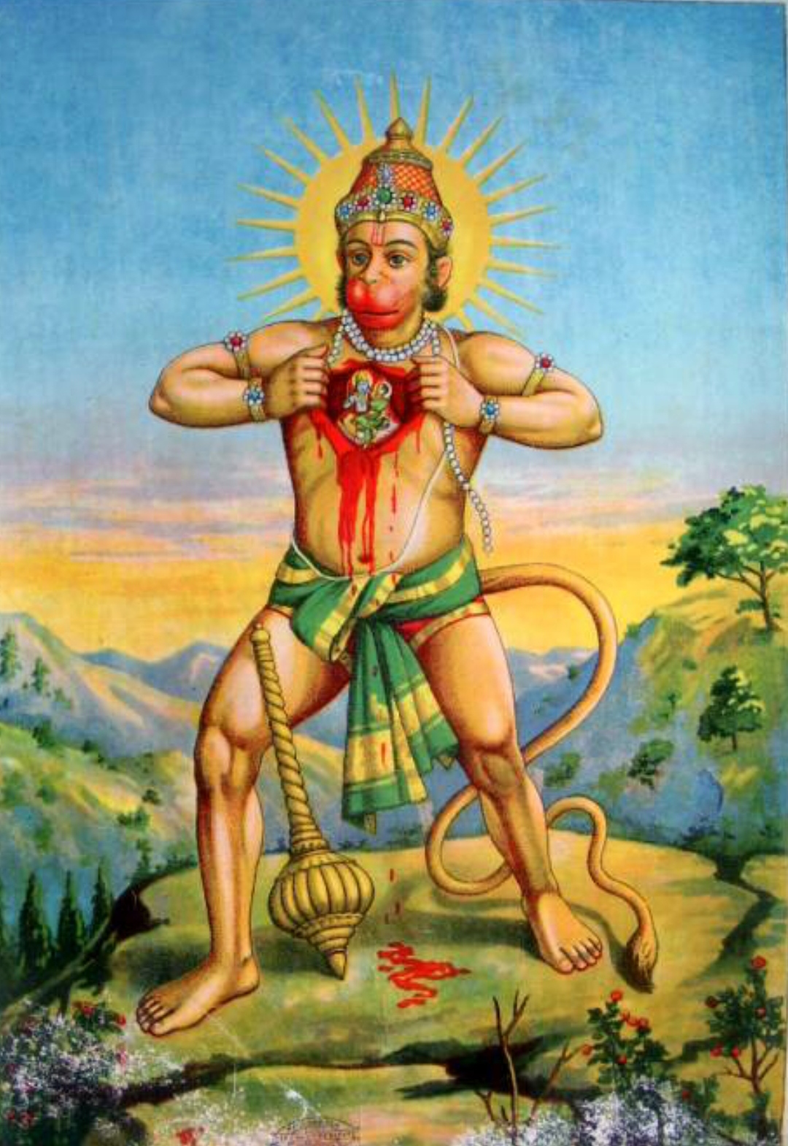

**Valmiki’s Hanuman**

* **Devoted Servant of Rama:  
  In Valmiki's *Ramayana*, Hanuman is primarily depicted as a devoted servant and disciple of Lord Rama. His unwavering loyalty to Rama is central to his character, demonstrating the ideals of service and devotion. Hanuman's commitment to Rama is evident throughout the epic, particularly in his daring endeavors, such as his leap across the ocean to reach Lanka and locate Sita. This act not only showcases his physical strength but also his fearless dedication to fulfilling Rama’s mission.**
* **Heroic Attributes:  
  Hanuman’s characterization in Valmiki's narrative emphasizes his exceptional physical prowess, intelligence, and resourcefulness. He is portrayed as a heroic figure capable of extraordinary feats, such as transforming his size at will, flying, and engaging in combat. For instance, during the battle in Lanka, he demonstrates remarkable strength by lifting mountains and fighting formidable foes, earning the respect of both allies and enemies alike. However, his feats, while impressive, are framed within the context of his mortal nature; he is revered for his abilities but is not elevated to divine status.**
* **Role in the Narrative:  
  Valmiki’s Hanuman plays a pivotal role in the unfolding of the Ramayana’s narrative. His intelligence and strategic thinking are crucial in orchestrating the rescue of Sita. He acts as a messenger, bridge-builder, and warrior, highlighting his multifaceted contributions to Rama’s cause. Hanuman’s actions, such as burning Lanka and rallying the vanara (monkey) army, reflect his heroism and emphasize the theme of loyalty to one's duty. His devotion to Rama, while profound, remains grounded in the mortal realm, allowing readers to connect with him as a relatable hero rather than a divine entity.**
* **Understated Divinity:  
  In Valmiki's work, Hanuman's divine qualities are present but understated. While he exhibits supernatural abilities, these are framed as extraordinary skills rather than indicators of his divine origin. This portrayal emphasizes the idea that even great heroes can possess human-like attributes, making Hanuman an approachable and relatable character. His humility, despite his accomplishments, reinforces the notion that true devotion and service are grounded in selflessness rather than ego.**

**Tulsidas’s Hanuman**

* **Elevated to Divine Status:  
  In stark contrast, Tulsidas’s *Ramcharitmanas* presents Hanuman as a divine figure, often worshipped in his own right. Tulsidas emphasizes Hanuman's divinity, portraying him as an ideal devotee whose existence is intricately tied to his unwavering love and devotion for Lord Rama. This elevation transforms Hanuman from a mere hero into a central figure of worship within the Bhakti tradition, embodying the essence of selfless devotion.**
* **Model of Bhakti:  
  Tulsidas’s Hanuman serves as a paragon for all Bhaktas (devotees), exemplifying the ideal relationship between a devotee and the divine. His devotion to Rama transcends the ordinary, reflecting the qualities of humility, loyalty, and dedication. Hanuman's journey and actions are framed as expressions of his singular devotion to Rama, reinforcing the idea that true spirituality is rooted in love and service. In this context, Hanuman becomes a model for aspiring devotees, teaching them that the path to divinity is paved with selfless love and devotion.**
* **Supernatural Feats as Divine Expressions:  
  In *Ramcharitmanas*, Hanuman's supernatural feats are depicted as manifestations of his divine nature rather than mere displays of heroism. His ability to transform, fly, and perform incredible feats is seen as an extension of his devotion and connection to Rama. For example, his leap to Lanka is not just a heroic act; it symbolizes the triumph of devotion over obstacles. This portrayal reinforces the belief that devotion can empower individuals to achieve the seemingly impossible, inspiring devotees to cultivate their own spiritual strength.**
* **The Hanuman Chalisa:  
  Tulsidas further solidified Hanuman’s status as a figure of worship by composing the *Hanuman Chalisa*, a devotional hymn extolling Hanuman's virtues and divine qualities. This work serves as a testament to Hanuman's significance in the Bhakti movement, providing devotees with a means to express their devotion and seek his blessings. The *Hanuman Chalisa* emphasizes Hanuman's humility, strength, and unwavering loyalty to Rama, making it a cornerstone of Bhakti literature and practice. Through this hymn, Tulsidas not only reinforces Hanuman's divine status but also highlights the accessibility of the divine for all devotees.**
* **Central Themes in Bhakti Tradition:  
  In Tulsidas’s portrayal, Hanuman’s unwavering devotion and humility become central themes of the Bhakti tradition. His character embodies the belief that genuine devotion is characterized by selflessness and surrender to the divine will. This perspective encourages devotees to emulate Hanuman's qualities in their own spiritual practices, fostering a deeper connection to Rama and the ideals of devotion, love, and service.**

**Chapter 6: Depiction of Major Events**

### Valmiki’s Ramayana

* **Focus on Chronological Narrative**: Valmiki’s Ramayana is renowned for its linear and chronological narrative structure, meticulously detailing the life and journey of Lord Rama from birth to his eventual return to Ayodhya. The epic begins with Rama's birth in the kingdom of Ayodhya, emphasizing his royal lineage and divine qualities. As the narrative unfolds, it follows significant events such as Rama's exile, Sita's abduction by Ravana, his alliance with the monkey king Sugriva and his loyal devotee Hanuman, the construction of the Setu (bridge) to Lanka, and the climactic battle against Ravana.

Each event is not merely a plot point but serves as a vehicle for deep ethical and moral lessons, particularly regarding the concept of dharma (righteous duty). For instance, Rama's exile is portrayed as a sacrifice for the sake of his father's honor and kingdom, exemplifying the ideal of fulfilling one's duty even at personal cost. The narrative reinforces the notion that adherence to dharma is paramount, and the consequences of actions ripple through the lives of individuals and the community at large.

* **Detailed Descriptions of Key Events**: Valmiki's epic is characterized by its rich, vivid descriptions of significant events that are laden with emotional depth. For example, the abduction of Sita is depicted with intense detail, highlighting her anguish and Rama's despair. This moment serves to evoke empathy in readers and underscores the themes of love, loss, and the struggle against evil.

One of the most striking episodes is Hanuman’s leap across the ocean to reach Lanka in search of Sita. Valmiki provides a detailed account of Hanuman's determination, physical prowess, and the emotional weight of his mission, emphasizing the interplay between human effort and divine assistance. The burning of Lanka, after Hanuman’s successful mission, is described with dramatic flair, showcasing the consequences of Ravana’s actions and the righteousness of Rama’s cause.

Furthermore, the final battle between Rama and Ravana is not just a confrontation of strength; it is depicted as a clash of ethical ideologies. The strategies employed, the emotions of the warriors, and the moral implications of each action are intricately woven into the narrative, allowing readers to reflect on the complexities of good versus evil.

### Tulsidas’s Ramcharitmanas

* **Devotional Interpretation of Events**: In contrast to Valmiki's chronological approach, Tulsidas’s Ramcharitmanas emphasizes the devotional significance behind the events of the epic. The narrative often shifts focus from the sequence of events to their spiritual meanings, allowing readers to engage with the text on a more personal and emotional level. For instance, when Hanuman embarks on his journey to search for Sita in Lanka, Tulsidas portrays this mission not merely as a heroic endeavor but as an expression of divine love and devotion. Hanuman's character is elevated to that of an ideal devotee, embodying the principles of devotion (bhakti) that characterize Tulsidas’s work.

The war with Ravana is framed as a cosmic struggle between good and evil, highlighting the inevitability of Rama’s victory due to his divine nature. Tulsidas places less emphasis on the tactical details of the battle and more on the moral and spiritual lessons that can be drawn from it, inviting readers to view the events through the lens of faith and devotion.

* **Key Events Presented as Divine Acts**: Tulsidas's interpretation elevates the events of the Ramcharitmanas to a divine level, emphasizing the spiritual dimensions and implications behind each action. Hanuman’s feats are celebrated not only as acts of bravery but as manifestations of divine grace. For instance, the construction of the bridge to Lanka is viewed as a collective act of devotion, symbolizing unity and faith among Rama's allies, rather than merely a logistical accomplishment.

The narrative positions Rama’s actions as part of his divine play (Lila), where every event is imbued with deeper spiritual significance. For example, the building of the Setu is not just a means to an end; it represents the power of collective faith and devotion in overcoming obstacles. Similarly, Rama's confrontation with Ravana transcends the physical battle, symbolizing the triumph of righteousness over adharma (unrighteousness) and serving as a reminder of the moral imperative to uphold justice.

Tulsidas’s narrative thus shifts from a purely mortal interpretation of events to a more transcendent view, where Rama's life serves as a blueprint for spiritual practice. His actions embody cosmic justice, reflecting the idea that every individual has a role to play in the divine order.

**Chapter 7: Influence and Popularity**

**Valmiki’s Ramayana**

* **Revered as the Original Source: Valmiki’s *Ramayana* is not just a literary work; it serves as the original source for the entire Rama narrative. Composed around 500 BCE, it holds an esteemed position in the Sanskrit literary canon and is viewed as an authoritative version of the epic. This text establishes the essential themes, character arcs, and moral dilemmas faced by its protagonists. Its narrative structure and ethical framework have influenced how the story of Rama has been interpreted and retold for centuries, providing a basis for understanding duty (dharma), righteousness, and justice. The *Ramayana* has become ingrained in the cultural and spiritual psyche of India, shaping philosophical discourses and offering profound insights into human behavior and societal values. Additionally, the work has influenced political thought, with leaders and rulers often invoking its themes to justify their actions and uphold ideals of kingship and governance.**
* **Influence on Art, Literature, Drama, and Dance: The impact of Valmiki’s *Ramayana* extends far beyond the written word. It has inspired a wealth of artistic expression, including painting, sculpture, and various performing arts. For instance, traditional dance forms such as Kathakali and Bharatanatyam often depict scenes from the *Ramayana*, utilizing intricate movements and emotive storytelling to convey the epic's themes. Similarly, the ancient Koodiyattam, a form of Sanskrit theatre, has incorporated the *Ramayana* into its performances, showcasing the text’s significance in cultural heritage. Furthermore, the *Ramayana* has transcended geographical boundaries, with numerous adaptations and interpretations found across Southeast Asia. Countries like Indonesia, Thailand, Cambodia, and Laos boast their own versions of the *Ramayana*, which have influenced local cultural and religious practices, such as shadow puppetry and temple art, demonstrating the universal appeal of Valmiki's narrative.**
* **A Key Text in the Sanskrit Literary Canon: Valmiki’s *Ramayana* is celebrated for its poetic elegance and philosophical depth, consisting of approximately 24,000 verses written in classical Sanskrit. It is considered a literary masterpiece, showcasing Valmiki’s skill in employing poetic devices such as similes, metaphors, and vivid imagery. Scholars continue to study the text for its thematic richness and linguistic prowess, exploring its contributions to the evolution of Sanskrit literature. The *Ramayana* serves as a source of inspiration for countless adaptations across various media, influencing both classical and contemporary literature, poetry, and art. Its continued relevance in academic and artistic circles highlights its enduring legacy in the literary tradition.**

**Tulsidas’s Ramcharitmanas**

* **Enormous Influence in North India: Tulsidas’s *Ramcharitmanas*, composed in the 16th century CE, holds a prominent place in the hearts of the people, especially in North India. Written in Awadhi, a dialect of Hindi, the *Ramcharitmanas* made the epic accessible to a broader audience, transcending linguistic barriers that often accompany classical texts. Its narrative simplicity and emotional depth resonate with the common people, enabling a deeper connection with the divine and the values embodied by Lord Rama. As a result, Tulsidas’s version has become a beloved retelling of Rama's life, emphasizing devotion and moral integrity, which has inspired a rich tradition of oral storytelling and recitation among diverse communities.**
* **Popular in Folk Traditions: The *Ramcharitmanas* plays a pivotal role in various folk traditions, particularly during the festival of Dussehra, when Ramlila performances bring the epic to life in vibrant and dramatic ways. These public enactments allow communities to engage with the story, fostering a sense of collective identity and reinforcing the moral teachings of the text. The performances are not merely theatrical but also serve as devotional practices, emphasizing the importance of faith, community participation, and the celebration of Lord Rama's ideals. By dramatizing key events, such as Rama's exile, Sita's abduction, and the final battle with Ravana, Ramlila creates an immersive experience that strengthens the cultural and spiritual bonds among participants and audiences alike.**
* **Integral to the Bhakti Movement: Tulsidas’s *Ramcharitmanas* emerged as a central text during the Bhakti movement, which emphasized personal devotion (bhakti) over ritualistic practices. This movement democratized religious worship, making spirituality more accessible to all individuals, regardless of caste or social standing. The *Ramcharitmanas* promotes the idea of a personal relationship with God, encouraging devotees to seek a direct connection with Lord Rama through love and devotion. This text has been recited in homes and temples alike, becoming a staple in devotional practices. The emphasis on surrender and love in Tulsidas’s work contrasts with the more duty-bound approach found in Valmiki’s *Ramayana*, showcasing the evolution of religious thought during the Bhakti era. The *Ramcharitmanas* continues to inspire countless devotees and remains integral to the spiritual fabric of Indian society.**

**Conclusion**

In conclusion, while Valmiki’s *Ramayana* and Tulsidas’s *Ramcharitmanas* both tell the story of Lord Rama, they do so from different perspectives that reflect the cultural, historical, and philosophical contexts in which they were written. Valmiki’s *Ramayana* is a classical Sanskrit epic focused on dharma, portraying Rama as an ideal human king with divine qualities, but still relatable in his human emotions and moral dilemmas. The epic emphasizes duty, justice, and the consequences of one’s actions, providing a detailed account of events and their philosophical significance.

On the other hand, Tulsidas’s *Ramcharitmanas* is a Bhakti devotional text, where Rama is depicted as the supreme divine being, and his story becomes a vehicle for spiritual transformation. The emphasis is on devotion (Bhakti) and the relationship between God and devotee. The characters and events are presented through a devotional lens, making the text more accessible to the common people and transforming the epic into a spiritual guide.

Both texts coexist and complement each other in Indian culture. While Valmiki’s *Ramayana* provides a moral and ethical framework, Tulsidas’s *Ramcharitmanas* offers a path to spiritual salvation through devotion. Together, they form a rich tapestry of religious, philosophical, and cultural narratives that continue to shape Indian literature, spirituality, and popular culture. The enduring legacy of both texts is evident in their influence on art, performance, and religious practice, ensuring that the story of Rama remains vibrant and relevant across generations.

### References

1. **Valmiki’s Ramayana**
   * Valmiki. Ramayana. Translated by Ralph T. H. Griffith, Motilal Banarsidass Publishers, 2000.
   * Doniger, Wendy. The Ramayana: A New Translation. Penguin Books, 2009.
   * Raghavan, V. Valmiki's Ramayana: A Critical Study. Sahitya Akademi, 2002.
2. **Tulsidas’s Ramcharitmanas**
   * Tulsidas. Ramcharitmanas. Translated by John L. Brockington, Oxford University Press, 1998.
   * Raghavan, V. Tulsidas: A Critical Study of His Works. Sahitya Akademi, 1992.
   * Tulsidas, Ramcharitmanas. Edited by A. N. Upadhyaya, Chaukhamba Sanskrit Pratishthan, 2004.
3. **Comparative Studies**
   * Brockington, John. The Ramayana: A Comparative Study. Oxford University Press, 1998.
   * Dalmia, Vasudha. The Nationalization of Hindu Traditions: Bhakti, Gender, and the Politics of Religion in Colonial India. University of California Press, 2001.
   * Narasimhan, S. The Bhakti Movement in Medieval India: A Comparative Perspective. Primus Books, 2014.
4. **Cultural Context**
   * Singh, S. P. The Concept of Dharma in the Ramayana. Journal of Indian Philosophy, vol. 27, no. 1, 1999, pp. 89-106.
   * Ghosh, N. K. A Historical Perspective on Ramayana: The Cultural Context. Indian Historical Review, vol. 22, no. 1, 1995, pp. 15-30.
5. **Philosophical Themes and Character Studies**
   * Jain, K. The Ideal of Dharma in Valmiki's Ramayana. In Dharma and Society in Ancient India, edited by B. K. Chaturvedi, Motilal Banarsidass Publishers, 2003.
   * Mehta, M. The Concept of God in the Ramcharitmanas. In Perspectives on the Ramayana, edited by T. R. Sharma, HarperCollins Publishers, 2006.
6. **Literary Analysis**
   * Joshi, A. K. Literary Devices in Valmiki’s Ramayana and Tulsidas’s Ramcharitmanas. Journal of Literature and Aesthetics, vol. 6, no. 2, 2013, pp. 45-58.
   * Bhattacharya, A. The Use of Language in the Ramayana and Ramcharitmanas: A Comparative Study. Indian Journal of Comparative Literature, vol. 12, no. 1, 2015, pp. 23-37.

### Additional Online Resources

* Internet Archive: Ramayana by Valmiki and Ramcharitmanas by Tulsidas (various translations available).
* Project Gutenberg: Public domain texts of Valmiki’s Ramayana and Tulsidas’s Ramcharitmanas.