**Aim: Implementation of Matrix Chain Multiplication.**

**Theory:**

Given a sequence of matrices, find the most efficient way to multiply these matrices together. The problem is not actually to perform the multiplications, but merely to decide in which order to perform the multiplications.  
We have many options to multiply a chain of matrices because matrix multiplication is associative. In other words, no matter how we parenthesize the product, the result will be the same.

Example: We are given the sequence {4, 10, 3, 12, 20, and 7}. The matrices have size 4 x 10, 10 x 3, 3 x 12, 12 x 20, 20 x 7. We need to compute M [i,j], 0 ≤ i, j≤ 5. We know M [i, i] = 0 for all i.

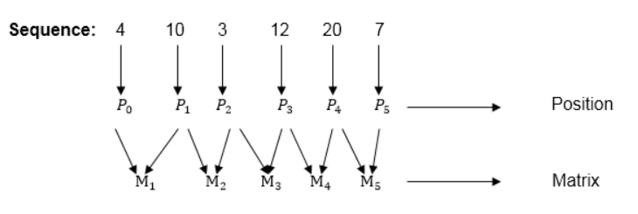

**Calculation of Product of 2 matrices:**

1. m (1,2) = m1 x m2

= 4 x 10 x 10 x 3

= 4 x 10 x 3 = 120

2. m (2, 3) = m2 x m3

= 10 x 3 x 3 x 12

= 10 x 3 x 12 = 360

3. m (3, 4) = m3 x m4

= 3 x 12 x 12 x 20

= 3 x 12 x 20 = 720

4. m (4,5) = m4 x m5

= 12 x 20 x 20 x 7

= 12 x 20 x 7 = 1680

**Now product of 3 matrices:**

**M [1, 3] = M1 M2 M3**

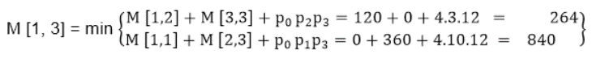

**Now Product of 4 matrices:**

**M [1, 4] = M1 M2 M3 M4**

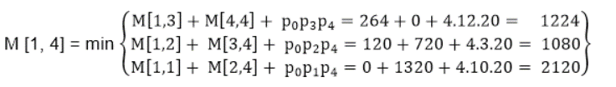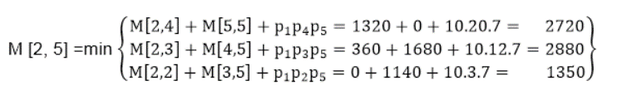

**Now Product of 5 matrices:**

**M [1, 5] = M1 M2 M3 M4 M5**

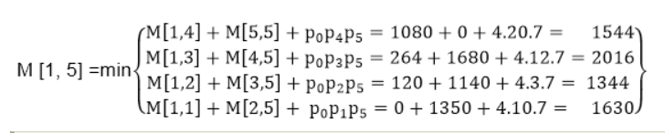

**M [1, 5] = 1344**

As comparing the output of different cases then '**1344'** is minimum output, so we insert 1344 in the table and M1 x M2 x(M3 x M4 x M5)combination is taken out in output making.

**Solution:** ((M1 M2)((M3 M4) M5))

**Complexity Analysis:**

The naive matrix multiplication algorithm contains three nested loops. For each iteration of the outer loop, the total number of the runs in the inner loops would be equivalent to the length of the matrix. Here, integer operations take O(1) time. In general, if the length of the matrix is n, the total time complexity would be O(n3 )

Running time:

– Θ(n^2 ) different calls to matrix-chain(i, j).

– The first time a call is made it takes O(n) time, not counting recursive calls.

– When a call has been made once it costs O(1) time to make it again.

⇓

O(n^3 ) time

– Another way of thinking about it: Θ(n 2 ) total entries to fill, it takes O(n) to fill one.

**Source Code:**

#include <stdio.h>

#include <limits.h>

int alpha = 65;

void parenthesis(int i, int j, int n, int para[n][n])

{

    if (i == j)

    {

        printf("%c", (char)alpha);

        alpha++;

        return;

    }

    printf("(");

    parenthesis(i, para[i][j], n, para);

    parenthesis(para[i][j] + 1, j, n, para);

    printf(")");

}

void mcm(int input[], int n)

{

    int matrix[n][n];

    int para[n][n];

    for (int i = 1; i < n; i++)

    {

        matrix[i][i] = 0;

    }

    for (int L = 2; L < n; L++)

    {

        for (int i = 1; i < n - L + 1; i++)

        {

            int j = i + L - 1;

            matrix[i][j] = INT_MAX;

            for (int k = i; k <= j - 1; k++)

            {

                int cost = matrix[i][k] + matrix[k + 1][j] + input[i - 1] * input[k] * input[j];

                if (cost < matrix[i][j])

                {

                    matrix[i][j] = cost;

                    para[i][j] = k;

                }

            }

        }

    }

    printf("Optimal Solution is : ");

    parenthesis(1, n - 1, n, para);

    printf("\nOptimal Cost is: %d", matrix[1][n - 1]);

}

int main()

{

    int n;

    printf("Enter number of matrices: ");

    scanf("%d", &n);

    int input[n];

    printf("Enter elements of array: ");

    for (int i = 0; i < n; i++)

    {

        scanf("%d", &input[i]);

    }

    mcm(input, n);

    return 0;

}

**Output:**

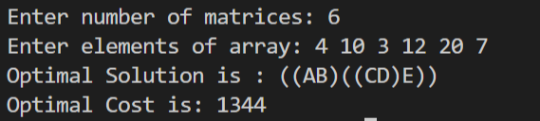

**Conclusion:** Thus, we have implemented matrix chain multiplication and have also found optimal cost for the same. Also, the optimal solution is being displayed along with parathesis.