CHAPTER – 1

Domain: Quantitative Finance
Title: Regime Switching Volatility Predictor

Problem Statement:
This project aims to develop a machine learning model to predict day-wise stock trends using historical data and technical indicators.
Explanation:
Stock market prediction is difficult because market prices change frequently due to many factors such as demand, supply, economic conditions, and investor behavior. Traditional methods often cannot properly analyze large amounts of financial data or capture complex patterns in market movements. Because of this, investors may find it hard to make accurate decisions based only on basic analysis.
The main problem addressed in this project is how to predict day-wise stock market trends using historical stock data and technical indicators. The dataset includes features like daily returns, volatility, RSI, moving averages, drawdown, VIX, and trend strength, which help represent market behavior more clearly.
This project aims to develop a machine learning model that can learn from historical data and predict future stock trends more accurately. The system also focuses on handling noisy data and providing reliable predictions using real-time stock inputs.

Dataset:
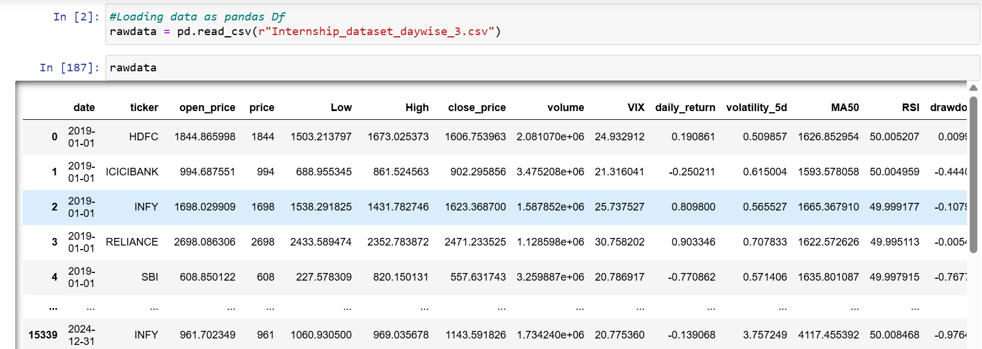
Approach:
We followed a systematic machine learning pipeline to develop the stock trend prediction system.
- Data Collection:
First, we collected and analyzed day-wise historical stock data for selected NSE (HDFC, ICICI Bank, INFY, Reliance, SBI, TCS, and Wipro) companies along with important technical indicators such as returns, volatility, RSI, moving averages, drawdown, VIX, and trend strength.
- Pre-processing:
Next, the dataset was pre-processed by handling missing values, selecting useful features, and applying feature scaling to improve model performance.
- Machine Learning Models:
After preprocessing, we worked on multiple machine learning algorithms including Logistic Regression, KNN, SVM, Decision Tree, Random Forest, Naïve Bayes, and XGBoost were trained and compared to identify the best-performing model.

- Model Evaluation:
The models were evaluated using accuracy, confusion matrix, ROC curve, and cross-validation methods.
Finally, the best model was Logistic Regression saved and integrated with real-time stock data input to provide practical and reliable day-wise trend predictions.

Sample Input & Sample Output:
The user enters a stock ticker symbol. The system fetches live stock data using an API, calculates technical indicators, and passes them to the trained ML model, which predicts the stock regime.
Sample Input:
The system takes stock ticker symbols as input from the user through the command-line interface.
Sample inputs are:
- HDFC
- ICICI Bank
- INFY
- Reliance
- SBI
- TCS
- Wipro

Example Input:
Enter Ticker (hdfc/icici/infy/reliance/sbi/tcs/wipro): hdfc
Sample Output:
After entering the ticker, the system fetches real-time stock data, processes technical indicators, and predicts the stock regime using the trained machine learning model.
Example Output:
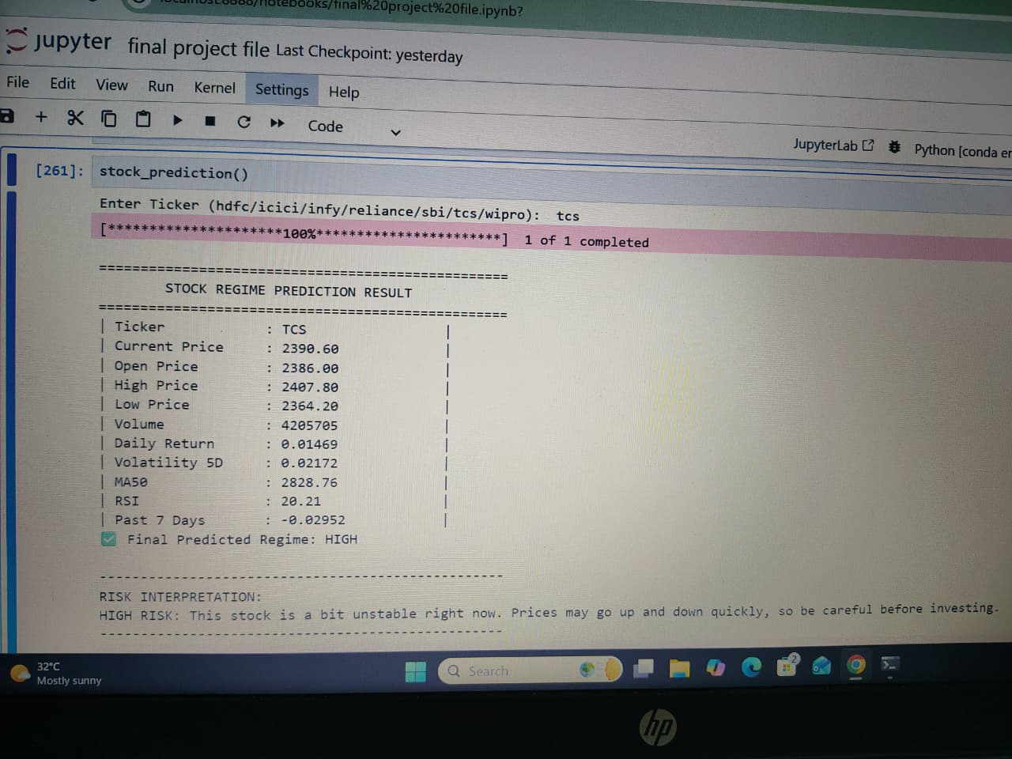
Sample Output for Predicting High:
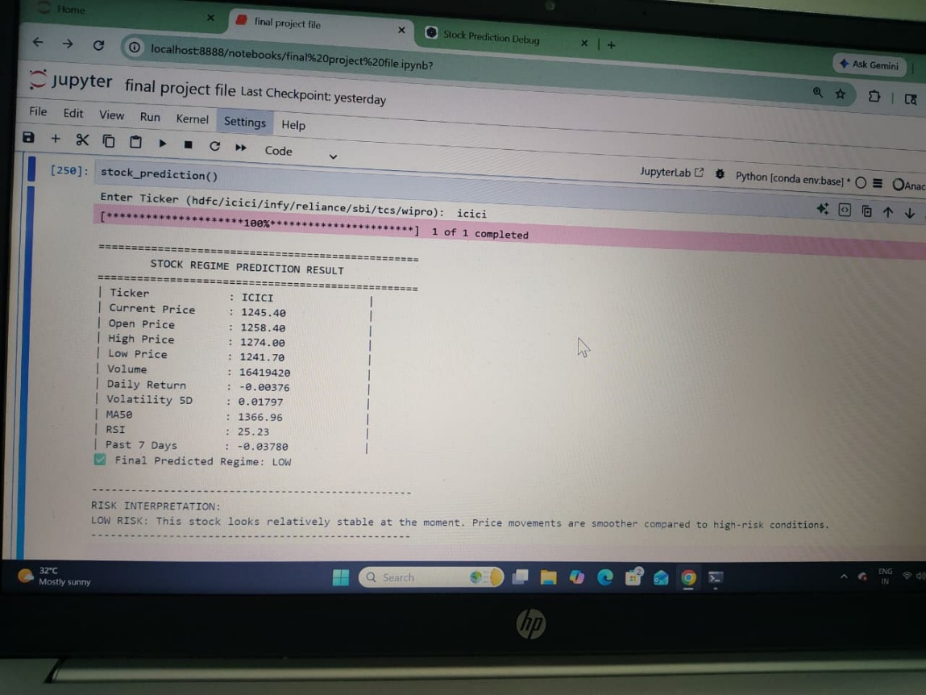
Sample Output for Predicting Low:
Finalized Model for Prediction:
We used Logistic Regression as the final model for prediction.
Logistic Regression is a supervised machine learning algorithm used for classification problems. In this project, it is used to classify stock trends into categories like:
- High
- Low
Pickle Files We Used:
In our project, we used pickle (.pkl) files to save and load the trained machine learning model.
- After training the Logistic Regression model, we saved it as a .pkl file
- Later, during prediction, we loaded the model directly from the pickle file
- This helps in making fast and real-time predictions
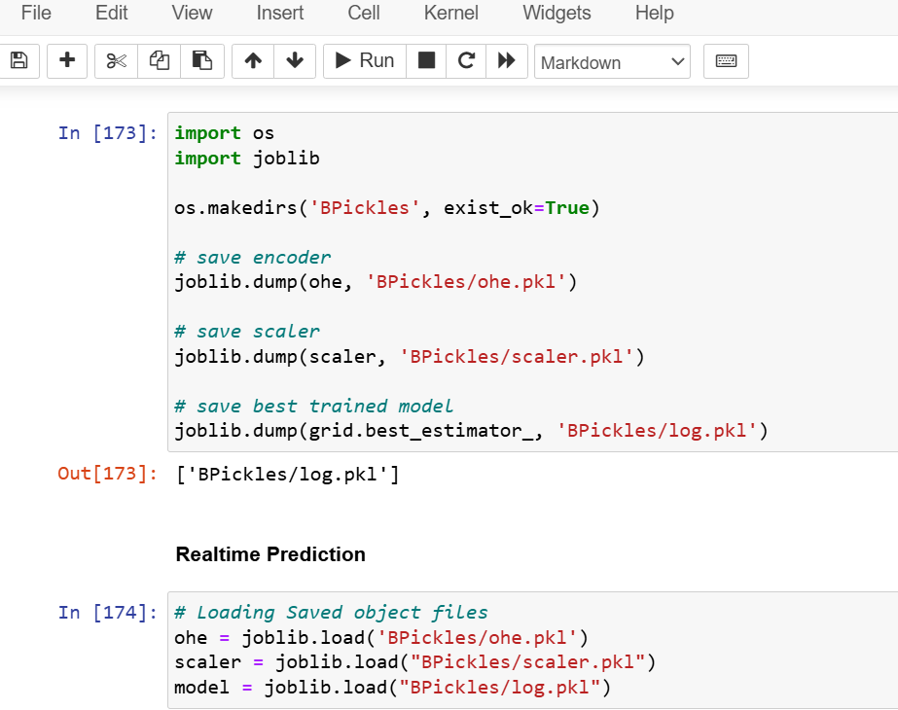
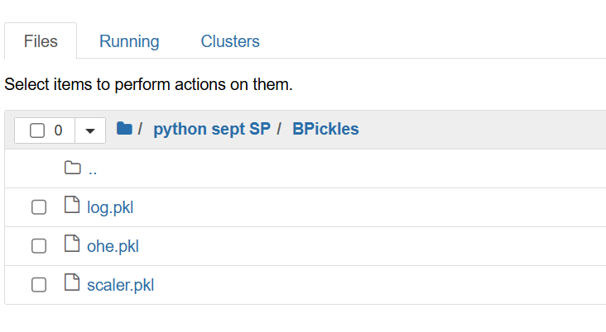
Pickle Files:

B2C (Business to Consumer):
Our system follows a B2C approach because it provides stock trend predictions directly to individual users/investors for decision-making.
Definition of B2C:
B2C means Business to Consumer. It is a type of business where a company sells its products or services directly to customers.

