**Critical Design Thinking**

**ASSIGNMENT – 01**

**Problem: -**

The Smartphone Addiction

Among our technological gadgets smartphones play the most important role , new generation devices offer other functionality beyond calling (internet availability , games , music players , etc.) In everyday it can be experienced that youth spend more time on their smartphones.

The intention of our study is to investigate the addiction of smartphones nowadays and to purpose some control measures over it.

**User Research Method: -**

Google form was created and was floated through Gmail and WhatsApp . The form consisted of 8 questions which had single / multiple choice , and theoretical options for user selection.

FORM LINK:- <https://forms.gle/264Cuh5JiL5qx91u5>

**Analysis: -**

The following analysis were made:

1. The below chart show the responses of users at what age did they receive smartphone.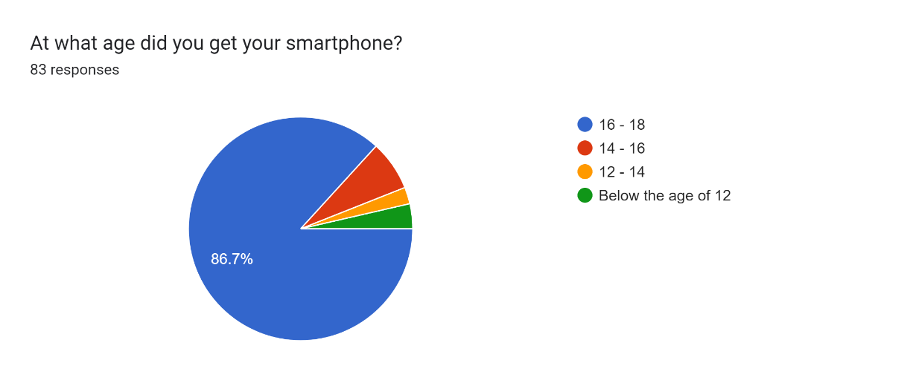
2. We asked about their condition when they were unable to use their smartphone , and following was the analysis

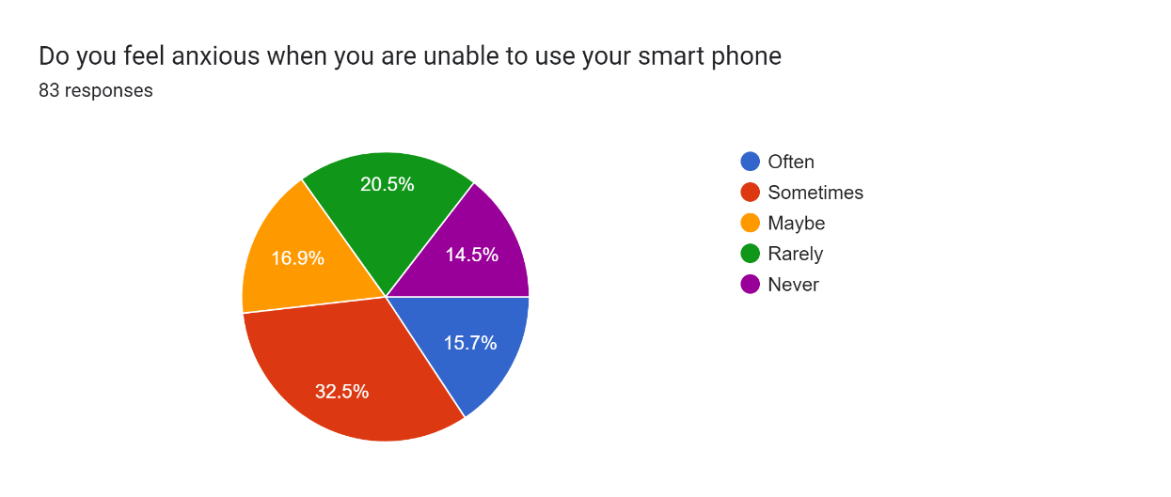

3. Their usage on various platforms:

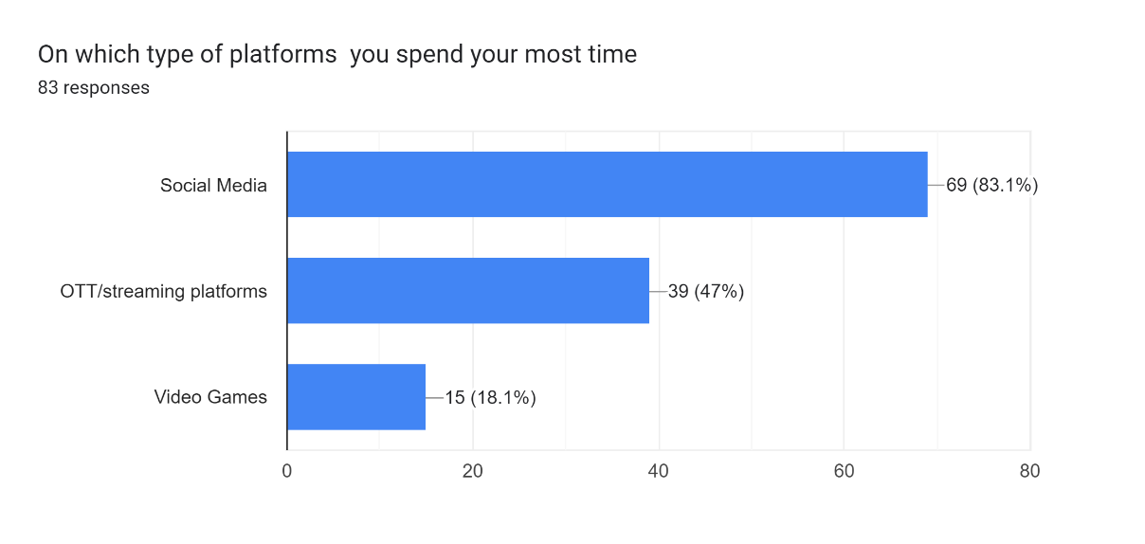

4. Did they failed in their addiction control ? , The response was contradictory to question which indeed is positive .

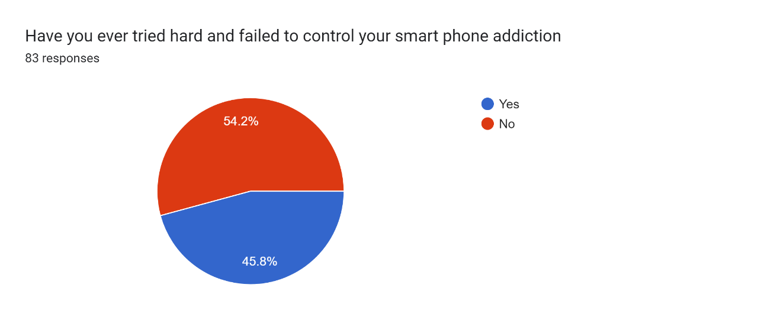

5. Neglection to their work or study

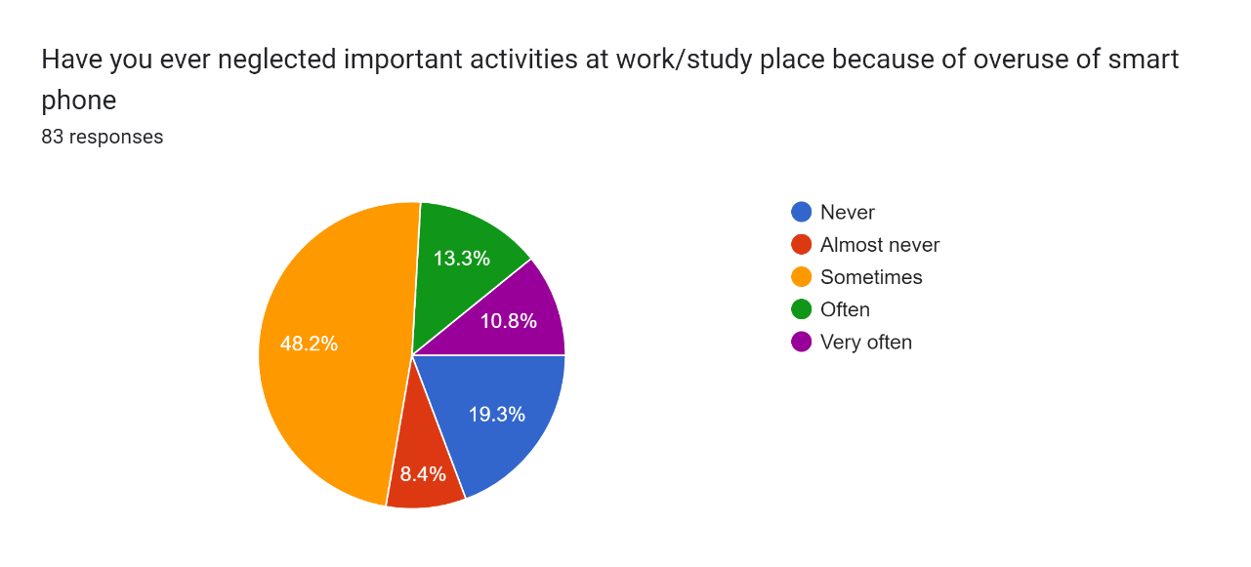

6. Missing their meal due to over engagement in their smartphones

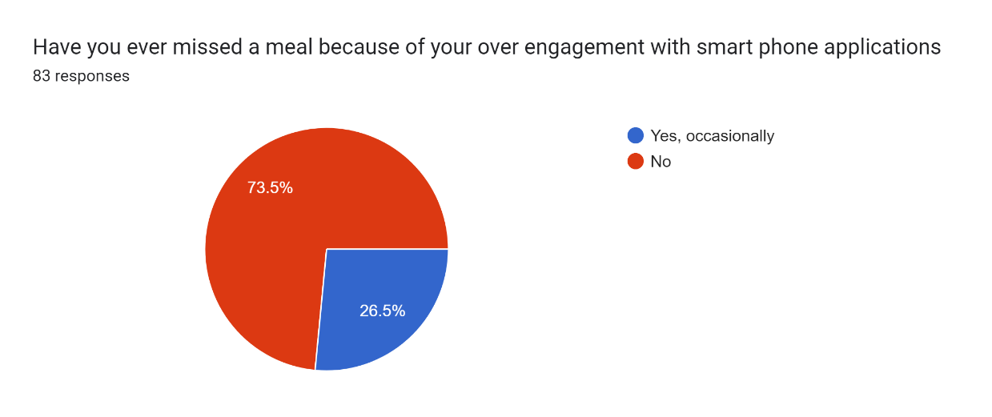

7. Sleep deprivation due to excess use of smartphone

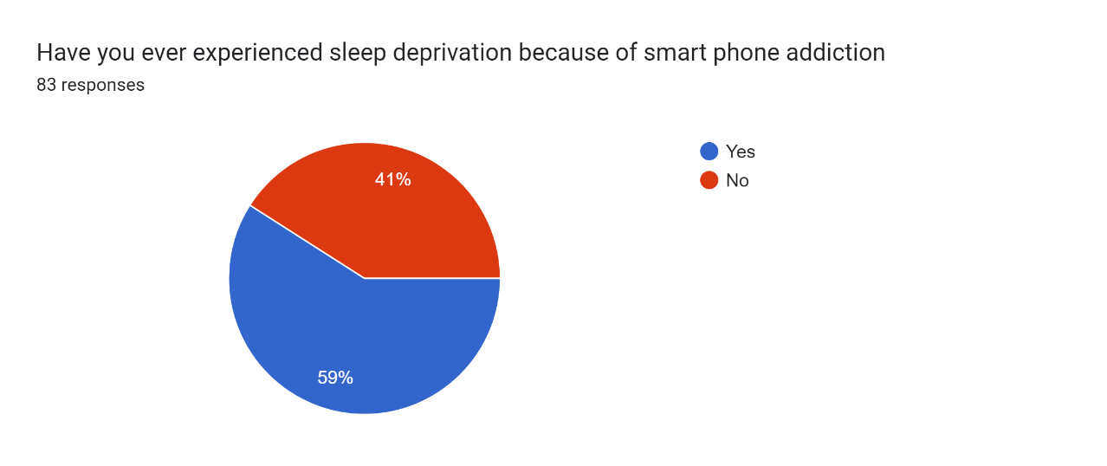

8. The last question was what were their measures to curb out addiction and some of the responses were

* Keep yourself on a schedule
* Delete all the addicted apps
* Use phone addiction control apps,self introspection.

And much more

**CONCLUSION:**

From the above research and analysis it were seen that about 45-50% of the users were facing addiction to smartphones such as sleep deprivation , skipping the assign work or procrastinating mainly , but at the same time they were able come up with some countermeasures that were effective in their own way

The above research was conducted under the guidance of Shweta Tiwaskar mam.

**NAME:** Yashraj Aware

**Roll no:** 2244006

**TEAM MEMBERS:** Aryan Pandita , Anushka Bhagwat , Kaustubh Bhoskar.

**CLASS:** S.Y. - D

**BATCH:** D1