Experiment No: 01 Date: /01/2026

Aim: To implement basic graphs such as null graph, complete graph, cycle graph, path graph, complete bipartite graph and wheel graph.

Theory:
In this experiment, several basic graph structures are implemented and visualized using Python. These include the null graph, complete graph, cycle graph, path graph, complete bipartite graph, and wheel graph. Instead of using built-in NetworkX graph generator functions, the graphs are constructed manually by adding nodes and edges using basic graph operations. This approach helps in understanding how the structure of each graph is formed internally.
A null graph is a graph that contains vertices but no edges. In such a graph, every node is isolated and there is no connection between any pair of vertices. In the program, this graph is created by adding nodes to a graph object using add_nodes_from() without adding any edges. Since no edges exist, the nodes appear as separate points in the visualization.
A complete graph is a graph in which every vertex is connected to every other vertex. This means that the number of edges is maximum for that number of vertices. In the program, this graph is created by first adding all nodes to the graph and then using nested loops to connect every pair of nodes using the add_edge() function. The condition i < j ensures that duplicate edges are not created.
A cycle graph is a graph where vertices form a closed chain or loop. Each vertex is connected to exactly two other vertices, and the last vertex connects back to the first vertex. In the program, this structure is created by connecting node i to (i+1) mod n. The modulo operation ensures that the final node connects back to the first node, completing the cycle.
A path graph is a simple graph where vertices are arranged in a linear sequence. Each vertex is connected only to its immediate neighbor. In the program, this is implemented by connecting node i to node i+1 using the add_edge() function. Unlike the cycle graph, the first and last vertices are not connected.
A complete bipartite graph is a graph in which the vertex set is divided into two disjoint subsets. Every vertex in the first subset is connected to every vertex in the second subset, but there are no connections between vertices within the same subset. In the program, two lists of nodes represent the two partitions. Nested loops are then used to connect every node from the first set to every node in the second set.
A wheel graph consists of a cycle graph with an additional central vertex connected to every vertex of the cycle. The outer vertices form the rim of the wheel and the center vertex forms the hub. In the program, node 0 is used as the center vertex and edges are added between the center and the outer vertices. The outer vertices are also connected in a cycle to form the wheel rim.
The NetworkX library is used to create and manage graph structures in the program. The function nx.Graph() is used to create an empty graph object. Nodes are added using add_nodes_from() and edges are added using add_edge(). These functions allow the programmer to manually construct graph structures and control exactly how vertices are connected.
The Matplotlib library is used for visualization of the graphs. Matplotlib is a widely used plotting library in Python that allows graphical representation of data and structures. In this program, the function plt.figure() is used to create a figure window that will contain multiple graph visualizations. The function plt.subplot() is used to divide the figure into multiple sections so that different graphs can be displayed in the same window. Each graph is drawn in a separate subplot.
The nx.draw() function is used to display the graph structure. It plots the nodes as points and edges as lines connecting them. The parameter with_labels=True ensures that node labels are displayed. The parameter node_color="pink" sets the color of the nodes to pink for visual clarity.
The program also uses layout functions such as nx.circular_layout() and nx.bipartite_layout() to position nodes in a meaningful arrangement. The circular layout arranges nodes around a circle, which is suitable for cycle and complete graphs. The bipartite layout separates the nodes into two groups for better visualization of bipartite graphs. For path and null graphs, manual position dictionaries are used so that nodes appear in a straight line.
Titles for each graph are added using the plt.title() function. This helps identify the type of graph displayed in each subplot. Finally, plt.show() is used to display the complete figure containing all the graphs.
Through this experiment, different types of basic graphs are constructed and visualized, helping in understanding their structure and connectivity. By manually creating edges and nodes instead of relying on built-in generator functions, the experiment demonstrates how graph structures are formed at a fundamental level.

Code(with NetworkX functions):

import networkx as nx
import matplotlib.pyplot as plt
import math
plt.figure()
g1 = nx.complete_graph(6)
plt.subplot(2,3,1)
nx.draw(g1, nx.circular_layout(g1), with_labels=True, node_color="pink")
plt.title("Complete Graph")
g2 = nx.cycle_graph(8)
plt.subplot(2,3,2)
nx.draw(g2, nx.circular_layout(g2), with_labels=True, node_color="pink")
plt.title("Cycle Graph")
g3 = nx.complete_bipartite_graph(3,4)
left = [0,1,2]
plt.subplot(2,3,3)
nx.draw(g3, nx.bipartite_layout(g3,left), with_labels=True, node_color="pink")
plt.title("Complete Bipartite")
g4 = nx.wheel_graph(6)
rim_nodes = list(range(1, 6))
pos4 = {0: (0, 0)}
for i, node in enumerate(rim_nodes):
theta = 2 * math.pi * i / len(rim_nodes)
pos4[node] = (math.cos(theta), math.sin(theta))
plt.subplot(2,3,4)
nx.draw(g4, pos4, with_labels=True, node_color="pink")
plt.title("Wheel Graph")
g5 = nx.path_graph(5)
pos5 = {i:(i,0) for i in range(5)}
plt.subplot(2,3,5)
nx.draw(g5, pos5, with_labels=True, node_color="pink")
plt.title("Path Graph")
g6 = nx.empty_graph(5)
pos6 = {i:(i,0) for i in range(5)}
plt.subplot(2,3,6)
nx.draw(g6, pos6, with_labels=True, node_color="pink")
plt.title("Null Graph")
plt.show()

Code(without NetworkX functions):

import networkx as nx
import matplotlib.pyplot as plt
import math
plt.figure()
g1 = nx.Graph()
nodes = list(range(6))
g1.add_nodes_from(nodes)
for i in nodes:
for j in nodes:
if i < j:
g1.add_edge(i, j)
plt.subplot(2,3,1)
nx.draw(g1, nx.circular_layout(g1), with_labels=True, node_color="pink")
plt.title("Complete Graph")
g2 = nx.Graph()
nodes = list(range(8))
g2.add_nodes_from(nodes)
for i in range(8):
g2.add_edge(i, (i+1) % 8)
plt.subplot(2,3,2)
nx.draw(g2, nx.circular_layout(g2), with_labels=True, node_color="pink")
plt.title("Cycle Graph")
g3 = nx.Graph()
left = [0,1,2]
right = [3,4,5,6]
g3.add_nodes_from(left + right)
for u in left:
for v in right:
g3.add_edge(u, v)
plt.subplot(2,3,3)
nx.draw(g3, nx.bipartite_layout(g3, left), with_labels=True, node_color="pink")
plt.title("Complete Bipartite")
g4 = nx.Graph()
g4.add_nodes_from(range(6))
for i in range(1,6):
g4.add_edge(0, i)
for i in range(1,6):
g4.add_edge(i, (i % 5) + 1)
rim_nodes = list(range(1,6))
pos4 = {0:(0,0)}
for i,node in enumerate(rim_nodes):
theta = 2*math.pi*i/len(rim_nodes)
pos4[node] = (math.cos(theta), math.sin(theta))
plt.subplot(2,3,4)
nx.draw(g4, pos4, with_labels=True, node_color="pink")
plt.title("Wheel Graph")
g5 = nx.Graph()
nodes = list(range(5))
g5.add_nodes_from(nodes)
for i in range(4):
g5.add_edge(i, i+1)
pos5 = {i:(i,0) for i in range(5)}
plt.subplot(2,3,5)
nx.draw(g5, pos5, with_labels=True, node_color="pink")
plt.title("Path Graph")
g6 = nx.Graph()
g6.add_nodes_from(range(5))
pos6 = {i:(i,0) for i in range(5)}
plt.subplot(2,3,6)
nx.draw(g6, pos6, with_labels=True, node_color="pink")
plt.title("Null Graph")
plt.show()

Output:
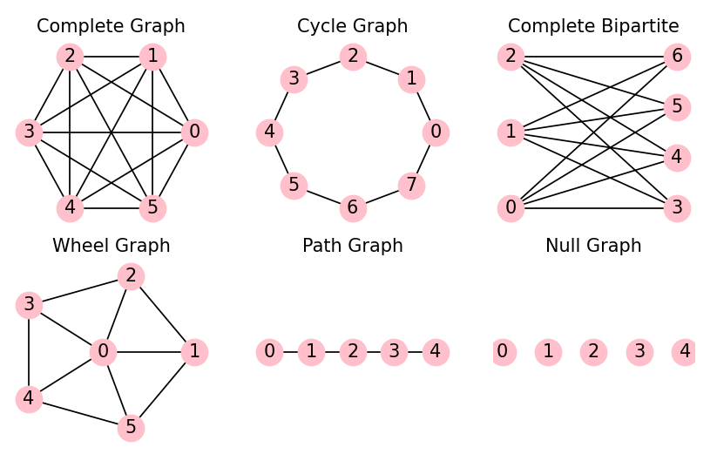

Conclusion: Basic graphs such as null graph, complete graph, cycle graph, path graph, complete bipartite graph, and wheel graph were successfully implemented and visualized using Python and NetworkX without using built-in graph generation functions.

