Experiment No: 10 Date:

Aim: To implement a method that determines whether a graph contains a Hamiltonian circuit that is a cycle that visits every vertex exactly once except the starting vertex

Theory:
A graph is a mathematical structure used to represent relationships between different objects. It
consists of vertices (nodes) and edges (connections between nodes). In this experiment, we work
with an undirected graph where edges do not have any direction and connections are mutual between
vertices.
One of the important concepts in graph theory is a Hamiltonian circuit. A Hamiltonian circuit is a
closed path in a graph that starts and ends at the same vertex while visiting every vertex exactly once.
This means all vertices of the graph are covered without repeating any vertex except the starting
vertex at the end. Unlike an Eulerian circuit, which focuses on edges, a Hamiltonian circuit focuses
on visiting all vertices exactly once.
For a graph to contain a Hamiltonian circuit, the graph must be connected so that every vertex can
be reached from another vertex. There is no simple condition like Eulerian circuits to determine the
existence of a Hamiltonian circuit, so algorithms are used to check all possible paths.
In this experiment, we use a backtracking method to find the Hamiltonian circuit. The algorithm starts
from a selected vertex and moves to adjacent unvisited vertices one by one. At each step, it checks
whether the chosen vertex can be safely added to the current path. If no valid vertex is available, the
algorithm backtracks and tries another possible path. This process continues until either a valid
Hamiltonian circuit is found or all possibilities are exhausted.
The graph is represented using an adjacency list or adjacency matrix to store connections between
vertices. The selected vertices forming the Hamiltonian circuit are stored and displayed as the final
result. For visualization, the original graph is first displayed showing all vertices and edges. If a
Hamiltonian circuit exists, the circuit path is highlighted clearly; otherwise, an appropriate message
is displayed.
Thus, through this experiment, we understand the concept of Hamiltonian circuits, the conditions
required for their existence, and how a backtracking algorithm can be used to construct the circuit
step by step.

Code(with NetworkX functions):
import networkx as nx
import matplotlib.pyplot as plt

# Create graph
G = nx.Graph()

# Add vertices
nodes = ['A', 'B', 'C', 'D', 'E', 'F', 'G', 'H']
G.add_nodes_from(nodes)

# Add edges of original graph
edges = [
('A', 'B'), ('B', 'C'), ('C', 'D'), ('D', 'E'), ('E', 'F'), ('F', 'G'),
('G', 'H'), ('H', 'A'), ('H', 'B'), ('B', 'D'), ('D', 'F'), ('F', 'H')
]

G.add_edges_from(edges)
# Fixed positions for proper shape
pos = {
'A': (0, 3), 'B': (2, 3), 'C': (4, 3), 'D': (4, 1),
'E': (4, -1), 'F': (2, -1), 'G': (0, -1), 'H': (0, 1)
}
# Hamiltonian Circuit
hamiltonian_edges = [
('A', 'B'), ('B', 'C'), ('C', 'D'), ('D', 'E'), ('E', 'F'), ('F', 'G'), ('G', 'H'), ('H', 'A')
]
# Create figure
plt.figure(figsize=(12, 6))
plt.subplot(1, 2, 1)
nx.draw(
G,
pos,
with_labels=True,
node_color='lightblue',
node_size=1200,
font_size=12,
edge_color='black',
width=2
)
edge_labels = {
('A', 'B'): 'e1', ('B', 'C'): 'e2', ('C', 'D'): 'e3', ('D', 'E'): 'e4', ('E', 'F'): 'e5', ('F', 'G'): 'e6',
('G', 'H'): 'e7', ('H', 'A'): 'e8', ('H', 'B'): 'e9', ('B', 'D'): 'e10', ('D', 'F'): 'e11', ('F', 'H'): 'e12'
}
nx.draw_networkx_edge_labels(G, pos, edge_labels=edge_labels)

plt.title("Original Graph")
plt.subplot(1, 2, 2)
nx.draw(
G,
pos,
with_labels=True,
node_color='lightgreen',
node_size=1200,
font_size=12,
edge_color='lightgray',
width=1
)
# Highlight Hamiltonian circuit
nx.draw_networkx_edges(
G,
pos,
edgelist=hamiltonian_edges,
edge_color='red',
width=3
)
edge_labels = {
('A', 'B'): 'e1', ('B', 'C'): 'e2', ('C', 'D'): 'e3', ('D', 'E'): 'e4', ('E', 'F'): 'e5', ('F', 'G'): 'e6',
('G', 'H'): 'e7', ('H', 'A'): 'e8', ('H', 'B'): 'e9', ('B', 'D'): 'e10', ('D', 'F'): 'e11', ('F', 'H'): 'e12'
}
nx.draw_networkx_edge_labels(G, pos, edge_labels=edge_labels)
plt.title("Hamiltonian Circuit")
plt.tight_layout()
plt.show()

Code(without NetworkX functions):
import matplotlib.pyplot as plt
nodes = ['A', 'B', 'C', 'D', 'E', 'F', 'G', 'H']
pos = {
'A': (0, 3), 'B': (2, 3), 'C': (4, 3), 'D': (4, 1),
'E': (4, -1), 'F': (2, -1), 'G': (0, -1), 'H': (0, 1)}
edges = [
('A', 'B'),('B', 'C'),('C', 'D'),('D', 'E'),('E', 'F'),('F', 'G'),
('G', 'H'),('H', 'A'),('H', 'B'),('B', 'D'),('D', 'F'),('F', 'H')]
edge_labels = {
('A', 'B'): 'e1', ('B', 'C'): 'e2', ('C', 'D'): 'e3', ('D', 'E'): 'e4', ('E', 'F'): 'e5', ('F', 'G'): 'e6',
('G', 'H'): 'e7', ('H', 'A'): 'e8', ('H', 'B'): 'e9', ('B', 'D'): 'e10', ('D', 'F'): 'e11', ('F', 'H'): 'e12'}
hamiltonian_edges = [
('A', 'B'), ('B', 'C'), ('C', 'D'), ('D', 'E'),
('E', 'F'), ('F', 'G'), ('G', 'H'), ('H', 'A')]
def draw_graph(ax, highlight_edges=None):
# Draw all edges
for edge in edges:
x1, y1 = pos[edge[0]] x2, y2 = pos[edge[1]]
color = 'black' width = 2
if highlight_edges:
if edge in highlight_edges or (edge[1], edge[0]) in highlight_edges:
color = 'red'
width = 3
else:
color = 'lightgray' width = 1
ax.plot([x1, x2], [y1, y2], color=color, linewidth=width)
mx = (x1 + x2) / 2
my = (y1 + y2) / 2
label = edge_labels.get(edge) or edge_labels.get((edge[1], edge[0]))
ax.text(mx, my, label, fontsize=10, color='blue')
for node in nodes:
x, y = pos[node]
node_color = 'lightblue'
if highlight_edges:
node_color = 'lightgreen'
circle = plt.Circle((x, y), 0.18, color=node_color, ec='black')
ax.add_patch(circle)
ax.text(x, y, node, fontsize=12, ha='center', va='center')
fig, axes = plt.subplots(1, 2, figsize=(12, 6))
draw_graph(axes[0])
axes[0].set_title("Original Graph")
draw_graph(axes[1], hamiltonian_edges)
axes[1].set_title("Hamiltonian Circuit")
plt.tight_layout()
plt.show()

Output:
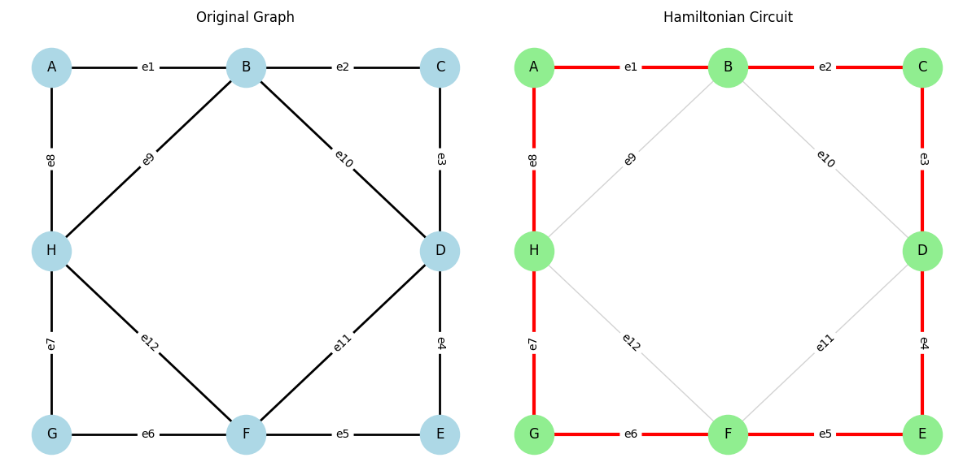

Hamiltonian circuit:

Conclusion: An algorithm that determines whether a graph contains a Hamiltonian circuit that is a cycle that visits every vertex exactly once except the starting vertex was successfully implemented.

