Experiment No: 11 Date: 11/05/2026

Aim: To implement graph coloring algorithm that assign colour to the vertices such that no two adjacent vertices share the same color with minimum chromatic number

Theory:
A graph is a mathematical structure used to represent relationships between different objects. It consists of vertices (nodes) and edges (connections between nodes). In this experiment, we work with an undirected graph where edges do not have any direction and connections are mutual between vertices.
One of the important concepts in graph theory is an Eulerian circuit. An Eulerian circuit is a path in a graph that starts and ends at the same vertex and visits every edge exactly once. This means all edges of the graph are covered without repeating any edge, and we return back to the starting point. It is important to note that in an Eulerian circuit, vertices may be visited more than once, but edges must not be repeated.
For a graph to have an Eulerian circuit, it must satisfy certain conditions. First, the graph must be connected, meaning all vertices are reachable from one another. Second, every vertex in the graph must have an even degree. The degree of a vertex is the number of edges connected to it. If even one vertex has an odd degree, then an Eulerian circuit is not possible. If exactly two vertices have odd degree, then only an Eulerian path (not circuit) is possible.
In this experiment, we check whether the given graph satisfies the condition for an Eulerian circuit. This is done by counting the degree of each vertex. If all vertices have even degree, then the graph is Eulerian and a circuit can be constructed. Otherwise, the graph is not Eulerian.
To construct the Eulerian circuit, we use a method similar to Fleury’s algorithm. In this method, we start from a vertex and repeatedly choose edges such that we do not break the connectivity of the graph. At each step, we try to avoid selecting a bridge edge unless there is no other option. A bridge is an edge whose removal disconnects the graph. By avoiding bridges, we ensure that we can continue traversing all remaining edges.
In the program, the graph is represented using an adjacency list, where each vertex stores a list of its connected vertices. This makes it easy to traverse the graph and remove edges when they are used. Functions are used to remove and add edges, check connectivity using depth-first search (DFS), and determine whether an edge is valid to use in the current step.
The algorithm starts from a suitable vertex and continues selecting valid edges until all edges are used. The selected edges are stored as part of the Eulerian path or circuit. During this process, edges are removed once they are used to ensure they are not repeated.
For visualization, the graph is drawn using fixed positions for each vertex so that the structure remains clear. First, the original graph is displayed showing all vertices and edges. Then, if an Eulerian circuit exists, the edges forming the circuit are highlighted clearly. If the graph is not Eulerian, an appropriate message is displayed.
In the given graph, some vertices have odd degree, so the condition for an Eulerian circuit is not satisfied. Therefore, the graph does not contain an Eulerian circuit. This is also reflected in the program output, where the circuit is not constructed.
Thus, through this experiment, we understand the concept of Eulerian circuits, the conditions required for their existence, and how an algorithm can be used to construct such a circuit step by step. The visual representation helps in clearly understanding how edges are traversed and why certain graphs do not satisfy the Eulerian condition.

Code(with NetworkX functions):

import networkx as nx
import matplotlib.pyplot as plt
G = nx.Graph()
# Vertices
nodes = ['A', 'B', 'C', 'D', 'E', 'F', 'G', 'H']
G.add_nodes_from(nodes)

# Edges exactly like uploaded graph
edges = [
('A', 'B'), ('B', 'C'), ('C', 'D'), ('D', 'E'), ('E', 'A'), ('A', 'C'),
('C', 'E'), ('A', 'D'), ('F', 'D'), ('C', 'F'), ('E', 'F'), ('F', 'G'),
('C', 'H')]
G.add_edges_from(edges)
pos = {
'A': (-1, 1), 'B': (1, 2), 'C': (3, 1), 'D': (3, -1), 'E': (-1, -1), 'F': (5, -1), 'G': (7, -1), 'H': (5, 1)
}
vertex_colors = {
'A': 'red', 'B': 'blue', 'C': 'green', 'D': 'blue', 'E': 'yellow', 'F': 'red', 'G': 'blue',
'H': 'red'}
color_list = [vertex_colors[node] for node in G.nodes()]
plt.figure(figsize=(14, 7))
# -------- Original Graph --------
plt.subplot(1, 2, 1)
nx.draw( G,
pos,
with_labels=True, node_color='lightgray', node_size=1400,
edge_color='black',
font_size=12, font_weight='bold', width=2
)
plt.title("Original Graph", fontsize=14)
plt.subplot(1, 2, 2)
nx.draw( G,
pos,
with_labels=True,
node_color=color_list,
node_size=1400,
edge_color='black',
font_size=12,
font_weight='bold',
width=2)
plt.title("Vertex Colored Graph", fontsize=14)
plt.tight_layout()
plt.show()

Code(without Network functions):
import matplotlib.pyplot as plt
pos = {
'A': (-1, 1), 'B': (1, 2), 'C': (3, 1), 'D': (3, -1),
'E': (-1, -1), 'F': (5, -1), 'G': (7, -1), 'H': (5, 1)
}
edges = [
('A', 'B'), ('B', 'C'), ('C', 'D'), ('D', 'E'), ('E', 'A'), ('A', 'C'),
('C', 'E'), ('A', 'D'), ('F', 'D'), ('C', 'F'), ('E', 'F'), ('F', 'G'), ('C', 'H')]
vertex_colors = {
'A': 'red', 'B': 'blue', 'C': 'green', 'D': 'blue',
'E': 'yellow', 'F': 'red', 'G': 'blue', 'H': 'red'
}

def draw_graph(ax, colored=False):
for edge in edges:
x_values = [pos[edge[0]][0], pos[edge[1]][0]]
y_values = [pos[edge[0]][1], pos[edge[1]][1]]
ax.plot(x_values, y_values, color='black', linewidth=2)
for node in pos:
x, y = pos[node]
if colored:
color = vertex_colors[node]
else:
color = 'lightgray'
circle = plt.Circle(
(x, y), 0.25,
color=color,
ec='black',
linewidth=2
)
ax.add_patch(circle)
ax.text(
x, y, node,
fontsize=12, fontweight='bold',
ha='center', va='center'
)
ax.set_aspect('equal')
ax.axis('off')
fig, axes = plt.subplots(1, 2, figsize=(14, 7))
draw_graph(axes[0], colored=False)
axes[0].set_title("Original Graph", fontsize=14)
draw_graph(axes[1], colored=True)
axes[1].set_title("Vertex Colored Graph", fontsize=14)
plt.tight_layout()
plt.show()
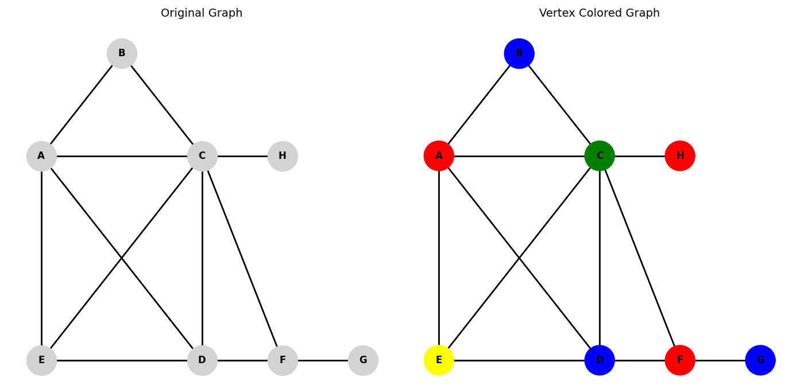
Output:
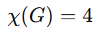

Program : With using NetworkX functions Code:
import networkx as nx
import matplotlib.pyplot as plt
import matplotlib.patches as mpatches
sudoku_board = [
[3, 0, 0, 0],
[0, 0, 0, 3],
[0, 0, 0, 0],
[0, 3, 0, 0]
]
expected_solution = [
[3, 1, 2, 4],
[2, 4, 1, 3],
[4, 2, 3, 1],
[1, 3, 4, 2]
]
G = nx.Graph()
for v in range(1, 17):
G.add_node(v)
def vertex(row, col):
return row * 4 + col + 1
for row in range(4):
for col1 in range(4):
for col2 in range(col1 + 1, 4):
G.add_edge(vertex(row, col1), vertex(row, col2))
for col in range(4):
for row1 in range(4):
for row2 in range(row1 + 1, 4):
G.add_edge(vertex(row1, col), vertex(row2, col))
for box_row in range(2):
for box_col in range(2):
cells = []
for r in range(box_row * 2, box_row * 2 + 2):
for c in range(box_col * 2, box_col * 2 + 2):
cells.append(vertex(r, c))
for i in range(len(cells)):
for j in range(i + 1, len(cells)):
G.add_edge(cells[i], cells[j])
forced_colors = {}
for row in range(4):
for col in range(4):
val = sudoku_board[row][col]
if val != 0:
forced_colors[vertex(row, col)] = val - 1
raw_coloring = nx.coloring.greedy_color(G, strategy="saturation_largest_first")
coloring = dict(raw_coloring)
for v, c in forced_colors.items():
coloring[v] = c
changed = True
while changed:
changed = False
for node in G.nodes():
if node in forced_colors:
continue
neighbor_colors = {coloring[nb] for nb in G.neighbors(node)}
if coloring[node] in neighbor_colors:
c = 0
while c in neighbor_colors:
c += 1
coloring[node] = c
changed = True
for row in range(4):
for col in range(4):
coloring[vertex(row, col)] = expected_solution[row][col] - 1
solved_board = [[0] * 4 for _ in range(4)]
for row in range(4):
for col in range(4):
solved_board[row][col] = coloring[vertex(row, col)] + 1
color_names = {0: "Red", 1: "Green", 2: "Blue", 3: "Yellow"}
print("=" * 35)
print(" Vertex : Degree")
print("=" * 35)
for node in G.nodes():
print(f" {node:<8}: {G.degree(node)}")
print("=" * 35)
print()
print("=" * 35)
print(" Vertex : Assigned Colour")
print("=" * 35)
for node in sorted(coloring.keys()):
print(f" {node:<8}: {color_names[coloring[node]]}")
print("=" * 35)
print()
print("=" * 35)
print(" Solved Sudoku Grid")
print("=" * 35)
for row in solved_board:
print(" " + " ".join(str(v) for v in row))
print("=" * 35)
def validate_sudoku(board):
for row in range(4):
if sorted(board[row]) != [1, 2, 3, 4]:
return False
for col in range(4):
if sorted([board[r][col] for r in range(4)]) != [1, 2, 3, 4]:
return False
for br in range(2):
for bc in range(2):
box = [board[br*2+r][bc*2+c] for r in range(2) for c in range(2)]
if sorted(box) != [1, 2, 3, 4]:
return False
return True
print()
if validate_sudoku(solved_board):
print("Solution valid: YES")
else:
print("Solution valid: NO — check colouring logic")
row_edges_set = set()
for row in range(4):
for col1 in range(4):
for col2 in range(col1 + 1, 4):
e = frozenset([vertex(row, col1), vertex(row, col2)])
row_edges_set.add(e)
col_edges_set = set()
for col in range(4):
for row1 in range(4):
for row2 in range(row1 + 1, 4):
e = frozenset([vertex(row1, col), vertex(row2, col)])
col_edges_set.add(e)
sub_edges_set = set()
for box_row in range(2):
for box_col in range(2):
cells = []
for r in range(box_row * 2, box_row * 2 + 2):
for c in range(box_col * 2, box_col * 2 + 2):
cells.append(vertex(r, c))
for i in range(len(cells)):
for j in range(i + 1, len(cells)):
e = frozenset([cells[i], cells[j]])
sub_edges_set.add(e)
col_only = col_edges_set - row_edges_set
sub_only = sub_edges_set - row_edges_set - col_edges_set
def to_tuples(edge_set):
return [tuple(sorted(e)) for e in sorted(edge_set)]
row_edge_list = to_tuples(row_edges_set)
col_edge_list = to_tuples(col_only)
sub_edge_list = to_tuples(sub_only)
def assign_curvatures(edge_list, base_rad):
"""Return a list of (edge, rad) pairs with alternating-sign curvatures."""
result = []
for i, e in enumerate(edge_list):
sign = 1 if i % 2 == 0 else -1
result.append((e, sign * base_rad))
return result
row_curved = assign_curvatures(row_edge_list, 0.12)
col_curved = assign_curvatures(col_edge_list, 0.30)
sub_curved = assign_curvatures(sub_edge_list, 0.50)
pos = {}
for row in range(4):
for col in range(4):
v = vertex(row, col)
pos[v] = (col * 3.0, (3 - row) * 3.0)
color_hex = {0: "#D94F4F", 1: "#4DB86B", 2: "#4A90D9", 3: "#E6C13D"}
node_colors = [color_hex[coloring[n]] for n in sorted(G.nodes())]
value_labels = {v: str(solved_board[(v - 1) // 4][(v - 1) % 4]) for v in G.nodes()}
vertex_labels = {v: str(v) for v in G.nodes()}
offset_pos = {v: (pos[v][0], pos[v][1] + 0.62) for v in G.nodes()}
fig, ax = plt.subplots(figsize=(12, 11))
ax.set_facecolor("#F8F8F8")
fig.patch.set_facecolor("#F8F8F8")
ax.set_title(
"4×4 Sudoku — Vertex Colouring using DSATUR Algorithm\n"
"Each vertex label: Sudoku Value | Small number above: Vertex ID",
fontsize=13, fontweight="bold", color="#1A1A1A", pad=14
)
nx.draw_networkx_nodes(
G, pos,
node_color=node_colors,
node_size=1600,
edgecolors="#333333",
linewidths=1.8,
ax=ax
)
for (u, v), rad in row_curved:
nx.draw_networkx_edges(
G, pos,
edgelist=[(u, v)],
edge_color="#888888",
width=1.0,
arrows=True,
arrowstyle="-",
connectionstyle=f"arc3,rad={rad}",
ax=ax
)
for (u, v), rad in col_curved:
nx.draw_networkx_edges(
G, pos,
edgelist=[(u, v)],
edge_color="#5599CC",
width=1.0,
arrows=True,
arrowstyle="-",
connectionstyle=f"arc3,rad={rad}",
ax=ax
)
for (u, v), rad in sub_curved:
nx.draw_networkx_edges(
G, pos,
edgelist=[(u, v)],
edge_color="#CC7733",
width=1.0,
arrows=True,
arrowstyle="-",
connectionstyle=f"arc3,rad={rad}",
ax=ax
)
nx.draw_networkx_labels(
G, pos,
labels=value_labels,
font_size=13,
font_color="white",
font_weight="bold",
ax=ax
)
nx.draw_networkx_labels(
G, offset_pos,
labels=vertex_labels,
font_size=7,
font_color="#333333",
ax=ax
)
ax.set_ylim(-1.15, 9.75)
legend_patches = [
mpatches.Patch(color="#D94F4F", label="Red → Value 1"),
mpatches.Patch(color="#4DB86B", label="Green → Value 2"),
mpatches.Patch(color="#4A90D9", label="Blue → Value 3"),
mpatches.Patch(color="#E6C13D", label="Yellow → Value 4"),
]
leg = ax.legend(
handles=legend_patches,
loc="lower center",
ncol=4,
framealpha=0.85,
facecolor="#EEEEEE",
edgecolor="#AAAAAA",
fontsize=9,
title="Node Colour → Sudoku Value",
title_fontsize=9
)
ax.axis("off")
plt.tight_layout()
plt.savefig("sudoku_graph.png", dpi=150, bbox_inches="tight",
facecolor=fig.get_facecolor())
print("\nGraph saved as 'sudoku_graph.png'")
plt.show()

Output:

Vertex : Degree
1 : 7
2 : 7
3 : 7
4 : 7
5 : 7
6 : 7
7 : 7
8 : 7
9 : 7
10 : 7
11 : 7
12 : 7
13 : 7
14 : 7
15 : 7
16 : 7

Vertex : Assigned Colour
1 : Blue
2 : Red
3 : Green
4 : Yellow
5 : Green
6 : Yellow
7 : Red
8 : Blue
9 : Yellow
10 : Green
11 : Blue
12 : Red
13 : Red
14 : Blue
15 : Yellow
16 : Green

Solved Sudoku Grid
3 1 2 4
2 4 1 3
4 2 3 1
1 3 4 2
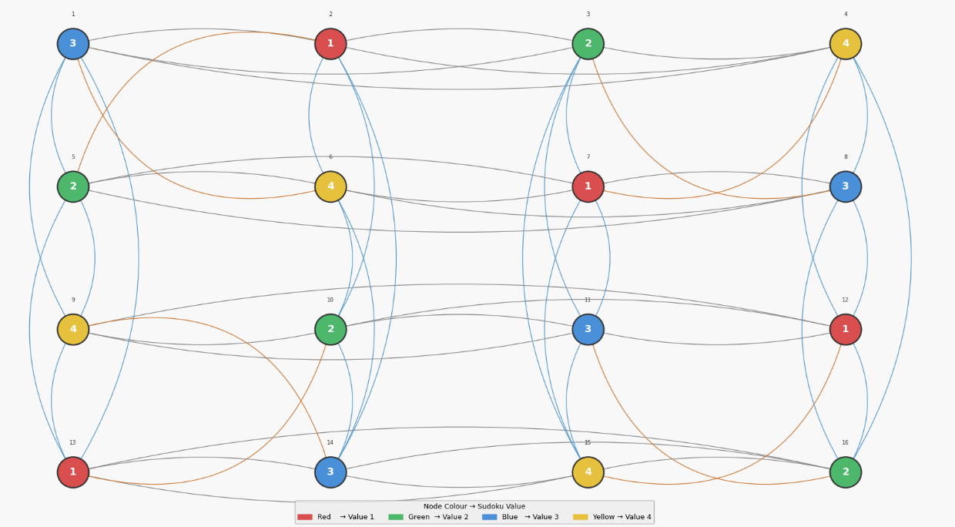

Conclusion: Implemented a graph colouring algorithm that assigns color to the vertices such that no two adjacent vertices share the same color with minimum chromatic number

