Experiment No: 2 Date:

Aim: To implement graph isomorphism verification inorder to compare structural equivalence between the graphs.
Theory:
Graph Isomorphism
Graph isomorphism is a concept in graph theory used to determine whether two graphs have the same structure, even if their vertex labels are different.
Two graphs are said to be isomorphic if there exists a one-to-one correspondence (mapping) between their vertex sets such that the adjacency of vertices is preserved. In simple terms, if two vertices are connected by an edge in one graph, then their corresponding vertices must also be connected in the other graph.
Thus, isomorphic graphs represent the same structural pattern, even though they may look different in labeling or drawing. This concept is useful in comparing networks and identifying structurally equivalent systems.

Properties of Isomorphic Graphs
Same Number of Vertices
Both graphs must have an equal number of vertices.
This is necessary to establish a one-to-one mapping between the vertices. If the number differs, the graphs cannot be isomorphic.
Same Number of Edges
Isomorphic graphs must contain the same number of edges.
Each edge in one graph must correspond to an edge in the other graph to maintain the structure.

Identical Degree Sequence
The degree of a vertex is the number of edges connected to it.
In isomorphic graphs, corresponding vertices must have the same degree. Hence, both graphs must have the same degree sequence.

Preservation of Adjacency
Adjacency relationships must remain unchanged.
If two vertices are connected in one graph, their corresponding vertices must also be connected in the other graph.
If two vertices are not connected, the same must hold in both graphs.

Same Structure, Different Representation Isomorphic graphs may appear different due to:
Different vertex labels
Different layouts or drawings
However, their internal connectivity structure remains identical. Graph isomorphism depends on structure, not on visual appearance.

Program 1: import networkx as nx
import matplotlib.pyplot as plt
from networkx.algorithms import isomorphism
plt.figure(figsize=(10, 8))
G = nx.Graph()
G.add_nodes_from([1, 2, 3, 4, 5, 6])
G.add_edges_from([
(1, 2), (2, 3), (3, 4), (1, 4),
(4, 5), (5, 6), (6, 1), (2, 6), (1, 3)])
pos = {
1: (0, 1.3),
2: (0, 2),
3: (1, 2),
4: (1, 1.3),
5: (0.8, 1.6),
6: (0.6, 1.4)}
plt.subplot(2, 2, 1)
nx.draw(G, pos, with_labels=True, node_size=800, node_color='lightblue')
plt.title("Original")
plt.axis('off')
G1 = nx.Graph()
G1.add_nodes_from([1, 2, 3, 4, 5, 6])
G1.add_edges_from([
(2, 3),
(1, 4),
(4, 5),
(5, 6),
(2, 6),
(1, 3)])
plt.subplot(2, 2, 2)
nx.draw(G1, pos, with_labels=True, node_size=800, node_color='yellow')
plt.title("Spanning Subgraph")
plt.axis('off')
G2 = nx.Graph()
G2.add_nodes_from([1, 2, 3, 4])
G2.add_edges_from([
(1, 2),
(2, 3),
(3, 4),
(1, 4),
(1, 3)])
pos2 = {
1: (0, 1.3),
2: (0, 2),
3: (1, 2),
4: (1, 1.3)
}
plt.subplot(2, 2, 3)
nx.draw(G2, pos2, with_labels=True, node_size=800, node_color='red')
plt.title("Induced Subgraph")
plt.axis('off')
G3 = nx.Graph()
G3.add_nodes_from([2, 4, 5, 6])
G3.add_edges_from([
(4, 5),
(2, 6)
])
plt.subplot(2, 2, 4)
nx.draw(G3, pos, with_labels=True, node_size=800, node_color='brown')
plt.title("Edge Induced Subgraph")
plt.axis('off')
plt.tight_layout()
plt.show()
GM1 = isomorphism.GraphMatcher(G, G1)
GM2 = isomorphism.GraphMatcher(G, G2)
GM3 = isomorphism.GraphMatcher(G, G3)
print("G and G1 are isomorphic:", GM1.is_isomorphic())
print("G and G2 are isomorphic:", GM2.is_isomorphic())
print("G and G3 are isomorphic:", GM3.is_isomorphic())
if GM1.is_isomorphic():
print("Mapping between G and G1:", GM1.mapping)

OUTPUT:

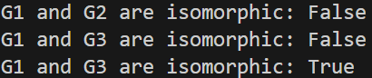
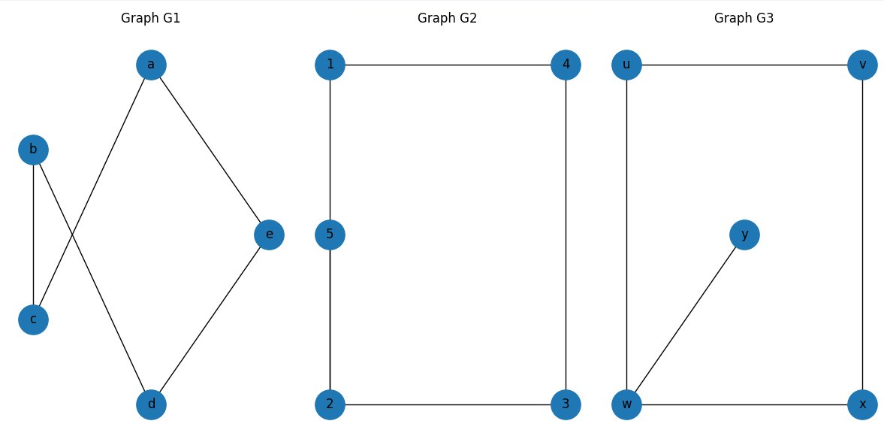

Program 2: Without using NetworkX functions
import matplotlib.pyplot as plt
import itertools
def draw_graph(edges, pos, title):
for edge in edges:
x = [pos[edge[0]][0], pos[edge[1]][0]]
y = [pos[edge[0]][1], pos[edge[1]][1]]
plt.plot(x, y, color='black')
for node in pos:
plt.scatter(pos[node][0], pos[node][1], s=800, color='black')
plt.text(pos[node][0], pos[node][1], str(node),
ha='center', va='center', color='white')
plt.title(title)
plt.axis('off') # ❗ remove x and y axes
def is_isomorphic(nodes1, edges1, nodes2, edges2):
if len(nodes1) != len(nodes2) or len(edges1) != len(edges2):
return False
for perm in itertools.permutations(nodes2):
mapping = dict(zip(nodes1, perm))
mapped_edges = set()
for u, v in edges1:
mapped_edges.add((mapping[u], mapping[v]))
mapped_edges.add((mapping[v], mapping[u]))
edges2_set = set(edges2) | set((v, u) for u, v in edges2)
if mapped_edges == edges2_set:
return True
return False
edges1 = [('a','c'), ('b','c'), ('b','d'), ('d','e'), ('a','e')]
nodes1 = ['a','b','c','d','e']
pos1 = {
'a': (1, 3),
'b': (0, 2),
'c': (0, 0),
'd': (1, -1),
'e': (2, 1)}
edges2 = [(1,2), (2,3), (3,4), (4,1), (5,2)]
nodes2 = [1,2,3,4,5]
pos2 = {
1: (0, 2),
2: (0, 0),
3: (3, 0),
4: (3, 2),
5: (0, 1)}
edges3 = [('w','x'), ('x','v'), ('v','u'), ('u','w'), ('w','y')]
nodes3 = ['w','x','v','u','y']
pos3 = {
'u': (0, 2),
'w': (0, 0),
'x': (2, 0),
'v': (2, 2),
'y': (1, 1)
}
plt.figure(figsize=(12,6))
plt.subplot(1,3,1)
draw_graph(edges1, pos1, "G1")
plt.subplot(1,3,2)
draw_graph(edges2, pos2, "G2")
plt.subplot(1,3,3)
draw_graph(edges3, pos3, "G3")
plt.tight_layout()
plt.show()
print("G1 and G2 Isomorphic:", is_isomorphic(nodes1, edges1, nodes2, edges2))
print("G1 and G3 Isomorphic:", is_isomorphic(nodes1, edges1, nodes3, edges3))
print("G2 and G3 Isomorphic:", is_isomorphic(nodes2, edges2, nodes3, edges3))

OUTPUT:



Conclusion: implemented graphisomorphism verification inorder to compare structural equivalence between the graph

