Experiment No: 3 Date:
Aim: To implement generations of various subgraphs such as induced subgraph, spanning subgraph and edge deleted subgraph.

Theory:
Subgraph
A subgraph is a graph formed from another graph by selecting some of its vertices and edges. If 𝐺 = (𝑉, 𝐸)is a graph, then a graph 𝐻 = (𝑉₁, 𝐸₁)is called a subgraph of 𝐺if:
𝑉₁ ⊆ 𝑉
𝐸₁ ⊆ 𝐸
This means that all vertices and edges in the subgraph must come from the original graph. No new vertices or edges can be added.
Subgraphs are useful because they allow us to study a smaller portion of a larger graph while preserving the relationships between selected vertices. This helps in analyzing specific properties or structures of the original graph.

Types of Subgraphs
- Induced Subgraph
An induced subgraph is formed by selecting a subset of vertices and including all edges that exist between those vertices in the original graph.
If 𝑆 ⊆ 𝑉, then the induced subgraph 𝐺[𝑆]contains:
Vertex set: 𝑆
All edges connecting vertices in 𝑆
In simple terms:
Once vertices are selected, no edge between them can be omitted.

- Spanning Subgraph
A spanning subgraph includes all vertices of the original graph but only some of its edges. If 𝐺 = (𝑉, 𝐸), then a spanning subgraph 𝐻has:
Same vertex set: 𝑉
Edge set: 𝐸₁ ⊆ 𝐸
This means:
All vertices are retained
Some edges may be removed
Spanning subgraphs are important in applications like spanning trees, which connect all vertices using the minimum number of edges.
- Edge Deleted Subgraph
An edge deleted subgraph is obtained by removing one or more edges from the original graph while keeping all vertices unchanged.
If an edge 𝑒 ∈ 𝐸is removed, the new graph is written as:
𝐺 − 𝑒
Key points:
Number of vertices remains the same
Number of edges decreases
This type of subgraph helps in studying how graph structure changes when connections are removed.

Program 1: With using NetworkX functions import networkx as nx
import matplotlib.pyplot as plt

# Create original graph
G = nx.Graph()

# Nodes
G.add_nodes_from([1, 2, 3, 4, 5, 6])

# Edges
G.add_edges_from([
(1, 2),
(2, 3),
(3, 4),
(4, 1),
(1, 6),
(2, 6),
(6, 5),
(5, 4),
(1,3)
])

# Fixed positions for consistent layout
pos = {
1: (0, 0),
2: (0, 2),
3: (2, 2),
4: (2, 0),
5: (1.5,1),
6: (1,0.4)
}

# 1. Spanning Subgraph
spanning = nx.Graph()
spanning.add_nodes_from(G.nodes())
spanning.add_edges_from([
(2, 3),
(4, 1),
(2, 6),
(6, 5),
(5, 4),
(1,3)
])

# 2. Vertex Induced Subgraph
nodes_subset = [1, 2, 6]
induced = G.subgraph(nodes_subset)

# 3. Edge Induced Subgraph
edge_subset = [(1, 6), (5, 4)]
edge_induced = nx.Graph()
edge_induced.add_edges_from(edge_subset)

# Plot all graphs
plt.figure(figsize=(12, 10))

# Original Graph
plt.subplot(2, 2, 1)
nx.draw(G, pos, with_labels=True, node_color='lightblue', node_size=800)
plt.title("Original Graph")

# Spanning Subgraph
plt.subplot(2, 2, 2)
nx.draw(spanning, pos, with_labels=True, node_color='lightgreen', node_size=800)
plt.title("Spanning Subgraph")

# Vertex Induced Subgraph
plt.subplot(2, 2, 3)
nx.draw(induced, pos, with_labels=True, node_color='orange', node_size=800)
plt.title("Vertex Induced Subgraph")

# Edge Induced Subgraph
plt.subplot(2, 2, 4)
nx.draw(edge_induced, pos, with_labels=True, node_color='pink', node_size=800)
plt.title("Edge Induced Subgraph")

plt.tight_layout()
plt.show()

Output:
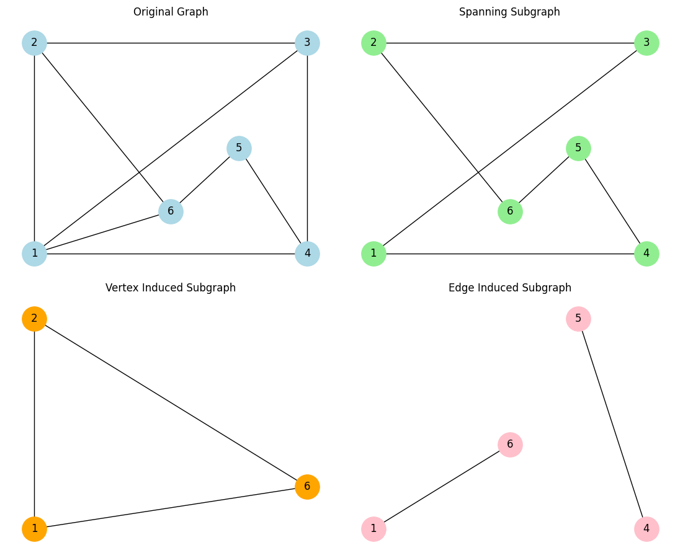

Program 2: Without using NetworkX functions
import matplotlib.pyplot as plt
pos = {
1: (0, 0),
2: (0, 2),
3: (2, 2),
4: (2, 0),
5: (1.5, 1),
6: (1, 0.4)
}

def draw_graph(nodes, edges, title):
for node in nodes:
x, y = pos[node]

plt.scatter(x, y, s=800, color='lightblue', edgecolors='black', zorder=3)

plt.text(x, y, str(node), fontsize=12, ha='center', va='center', color='black', zorder=4)

for (u, v) in edges:
x1, y1 = pos[u]
x2, y2 = pos[v]
plt.plot([x1, x2], [y1, y2], color='black', zorder=1)

plt.title(title)
plt.axis('off')

# Original Graph
nodes = [1, 2, 3, 4, 5, 6]
edges = [
(1, 2), (2, 3), (3, 4), (4, 1),
(1, 6), (2, 6), (6, 5), (5, 4), (1, 3)
]
# Spanning Subgraph
spanning_edges = [
(2, 3), (4, 1), (2, 6),
(6, 5), (5, 4), (1, 3)
]
# Vertex Induced Subgraph
induced_nodes = [1, 2, 6]
induced_edges = [
(1, 2), (1, 6), (2, 6)
]
# Edge Induced Subgraph
edge_induced_edges = [(1, 6), (5, 4)]
edge_induced_nodes = list(set([n for edge in edge_induced_edges for n in edge]))

plt.figure(figsize=(12, 10))

# Original
plt.subplot(2, 2, 1)
draw_graph(nodes, edges, "Original Graph")

# Spanning
plt.subplot(2, 2, 2)
draw_graph(nodes, spanning_edges, "Spanning Subgraph")

# Vertex Induced
plt.subplot(2, 2, 3)
draw_graph(induced_nodes, induced_edges, "Vertex Induced Subgraph")

# Edge Induced
plt.subplot(2, 2, 4)
draw_graph(edge_induced_nodes, edge_induced_edges, "Edge Induced Subgraph")

plt.tight_layout()
plt.show()

Output:
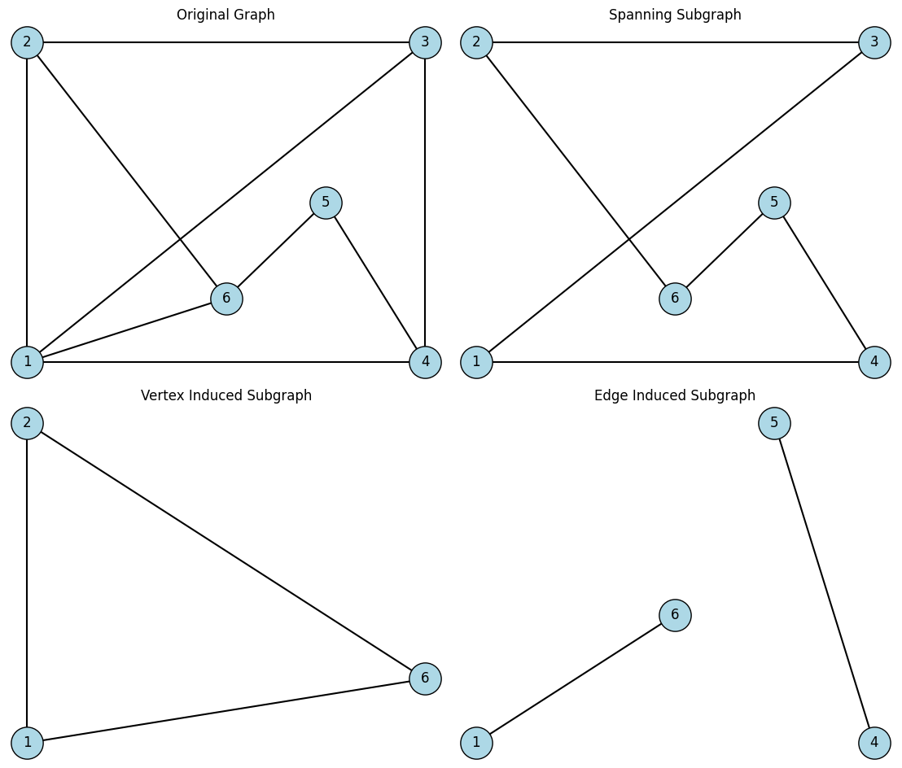

Conclusion: Implemented generations of various subgraphs such as induced subgraph, spanning subgraph and edge deleted subgraph

