Experiment No: 4 Date:
Aim: To implement construction of a graph for a given degree sequence, verifying the sequence is graphical.

Theory:
Degree Sequence of a Graph
A degree sequence of a graph is a list that represents the degrees of all the vertices in the graph. The degree of a vertex indicates the number of edges connected to it.
This sequence is usually written in non-increasing order, meaning the highest degree appears first. For example, if a graph has five vertices with degrees 3, 2, 2, 1, and 0, the degree sequence is written as:
(3, 2, 2, 1, 0)
Degree sequences are important in graph theory because they describe how vertices are connected and help determine whether such a graph can exist. A sequence that corresponds to at least one valid graph is called a graphical sequence.
Important Rule: The sum of all vertex degrees must be even, since each edge contributes to the degree of two vertices.

Constructing a Graph from a Degree Sequence
To construct a graph from a given degree sequence, vertices are first assigned according to the sequence, and edges are added so that each vertex satisfies its required degree. One common technique used for this purpose is the Havel–Hakimi method.
In this method, the sequence is first arranged in decreasing order. The vertex with the largest degree is then connected to the next set of vertices equal to its degree value. After making these connections, the degrees of those vertices are reduced by one.
The updated sequence is again rearranged in descending order, and the same process is repeated. If at any step a negative value appears or the connections cannot be completed, the sequence cannot represent a valid graph. However, if the sequence eventually becomes all zeros, it means the graph has been successfully constructed.

Using NetworkX in Python
In Python, the NetworkX library provides built-in tools that simplify the process of generating graphs from degree sequences.
The function havel_hakimi_graph() automatically constructs a graph using the Havel–Hakimi algorithm.
The function configuration_model() generates a graph by randomly pairing half- edges (also called stubs).
The function degree_sequence_tree() creates a tree when the given sequence represents a valid tree degree sequence.
After generating the graph, it can be visualized using functions like draw() along with layouts such as spring_layout(), which arrange the vertices and edges clearly.

Program 1 : With using NetworkX functions import networkx as nx
import matplotlib.pyplot as plt
deg_seq = list(map(int, input("Enter the degree sequence (space separated): ").split())) graph = nx.havel_hakimi_graph(deg_seq)
layout = nx.circular_layout(graph)

plt.figure(figsize=(6,6)) nx.draw_networkx(
graph, pos=layout, with_labels=True,
node_color='skyblue', node_size=1200, edge_color='black', font_size=10
)
plt.title("Graph from Given Degree Sequence") plt.axis('off')
plt.show()

Output:
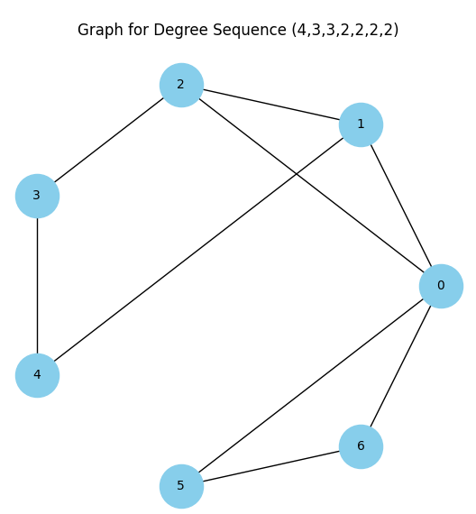

Program 2 : Without using NetworkX functions
import networkx as nx
import matplotlib.pyplot as plt
import math
seq = list(map(int, input("Enter degree sequence: ").split()))
size = len(seq)
g = nx.Graph()
g.add_nodes_from(range(size))
pairs = [(seq[i], i) for i in range(size)]
while True:
pairs.sort(key=lambda x: x[0], reverse=True)
deg, node = pairs.pop(0)
if deg == 0:
graphs.append(g.copy())
titles.append(f"Step {step}: Completed")
break
if deg > len(pairs):
print("Invalid degree sequence")
exit()
for j in range(deg):
if d - 1 < 0:
print("Invalid degree sequence")
exit()
pairs[j] = (d - 1, nbr)
graphs.append(g.copy())
titles.append(f"Step {step}: {node} → {', '.join(edges_added)}")
step += 1
final_graph = graphs[-1]
pos = nx.spring_layout(final_graph, seed=42)
num_steps = len(graphs)
if num_steps == 1:
axes = [axes]
else:
for i in range(num_steps):
nx.draw(
graphs[i],
pos,
ax=axes[i],
with_labels=True,
node_color='orange',
)
axes[i].set_title(titles[i], fontsize=10)
for i in range(num_steps, len(axes)):
axes[i].axis('off')
plt.subplots_adjust(hspace=0.6, wspace=0.3)
plt.suptitle(
"Step-by-Step Graph Construction (Havel-Hakimi)",
fontsize=16,
y=0.98
)
plt.show()

Output:

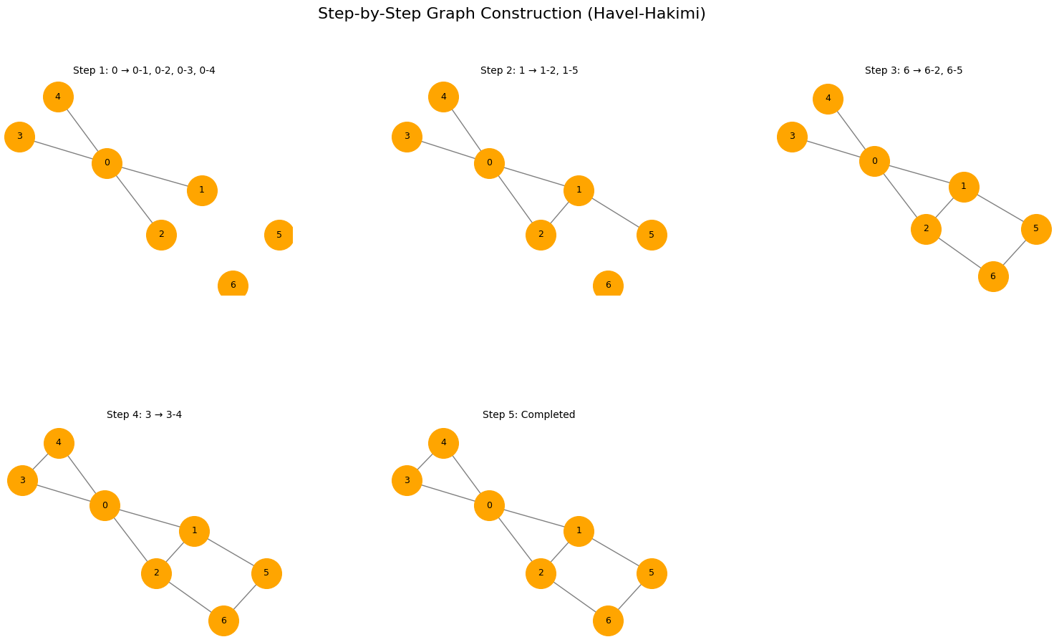

Conclusion: Implemented construction of a graph for a given degree sequence, verified the sequence is graphical.

