Experiment No: 5 Date:
Aim: Convert the original graph into its line graph, where each edge of the original graph becomes the vertex in the new graph, and adjacency is defined by shared endpoints in the original graph

Theory:
In graph theory, a line graph is a transformation of a given graph where the focus shifts from vertices to edges. Consider a simple graph 𝐺 = (𝑉, 𝐸), where 𝑉represents vertices and 𝐸represents edges. The line graph of 𝐺, written as 𝐿(𝐺), is constructed by treating each edge of 𝐺as a vertex in the new graph.
In this transformed graph, two vertices in 𝐿(𝐺)are connected if and only if their corresponding edges in the original graph 𝐺have a common endpoint. In other words, whenever two edges in 𝐺meet at a vertex, they become adjacent vertices in 𝐿(𝐺).
Formally, if 𝐺 = (𝑉, 𝐸), then its line graph is defined as:
𝐿(𝐺) = (𝑉′, 𝐸′)
𝑉′ = 𝐸
𝐸′ = {(𝑒_{𝑖}, 𝑒_{𝑗}) ∣ 𝑒_{𝑖} and 𝑒_{𝑗} are incident in 𝐺}
This construction effectively converts edge adjacency in 𝐺into vertex adjacency in 𝐿(𝐺), making it useful for analyzing relationships between edges.
Suppose a graph contains edges:
𝑒₁ = (𝑢, 𝑣)
𝑒₂ = (𝑣, 𝑤)
𝑒₃ = (𝑤, 𝑥)
Here:
𝑒₁and 𝑒₂meet at vertex 𝑣
𝑒₂and 𝑒₃meet at vertex 𝑤
In the corresponding line graph:
Each edge becomes a vertex
There will be an edge between vertices representing 𝑒₁and 𝑒₂
Another edge will connect vertices representing 𝑒₂and 𝑒₃
Key Characteristics of Line Graphs
Vertex Count : The total number of vertices in 𝐿(𝐺)is equal to the number of edges in 𝐺.

Edge Formation Rule : Edges in 𝐿(𝐺)are determined by how many pairs of edges in
𝐺share a common vertex. If a vertex in 𝐺has degree 𝑑, it contributes ^{𝑑(𝑑−1)}edges in 𝐿(𝐺),
2
since each pair of incident edges forms one connection.

Simplicity : When 𝐺is a simple graph, 𝐿(𝐺)will also be simple, meaning no loops or parallel edges are formed.

Isolated Elements : If an edge in 𝐺is not adjacent to any other edge, it becomes an isolated vertex in 𝐿(𝐺).
Non-adjacent Edges : Edges in 𝐺that do not share a vertex remain non-adjacent in the line graph.

Program 1: With using NetworkX functions import networkx as nx
import networkx as nx
import matplotlib.pyplot as plt
G = nx.Graph()
edges = [
('A', 'B', 1),
('A', 'C', 2),
('B', 'C', 3),
('A', 'D', 4),
('A', 'E', 5),
('B', 'F', 6),
('C', 'F', 7),
('B', 'D', 8),
('C', 'E', 9),
('D', 'E', 10),
('D', 'F', 11),
('E', 'F', 12)]
G.add_weighted_edges_from(edges)
pos = {
'A': (0, 3),
'B': (-2, 2),
'C': (2, 2),
'D': (-2, 0),
'E': (2, 0),
'F': (0, -2)}
L = nx.line_graph(G)
plt.figure(figsize=(14, 6))
plt.subplot(1, 2, 1)
nx.draw(
G,,
with_labels=True,
node_size=2000,
node_color='lightblue',
font_size=12,
edgecolors='black'
)
edge_labels = nx.get_edge_attributes(G, 'weight')
nx.draw_networkx_edge_labels(
pos,
edge_labels=edge_labels,
font_size=10
)
plt.title("Original Graph")
plt.axis('off')
plt.subplot(1, 2, 2)
line_pos = nx.spring_layout(L, seed=42)
nx.draw(
line_pos,
with_labels=True,
node_size=1800,
node_color='lightgreen',
font_size=8,
edgecolors='black')
plt.title("Line Graph")
plt.tight_layout()
plt.show()

Program 2 : Without using NetworkX functions import networkx as nx
import matplotlib.pyplot as plt
import math
nodes = ['A', 'B', 'C', 'D', 'E', 'F']
edges = [
('A', 'B', 1),
('A', 'C', 2),
('B', 'C', 3),
('A', 'D', 4),
('A', 'E', 5),
('B', 'F', 6),
('C', 'F', 7),
('B', 'D', 8),
('C', 'E', 9),
('D', 'E', 10),
('D', 'F', 11),
('E', 'F', 12)
]
pos = {
'A': (0, 3),
'B': (-2, 2),
'C': (2, 2),
'D': (-2, 0),
'E': (2, 0),
'F': (0, -2)
}
line_nodes = []
for u, v, w in edges:
line_nodes.append((u, v))
line_edges = []
for i in range(len(edges)):
u1, v1, w1 = edges[i]
plt.figure(figsize=(14, 6))
plt.subplot(1, 2, 1)
for u, v, w in edges:
x1, y1 = pos[u]
x2, y2 = pos[v]
plt.plot([x1, x2], [y1, y2], 'black')
mx = (x1 + x2) / 2
my = (y1 + y2) / 2
plt.text(mx, my, str(w), fontsize=10, color='blue')
plt.title("Original Graph")
plt.subplot(1, 2, 2)
for i, node in enumerate(line_nodes):
angle = i * angle_step
x = 3 * math.cos(angle) y = 3 * math.sin(angle)
line_pos[node] = (x, y)
for n1, n2 in line_edges:
x1, y1 = line_pos[n1]
x2, y2 = line_pos[n2]
for node in line_nodes:
circle = plt.Circle((x, y), 0.3,
plt.gca().add_patch(circle)
plt.text(x, y,
plt.title("Line Graph")
plt.tight_layout()
plt.show()

Output:
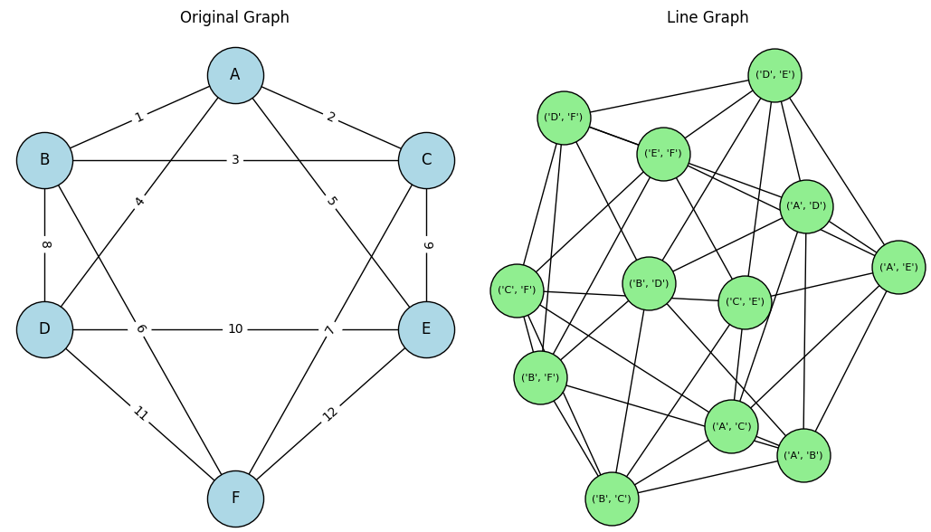

Conclusion: Converted the original graph into its line graph, where each edge of the original graph becomes the vertex in the new graph, and adjacency is defined by shared endpoints in the original graph.

