Experiment No: 6 Date:

Aim: To implement Kruskal’s algorithm to generate MST , ensuring all vertices are connected with minimum possible total edge weight and without cycles.

Theory:
In Graph Theory, a Minimum Spanning Tree (MST) is a subset of edges in a connected, weighted, undirected graph that connects all vertices with the minimum total edge weight and no cycles.
Kruskal’s Algorithm is one of the most efficient methods to construct an MST. It follows a greedy approach, selecting edges with the smallest weight first while avoiding cycles.

Definition of Minimum Spanning Tree A spanning tree of a graph:
Connects all vertices
Contains exactly (V - 1) edges, where V is the number of vertices Has no cycles

A Minimum Spanning Tree (MST) is a spanning tree with the least possible total weight among all spanning trees of the graph.

Kruskal’s Algorithm
Kruskal’s Algorithm builds the MST by selecting edges in increasing order of weight, ensuring that no cycles are formed.

Working Principle
The algorithm follows these steps:
- Sort all edges in ascending order of weight
- Start with an empty MST
- Pick the smallest edge:
  - If it does not form a cycle, include it in MST
  - Otherwise, discard it
- Repeat until:
  - MST contains (V - 1) edges
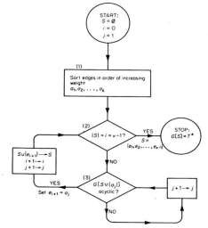

Program 1 : With using NetworkX functions
import networkx as nx
import matplotlib.pyplot as plt
import math
G = nx.Graph()
edges = [
(0, 1, 7),
(0, 3, 5),
(1, 2, 8),
(1, 3, 9),
(1, 4, 7),
(2, 4, 5),
(3, 4, 15),
(3, 5, 6),
(4, 5, 8),
(4, 6, 9),
(5, 6, 11)
]
G.add_weighted_edges_from(edges)
pos = {
0: (0, 3),
1: (2, 3),
2: (4, 3),
3: (1, 2),
4: (3, 2),
5: (1.5, 1),
6: (4, 1)
}
.figure(figsize=(8, 6))
nx.draw(
G,
pos,
with_labels=True,
node_color='pink',
node_size=1000,
edgecolors="black"
)
labels = nx.get_edge_attributes(G, 'weight')
nx.draw_networkx_edge_labels(
G,
pos,
edge_labels=labels
)
plt.title("Original Graph")
plt.gca().set_aspect('equal')
plt.show()
parent = {}
rank = {}
def find(u):
if parent[u] != u:
parent[u] = find(parent[u]) return parent[u]
def union(u, v):
ru = find(u)
rv = find(v)
if ru == rv:
return False
if rank[ru] > rank[rv]:
parent[rv] = ru
else:
parent[rv] = ru
rank[ru] += 1
return True
edges_sorted = sorted(edges, key=lambda x: x[2])
mst = nx.Graph()
mst.add_nodes_from(G.nodes())
steps = []
selected_edges = []
total_cost = 0
for u, v, w in edges_sorted:
if union(u, v):
mst.add_edge(u, v, weight=w)
total_cost += w
selected_edges.append((u, v))
steps.append(list(selected_edges))
cols = 3
rows = math.ceil(len(steps) / cols)
fig, axes = plt.subplots(rows, cols, figsize=(12, rows * 4))
axes = axes.flatten()
for i, step_edges in enumerate(steps):
temp = nx.Graph()
temp.add_nodes_from(G.nodes())
temp.add_edges_from(step_edges)
ax = axes[i]
nx.draw_networkx_nodes(
temp, pos,
node_color='lightblue',
)
nx.draw_networkx_labels(
temp,
pos, )
prev_edges = step_edges[:-1]
curr_edge = [step_edges[-1]]

edge_labels = {
(u, v): G[u][v]['weight']
for u, v in step_edges }
nx.draw_networkx_edge_labels(
temp,
pos,
edge_labels=edge_labels, )
ax.set_title(f"Step {i+1}")
ax.set_aspect('equal')
ax.axis('off')
for j in range(i + 1, len(axes)):
axes[j].axis('off')
plt.tight_layout()
plt.show()
print("Edges in MST:")
for u, v, w in mst.edges(data='weight'):
print(f"{u} -- {v} Weight = {w}")
print("\nTotal MST Cost =", total_cost)

Program 2 : Without using NetworkX functions import matplotlib.pyplot as plt
import matplotlib.pyplot as plt import math
edges = [ (0, 1, 7),
(0, 3, 5),
(1, 2, 8),
(1, 3, 9),
(1, 4, 7),
(2, 4, 5),
(3, 4, 15),
(3, 5, 6),
(4, 5, 8),
(4, 6, 9),
(5, 6, 11)
]
nodes = [0, 1, 2, 3, 4, 5, 6]
pos = {
0: (0, 3),
1: (2, 3),
2: (4, 3),
3: (1, 2),
4: (3, 2),
5: (1.5, 1),
6: (4, 1)
}
def draw_graph(ax, draw_edges, highlight_edge=None, title=""): for node in nodes:
x, y = pos[node] circle = plt.Circle(
(x, y), 0.18,
color='pink' if highlight_edge is None else 'lightblue', ec='black'
)
ax.add_patch(circle) ax.text(
x,
y, str(node),
)
for u, v in draw_edges: x1, y1 = pos[u]
x2, y2 = pos[v] color = 'black'
width = 2
if highlight_edge == (u, v): color = 'red'
width = 3 ax.plot(
[x1, x2],
[y1, y2],

)
for a, b, w in edges:
if (a == u and b == v) or (a == v and b == u):
my = (y1 + y2) / 2 ax.text(
mx,
my,
bbox=dict(facecolor='white', edgecolor='none')
)
ax.set_title(title) ax.set_aspect('equal')
draw_graph(ax, all_edges, title="Original Graph") plt.show()
parent = {} rank = {} def find(u):
if parent[u] != u:
parent[u] = find(parent[u]) return parent[u]
def union(u, v):
else:
parent[rv] = ru rank[ru] += 1
return True
for node in nodes: parent[node] = node
mst_edges = []
steps = [] total_cost = 0
for u, v, w in edges_sorted: if union(u, v):
mst_edges.append((u, v, w)) total_cost += w steps.append(list(mst_edges)

step[-1]
cu, cv, cw = current_edge current = [(cu, cv)]
all_step_edges = prev_edges + current draw_graph(
ax, all_step_edges,)
for j in range(i + 1, len(axes)): axes[j].axis('off')
plt.tight_layout() plt.show()
print("Edges in MST:") for u, v, w in mst_edges:
print(f"{u} -- {v} Weight = {w}") print("\nTotal MST Cost =", total_cost)

Output:

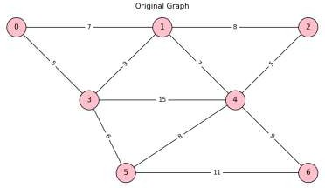

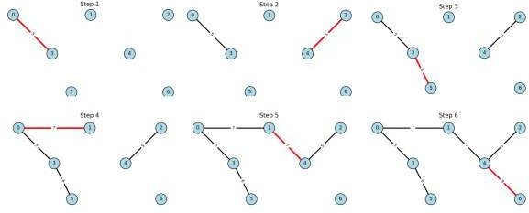

Conclusion: Implemented Kruskal’s algorithm to generate MST , ensuring all vertices are connected with minimum possible total edge weight and without cycles.

