Experiment No: 7 Date:
Aim: To implement shortest path algorithm in order to compute the shortest path between vertices in a weighted graph

Theory:
In Graph Theory, the shortest path problem involves finding the minimum distance (or cost) path between two vertices in a weighted graph. This problem has wide applications in network routing, GPS navigation, transportation systems, and communication networks. One of the most commonly used algorithms to solve this problem is Dijkstra’s Algorithm. It is a greedy algorithm that finds the shortest path from a source vertex to all other vertices in a graph with non-negative edge weights.

Definition of Shortest Path
The shortest path between two vertices is the path that has the minimum total sum of edge weights among all possible paths connecting them.

Dijkstra’s Algorithm:
Dijkstra’s Algorithm computes the shortest path from a source vertex to all other vertices in a weighted graph.

Working Principle:
The algorithm follows these steps:
- Initialize distances of all vertices as infinity, except the source vertex (set to 0)
- Mark all vertices as unvisited
- Select the unvisited vertex with the smallest distance
- For the selected vertex:
  - Update the distance of its adjacent vertices
  - If new distance is smaller, update it
- Mark the current vertex as visited
- Repeat until all vertices are visited or the shortest path is found
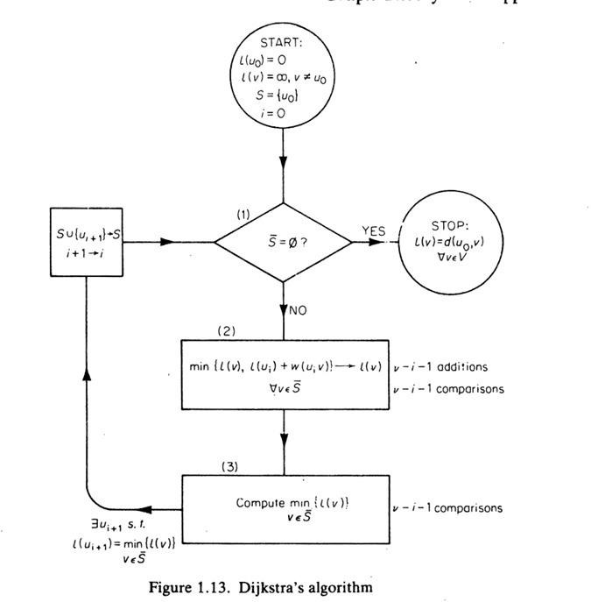

Program 1: With using NetworkX functions
import networkx as nx
import matplotlib.pyplot as plt
import math
graph = {
'A': {'B':4, 'C':6, 'D':5},
'B': {'A':4, 'C':1, 'E':7},
'C': {'A':6, 'B':1, 'D':2, 'E':5, 'F':4},
'D': {'A':5, 'C':2, 'F':5},
'E': {'B':7, 'C':5, 'F':1, 'G':6},
'F': {'C':4, 'D':5, 'E':1, 'G':8},
'G': {'E':6, 'F':8}
}

def dijkstra_table(graph, start):
nodes = list(graph.keys())
dist = {node: math.inf for node in nodes}
visited = []
dist[start] = 0
parent = {node: None for node in nodes}

print("\nDijkstra Table:\n")
print("S\tS'\t\tA\tB\tC\tD\tE\tF\tG\tUi+1")

while len(visited) < len(nodes):
u = min((node for node in nodes if node not in visited), key=lambda x: dist[x])
visited.append(u)

for v, w in graph[u].items():
if v not in visited and dist[u] + w < dist[v]:
dist[v] = dist[u] + w
parent[v] = u

dist_values = [dist[n] if dist[n] != math.inf else '∞' for n in nodes]
next_node = None
if len(visited) < len(nodes):
next_node = min((node for node in nodes if node not in visited), key=lambda x: dist[x])

print(f"{u}\t{' '.join(visited)}\t\t" + "\t".join(map(str, dist_values)) + f"\t{next_node}")

return dist, parent
dist, parent = dijkstra_table(graph, 'A')
def get_path(parent, target):
path = []
while target:
path.append(target)
target = parent[target]
return path[::-1]

target = 'G'
path = get_path(parent, target)

print("\nShortest Path:", path)
print("Total Distance:", dist[target])

G = nx.Graph()
for u in graph:
for v, w in graph[u].items():
G.add_edge(u, v, weight=w)
pos = nx.spring_layout(G, seed=42)
plt.figure(figsize=(12,6))
plt.subplot(1,2,1)
nx.draw(G, pos, with_labels=True, node_size=1000)
nx.draw_networkx_edge_labels(G, pos, edge_labels=nx.get_edge_attributes(G,'weight'))
plt.title("Original Graph")
plt.subplot(1,2,2)
nx.draw(G, pos, with_labels=True, node_size=1000)
nx.draw_networkx_edge_labels(G, pos, edge_labels=nx.get_edge_attributes(G,'weight'))
path_edges = list(zip(path, path[1:]))
nx.draw_networkx_edges(G, pos, edgelist=path_edges, width=3, edge_color='red')
plt.title("Shortest Path Highlighted")
plt.show()

Program 2: Without using NetworkX functions
import matplotlib.pyplot as plt
import math
graph = {
'A': {'B':4, 'C':6, 'D':5},
'B': {'A':4, 'C':1, 'E':7},
'C': {'A':6, 'B':1, 'D':2, 'E':5, 'F':4},
'D': {'A':5, 'C':2, 'F':5},
'E': {'B':7, 'C':5, 'F':1, 'G':6},
'F': {'C':4, 'D':5, 'E':1, 'G':8},
'G': {'E':6, 'F':8}
}
def dijkstra_table(graph, start):
nodes = list(graph.keys())
dist = {node: math.inf for node in nodes}
visited = []
dist[start] = 0
parent = {node: None for node in nodes}

print("\nDijkstra Table:\n")
print("S\tS'\t\tA\tB\tC\tD\tE\tF\tG\tUi+1")

while len(visited) < len(nodes):
u = min((node for node in nodes if node not in visited), key=lambda x: dist[x])
visited.append(u)

for v, w in graph[u].items():
if v not in visited and dist[u] + w < dist[v]:
dist[v] = dist[u] + w
parent[v] = u

dist_values = [dist[n] if dist[n] != math.inf else '∞' for n in nodes]
next_node = None
if len(visited) < len(nodes):
next_node = min((node for node in nodes if node not in visited), key=lambda x: dist[x])

print(f"{u}\t{' '.join(visited)}\t\t" + "\t".join(map(str, dist_values)) + f"\t{next_node}")

return dist, parent
dist, parent = dijkstra_table(graph, 'A')

def get_path(parent, target):
path = []
while target:
path.append(target)
target = parent[target]
return path[::-1]
target = 'G'
path = get_path(parent, target)

print("\nShortest Path:", path)
print("Total Distance:", dist[target])

pos = {
'A': (0, 1),
'B': (2, 3),
'C': (2, 1),
'D': (2, -1),
'E': (4, 2),
'F': (4, 0),
'G': (6, 1)
}

edges = []
seen = set()
for u in graph:
for v, w in graph[u].items():
if (v, u) not in seen:
edges.append((u, v, w))
seen.add((u, v))
path_edges = list(zip(path, path[1:]))

def draw_graph(highlight=False):
for u, v, w in edges:
x = [pos[u][0], pos[v][0]]
y = [pos[u][1], pos[v][1]]
if highlight and ((u, v) in path_edges or (v, u) in path_edges):
plt.plot(x, y, linewidth=3, color='red')
else:
plt.plot(x, y, color='black')
mid_x = (pos[u][0] + pos[v][0]) / 2
mid_y = (pos[u][1] + pos[v][1]) / 2
plt.text(mid_x, mid_y, str(w), color='blue')

for node, (x, y) in pos.items():
plt.scatter(x, y, s=800)
plt.text(x, y, node, ha='center', va='center', color='white')

plt.axis('off')

plt.figure(figsize=(12,6))

plt.subplot(1,2,1)
draw_graph(False)
plt.title("Original Graph")

plt.subplot(1,2,2)
draw_graph(True)
plt.title("Shortest Path Highlighted")

plt.show()

Output:

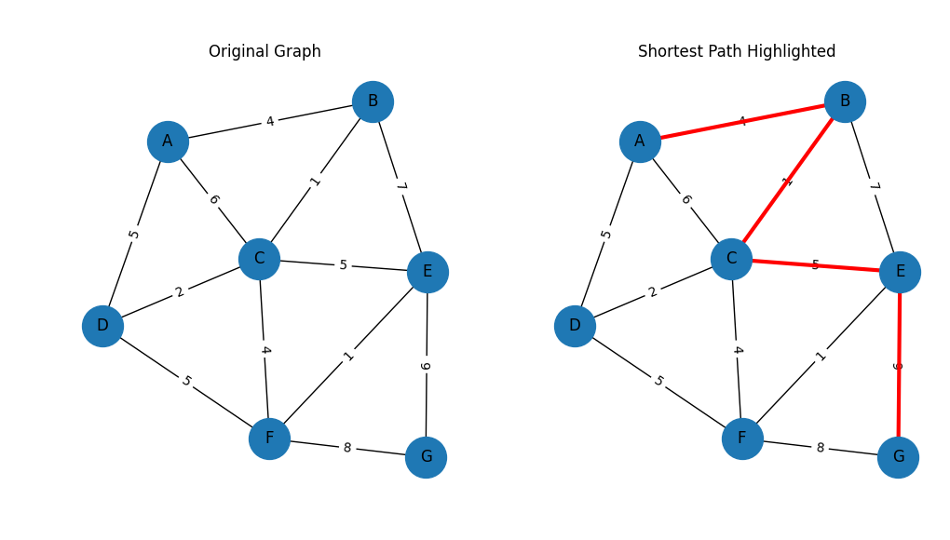

S S' A B C D E F G Ui+1
A A 0 4 6 5 ∞ ∞ ∞ B
B A B 0 4 5 5 11 ∞ ∞ C
C A B C 0 4 5 5 10 9 ∞ D
D A B C D 0 4 5 5 10 9 ∞ F
F A B C D F 0 4 5 5 10 9 17 E
E A B C D F E 0 4 5 5 10 9 16 G
G A B C D F E G 0 4 5 5 10 9 16 None

Shortest Path: ['A', 'B', 'C', 'E', 'G']
Total Distance: 16

Conclusion: Implemented shortest path algorithm in order to compute the shortest path between vertices in a weighted graph.

