## A

## PROJECT REPORT ON

## THE FASHION FIND

## SUBMITTED TO



## Maharashtra Education Society’s

## MES SENIOR COLLEGE, PUNE

## (Affiliated to SAVITRIBAI PHULE PUNE UNIVERSITY)

## IN PARTIAL FULFILLMENT OF

## BACHELOR OF BUSINESS ADMINISTRATION

## (COMPUTER APPLICATION)

## (Academic Year 2023-24)

## SUBMITTED BY

## Mr. Yashraj Renke Roll No :- 2230034

## SYBBA-CA(Semester-IV)

## UNDER THE GUIDANCE OF

## Dr./ Prof. Prathibha Patil

I would like to take this opportunity to express my heartfelt gratitude and appreciation for the completion of The **Fashion Find** as a part of my academic curriculum. Throughout this project, I had the privilege of working independently under the guidance and mentorship of **Prof. Prathibha Patil.** I would like to thank MES Senior College, Principal Sir, All Faculty members, peers and friends for their support and encouragement throughout this project. Their valuable suggestions, brainstorming sessions, and willingness to provide feedback greatly contributed to the overall success of this project.

Student Name: Yashraj Renke

Roll No: 2230034

**INDEX**

|  |  |  |
| --- | --- | --- |
| **Sr. No** | **Topic** | **Page No.** |
| **1** | Introduction   * Problem Statement * Objective of System * Software/Hardware Specifications | **1** |
| **2** | Proposed System   * Scope and limitations of existing systems * Project perspective, features * Functional Requirement * Performance Requirement * Security Requirement | **2** |
| **3** | System Design   * + - E-R Diagram     - Data Flow Diagram     - User Interface Design (Screens etc.) |  |
| **4** | Limitations |  |
| **5** | Future Enhancement |  |
| **6** | Conclusion |  |
| **7** | Bibliography |  |
| **8** | Annexure:   * Sample program code |  |

**Introduction**

**Problem Statement :-**

The current online shopping landscape is fragmented, with consumers needing to visit multiple websites to purchase a wide range of products, including eyewear, clothing, footwear, and smart accessories. This disjointed experience complicates the shopping process, making it time-consuming and less user-friendly. The Fashion Find seeks to address this challenge by creating a one-stop website that consolidates a broad spectrum of products, streamlining the shopping experience for consumers seeking variety and convenience.

**Objective :-**

Primary objective of red store is to Create a sense of community centered around sports enthusiasts among users through informative blogs, shared reviews, and participation in promotional events. The Fashion Find as a trusted and trend-setting brand by consistently delivering quality products and engaging content, enhancing brand loyalty and consumer satisfaction

**Software/Hardware Specifications :-**

These are the minimum specifications of hardware →

* 2 GB Ram,
* 4GB SSD/HDD
* Processor 2 GHz

These are the software specifications **→**

* HTML
* CSS
* JS

**Proposed system**

1. Scope And Limitations Of Existing Systems :-

Existing e-commerce platforms often struggle to provide a seamless balance between affordability and semi-luxury, primarily due to limitations such as:

* **Inability to Handle Mass Traffic:** platform fails during peak shopping periods, resulting in lost sales and customer dissatisfaction.
* **Limited Product Range:** The absence of a comprehensive selection that spans various categories and styles restricts consumer choice.
* **Inadequate Personalization:** A lack of personalized shopping experiences makes it difficult for users to find products that match their preferences and needs.

2. Project Perspective And Features :-

THE FASHION FIND is designed to redefine e-commerce by offering an unmatched selection of affordable semi-luxury products. The platform is committed to delivering a superior shopping experience that encompasses a vast range of clothing, shoes, and accessories. By addressing the limitations of existing systems, THE FASHION FIND aims to become the preferred online destination for savvy shoppers looking for quality, style, and value.

**Features:**

* **Wide Product Selection:** A diverse array of affordable semi-luxury items.
* **Advanced Personalization:** Tailored product recommendations based on user behavior and preferences.
* **User Engagement:** Interactive features like reviews, ratings, and community forums.
* **Efficient Search and Navigation:** Intuitive search functionality with comprehensive filtering options.
* **Informative Blogs :** various engaging and informative blogs related to Products.

3. Requirement Analysis :-

* **Functional Requirements:**
  + **Account Management:** Users must be able to register and login, their profiles.(front end only)
  + **Product Management:** Admins need capabilities to add, update, and remove listings efficiently.
  + **Customer Service:** Features for handling inquiries, returns, and feedback are essential.
* **Performance Requirements:**
  + **Scalability:** The platform must scale dynamically to handle mass traffic without degradation in performance.
  + **Responsiveness:** Quick load times and responsive design for an optimal user experience across devices.
  + **Uptime:** Ensure high availability, especially during peak shopping periods, to maintain customer trust and satisfaction.
* **Security Requirements:**
  + **Data Protection:** Implement robust encryption for user data and transactions to protect against breaches.
  + **Regular Audits:** constant survey and updating to maintain security

**System Design**

1. Entity Relation Diagram (ER-Diagram)

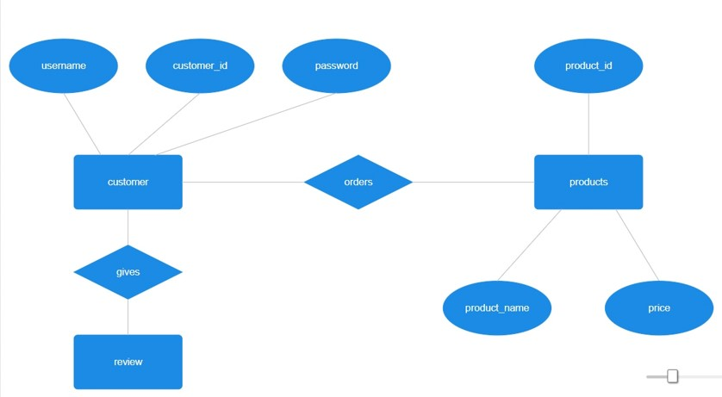

2. Data Flow Diagram (DFD)

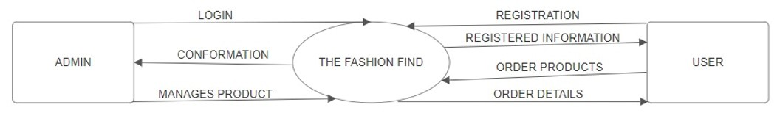

3. User Interface

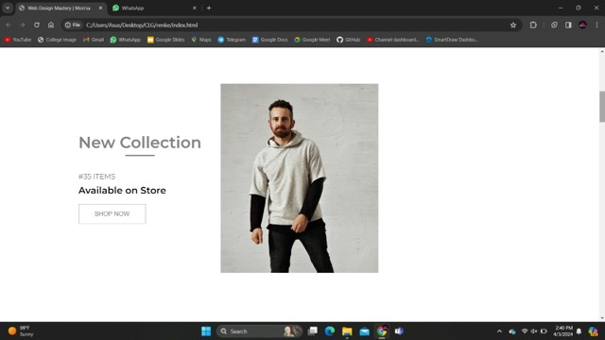

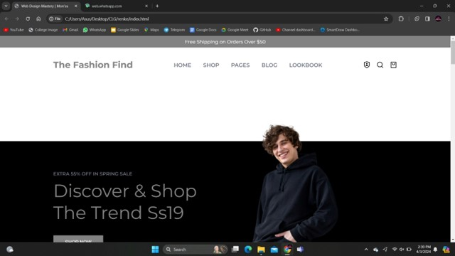

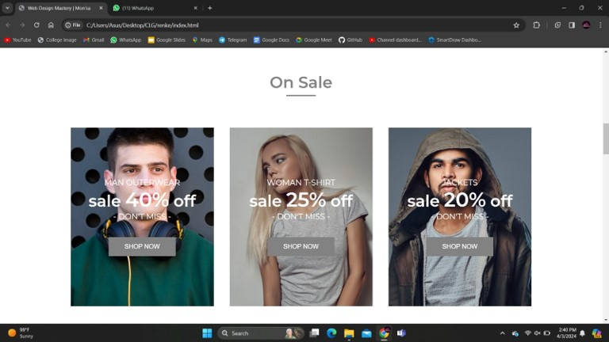

**Limitations**

1. SIZE ISSUES IF CUSTOMER DOSENT KNOW PERFECT SIZE.
2. DELIVERY API NOT ISSUED
3. PAYMENT OUTSIDE INDIA NEEDS TIME TO CONFIRM

**Future Enhancement**

* + MAKING WEBSITE WORLDWIDE SMOOTH AND FREELY
  + Complex product filtering and sorting.
  + Advanced product catalog management.

**Conclusion**

In general, today’s businesses must always strive to create the next best thing that consumers will want because consumers continue to desire their products, services etc. to continuously be better, faster, and cheaper.  In this world of new technology, businesses need to accommodate to the new types of consumer needs and trends because it will prove to be vital to their business’ success and survival.  E-commerce is continuously progressing and is becoming more and more important to businesses as technology continues to advance and is something that should be taken advantage of and implemented. From the inception of the Internet and e-commerce, the possibilities have become endless for both businesses and consumers.  Creating more opportunities for profit and advancements for businesses, while creating more options for consumers.  However, just like anything else, e-commerce has its disadvantages including consumer uncertainties, but nothing that can’t be resolved or avoided by good decision-making and business practices.

**Bibliography**

[**https://www.w3schools.com**](https://www.w3schools.com)

[**https://www.javatpoint.com**](https://www.javatpoint.com)

[**https://www.tutorialspoint.com**](https://www.tutorialspoint.com)

[**https://cdnjs.com/libraries/gsap**](https://cdnjs.com/libraries/gsap)

**Head First HTML & CSS**

**OEILLY**

**Annexure**

Sample HTML Code :-

<div id="nav">

<img src="C:\Users\Asus\Desktop\CLG\Project\assets\logo.png">

<h4>Home</h4>

<h4>Information</h4>

<h4>Products</h4>

<h4>About Us</h4>

<h4>Contact Us</h4>

</div>

Sample CSS Code :-

*

{

margin: 0;

padding: 0;

box-sizing:

border-box;

font-family: 'Gill Sans', 'Gill Sans MT', Calibri, 'Trebuchet MS', sans-serif;

color: #fff;

}

html, body

{

height: 100%;

width: 100%;

}