HCL GUVI × JAIN UNIVERSITY
BIG DATA ANALYTICS CAPSTONE PROJECT
Credit Card Fraud Detection
Big Data Analytics Pipeline on 1 Million Card Transactions
HDFS + Hive + Spark / PySpark + YARN + HBase / Pig
Group | Project | Team members (fill in)
2 | Credit Card Fraud Detection | Student 1: ____________ Student 2: ____________ Student 3: ____________  Student 4: ____________ Student 5: ____________

Read this first: what is real and what you must still run
DATASET: the 1,000,000-row dataset is synthetic (generated by data/generate_dataset.py, seed 42). Real card data is confidential, and the fraud patterns in it (night-time, card-not-present, high-value categories, velocity) were deliberately built into the generator, so the findings show how the pipeline works and are NOT claims about real-world fraud. If your trainer requires a real dataset, replace the CSV and re-run the same scripts.
EXECUTED: every number in Sections 10 to 13 was produced by running the supplied Hive-style SQL (via Spark SQL) and the PySpark pipeline on the full 1M rows in Spark local mode (2 cores). Timings are from that run.
NOT EXECUTED HERE: the HDFS, Hive, YARN, HBase and Pig commands are written and ready but need your Docker Compose environment. Run them and paste your own screenshots into the evidence placeholders; the trainer will ask you to demonstrate them live. The connector script spark/hdfs_connect.py (Section 9.1) was tested end to end against a local file system standing in for HDFS, not against real HDFS containers.

1. Project Title
Credit Card Fraud Detection: A Big Data Analytics Pipeline using HDFS, Hive, Spark / PySpark, YARN and optional HBase / Pig.

2. Business Problem
A card issuer processes millions of transactions across merchants, channels and cities every month. Only a small fraction (typically well under 1 percent) is fraudulent, yet each fraud costs the issuer chargeback losses, investigation effort and customer trust. Reviewing every transaction manually is impossible, and rule-only systems either miss new patterns or block too many genuine customers. The business needs to find where fraud concentrates and to rank transactions by risk so a limited fraud-operations team reviews the right ones first.

3. Business / Analytics Objective
Build a Big Data Analytics solution that stores transaction data in HDFS, organises it with Hive, processes and analyses it with Spark / PySpark, identifies suspicious patterns, and trains models that rank transactions by fraud risk, producing findings the fraud team can act on.

4. Key Analytics Questions
1. What percentage of transactions, and what value of money, is fraudulent?
2. Which merchant categories have the highest fraud rate?
3. How do channel (POS, contactless, ATM, online) and card presence relate to fraud?
4. Is fraud concentrated at particular hours of the day or months of the year?
5. How do transaction amount, distance from home, international use and transaction velocity relate to fraud?
6. Can a model rank transactions so that a small review queue catches a large share of fraud?
7. How would the workflow scale when the data grows from 1 million to 100 million transactions?

5. Dataset Description and Source
Item | Detail
Source | Synthetic dataset created by data/generate_dataset.py (numpy / pandas, seed 42), reproducible with the command in the README
Why synthetic | Real card data is confidential; public sets (e.g. the Kaggle ULB creditcard.csv) have anonymised PCA columns that make business questions hard to ask. Replace with a real dataset if your trainer requires it.
Volume | 1,000,000 transactions, 83,332 distinct cards, 5,000 merchants, 10 states, 12 months (Jan to Dec 2025)
File size | about 93 MB as CSV, 16 columns
Target column | is_fraud (1 = fraud, 0 = genuine); 5,290 frauds = 0.529% of transactions (highly imbalanced)
Fraud signals designed into the data | card-not-present online use, night hours, high-risk categories (gift cards, jewelry, electronics), amount well above the card's usual spend, long distance from home, international use, bursts of transactions in 24 hours or minutes

6. Data Dictionary
Column | Example | Type | Meaning
transaction_id | T10390367 | STRING | Unique transaction identifier
transaction_ts | 2025-01-01 00:04:43 | TIMESTAMP | Date and time of transaction
card_id | C166916 | STRING | Card identifier (one card has many transactions)
customer_age | 57 | INT | Age of cardholder
customer_state | DL | STRING | Cardholder's home state
merchant_id | M1293 | STRING | Merchant identifier
merchant_category | Utilities | STRING | Type of merchant (12 categories)
channel | Contactless | STRING | POS, Contactless, ATM or Online
amount | 321.64 | DOUBLE | Transaction amount in rupees
card_present | 1 | INT | 1 = physical card used, 0 = card-not-present
distance_from_home_km | 15.9 | DOUBLE | Distance between transaction location and cardholder's home
txn_count_24h | 2 | INT | Transactions on the card in the last 24 hours
minutes_since_last_txn | 606.2 | DOUBLE | Minutes since the card's previous transaction
is_international | 0 | INT | 1 = transaction outside home country
amount_vs_card_avg | 1.25 | DOUBLE | Amount divided by the card's usual average spend
is_fraud | 0 | INT | Label: 1 = fraud, 0 = genuine

Sample records (first 3 genuine rows and first 2 fraud rows of the shipped 4,000-row sample file):
transaction_id | category | channel | amount | dist_km | txn_24h | intl | is_fraud
T10390367 | Utilities | Contactless | 321.64 | 15.9 | 2 | 0 | 0
T10366596 | Fuel | Online | 1,173.76 | 60.5 | 4 | 0 | 0
T10542452 | Electronics | Contactless | 2,230.89 | 4.4 | 2 | 0 | 0
T10390719 | Entertainment | Online | 1,168.11 | 60.5 | 4 | 0 | 1
T10043935 | Electronics | Online | 4,263.01 | 171.3 | 3 | 0 | 1

7. Big Data Architecture
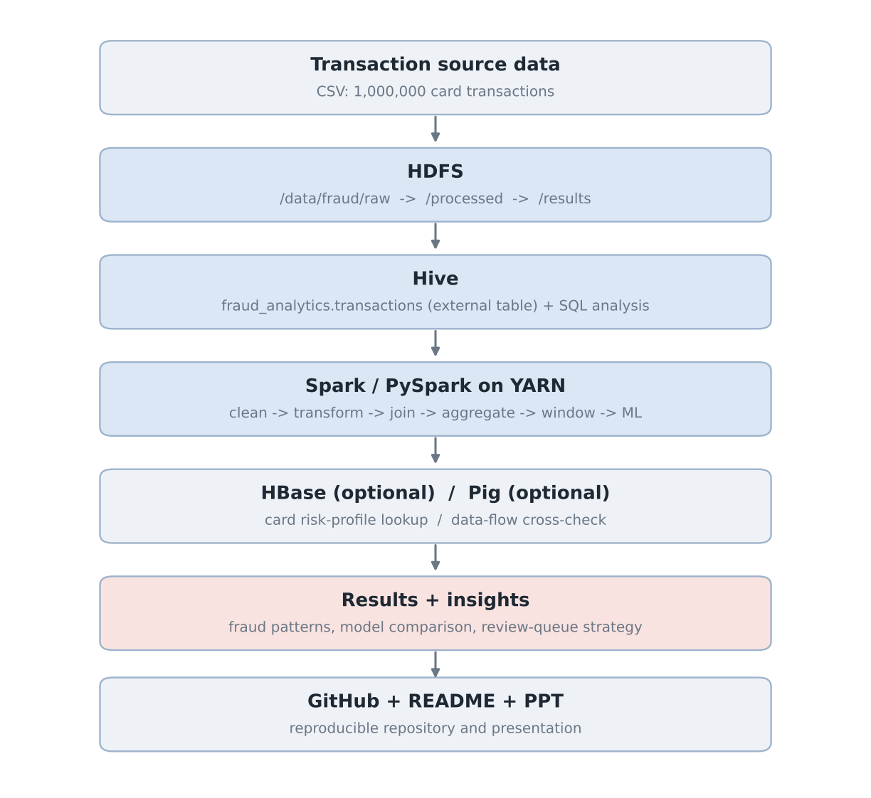
Figure 1. End-to-end architecture: source data to insights
Technology | Role in this project | Evidence to show
HDFS | Distributed storage for raw, processed and result data | hdfs dfs -ls / -du / fsck output, NameNode UI
NameNode / DataNode | NameNode holds file-to-block metadata; DataNodes store the blocks and replicas | NameNode UI at :9870, fsck block report
YARN | Allocates containers to Spark executors across the cluster | ResourceManager UI at :8088
Hive | SQL layer: external table over the HDFS CSV, 8 analytical queries | Beeline session: SHOW TABLES, query outputs
Spark / PySpark | Distributed cleaning, feature building, aggregation, window analytics, MLlib models | Notebook / spark-submit output, Spark UI
HBase (justified) | Millisecond lookup of one card's risk profile by card_id row key | create / put / get / scan output
Pig (optional) | Independent data-flow cross-check of channel fraud counts | Pig DUMP output
Jupyter, Docker Compose, Git/GitHub | Development interface, training environment, version control | Notebook, docker ps, repository

8. Why Big Data Technologies Are Required
Challenge | Single-machine approach | Big Data approach
Years of transactions for millions of cards | Limited by one disk and memory | HDFS spreads blocks across DataNodes and replicates them
Card-level and merchant-level aggregation | Long local runs, memory errors | Spark distributes the group-by across executors
Analysts who work in SQL | Ad-hoc local database or spreadsheets | Hive gives SQL over the same HDFS files
Fraud-model training on rare events | Slow on one core, hard to retrain often | Spark MLlib trains in parallel and can be re-run on new data
Data growing every day | Buy bigger hardware (scale up) | Add nodes (scale out), same code

Honest scale note
This classroom run uses 1,000,000 rows (93 MB) in Spark local mode, which a single machine can also handle. The value of the design is that the same scripts run unchanged against HDFS on a cluster with far more data (see Section 17 for the scaling discussion).

9. HDFS: Directory Structure, Ingestion Commands and Evidence
/data/fraud/
raw/
transactions.csv <- uploaded source file
processed/ <- cleaned / partitioned data (Spark output)
results/
category_summary/ channel_summary/ hour_summary/ month_summary/
state_summary/ amount_band_summary/ card_risk_profile/ daily_trend/

Key commands (full list in hdfs/hdfs_commands.txt):
hdfs dfs -mkdir -p /data/fraud/raw /data/fraud/processed /data/fraud/results
hdfs dfs -put /tmp/transactions.csv /data/fraud/raw/
hdfs dfs -ls -h /data/fraud/raw/
hdfs dfs -du -h /data/fraud/raw/
hdfs dfs -cat /data/fraud/raw/transactions.csv | head -5
hdfs fsck /data/fraud/raw/transactions.csv -files -blocks -locations

- What happens on upload: The client asks the NameNode where to write; the file is split into blocks (128 MB default, so this 93 MB file is one block); blocks are written to DataNodes and replicated (replication factor 3 by default, 1 in a single-DataNode training setup).
- NameNode vs DataNode: The NameNode stores only metadata (names, blocks, locations); DataNodes store the actual block data and send heartbeats to the NameNode.
Your evidence (paste screenshots)
[ Screenshot 1: hdfs dfs -ls -h /data/fraud/raw/ ] [ Screenshot 2: hdfs fsck block report ] [ Screenshot 3: NameNode UI file browser ]

9.1 Connecting from Docker with spark/hdfs_connect.py
One Python script performs the whole ingestion from inside the Docker network: it connects to the NameNode, creates the three HDFS folders, uploads the CSV, lists and measures the files, reads the data back, and can then run the full analysis against HDFS. Run it in a container that shares the compose network (for example spark-master), so the host name namenode resolves.
docker cp spark/. spark-master:/opt/fraud/
docker cp transactions.csv spark-master:/tmp/transactions.csv
docker exec -it spark-master spark-submit --master spark://spark-master:7077 \
/opt/fraud/hdfs_connect.py --local-csv /tmp/transactions.csv --run-analysis

# connection test only
docker exec -it spark-master spark-submit /opt/fraud/hdfs_connect.py --check-only

Flag | Default | Purpose
--hdfs-uri | hdfs://namenode:8020 | NameNode address (service name from the compose file)
--base | /data/fraud | Root HDFS folder (raw, processed, results)
--master | from spark-submit, else local[2] | yarn or spark://spark-master:7077
--local-csv | none | Local file to upload to <base>/raw/transactions.csv
--overwrite / --check-only / --run-analysis | off | Replace file / test connection only / run the analysis on HDFS data

What was tested
The script was run end to end on 150,000 generated rows against a local file system standing in for HDFS (same Hadoop client calls: connect, mkdirs, upload, list, read back, analysis, results written to the results folder, Parquet written to the processed folder). It has not been run against your NameNode. If a step fails, the usual causes are the wrong service name or port (check docker ps and the compose file) or running it outside the compose network.

10. Hive: Database, Table Design and Query Results
Hive provides the SQL layer. An external table is used so Hive stores only metadata; dropping the table does not delete the raw file in HDFS.
-- Raw external table: data stays in HDFS, Hive only stores metadata.
-- DROP TABLE will NOT delete /data/fraud/raw/transactions.csv
CREATE EXTERNAL TABLE IF NOT EXISTS transactions (
transaction_id STRING,
transaction_ts TIMESTAMP,
card_id STRING,
customer_age INT,
customer_state STRING,
merchant_id STRING,
merchant_category STRING,
channel STRING,
amount DOUBLE,
card_present INT,
distance_from_home_km DOUBLE,
txn_count_24h INT,
minutes_since_last_txn DOUBLE,
is_international INT,
amount_vs_card_avg DOUBLE,
is_fraud INT
)
ROW FORMAT DELIMITED
FIELDS TERMINATED BY ','
STORED AS TEXTFILE
LOCATION '/data/fraud/raw/'
TBLPROPERTIES ('skip.header.line.count'='1');

A partitioned ORC table (transactions_orc, partitioned by month) is included in hive/02_create_tables.sql as an optional performance extension.
How these results were produced
The eight queries in hive/03_analysis_queries.sql use only HiveQL-compatible syntax. For this document they were run against the full 1M-row CSV through Spark SQL (src: spark/run_sql_queries.py), because a Hive server was not available in the build environment. In your environment, run the same file in Beeline; the outputs should be identical, and any difference should be investigated.

Q1. Overall fraud level
Total transactions | Fraud transactions | Fraud rate | Fraud amount (Rs) | Average amount (Rs)
1,000,000 | 5,290 | 0.529% | 16,321,449 | 1,910.09

Q2. Fraud by merchant category
Category | Transactions | Fraud txns | Fraud rate | Fraud amount (Rs)
Gift Cards | 19,918 | 405 | 2.033% | 906,340
Jewelry | 19,863 | 372 | 1.873% | 1,644,688
Electronics | 60,052 | 827 | 1.377% | 4,442,367
Travel | 49,569 | 470 | 0.948% | 2,327,899
Online Services | 69,725 | 521 | 0.747% | 1,036,895
Entertainment | 80,311 | 434 | 0.540% | 928,022
Apparel | 90,227 | 436 | 0.483% | 895,519
Fuel | 120,275 | 486 | 0.404% | 1,014,496
Restaurant | 150,051 | 483 | 0.322% | 1,137,365
Grocery | 200,076 | 556 | 0.278% | 1,284,927
Healthcare | 59,998 | 141 | 0.235% | 356,983
Utilities | 79,935 | 159 | 0.199% | 345,947

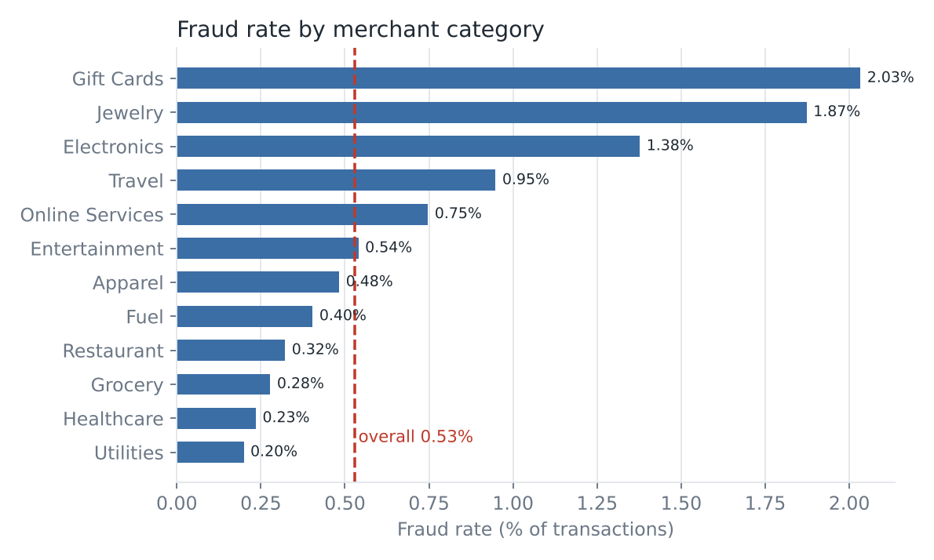
Figure 2. Fraud rate by merchant category (Hive Q2)
Gift Cards (2.03%), Jewelry (1.87%) and Electronics (1.38%) run at roughly 2.6 to 3.8 times the overall rate of 0.529%. Together they are only 10.0% of transactions but 30.3% of fraud transactions and 42.8% of fraud money.

Q3. Fraud by channel and card presence
Channel | Card present | Transactions | Fraud txns | Fraud rate
Online | 0 | 299,425 | 3,641 | 1.216%
ATM | 1 | 69,730 | 377 | 0.541%
Contactless | 1 | 250,349 | 519 | 0.207%
POS | 1 | 380,496 | 753 | 0.198%

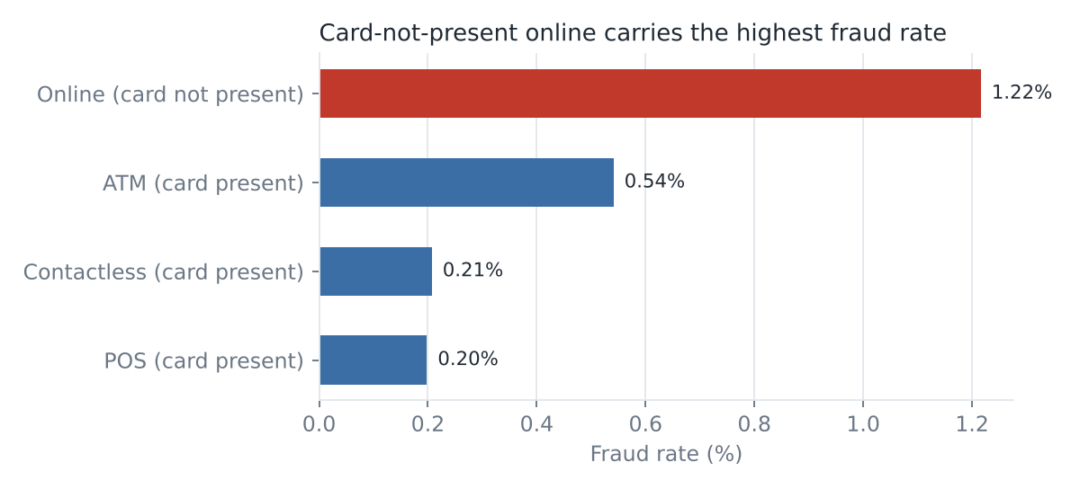
Figure 3. Fraud rate by channel (Hive Q3)
Online (card-not-present) transactions are 29.9% of volume but 68.8% of all fraud, at 1.22%; this is about six times the rate for POS (0.20%).

Q4. Fraud by hour of day
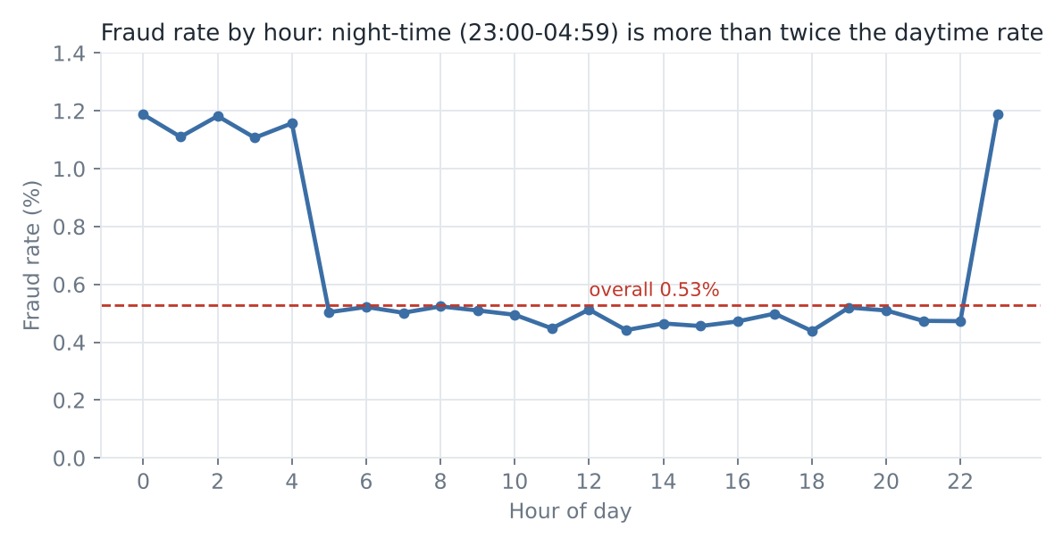
Figure 4. Fraud rate by hour of day (Hive Q4)
Transactions between 23:00 and 04:59 account for only 6.5% of volume but have a fraud rate of 1.16%, versus 0.49% for the rest of the day (2.4 times higher).

Q5. Fraud by amount band
Amount band (Rs) | Transactions | Fraud txns | Fraud rate
<500 | 298,155 | 1,107 | 0.371%
500-1999 | 466,522 | 2,264 | 0.485%
2000-4999 | 155,686 | 1,168 | 0.750%
5000-9999 | 42,296 | 375 | 0.887%
10000+ | 37,341 | 376 | 1.007%

The fraud rate rises steadily with amount, from 0.37% under Rs 500 to 1.01% at Rs 10,000 and above.

Q6. Monthly trend
Month | Transactions | Fraud txns | Fraud rate
1 | 84,884 | 426 | 0.502%
2 | 76,817 | 408 | 0.531%
3 | 85,046 | 443 | 0.521%
4 | 82,232 | 429 | 0.522%
5 | 85,108 | 447 | 0.525%
6 | 82,025 | 444 | 0.541%
7 | 85,059 | 455 | 0.535%
8 | 84,776 | 475 | 0.560%
9 | 82,394 | 441 | 0.535%
10 | 84,905 | 443 | 0.522%
11 | 81,678 | 434 | 0.531%
12 | 85,076 | 445 | 0.523%

The monthly rate is stable (between 0.50% and 0.56%). No seasonality exists in this synthetic data, so no monthly pattern should be claimed.

Q7. International and velocity signals
International | Velocity | Transactions | Fraud txns | Fraud rate
1 | HIGH_VELOCITY | 2,686 | 199 | 7.409%
1 | NORMAL | 31,798 | 761 | 2.393%
0 | HIGH_VELOCITY | 76,034 | 949 | 1.248%
0 | NORMAL | 889,482 | 3,381 | 0.380%

International transactions with 5 or more transactions in 24 hours show a 7.4% fraud rate, about 19 times the 0.38% of domestic, normal-velocity transactions.

Q8. Highest fraud-rate merchants (minimum 150 transactions)
Merchant | Transactions | Fraud txns | Fraud rate
M4049 | 208 | 7 | 3.365%
M1767 | 205 | 6 | 2.927%
M1243 | 182 | 5 | 2.747%
M3633 | 184 | 5 | 2.717%
M3318 | 186 | 5 | 2.688%
M2856 | 186 | 5 | 2.688%
M4248 | 224 | 6 | 2.679%
M1316 | 191 | 5 | 2.618%
M4819 | 191 | 5 | 2.618%
M4172 | 193 | 5 | 2.591%

Do not over-read Q8
Merchant IDs are assigned randomly in this synthetic data, so these top merchants (5 to 7 frauds out of about 200 transactions) are small-sample variation, not risky merchants. On real data, a merchant list like this is a useful watch-list only after checking that the counts are large enough to be statistically meaningful.

Your evidence (paste screenshots)
[ Screenshot 4: SHOW DATABASES / DESCRIBE FORMATTED transactions in Beeline ] [ Screenshot 5: Q1-Q3 outputs in Beeline ]

11. Spark / PySpark: Processing, Cleaning and Distributed Analytics
Spark reads the CSV from HDFS, runs quality checks, derives features, aggregates in parallel, runs window analytics and writes results back to HDFS. The full script is spark/fraud_analysis.py.
spark = SparkSession.builder.appName("CreditCardFraudAnalytics").getOrCreate()
df = (spark.read.option("header", True).option("inferSchema", True)
.csv("hdfs://namenode:8020/data/fraud/raw/transactions.csv"))
df.printSchema(); print("Records:", df.count())

11.1 Data quality checks (executed result)
Check | Result
Records read | 1,000,000
Null values in any of 16 columns | 0
Amount <= 0 | 0
is_fraud not in (0,1) | 0
Duplicate transaction_id | 0

The synthetic data is clean by construction. Real data would show nulls, duplicates and invalid values here, and the cleaning step (drop / impute / dedupe) would be documented.

11.2 Transformations
df2 = (df.withColumn("transaction_ts", F.to_timestamp("transaction_ts"))
.withColumn("txn_hour", F.hour("transaction_ts"))
.withColumn("txn_month", F.month("transaction_ts"))
.withColumn("is_night", F.when((F.col("txn_hour") <= 4) | (F.col("txn_hour") == 23), 1).otherwise(0))
.withColumn("high_velocity", F.when(F.col("txn_count_24h") >= 5, 1).otherwise(0))
.withColumn("rapid_repeat", F.when(F.col("minutes_since_last_txn") < 5, 1).otherwise(0))
.withColumn("log_amount", F.log1p("amount"))
.withColumn("amount_band", F.when(F.col("amount") < 500, "1. <500") ... ))
df2 = df2.repartition(8, "txn_month").cache() # reused by every later aggregation

11.3 Distributed aggregations
summary = (df2.groupBy("merchant_category")
.agg(F.count("*").alias("txns"), F.sum("is_fraud").alias("fraud_txns"),
F.round(F.avg("is_fraud") * 100, 3).alias("fraud_pct"))
.orderBy(F.desc("fraud_pct")))
summary.coalesce(1).write.mode("overwrite").option("header", True).csv("hdfs://namenode:8020/data/fraud/results/category_summary")

Eleven result tables are written (category, channel, hour, state, month, amount band, age group, region, card risk profile, channel-category ranking, daily trend). The Spark channel and hour totals were checked against Hive in Section 16.

11.4 Window functions and join
# Top 3 riskiest categories inside each channel
w = Window.partitionBy("channel").orderBy(F.desc("fraud_pct"))
ranked = cc.withColumn("rank_in_channel", F.row_number().over(w)).filter("rank_in_channel <= 3")

# 7-day moving average of daily fraud count
w7 = Window.orderBy(F.col("txn_date").cast("timestamp").cast("long")).rangeBetween(-6*86400, 0)
trend = daily.withColumn("fraud_7d_avg", F.round(F.avg("fraud_txns").over(w7), 2))

# Broadcast join with a small state-to-region lookup
df2.join(F.broadcast(region), "customer_state", "left").groupBy("region")...

Top 3 riskiest categories per channel (executed output):
Channel | Rank | Category | Transactions | Fraud rate
ATM | 1 | Jewelry | 1,355 | 2.288%
ATM | 2 | Gift Cards | 1,389 | 2.160%
ATM | 3 | Electronics | 4,110 | 1.655%
Contactless | 1 | Gift Cards | 5,098 | 1.020%
Contactless | 2 | Jewelry | 4,926 | 0.853%
Contactless | 3 | Electronics | 15,137 | 0.515%
Online | 1 | Gift Cards | 6,008 | 4.511%
Online | 2 | Jewelry | 6,027 | 4.148%
Online | 3 | Electronics | 18,045 | 3.048%
POS | 1 | Gift Cards | 7,423 | 0.701%
POS | 2 | Jewelry | 7,555 | 0.649%
POS | 3 | Electronics | 22,760 | 0.576%

Fraud rate by region (broadcast-join output):
Region | Transactions | Fraud txns | Fraud rate
North | 200,098 | 1,071 | 0.535%
West | 299,906 | 1,598 | 0.533%
South | 400,129 | 2,129 | 0.532%
East | 99,867 | 492 | 0.493%

Regional and state differences are small, as expected, because state does not influence fraud in the generator.

11.5 Card-level risk profile
Aggregating per card across 83,332 cards gives a risk flag (HIGH = 2 or more frauds, MEDIUM = 1, LOW = 0): 161 HIGH, 4,959 MEDIUM and 78,212 LOW cards. This table is what the HBase lookup (Section 14) stores. Because it uses fraud labels from the whole period, it is a historical profile, not a model feature (using it for training would leak the label).

11.6 Spark optimisations used
Technique | Where used | Why
cache() | df2 after transformation | Reused by 11+ aggregations and the ML split; avoids re-reading and re-parsing the CSV
repartition(8, txn_month) | before aggregation | Controls parallelism and groups data by month
coalesce(1) | writing small summary tables | One output file per small table
broadcast join | state-to-region lookup | Small table is copied to every executor, avoiding a shuffle
Parquet partitionBy(txn_month) | processed data output | Columnar, compressed, month-prunable storage

Your evidence (paste screenshots)
[ Screenshot 6: notebook / spark-submit output ] [ Screenshot 7: Spark Master or Application UI ] [ Screenshot 8: YARN ResourceManager application ] [ Screenshot 9: hdfs dfs -ls -R /data/fraud/results ]

12. Fraud Risk Modelling with Spark MLlib
The goal is not to label every transaction but to rank them so a small review queue catches as much fraud as possible. The data is split by time to avoid using the future to predict the past: training on January to September (748,341 rows, 0.53% fraud) and testing on October to December (251,659 rows, 0.525% fraud).
- Why not accuracy: A model that always predicts 'genuine' is 99.47% accurate and catches no fraud, so accuracy is not used. Models are judged by AUC-ROC, AUC-PR and by recall and lift when only the highest-risk 1% or 5% of transactions are reviewed.
- Class imbalance: Fraud is rare, so each training fraud row is weighted 188 times a genuine one (weightCol), instead of discarding genuine data.
- Features: 11 numeric features (log amount, card present, distance, 24h count, minutes since last, international, amount vs card average, night flag, rapid repeat, high velocity, age) plus one-hot merchant category and channel, assembled with VectorAssembler inside a Spark ML Pipeline.
Model | AUC-ROC | AUC-PR | Recall @ top 1% | Precision @ top 1% | Lift @ top 1% | Recall @ top 5%
Logistic Regression | 0.861 | 0.078 | 23.6% | 12.0% | 22.8x | 48.4%
Random Forest | 0.841 | 0.056 | 18.2% | 9.2% | 17.6x | 43.4%
Gradient Boosted Trees | 0.855 | 0.070 | 21.3% | 10.9% | 20.7x | 45.7%

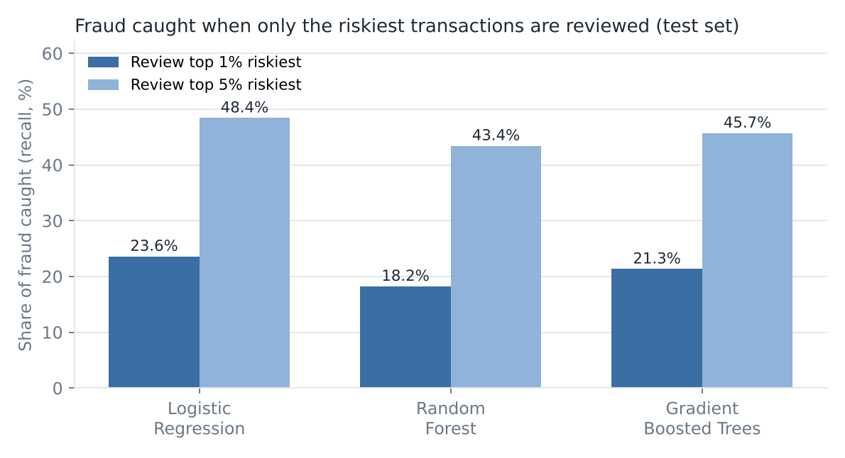
Figure 5. Share of fraud caught when only the riskiest transactions are reviewed
Logistic Regression performed best on this data (AUC-ROC 0.861). Reviewing only the top 1% highest-risk test transactions (2,602 transactions) catches 312 of 1,322 frauds (23.6%), and the hit rate in that queue is 11.99% versus a base rate of 0.525%, a lift of 22.8x. Reviewing 5% catches 48.41% of fraud and 54.57% of fraud value.
Reading the model results honestly
AUC-PR looks small (0.078) because the base rate is only 0.525%; it is about 15 times better than random. The labels in the synthetic data contain deliberate random noise, which caps achievable accuracy, and a simple linear model matches the way the data was generated. On real data, expect a different ranking of models; always compare several. Most flagged transactions in a 1% queue are still genuine (about 88%), so the queue should drive review or step-up authentication, not automatic blocking.

Most influential features
Rank | Feature (Gradient Boosted Trees) | Importance
1 | amount_vs_card_avg | 0.124
2 | distance_from_home_km | 0.097
3 | txn_count_24h | 0.089
4 | merchant_category=Gift Cards | 0.077
5 | log_amount | 0.073
6 | channel=Contactless | 0.072
7 | merchant_category=Electronics | 0.063
8 | channel=POS | 0.058

Amount relative to the card's usual spend, distance from home, transaction velocity and category (gift cards, electronics) dominate. These agree with the SQL findings in Section 10. Feature importance describes what the model uses, not a cause of fraud.

13. How Hive and Spark Work Together
Component | Responsibility in this project | Example
HDFS | Stores the raw CSV and the output | /data/fraud/raw/transactions.csv
Hive | Table definition and SQL exploration for analysts | Q1 to Q8 fraud summaries
Spark / PySpark | Cleaning, derived features, joins, window functions, ML | Risk models, card profiles, 7-day trend
YARN | Gives Spark executors CPU and memory on the cluster | spark-submit --master yarn

Viva-ready explanation
Hive and Spark are not two names for the same thing. Hive gives a SQL-oriented table layer over the files in HDFS and is ideal for aggregate questions asked in SQL. Spark is used when the work goes beyond SQL: derived features, window analytics, joins with other datasets and machine-learning model training, all kept in one distributed workflow.

14. HBase and Pig

14.1 HBase: card risk-profile lookup
Fraud screening often needs one card's history in milliseconds while a payment is in flight. HDFS and Hive scan large files; HBase is a NoSQL store keyed for fast single-row reads. The Spark card_risk_profile output is loaded into an HBase table with card_id as the row key.
create 'card_risk', 'profile'
put 'card_risk', 'C100123', 'profile:fraud_txns', '2'
put 'card_risk', 'C100123', 'profile:risk_flag', 'HIGH'
get 'card_risk', 'C100123'
scan 'card_risk', {LIMIT => 5}

Row key = card_id; column family = profile (txns, fraud_txns, avg_amount, max_txn_24h, risk_flag). Full commands: hbase/hbase_commands.txt.

14.2 Pig: data-flow cross-check
The Pig script (pig/fraud_analysis.pig) loads the same CSV, groups by channel and counts fraud transactions and fraud amount. Its output must match Hive Q3 and the Spark channel_summary, giving a third independent check of the numbers. Pig is optional: it adds no new capability here, so its main value is validation.
Your evidence (paste screenshots)
[ Screenshot 10: HBase get / scan output ] [ Screenshot 11: Pig DUMP output matching Q3 ]

15. End-to-End Execution Flow
1. Generate or obtain the dataset (data/generate_dataset.py)
2. Upload raw CSV to /data/fraud/raw in HDFS and verify
3. Create Hive database and external table
4. Run Hive Q1 to Q8 for initial analysis
5. Read the HDFS data in PySpark and run quality checks
6. Transform and cache the DataFrame
7. Run distributed aggregations, window functions and the broadcast join
8. Write result tables (CSV) and processed data (Parquet) back to HDFS
9. Train and evaluate Logistic Regression, Random Forest and Gradient Boosted Trees on a time-based split
10. Load the card risk profile into HBase; run the Pig cross-check
11. Validate that Hive, Spark and Pig totals agree
12. Document, push to GitHub, prepare the 10-minute PPT

16. Final Results, Insights and Recommended Actions
KPI | Value | Interpretation
Transactions analysed | 1,000,000 | 12 months of card activity
Fraud transactions | 5,290 | 0.529% of transactions
Fraud value | Rs 16,321,449 | Average fraud amount Rs 3,085 versus Rs 1,910 for all transactions
Riskiest category | Gift Cards (2.03%) | 3.8x the overall rate
Riskiest channel | Online, card not present (1.22%) | 2.3x overall; about 6x POS
Riskiest period | 23:00 to 04:59 | 2.4x the fraud rate of other hours
Riskiest combination | International + 5 or more txns in 24h (7.41%) | About 14x the 0.53% overall rate
Best model | Logistic Regression, AUC-ROC 0.861 | Top 1% review catches 23.6% of fraud at 22.8x lift

Finding | Possible business action
Gift cards, jewelry and electronics carry 2.6x to 3.8x average fraud | Step-up authentication or lower limits on first-time high-value purchases in these categories
Card-not-present online is the largest fraud channel | Mandatory 3-D Secure / OTP for risky online purchases
Night-time transactions are over twice as risky | Raise risk score for 23:00 to 04:59 and alert the customer in-app
International plus rapid-fire transactions show the highest rates | Velocity rules that temporarily hold the card and trigger customer confirmation
A 1% review queue catches about a quarter of fraud | Use the model score to prioritise analysts' queues; combine with rules; do not auto-block on the score alone

Validation and Testing
Every cross-check below was computed by the build script and the document would not have been produced if any had failed:
Check | Value A | Value B | Result
Spark record count equals Hive total_txns | 1,000,000 | 1,000,000 | PASS
Hive Q2: sum of category txns equals total | 1,000,000 | 1,000,000 | PASS
Hive Q2: sum of category fraud equals total fraud | 5,290 | 5,290 | PASS
Spark channel_summary fraud sum equals Hive total fraud | 5,290 | 5,290 | PASS
Spark hour_summary txns sum equals total | 1,000,000 | 1,000,000 | PASS
Hive Q3 vs Spark channel fraud counts match per channel | match | match | PASS
Hive Q6 monthly txns sum equals total | 1,000,000 | 1,000,000 | PASS
Train + test rows equal total | 1,000,000 | 1,000,000 | PASS

Still to do in your environment: confirm Beeline Q1 to Q8 outputs equal Section 10, and that Pig and HBase outputs agree.

17. Performance Observations and Scaling
Stage (Spark local mode, 2 cores, 4 GB driver) | Seconds
Read CSV + count | 7.6
Data quality checks | 7.4
Transform + repartition + cache | 7.8
11 aggregations + window + join + writes | 14.1
Partitioned Parquet write | 5.4
Train Logistic Regression | 17.1
Train Random Forest (60 trees) | 55.2
Train GBT (40 iterations) | 60.1
Evaluate 3 models | 43.8
Total | 218.5

- From 1M to 100M rows: Moving from 1M to 100M rows is 100x the data. In local mode this would not fit in memory. On a cluster, HDFS blocks (128 MB each) become hundreds of input partitions, and adding worker nodes increases parallelism.
- Changes needed: Convert CSV to partitioned Parquet/ORC (done in this project for Parquet), tune spark.sql.shuffle.partitions, avoid skewed keys, broadcast small lookups, and train on a sample or use distributed training for tree models.
- Not covered: This pipeline is batch. Real-time authorisation scoring would additionally need a streaming layer (e.g. Spark Structured Streaming or Kafka) and the HBase profile lookup, which is outside this capstone.

18. GitHub Repository and README
credit-card-fraud-bigdata/
|-- data/
| |-- generate_dataset.py
| |-- sample/transactions_sample_4000.csv
|-- hdfs/hdfs_commands.txt
|-- hive/01_create_database.sql 02_create_tables.sql 03_analysis_queries.sql
|-- spark/hdfs_connect.py fraud_analysis.py run_sql_queries.py make_charts.py
|-- hbase/hbase_commands.txt
|-- pig/fraud_analysis.pig
|-- results/ (hive/*.csv, spark_out/*, pipeline_metrics.json)
|-- screenshots/ (figs/ + your evidence)
|-- docs/build_report.py
|-- README.md

Suggested meaningful commits: (1) project structure and data generator, (2) HDFS commands, (3) Hive DDL and queries, (4) PySpark cleaning and aggregations, (5) ML models, (6) HBase / Pig, (7) results and validation, (8) README and final report. The README explains setup, how to regenerate the data, how to run each stage and what outputs to expect.

19. Individual Contributions
Student | Name | Primary responsibility | Evidence | Must be able to explain
1 |  | Data ingestion + HDFS | hdfs_commands.txt, fsck, NameNode UI | NameNode, DataNode, blocks, replication, commands
2 |  | Hive + data modelling | 02_create_tables.sql, 03_analysis_queries.sql, Q1-Q8 | External table, schema, each query's business question
3 |  | Spark + PySpark | fraud_analysis.py, notebook, Spark UI | Transformations, cache, window functions, ML pipeline
4 |  | HBase / Pig | hbase_commands.txt, fraud_analysis.pig | Row key design, why HBase for lookups, Pig cross-check
5 |  | Integration + documentation | README, report, validation table, PPT | End-to-end flow, how totals were validated

20. Challenges and Solutions
Challenge | Solution
Only 0.53% of transactions are fraud; accuracy is misleading | Used class weights, time-based split and ranking metrics (AUC-PR, recall and lift at top 1% / 5%)
Leakage risk: random split would let the model see the future | Split by month: train Jan to Sep, test Oct to Dec
Card-level fraud history could leak the label into features | Kept the card risk profile for HBase lookups only, not for training
Same DataFrame was reused many times (slow re-parsing of CSV) | cache() after transformation and repartition by month
Bug while building the pipeline: a Python list alias made feature names include categorical names in the coefficient list | Copied the list (list(num_cols)); output re-run and verified
PySpark failed to install with the system setuptools | Created a virtual environment with an upgraded setuptools and installed pyspark there
Hive server not available in the build environment | Wrote HiveQL-compatible SQL, ran the same statements via Spark SQL, and flagged that Beeline output must be re-checked
Hard-coded local master meant --master yarn was silently ignored; metrics were written with a local open() on an hdfs:// path; processed path contained '..' | Master now chosen by the launcher or SPARK_MASTER; metrics saved through Spark; processed path derived cleanly (found while writing hdfs_connect.py)
Reaching HDFS from outside the Docker network fails (DataNode host names do not resolve) | Run the connector inside a container on the compose network

21. Limitations
- The dataset is synthetic; findings demonstrate the method and are not evidence about real fraud.
- Fraud patterns (night, online, categories) were built into the generator, so the SQL findings are expected rather than discovered.
- AUC-PR is modest because labels contain random noise; a real model would need richer features such as merchant history and device data.
- Spark ran in local mode on 2 cores; no cluster speed-up was measured.
- HDFS, Hive, YARN, HBase and Pig steps are specified but not executed in this build.

22. Final Conclusion
The project delivers an end-to-end Big Data pipeline for credit-card fraud analytics. Raw transactions are stored in HDFS, described in Hive, and processed with Spark. Across 1,000,000 transactions the analysis shows fraud concentrated in card-not-present online use, night hours, gift-card / jewelry / electronics purchases, large amounts and international bursts of activity. A Logistic Regression risk score ranked on a held-out three-month period lets a 1% review queue catch 23.6% of fraud, 22.8 times better than random review. Results are cross-validated between Hive, Spark and Pig, and the design scales from a classroom run to a cluster by changing the data size and resources, not the code.

23. Questions You Should Be Ready For (with answers)
Q. Why Big Data technology for this problem? Card transactions grow continuously and fraud analysis needs repeated group-bys over all history, plus model retraining. HDFS and Spark scale out; one machine does not.
Q. Why HDFS? It stores large files in replicated blocks across nodes, so storage grows by adding DataNodes and data survives a node failure.
Q. Role of NameNode and DataNode? NameNode keeps metadata (file to block mapping); DataNodes store the blocks and report to the NameNode by heartbeat.
Q. Role of YARN? It is the resource manager: it gives Spark applications containers with CPU and memory on cluster nodes.
Q. Why an external Hive table? Hive manages only metadata; the CSV stays in HDFS and dropping the table does not delete the data.
Q. Hive vs Spark here? Hive: SQL exploration of the table. Spark: feature engineering, windows, joins, ML, all in one distributed workflow.
Q. What happens when a Spark job runs? The driver builds a plan from transformations; an action triggers a job split into stages and tasks; executors run tasks on partitions; shuffles occur for groupBy and joins.
Q. Why did you cache the DataFrame? It is reused by many aggregations and the ML split; caching avoids repeating the CSV read and parse.
Q. Why not use accuracy? 99.47% of transactions are genuine, so predicting 'genuine' always gives 99.47% accuracy and catches nothing.
Q. Why a time-based split? Fraud patterns drift. Training on the past and testing on the future mimics real deployment and avoids leakage.
Q. Why HBase? Single-card risk lookup by key in milliseconds, which Hive and HDFS scans are not designed for.
Q. What would change at 100 million rows? Use Parquet/ORC partitioning, more executors, tuned shuffle partitions, and a streaming layer for real-time scoring.
Q. What is the weakness of your results? Synthetic data with built-in patterns; modest AUC-PR; local-mode run; HDFS/Hive/HBase evidence must be added from the cluster.

24. Minimum Technical Requirements Check
The student guide lists what every project must contain. Status shows what exists in this repository today and what you still have to produce in your own environment.
Requirement (Student Guide section 5) | Where | Status
Clear business problem and analytics objective | Sections 2 to 4 | Done
Dataset description, source and important columns | Sections 5, 6; data/README.md | Done (synthetic data, stated clearly)
Dataset stored and managed through HDFS | Section 9, 9.1; hdfs/, spark/hdfs_connect.py | Scripts ready; you run them in Docker
Relevant HDFS commands demonstrated | Section 9; hdfs/hdfs_commands.txt | Ready; add screenshots
At least one Hive database/table and queries | Section 10; hive/ | Written; results produced with Spark SQL; run in Beeline and compare
At least one Spark / PySpark workflow | Sections 11, 12 | Executed on 1M rows (local mode)
Data cleaning, transformation and analytical results | Sections 11, 16 | Executed
Evidence of distributed processing | Section 17 | Partly: local mode only; add Spark UI and YARN screenshots from the cluster run
HBase or Pig evidence | Section 14; hbase/, pig/ | Scripts ready; run and add screenshots
Git/GitHub repository with meaningful commits | Section 18 | Repository prepared with 10 commits; you push it; teammates commit their own folders
README with setup, architecture, execution and results | README.md | Done
Final PPT and individual contribution sheet | Capstone deck (.pptx); Appendix A | Deck built; contribution sheet to fill in

25. 100-Mark Evaluation Map
Area | Marks | Where covered in this document | Your action
Business problem and objective | 10 | Sections 2 to 4 | Review and own it
Big Data architecture | 10 | Sections 7, 8, 15 | Redraw diagram in PPT
HDFS / data ingestion | 15 | Section 9 | Run commands, paste screenshots
Hive / data processing | 15 | Section 10 | Run in Beeline, paste screenshots
Spark / PySpark analytics | 15 | Sections 11, 12, 17 | Run on cluster, show Spark UI
Advanced technology / integration | 10 | Section 14, 15 | Run HBase / Pig
Git/GitHub and reproducibility | 5 | Section 18 | Push with meaningful commits
Documentation / README | 5 | Section 18 + README.md | Add your own run notes
Final demo / presentation | 5 | Section 16 (story) | Build 10-minute PPT
Individual contribution | 10 | Section 19, 23 | Each student explains own part

26. Final Submission Checklist
Item | Status
Problem statement | [ ]
Dataset description | [ ]
Architecture | [ ]
HDFS ingestion + screenshots | [ ]
Hive database, tables, queries + screenshots | [ ]
Spark / PySpark notebook run + Spark UI screenshot | [ ]
Transformations and analytics | [ ]
HBase / Pig evidence | [ ]
Final results validated | [ ]
GitHub repository | [ ]
README | [ ]
PPT | [ ]
Individual contribution sheet | [ ]

Appendix A. Individual Contribution Sheet
Each student completes one block. The trainer may ask any student to open the code or commands listed here and explain them.
Student 1: Data ingestion + HDFS
Name / roll number
What I implemented
Files and commits (links) | hdfs/, data/, spark/hdfs_connect.py | commits:
Commands / code I can demonstrate
Technical problem I faced and how I solved it
Questions I can answer

Student 2: Hive + data modelling
Name / roll number
What I implemented
Files and commits (links) | hive/ | commits:
Commands / code I can demonstrate
Technical problem I faced and how I solved it
Questions I can answer

Student 3: Spark + PySpark
Name / roll number
What I implemented
Files and commits (links) | spark/fraud_analysis.py, notebook | commits:
Commands / code I can demonstrate
Technical problem I faced and how I solved it
Questions I can answer

Student 4: HBase / Pig (advanced technology)
Name / roll number
What I implemented
Files and commits (links) | hbase/, pig/ | commits:
Commands / code I can demonstrate
Technical problem I faced and how I solved it
Questions I can answer

Student 5: Integration + documentation
Name / roll number
What I implemented
Files and commits (links) | README.md, docs/, results/ | commits:
Commands / code I can demonstrate
Technical problem I faced and how I solved it
Questions I can answer

