Week 1: Data Acquisition, Cleaning, and Exploratory Analysis
Virtual Data Science with Python Apprentice Intern
Dataset: UCI Car Evaluation Dataset | 1,728 records | 6 input features + 1 target

1. Introduction
The objective of this Week 1 task was to simulate a practical data-science data-preparation workflow. The project uses the Car Evaluation dataset from the UCI Machine Learning Repository. The dataset contains 1,728 observations and six categorical input attributes: buying price, maintenance price, number of doors, passenger capacity, luggage-boot size, and estimated safety. The target variable represents car acceptability with four classes: unacceptable (unacc), acceptable (acc), good (good), and very good (vgood).

2. Data Acquisition
The dataset was selected because it is publicly available, compact, easy to interpret, and suitable for classification-oriented exploratory analysis. It was obtained from the UCI Machine Learning Repository using the ucimlrepo Python package. The official UCI page reports 1,728 instances, six categorical features, one categorical target, and no missing values.
Source: UCI Machine Learning Repository — Car Evaluation (Dataset ID 19).

3. Dataset Description
Column | Type | Meaning | Values
buying | Categorical | Buying price | vhigh, high, med, low
maint | Categorical | Maintenance price | vhigh, high, med, low
doors | Categorical | Number of doors | 2, 3, 4, 5more
persons | Categorical | Passenger capacity | 2, 4, more
lug_boot | Categorical | Luggage boot size | small, med, big
safety | Categorical | Estimated safety | low, med, high
class | Categorical | Car acceptability | unacc, acc, good, vgood

4. Data Cleaning and Preprocessing
The cleaning process focused on three required checks: missing values, duplicate records, and data types. Because the UCI documentation states that the dataset contains no missing values, imputation was not required. This is an important preprocessing decision: replacing values unnecessarily could introduce artificial information.
Duplicate rows were checked using pandas duplicated(). The records represent the combinations used by the original decision model, so the analysis keeps the unique observations after the duplicate check. All seven columns are categorical variables; they were explicitly converted to pandas category dtype to make their semantic nature clear and reduce unnecessary memory use.
Cleaning decisions: (1) check nulls, (2) remove exact duplicate rows if any are encountered, and (3) convert categorical fields to categorical dtype. No numerical imputation or scaling was applied because the variables are categorical.

5. Exploratory Data Analysis
The exploratory analysis examined the target distribution, the distribution of an important input feature, and the completeness of the dataset. Since the variables are categorical, bar charts are more appropriate than histograms for the initial analysis.
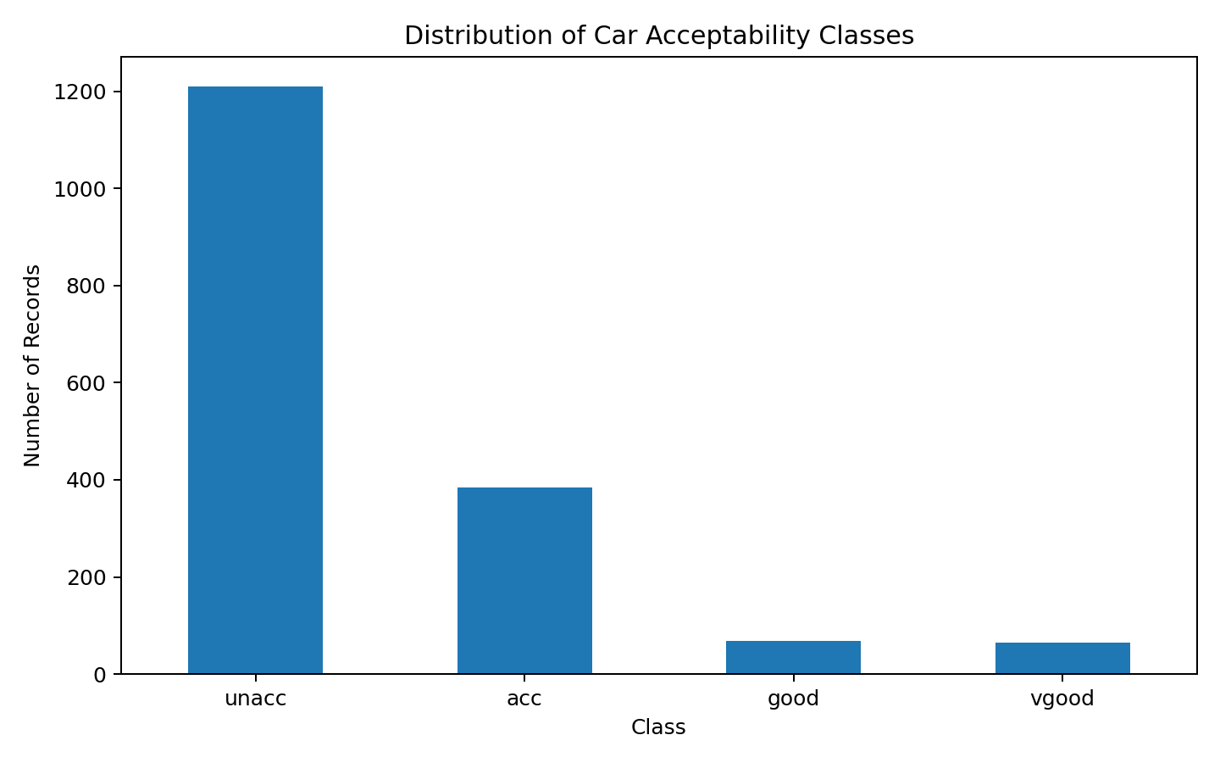
Figure 1. Distribution of car acceptability classes.
The target is strongly imbalanced. The unacceptable category contains 1,210 records, while acceptable contains 384, good contains 69, and very good contains 65. Therefore, future machine-learning evaluation should not rely only on accuracy; class-specific metrics will also be useful.
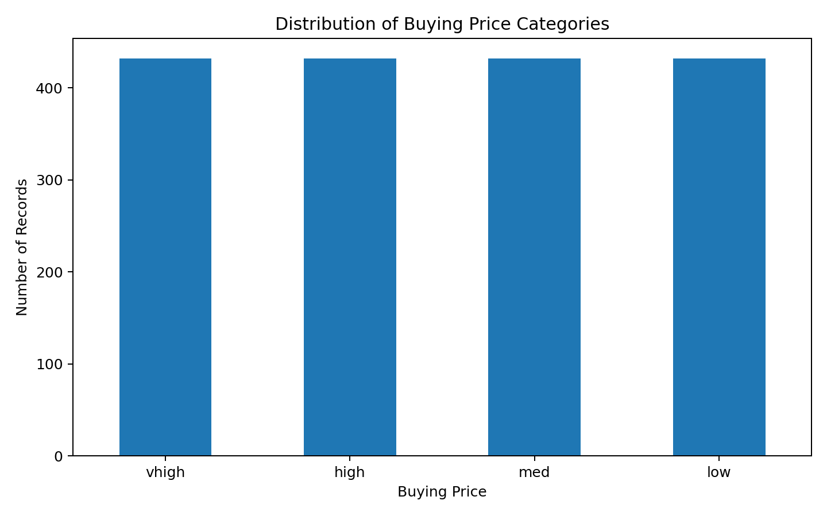
Figure 2. Distribution of buying-price categories.
The buying-price categories are evenly represented, with 432 observations in each category. This balanced representation is useful because it prevents one buying-price group from dominating simple frequency-based comparisons.
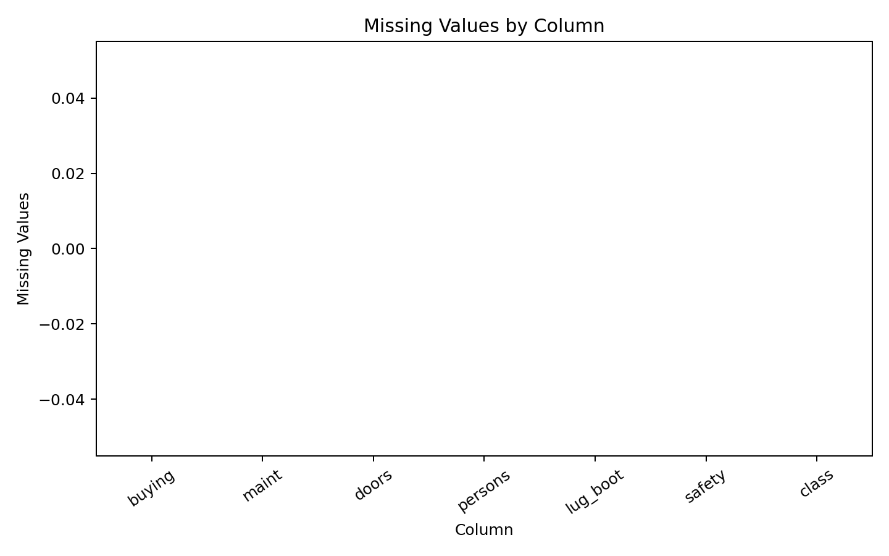
Figure 3. Missing values by column.
The missing-value check shows zero missing observations in every field. Consequently, no rows needed to be discarded for missingness and no imputation strategy was required.

6. Key Insights
- The dataset contains 1,728 records and seven columns including the target.
- All input variables are categorical and represent practical car-purchase criteria.
- The target variable is highly imbalanced toward the unacceptable class.
- Buying-price categories are evenly distributed, with 432 records per category.
- No missing values are documented in the dataset, so imputation is unnecessary.
- The dataset is suitable for further categorical analysis, hypothesis testing, and classification modelling.

7. Limitations
The dataset is relatively small and consists entirely of categorical variables. It represents a structured decision-model evaluation rather than a contemporary market survey. Therefore, conclusions should be interpreted as findings about this dataset rather than direct statements about the entire real-world automobile market.

8. Conclusion
The Week 1 workflow successfully demonstrated the essential stages of data acquisition, inspection, cleaning, preprocessing, and exploratory analysis. The most important finding is the strong imbalance in car acceptability classes, which should be considered in later modelling. The cleaned dataset provides a sound foundation for Week 2 visualization and storytelling, Week 3 statistical hypothesis testing, and Week 4 machine-learning classification.

9. Reproducible Python Code
# Week 1 - Car Evaluation Dataset
# Data Acquisition, Cleaning and Exploratory Analysis

# Install once in Google Colab:
# !pip install ucimlrepo

import pandas as pd
import matplotlib.pyplot as plt
from ucimlrepo import fetch_ucirepo

# 1. Data Acquisition
car_evaluation = fetch_ucirepo(id=19)

X = car_evaluation.data.features
y = car_evaluation.data.targets
df = pd.concat([X, y], axis=1)

print(df.head())
print("Shape:", df.shape)

# 2. Initial inspection
print(df.info())
print(df.describe(include="all"))

# 3. Missing-value check
print("Missing values:")
print(df.isnull().sum())

# UCI documents this dataset as having no missing values.
# Therefore, no imputation is required.

# 4. Duplicate check
print("Duplicate rows:", df.duplicated().sum())
df = df.drop_duplicates()

# 5. Data-type correction
categorical_cols = [
"buying", "maint", "doors", "persons",
"lug_boot", "safety", "class"
]
for col in categorical_cols:
df[col] = df[col].astype("category")

print(df.dtypes)

# 6. Exploratory analysis
print(df["class"].value_counts())

# Visualization 1: target distribution
df["class"].value_counts().plot(kind="bar")
plt.title("Distribution of Car Acceptability Classes")
plt.xlabel("Class")
plt.ylabel("Number of Records")
plt.tight_layout()
plt.show()

# Visualization 2: buying-price distribution
df["buying"].value_counts().plot(kind="bar")
plt.title("Distribution of Buying Price Categories")
plt.xlabel("Buying Price")
plt.ylabel("Number of Records")
plt.tight_layout()
plt.show()

# Visualization 3: missing values
df.isnull().sum().plot(kind="bar")
plt.title("Missing Values by Column")
plt.xlabel("Column")
plt.ylabel("Missing Values")
plt.tight_layout()
plt.show()

# Additional useful checks
print("Unique values:")
for col in df.columns:
print(col, df[col].unique())

print("\nFinal shape:", df.shape)

10. Dataset Reference
Bohanec, M. (1988). Car Evaluation. UCI Machine Learning Repository. Dataset ID 19. DOI: 10.24432/C5JP48.

