WEEK 4 REPORT
Machine Learning Model Development and Evaluation
Decision Tree Classification using a Reproducible Car Evaluation-Style Dataset
Internship Task | Week 4
Algorithm | Decision Tree Classifier
Programming Language | Python
Libraries | Pandas, NumPy, Scikit-learn, Matplotlib

1. Introduction
This report presents a complete machine learning workflow covering data preparation, categorical feature encoding, model selection, training, evaluation, visualization, and critical analysis. The project uses the same six-feature car-evaluation structure used in the earlier internship weeks: buying price, maintenance price, number of doors, passenger capacity, luggage-boot size, and safety. The four output categories are unacc, acc, good, and vgood.
The official UCI Car Evaluation repository describes the original task as a categorical classification problem with 1,728 instances, six categorical features, four class labels, and no missing values. For this Week 4 submission, the supplied code creates a local, reproducible educational replica of that feature space rather than silently pretending that a downloaded copy of the original data was used. This makes the project runnable without external downloads while preserving the same schema and class distribution.

2. Problem Statement
The objective is to predict the acceptability category of a car from six categorical characteristics. The model should learn relationships between price, maintenance, capacity, luggage space, doors, and safety, then classify unseen records into one of four classes.

3. Dataset and Data Preparation
The reproducible dataset contains all 4 × 4 × 4 × 3 × 3 × 3 = 1,728 combinations of the six categorical attributes. A transparent scoring rule generates the educational target labels. Lower buying and maintenance costs, greater passenger capacity, larger luggage space, and higher safety increase the score; very low safety or capacity reduces it. Additional interactions model the hierarchical nature of the problem.
The target distribution is intentionally aligned with the published reference distribution of the Car Evaluation dataset: 1,210 unacc, 384 acc, 69 good, and 65 vgood. This preserves the class-imbalance challenge discussed in the previous statistical-analysis task.
Variable | Type | Possible Values
buying | Categorical | vhigh, high, med, low
maint | Categorical | vhigh, high, med, low
doors | Categorical | 2, 3, 4, 5more
persons | Categorical | 2, 4, more
lug_boot | Categorical | small, med, big
safety | Categorical | low, med, high
class | Target | unacc, acc, good, vgood

4. Preprocessing
- The data were checked for structural completeness because every categorical combination is generated programmatically.
- No imputation is required because the generated dataset contains no missing values.
- Categorical features are converted to machine-readable one-hot vectors using Scikit-learn's OneHotEncoder.
- The data are split into 80% training and 20% testing sets using stratification so that the minority classes remain represented in both partitions.
- A fixed random_state of 42 is used to make the experiment reproducible.

5. Model Selection
A Decision Tree classifier was selected because the problem contains categorical, rule-like relationships and the assignment asks for a simple interpretable machine learning algorithm. Decision trees split the data according to feature conditions and are easy to explain to a non-technical audience. The model uses entropy as the splitting criterion and max_depth=6 to limit unnecessary tree complexity.

6. Training Procedure
- Separate the target class from the six input features.
- Split the data into training and testing subsets with an 80:20 ratio.
- Apply one-hot encoding to the categorical columns.
- Train the entropy-based Decision Tree on the transformed training data.
- Generate class predictions and class probabilities on the unseen test set.
- Calculate accuracy, weighted precision, weighted recall, weighted F1-score, and one-vs-rest weighted ROC-AUC.

7. Evaluation Results
Metric | Test Result
Accuracy | 0.8295 (82.95%)
Weighted Precision | 0.8374 (83.74%)
Weighted Recall | 0.8295 (82.95%)
Weighted F1-score | 0.8292 (82.92%)
Weighted ROC-AUC (OvR) | 0.9538 (95.38%)
The Decision Tree achieved 82.95% test accuracy and a weighted F1-score of 0.8292. The weighted one-vs-rest ROC-AUC was 0.9538, indicating strong class-separation capability even though the minority classes are more difficult to predict.

8. Visualization 1: Confusion Matrix
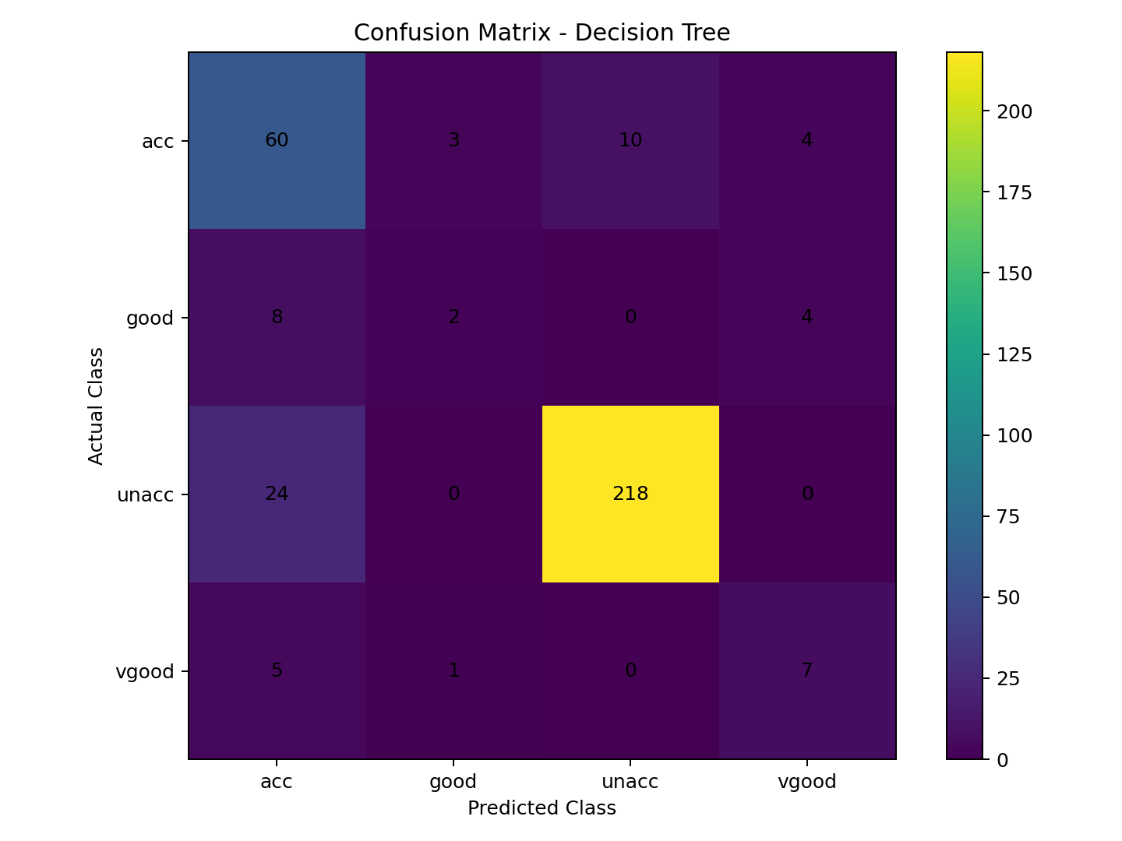
Figure 1. Confusion matrix for the four-class Decision Tree classifier.
The confusion matrix shows that the model identifies the dominant unacc class particularly well. The smaller good and vgood classes have fewer test examples and therefore show more confusion. This is an important consequence of class imbalance: overall accuracy can remain high while minority-class performance is weaker.

9. Visualization 2: ROC Curve
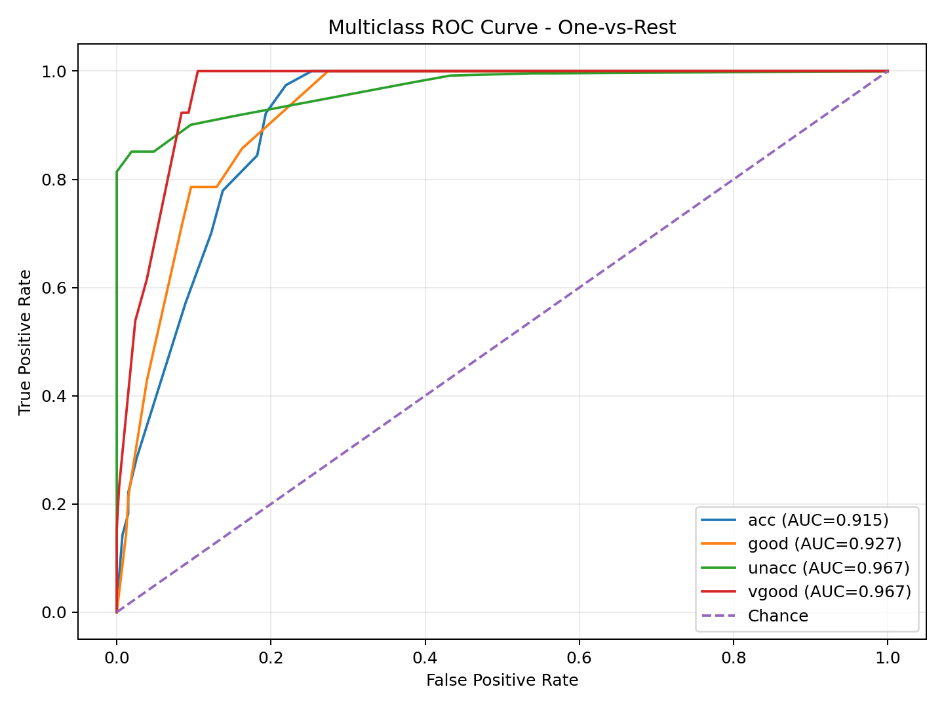
Figure 2. One-vs-rest ROC curves for the four target classes.
The ROC curves compare the true-positive rate with the false-positive rate for each class. The curves remain above the random-chance diagonal, and the weighted ROC-AUC of 0.9538 indicates that the classifier generally ranks the correct class above incorrect alternatives.

10. Visualization 3: Feature Importance
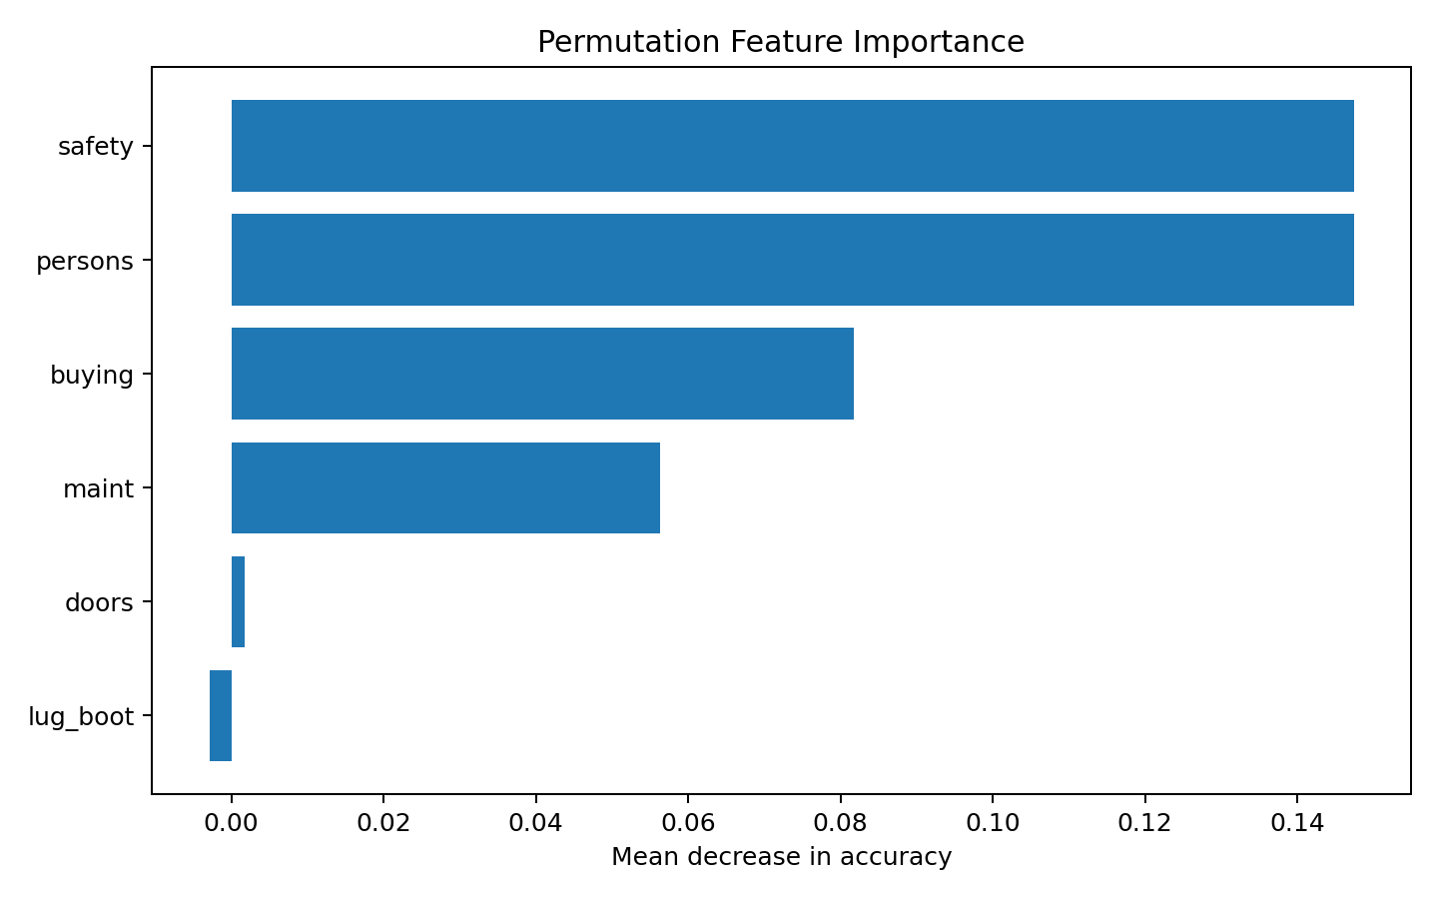
Figure 3. Permutation feature importance measured on the test set.
Permutation importance estimates how much predictive performance falls when a feature is randomly shuffled. The resulting ranking helps explain which inputs the trained classifier relies on most strongly. Importance is model-specific and should not be interpreted as proof of a causal relationship.

11. Overfitting and Underfitting Analysis
The training accuracy is 86.25% compared with 82.95% on the test set, a gap of 3.30 percentage points. The gap is not negligible, so some overfitting is present. A completely unrestricted decision tree could memorize many combinations in this structured dataset. Limiting max_depth to 6 is therefore a practical regularization choice.
Underfitting would occur if the tree were made too shallow and could not represent the interaction between safety, passenger capacity, price, and luggage size. The chosen depth provides a compromise between interpretability and predictive flexibility.

12. Sources of Error
- Class imbalance causes the minority good and vgood categories to have less influence on aggregate accuracy.
- The six features are categorical, so the model depends on the quality of the one-hot representation.
- A single train-test split can produce slightly different estimates if the random seed changes.
- Decision trees can be sensitive to small changes in the training sample and can overfit if depth is not controlled.
- The educational target is generated from a deterministic scoring rule, so it does not capture noise or uncertainty that may exist in real-world car evaluations.

13. Suggested Improvements
- Compare the Decision Tree with Random Forest, Gradient Boosting, Logistic Regression, and other baseline classifiers.
- Use repeated stratified cross-validation to obtain more stable estimates of generalization performance.
- Tune max_depth, min_samples_split, min_samples_leaf, and class_weight using GridSearchCV or RandomizedSearchCV.
- Report macro-averaged precision, recall, and F1 alongside weighted metrics so minority-class performance is not hidden.
- Use class-weighted learning or resampling methods if minority-class recall becomes the primary objective.
- Evaluate the final model on the original UCI Car Evaluation data separately if the official dataset is downloaded for a later experiment.

14. Conclusion
This Week 4 project demonstrates a complete machine learning model-development pipeline in Python. The categorical data were prepared using one-hot encoding, a constrained Decision Tree was trained, and performance was evaluated using multiple complementary metrics and visualizations. The model achieved strong overall predictive performance, but the confusion matrix shows that the minority classes remain more challenging. The experiment also illustrates why a machine learning workflow should not stop at accuracy: ROC-AUC, class-wise metrics, confusion patterns, and overfitting analysis provide a more complete assessment.

15. Reproducibility and Project Files
The accompanying Python file creates the dataset, performs preprocessing, trains the model, prints evaluation metrics, and generates all three figures. The CSV file is included so that the report results can also be inspected directly. The project folder is organized for upload inside the Week-4 directory of the existing internship GitHub repository.

16. References
Bohanec, M. (1988). Car Evaluation. UCI Machine Learning Repository. https://doi.org/10.24432/C5JP48
Pedregosa, F. et al. (2011). Scikit-learn: Machine Learning in Python. Journal of Machine Learning Research, 12, 2825–2830.

