Week 3: Statistical Analysis and Hypothesis Testing in Python
Virtual Data Science with Python Apprentice Intern
UCI Car Evaluation Dataset | 1,728 observations

1. Introduction
This report presents a statistical hypothesis-testing exercise using the UCI Car Evaluation dataset. The purpose is to determine whether the observed distribution of car acceptability categories is consistent with an equal distribution across the four possible evaluation classes. This question is useful from a data-quality and decision-support perspective because a strongly uneven class distribution affects how car-quality information should be interpreted and how later classification models should be evaluated.

2. Dataset and Research Question
The UCI Car Evaluation dataset contains 1,728 instances and six categorical input attributes: buying price, maintenance price, number of doors, passenger capacity, luggage-boot size, and estimated safety. The target variable has four classes: unacc, acc, good, and vgood. The published class counts are 1,210, 384, 69, and 65 respectively, with no missing values.
Research question: Is the distribution of car acceptability categories significantly different from an equal four-class distribution?

3. Hypotheses
H₀ (null hypothesis): The four car acceptability classes are equally distributed.
H₁ (alternative hypothesis): The four car acceptability classes are not equally distributed.
Significance level: α = 0.05.

4. Statistical Methodology
A chi-square goodness-of-fit test was selected because the outcome is categorical and the analysis compares observed category frequencies with a specified expected distribution. Under H₀, each of the four classes represents 25% of the observations. With 1,728 records, the expected frequency is 432 records per class.
The test statistic is χ² = Σ((Observed − Expected)² / Expected). The degrees of freedom are k − 1 = 3. A p-value below 0.05 provides evidence against H₀.

5. Test Results
Chi-square statistic: 2023.2546
Degrees of freedom: 3
p-value: 0.000e+00
Decision at α = 0.05: Reject H₀.
Class | Observed | Expected | Observed %
unacc | 1210 | 432 | 70.02%
acc | 384 | 432 | 22.22%
good | 69 | 432 | 3.99%
vgood | 65 | 432 | 3.76%
The p-value is far below 0.05, so the null hypothesis is rejected. The data provide very strong statistical evidence that the four car acceptability categories are not equally distributed. The observed distribution is dominated by the unacceptable class.

6. Visualization 1 — Observed vs Expected
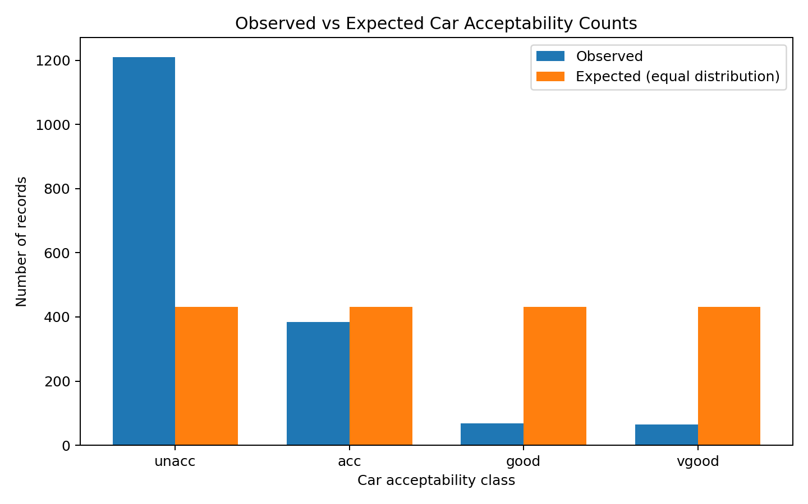
Figure 1. Observed class counts compared with the equal-distribution expectation.
If the classes were equally distributed, each category would contain 432 records. Instead, unacceptable contains 1,210 records, while good and very good contain only 69 and 65.

7. Visualization 2 — Class Percentage Share
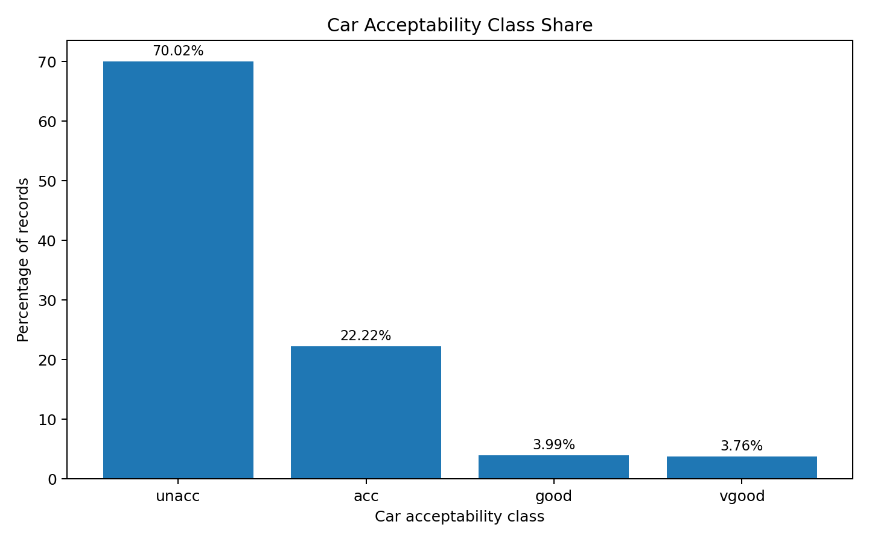
Figure 2. Percentage share of each car acceptability class.
Approximately 70.02% of observations are unacceptable, 22.22% acceptable, 3.99% good, and 3.76% very good. This communicates the practical magnitude of the imbalance.

8. Visualization 3 — Confidence Intervals
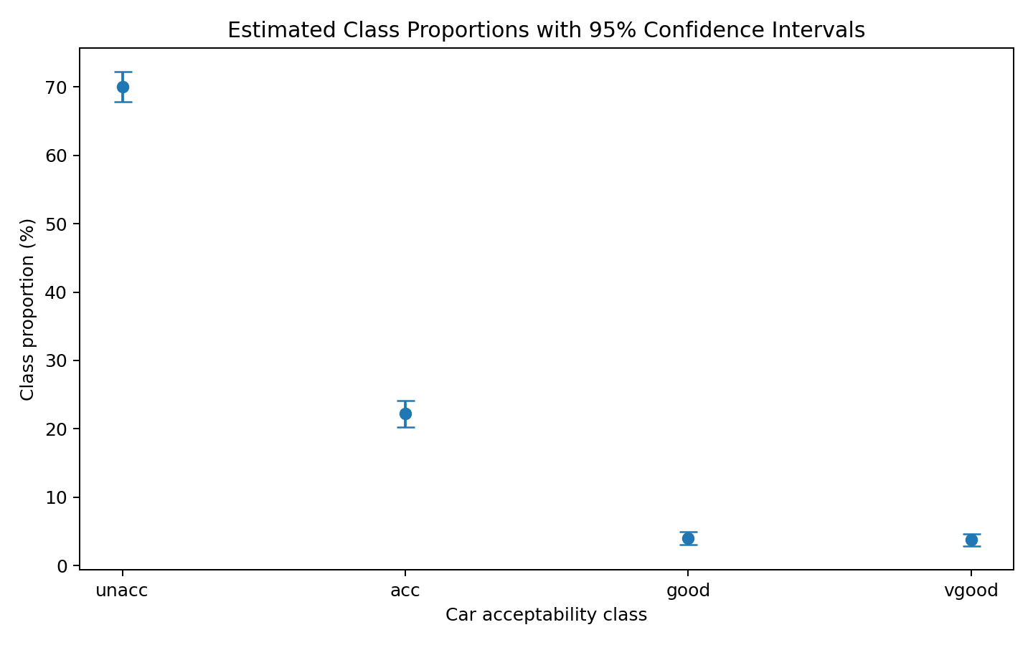
Figure 3. Approximate 95% confidence intervals for class proportions.
The confidence intervals describe uncertainty around the estimated class proportions. The large sample makes the intervals relatively narrow and the dominant unacceptable class remains clear.

9. Interpretation and Practical Implications
- The car evaluation data are highly imbalanced rather than evenly distributed.
- A simple accuracy measure in future classification work could be misleading because the unacceptable class is much larger than the other classes.
- Future machine-learning evaluation should include precision, recall, F1-score, and a confusion matrix in addition to accuracy.
- The statistical result formally validates the imbalance observed during exploratory analysis.
- The finding provides a useful basis for the machine-learning stage of the project.

10. Assumptions and Limitations
The chi-square goodness-of-fit test treats the four classes as categorical outcomes and assumes independent observations. All expected frequencies are 432, comfortably above common minimum-frequency guidelines. The analysis tests equality of class proportions; it does not establish causal relationships between individual car attributes and the final evaluation. The dataset is derived from a structured decision model, so results should not be generalized directly to modern real-world vehicle markets.

11. Conclusion
The hypothesis test produced χ² = 2023.2546, df = 3, with p < 0.001. Therefore, H₀ is rejected at the 5% significance level. The dataset is clearly not equally distributed across the four acceptability categories. This is an important finding for later modelling because class-sensitive evaluation metrics will be necessary.

12. Reproducible Python Code
# Week 3 - Statistical Analysis and Hypothesis Testing
# UCI Car Evaluation Dataset

import numpy as np
import pandas as pd
import matplotlib.pyplot as plt
from scipy.stats import chisquare

classes = ["unacc", "acc", "good", "vgood"]
observed = np.array([1210, 384, 69, 65])
total = observed.sum()

# H0: The four car acceptability classes are equally distributed.
# H1: The four car acceptability classes are not equally distributed.

expected = np.repeat(total / len(classes), len(classes))

chi2, p_value = chisquare(f_obs=observed, f_exp=expected)

print("Observed:", observed)
print("Expected:", expected)
print("Chi-square statistic:", chi2)
print("Degrees of freedom:", len(classes) - 1)
print("p-value:", p_value)

alpha = 0.05
if p_value < alpha:
print("Reject H0: the class distribution is significantly different from equal.")
else:
print("Fail to reject H0.")

# Approximate 95% confidence intervals for class proportions
proportions = observed / total
se = np.sqrt(proportions * (1 - proportions) / total)
ci_low = proportions - 1.96 * se
ci_high = proportions + 1.96 * se

results = pd.DataFrame({
"class": classes,
"observed": observed,
"percentage": proportions * 100,
"ci_low": ci_low * 100,
"ci_high": ci_high * 100
})
print(results)

plt.bar(classes, observed)
plt.title("Observed Car Acceptability Counts")
plt.xlabel("Class")
plt.ylabel("Number of records")
plt.show()

13. References
UCI Machine Learning Repository. Car Evaluation Dataset, Dataset ID 19. Bohanec, M. (1988). DOI: 10.24432/C5JP48.

