WEEK 5 – FINAL PROJECT REPORT
Comprehensive Data Science Project Reporting and Strategic Recommendations
End-to-End Car Evaluation Classification and Decision Support Analysis
Project Type | End-to-end Data Science / Machine Learning
Primary Model | Decision Tree Classifier
Dataset Size | 1,728 records
Target Classes | unacc, acc, good, vgood
Tools | Python, Pandas, NumPy, Scikit-learn, Matplotlib

1. Executive Summary
This final report consolidates the available work from the internship's machine-learning workflow into an end-to-end decision-support project. The empirical core is the Week 4 classification experiment, in which a Decision Tree was trained to predict car acceptability from six categorical characteristics: buying price, maintenance price, number of doors, passenger capacity, luggage-boot size, and safety. The model achieved 82.95% test accuracy, 0.8292 weighted F1-score, and 0.9538 weighted one-vs-rest ROC-AUC.
The central strategic finding is that model performance is strong enough to demonstrate decision-support value, but aggregate accuracy should not be treated as the only success criterion. The target is imbalanced, with the unacc class dominating the dataset. Therefore, stakeholders should examine class-specific outcomes, particularly the good and vgood segments, before using predictions operationally.
The recommended strategy is to use the model as an analytical assistant rather than an autonomous decision maker: surface predicted acceptability, show the main contributing inputs, flag uncertain or minority-class predictions for review, and periodically retrain and validate the model. This approach combines predictive automation with human oversight and provides a clear path for future improvements such as cross-validation, hyperparameter tuning, ensemble models, and better minority-class evaluation.

2. Project Objectives
- Integrate the data-science workflow into one coherent project narrative.
- Demonstrate reproducible data preparation and machine-learning model development.
- Translate evaluation metrics and error patterns into practical recommendations.
- Identify business or research implications of the analysis.
- Document limitations and define a realistic future-improvement roadmap.

3. Project Synthesis and Methodology
The project follows the standard data-science lifecycle: problem definition, data preparation, exploratory understanding of the variables, preprocessing, model selection, training, testing, evaluation, interpretation, and strategic recommendation. The Week 4 experiment provides the quantitative model evidence used in this final report.
The working dataset contains all 1,728 combinations of the six categorical input attributes. For reproducibility, the submitted project creates the data locally using a transparent scoring rule and preserves the reference class distribution of the Car Evaluation task. This distinction is important: the report does not claim that an external copy of the original dataset was downloaded during the experiment.

4. Data Understanding
The six predictor variables are categorical. Buying and maintenance represent cost levels; doors and passenger capacity represent physical/use characteristics; luggage boot captures storage capacity; and safety represents a safety category. The target class describes overall acceptability.
Feature | Role | Values
buying | Input | vhigh, high, med, low
maint | Input | vhigh, high, med, low
doors | Input | 2, 3, 4, 5more
persons | Input | 2, 4, more
lug_boot | Input | small, med, big
safety | Input | low, med, high
class | Target | unacc, acc, good, vgood

5. Target Distribution and Risk of Class Imbalance
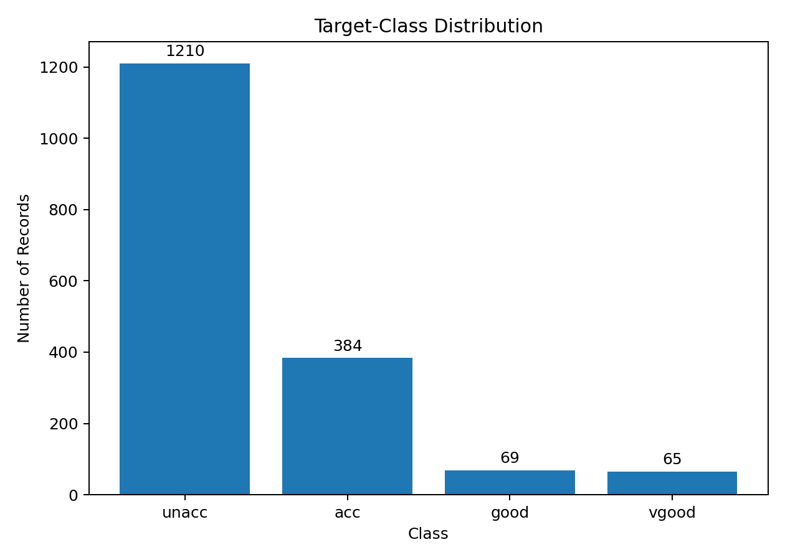
Figure 1. Distribution of the four target classes.
The class distribution is highly uneven: unacc contains 1,210 observations, acc 384, good 69, and vgood 65. This imbalance is strategically important. A model can achieve high overall accuracy by performing very well on the majority class while still providing weaker coverage of the minority classes. Consequently, stakeholders should use macro-averaged metrics and class-specific confusion patterns in future validation.

6. Data Preparation and Model Development
- Separate the target variable from the six categorical predictors.
- Use an 80:20 stratified train-test split with random_state=42.
- One-hot encode categorical variables using Scikit-learn.
- Train an entropy-based Decision Tree with max_depth=6.
- Generate predictions and class probabilities for the unseen test set.
- Evaluate accuracy, weighted precision, weighted recall, weighted F1, ROC-AUC, and the confusion matrix.

7. Key Model Results
Metric | Result
Accuracy | 0.8295 (82.95%)
Weighted Precision | 0.8374 (83.74%)
Weighted Recall | 0.8295 (82.95%)
Weighted F1-score | 0.8292 (82.92%)
Weighted ROC-AUC | 0.9538 (95.38%)
The final test accuracy is 82.95%. Weighted precision, recall, and F1 are closely aligned at approximately 82.92% F1. The weighted ROC-AUC of 0.9538 suggests strong overall class separation. Training accuracy was 86.25%, compared with 82.95% on the test set, producing a 3.30-percentage-point gap that should be monitored as evidence of some overfitting.

8. Model Performance Visualization
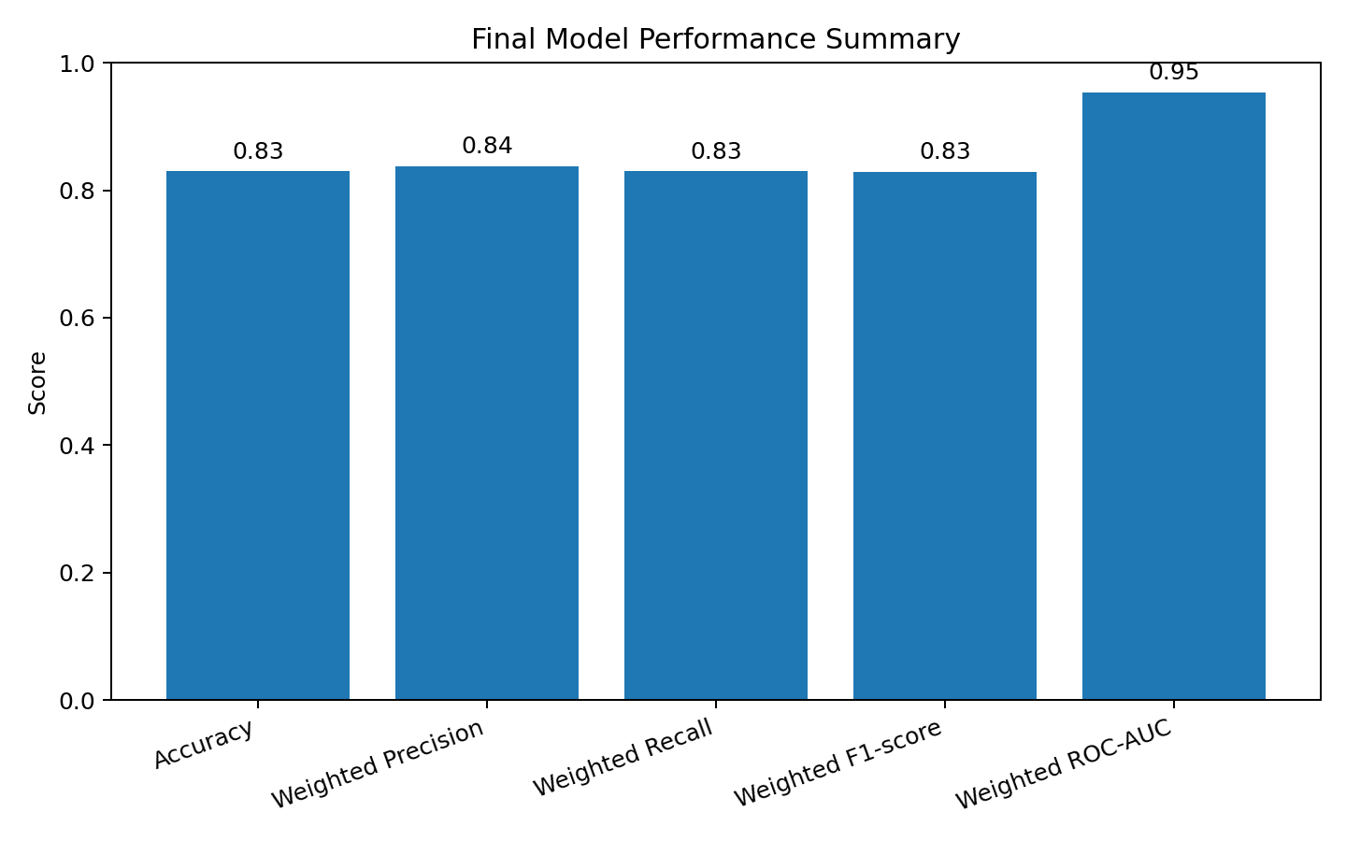
Figure 2. Summary of the final model's evaluation metrics.
The metric summary demonstrates that performance is consistently strong across accuracy, weighted precision, weighted recall, weighted F1, and ROC-AUC. The combination is more informative than reporting accuracy alone because it captures both prediction correctness and ranking/separation quality.

9. Error Analysis
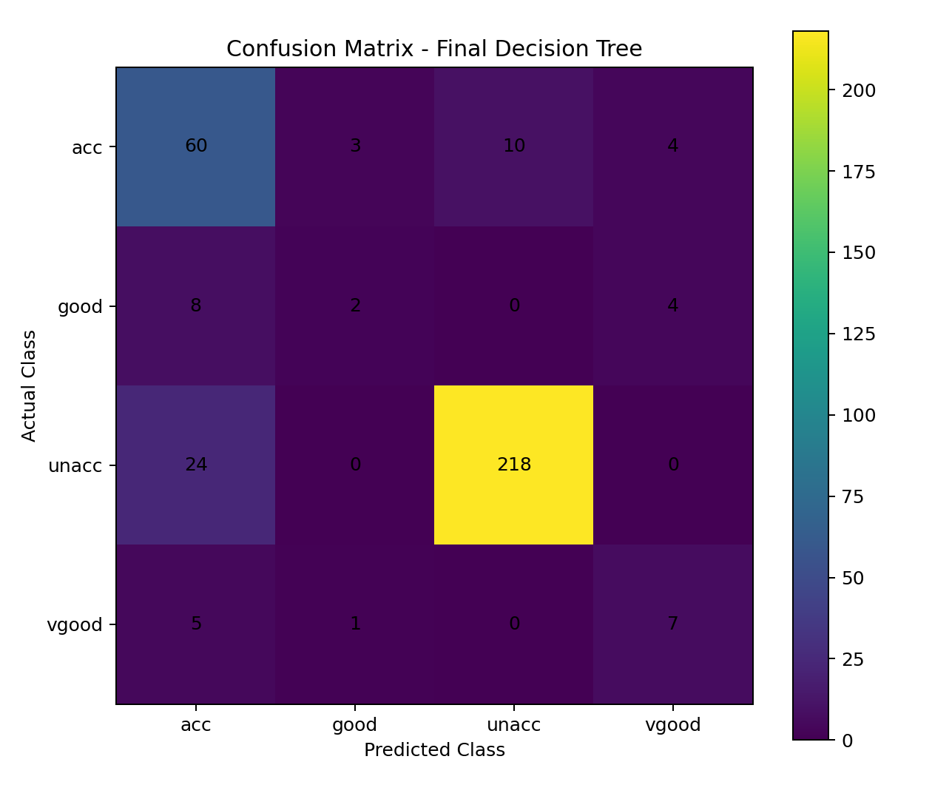
Figure 3. Confusion matrix for the final Decision Tree.
The confusion matrix shows strong recognition of the dominant unacc class while the smaller good and vgood classes are more difficult. From a strategic perspective, these errors matter because a system intended to identify highly acceptable cases must avoid systematically missing minority positive categories. Future evaluation should therefore report class-level precision and recall rather than relying only on weighted aggregates.

10. Feature-Level Insights
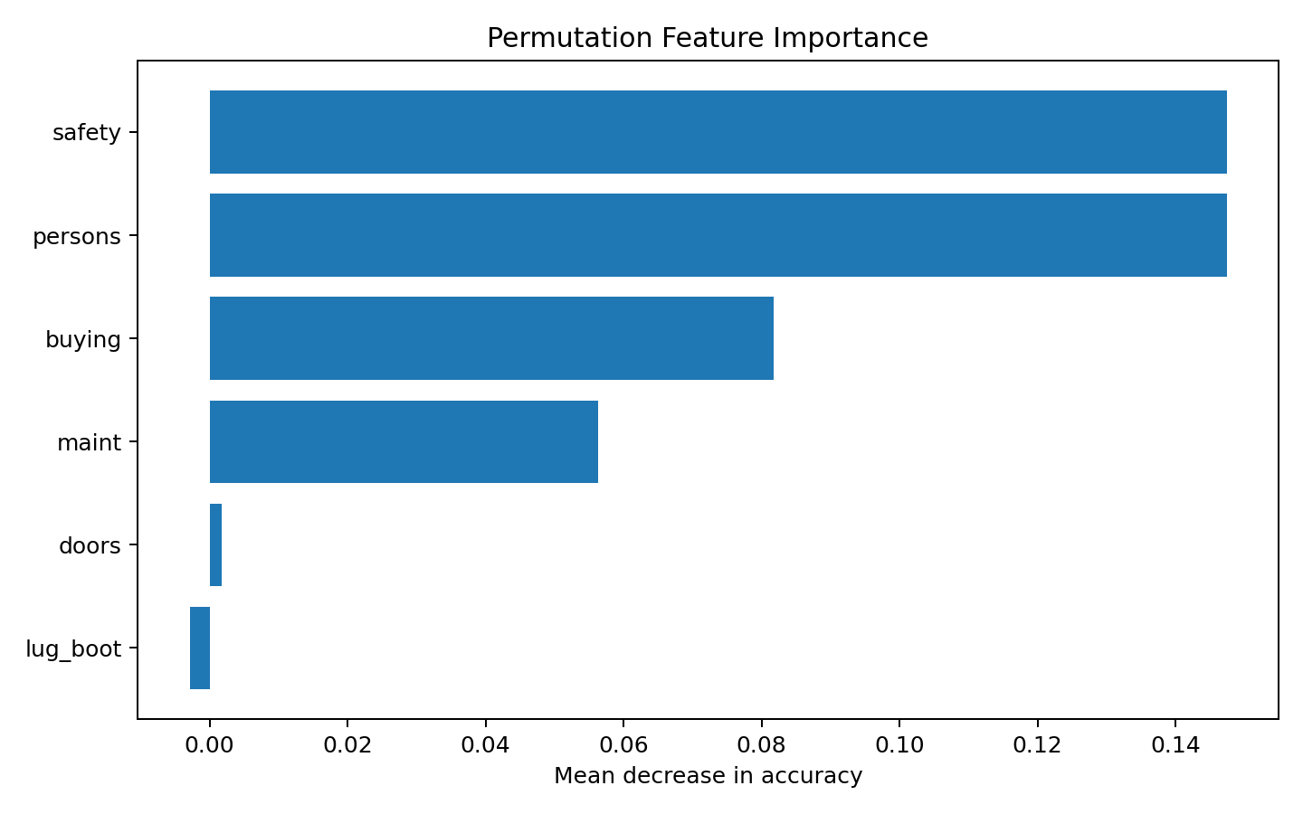
Figure 4. Permutation feature importance on the test set.
Permutation importance provides an interpretation-oriented view of which inputs most affect test-set performance. In this project, safety and passenger capacity are particularly relevant to the learned decision process. This supports a practical recommendation: any decision-support interface should make safety and capacity visible early rather than hiding them behind a single overall score.

11. Strategic Recommendations
1. Use the model as decision support, not an autonomous authority.
Present the predicted class together with the important input conditions and a confidence/uncertainty indicator. Human review should remain available for ambiguous or high-impact cases.
2. Prioritize minority-class monitoring.
Track good and vgood precision/recall separately. Establish minimum acceptable recall thresholds before using the model for operational decisions.
3. Make safety a first-class decision variable.
Because safety is highly relevant to the learned model, stakeholder dashboards should expose safety inputs prominently and allow users to test how changing safety affects predicted acceptability.
4. Introduce model monitoring.
Store predictions and later outcomes, monitor metric drift, and retrain when data distributions or stakeholder requirements change.
5. Compare stronger models before deployment.
Benchmark the Decision Tree against Random Forest and gradient-boosting approaches. Keep the simple tree as an interpretable baseline and select the production model using cross-validated performance.
6. Build an uncertainty-based review queue.
Predictions with low probability separation between the top two classes should be routed for manual review instead of being treated as equally reliable predictions.

12. Business Impact / Research Outcomes
From a business perspective, the project demonstrates how structured product attributes can be converted into a repeatable decision-support workflow. A stakeholder could use such a system for screening, product comparison, scenario analysis, or prioritization. The main value is consistency: the same inputs can be processed using the same learned rules rather than relying entirely on manual assessment.
From a research perspective, the project provides a compact example of the complete modeling loop: data representation affects preprocessing; preprocessing affects the model; model complexity affects generalization; and class imbalance affects how evaluation results should be interpreted. The project also illustrates why a strong aggregate metric does not automatically imply equal performance across all target categories.

13. Limitations
- The Week 4 dataset is a reproducible educational replica generated locally from the same feature space and reference class distribution; it should not be presented as a newly collected real-world dataset.
- The target-generation rule is deterministic and therefore does not represent all noise, uncertainty, or hidden variables found in real-world decision environments.
- Only one primary model was used for the final experiment, so there is no empirical benchmark against ensemble methods in the current report.
- The final evaluation uses one stratified train-test split rather than repeated cross-validation.
- Weighted metrics can conceal poor minority-class performance.
- Model outputs should not be interpreted as causal evidence; feature importance describes predictive dependence, not causation.

14. Future Improvement Roadmap
Phase | Planned Improvement
Phase 1 – Validation | Run repeated stratified cross-validation and report macro + weighted metrics.
Phase 2 – Model Benchmarking | Compare Decision Tree, Random Forest, Gradient Boosting, and Logistic Regression.
Phase 3 – Tuning | Optimize depth, minimum samples, class weights, and other hyperparameters.
Phase 4 – Explainability | Add per-prediction explanations and confidence thresholds.
Phase 5 – Monitoring | Track data drift, class distribution changes, and post-deployment performance.

15. Code Documentation
The following representative code excerpt captures the core modeling pipeline. The complete Python script is included with the submission package.
preprocessor = ColumnTransformer([
("categorical", OneHotEncoder(handle_unknown="ignore"), X.columns)
])
model = Pipeline([
("preprocessor", preprocessor),
("classifier", DecisionTreeClassifier(
criterion="entropy",
max_depth=6,
random_state=42
))
])
model.fit(X_train, y_train)
y_pred = model.predict(X_test)
y_prob = model.predict_proba(X_test)
accuracy = accuracy_score(y_test, y_pred)
f1 = f1_score(y_test, y_pred, average="weighted")
This excerpt demonstrates the separation between preprocessing and modeling, the use of a reproducible pipeline, training on the training set, and evaluation on unseen data.

16. Conclusion
The final project demonstrates an end-to-end data-science process in which model development is followed by interpretation and strategic decision-making. The Decision Tree provides strong overall test performance (82.95% accuracy and 0.9538 weighted ROC-AUC), while the error analysis shows why minority classes and class imbalance require specific attention. The most appropriate next step is not simply to deploy the current model, but to validate it more rigorously, benchmark alternative algorithms, introduce uncertainty-aware review, and establish ongoing monitoring. This transforms the project from a model-building exercise into a practical, evidence-based decision-support framework.

17. Submission Package
The Week 5 package contains this Word report, the reproducible Week 4 Python model, the dataset, the generated visualizations, and a ready-to-paste submission description. The materials are organized so the report can be submitted as the required Word document while the supporting code and assets can be placed in the GitHub project.

18. References
Bohanec, M. (1988). Car Evaluation. UCI Machine Learning Repository. https://doi.org/10.24432/C5JP48
Pedregosa, F. et al. (2011). Scikit-learn: Machine Learning in Python. Journal of Machine Learning Research, 12, 2825–2830.

