Week 2: Advanced Data Visualization and Storytelling with Python
Virtual Data Science with Python Apprentice Intern
Car Evaluation Dataset — UCI Machine Learning Repository

1. Introduction
This week extends the Week 1 exploratory analysis into a data-storytelling exercise. Instead of presenting charts independently, the visualizations are arranged as a narrative: first, the audience sees the imbalance in the outcome; next, the balance of the input space; then the diversity of the decision factors; and finally the structure of the categorical variables. The same UCI Car Evaluation dataset is retained so that the project develops continuously across weeks.

2. Dataset and Audience
The UCI Car Evaluation dataset contains 1,728 observations, six categorical input features, and one categorical target. The input variables describe buying price, maintenance price, doors, passenger capacity, luggage-boot size, and estimated safety. The target has four classes: unacc, acc, good, and vgood. UCI reports that the dataset has no missing values. The intended audience for this storytelling exercise is a non-technical stakeholder who needs to understand what the dataset contains before making analytical or modelling decisions.

3. Visualization Strategy
Bar charts are used where exact category comparisons matter. A 100% stacked profile is used to communicate balance across features, while entropy summarizes categorical diversity with a single comparable measure. A pie chart is included only for the high-level share of the target classes, where part-to-whole communication is intuitive. A cardinality chart explains how many possible levels each decision factor contains.
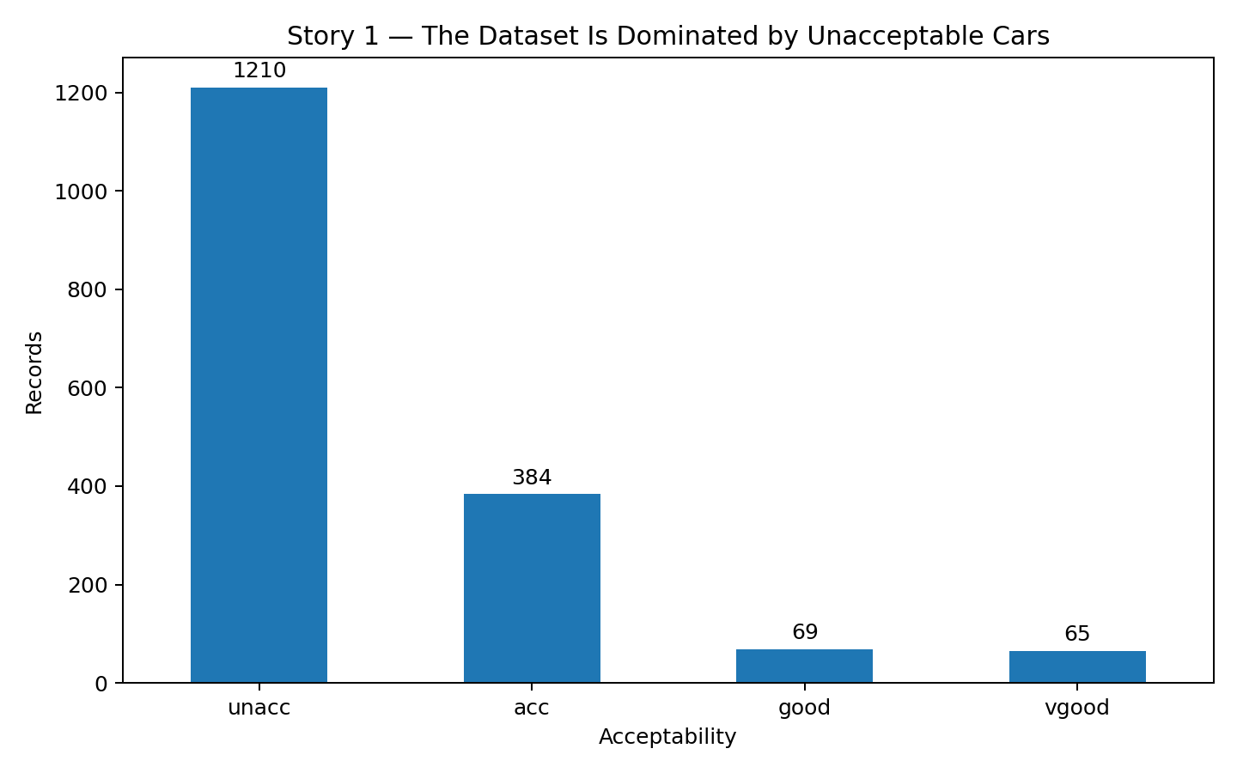
Figure 1 — The outcome is highly imbalanced.
The first visual establishes the central story. The unacceptable class contains 1,210 of 1,728 records, while acceptable contains 384, good 69, and very good 65. This means a model that simply favors the majority class could appear strong on accuracy while providing weak performance for the smaller classes. The chart therefore motivates class-aware evaluation in later weeks.
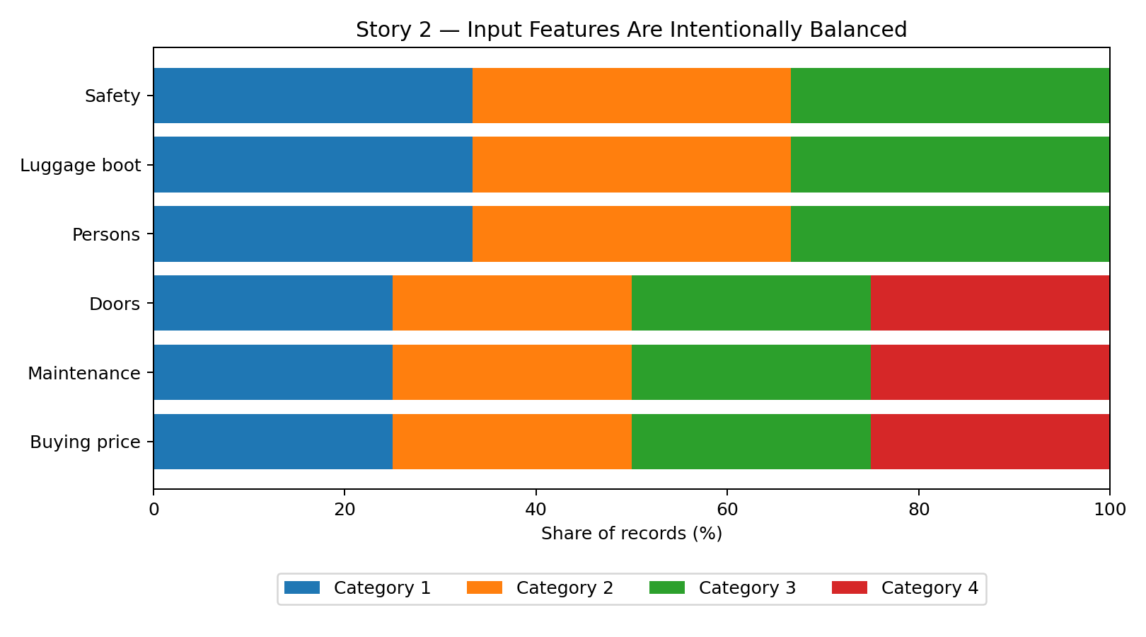
Figure 2 — The input factors are evenly represented.
Unlike the target, the input categories are deliberately balanced. Buying price, maintenance, and doors each have 432 observations per category, while persons, luggage boot, and safety each have 576 observations per category. This is useful for storytelling because differences in target outcomes are not caused by simple over-representation of one input category.
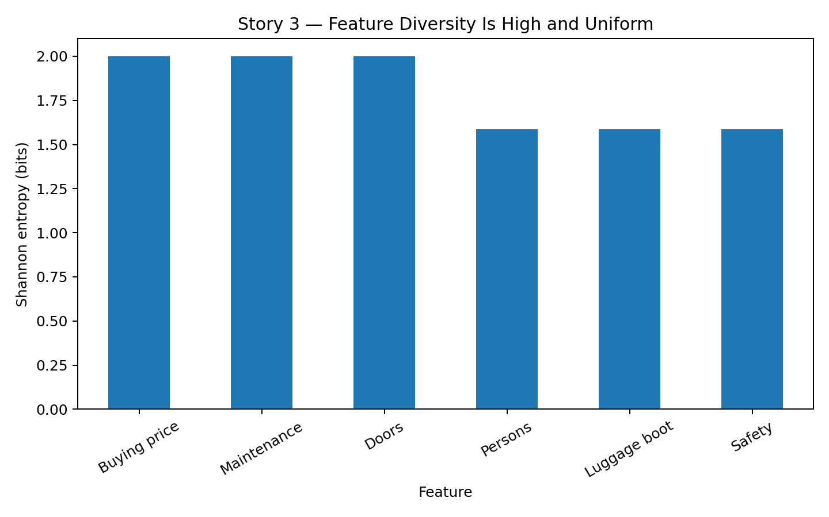
Figure 3 — The categorical inputs have high and consistent diversity.
Shannon entropy summarizes how evenly observations are spread among categories. Four-category variables have 2 bits of entropy, while three-category variables have about 1.585 bits. The similar values show that each input feature has a well-distributed set of possible states rather than being dominated by one category.
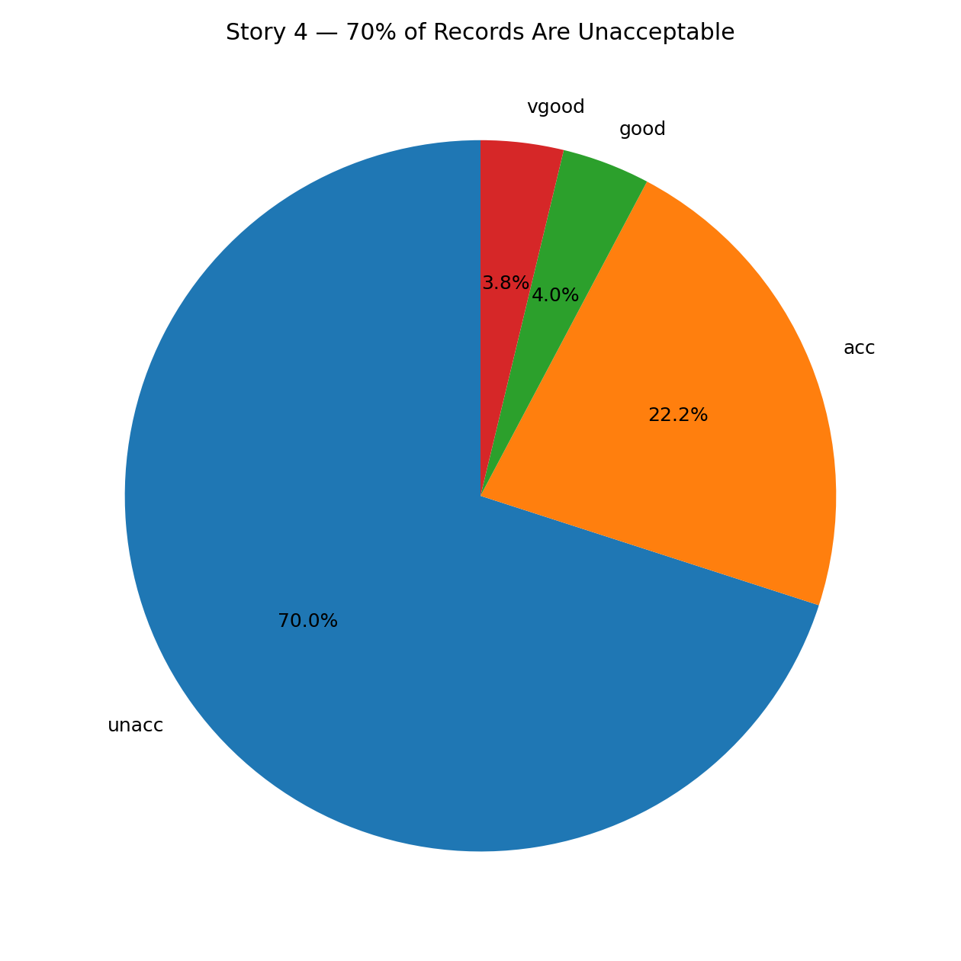
Figure 4 — Approximately seven in ten records are unacceptable.
The percentage view translates the raw counts into an intuitive stakeholder message. About 70% of observations belong to the unacceptable class. The remaining approximately 30% are split among acceptable, good, and very good cars. This reinforces the need to avoid interpreting overall accuracy without considering class distribution.
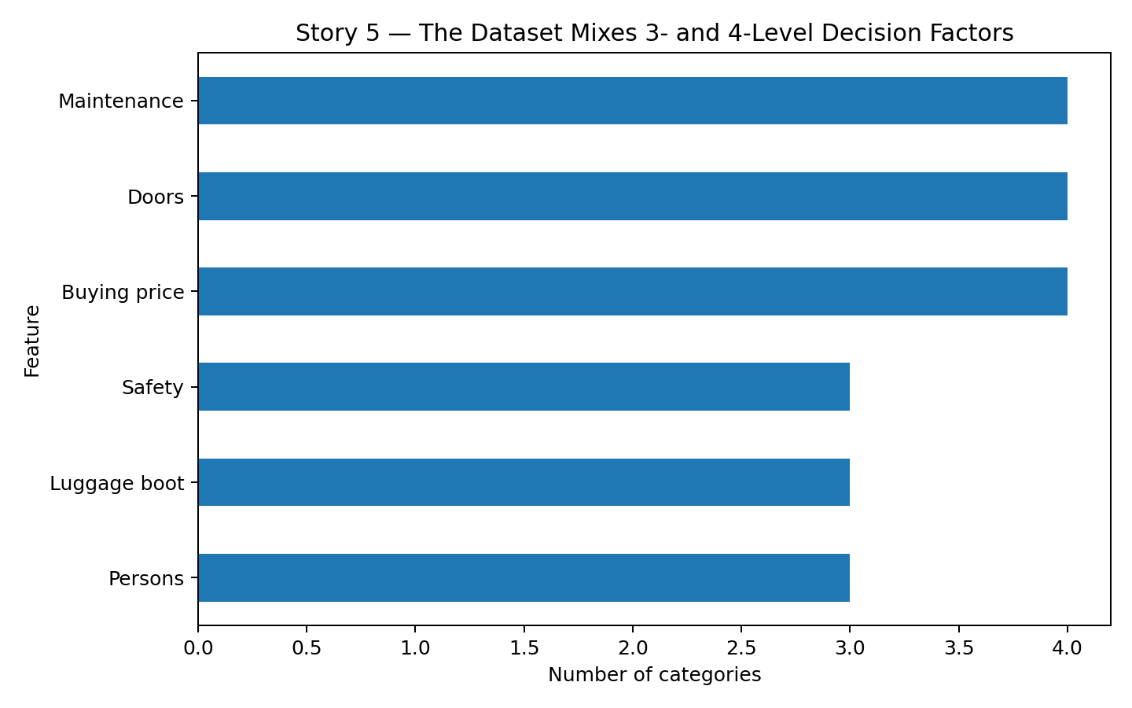
Figure 5 — The dataset combines four-level and three-level decision factors.
The cardinality chart shows that buying, maintenance, and doors have four categories, while persons, luggage boot, and safety have three. This helps a non-technical audience understand why some variables offer more possible states than others and prepares the dataset for categorical encoding in later machine-learning work.

4. Overall Data Story
The visual narrative reveals an important contrast: the dataset is balanced in its input design but imbalanced in its outcome. Every input category is represented evenly, which reduces a common source of sampling bias in descriptive analysis. However, the target distribution is heavily concentrated in the unacceptable class. For a business or decision-support audience, this means the analytical challenge is not simply understanding which categories exist; it is understanding which combinations of attributes lead to better or worse evaluations. This observation naturally motivates Week 3 hypothesis testing and Week 4 classification modelling.

5. Business / Scientific Implications
- Safety and passenger-related factors should receive particular attention in later analysis because the dataset is designed around practical car acceptability criteria.
- Decision-makers should avoid relying on overall class frequency alone; minority outcomes such as good and very good require focused analysis.
- The balanced representation of input categories provides a strong basis for comparing groups without one category dominating because of sample size.
- The dataset's categorical structure makes it suitable for decision trees, categorical association analysis, and other interpretable methods.
- Visualization choices should match the question: bars for comparisons, proportions for part-to-whole interpretation, and entropy for a compact measure of distributional diversity.

6. Limitations
The dataset is a structured car-evaluation benchmark derived from a hierarchical decision model rather than a current market survey. It therefore should not be interpreted as a direct representation of today's automobile buyers. The visualizations in this report intentionally emphasize exact marginal distributions and do not claim causal relationships between individual features and the target. Cross-feature relationships will be tested more formally in later stages.

7. Conclusion
Week 2 transformed the Week 1 exploratory results into a coherent visual narrative. The main message is clear: the input space is deliberately well balanced, but the target outcome is strongly imbalanced. This distinction is important for future modelling and statistical analysis. The visual storytelling approach also demonstrates how chart selection and explanatory captions can make categorical data understandable to a non-technical audience.

8. Reproducible Python Code
# Week 2 - Advanced Data Visualization and Storytelling
import pandas as pd
import matplotlib.pyplot as plt
from ucimlrepo import fetch_ucirepo

# Load the same dataset used in Week 1
car_evaluation = fetch_ucirepo(id=19)
X = car_evaluation.data.features
y = car_evaluation.data.targets
df = pd.concat([X, y], axis=1)

# 1. Target distribution
df["class"].value_counts().plot(kind="bar")
plt.title("Distribution of Car Acceptability")
plt.xlabel("Class")
plt.ylabel("Records")
plt.tight_layout()
plt.show()

# 2. Feature distributions
for col in df.columns[:-1]:
df[col].value_counts().plot(kind="bar")
plt.title(f"Distribution of {col}")
plt.xlabel(col)
plt.ylabel("Records")
plt.tight_layout()
plt.show()

# 3. Feature entropy / diversity
import numpy as np
def entropy(series):
p = series.value_counts(normalize=True)
return -(p * np.log2(p)).sum()

entropy_scores = {
col: entropy(df[col]) for col in df.columns[:-1]
}
print("Feature entropy:", entropy_scores)

# 4. Target percentage
target_pct = df["class"].value_counts(normalize=True) * 100
target_pct.plot(kind="pie", autopct="%1.1f%%")
plt.title("Share of Car Acceptability Classes")
plt.ylabel("")
plt.show()

# 5. Feature cardinality
cardinality = df.nunique().drop("class")
cardinality.sort_values().plot(kind="barh")
plt.title("Number of Categories per Feature")
plt.xlabel("Number of categories")
plt.show()

9. References
Bohanec, M. (1988). Car Evaluation. UCI Machine Learning Repository. DOI: 10.24432/C5JP48.
UCI Machine Learning Repository documentation was used for dataset characteristics and variable definitions.

