Name- Yashraj Rajput

Internship Domain- Front end web development

Batch-Jan 2023

Date of Submission- 11th April 2023



Fastfindfirm, Thane,

Maharashtra, India .400610

Personal Portfolio Website

A case study submitted for the mandate of

Fastfindfirm

For internship work completed during

Front end web development internship

By

Yashraj Rajput

Personal Portfolio Website using HTML, CSS

And JavaScript

Yashraj Rajput

Department of Computer Engineering

Modern Education Society’s College Of

Engineering , Pune.

[Yashrajput3589@gmail.com](mailto:Yashrajput3589@gmail.com)

Abstract : Welcome to my personal portfolio website! Here, you'll find a showcase of my work and accomplishments in various fields, including graphic design, web development, and digital marketing. Through my portfolio, I aim to demonstrate my skills, creativity, and passion for my craft. I invite you to browse through my projects, learn more about my professional background, and connect with me to discuss potential collaborations. Thank you for visiting!

Keywords : HTML , CSS , JS and Bootstrap .

Introduction : Hello and welcome to my personal portfolio website! My name is Yashraj, and I am a web developer based in Pune , Maharashtra . As a creative professional with proficient in the web development , I honed my skills in HTML , CSS and Bootstrap . Through this website, I hope to showcase my best work and highlights my achievements in various projects I have worked on .

As you browse through my portfolio, you will see examples of my design aesthetic, technical proficiency, and attention to detail. I am proud to have worked with a diverse range of clients, from small startups to large corporations, and I am always eager to take on new challenges.

Thank you for taking the time to visit my portfolio website. I hope it gives you a sense of my capabilities and inspires you in your own creative pursuits. If you have any questions or would like to discuss potential projects, please don't hesitate to contact me.

The following are my personal portfolio website’s snapshots :

1. Home Page

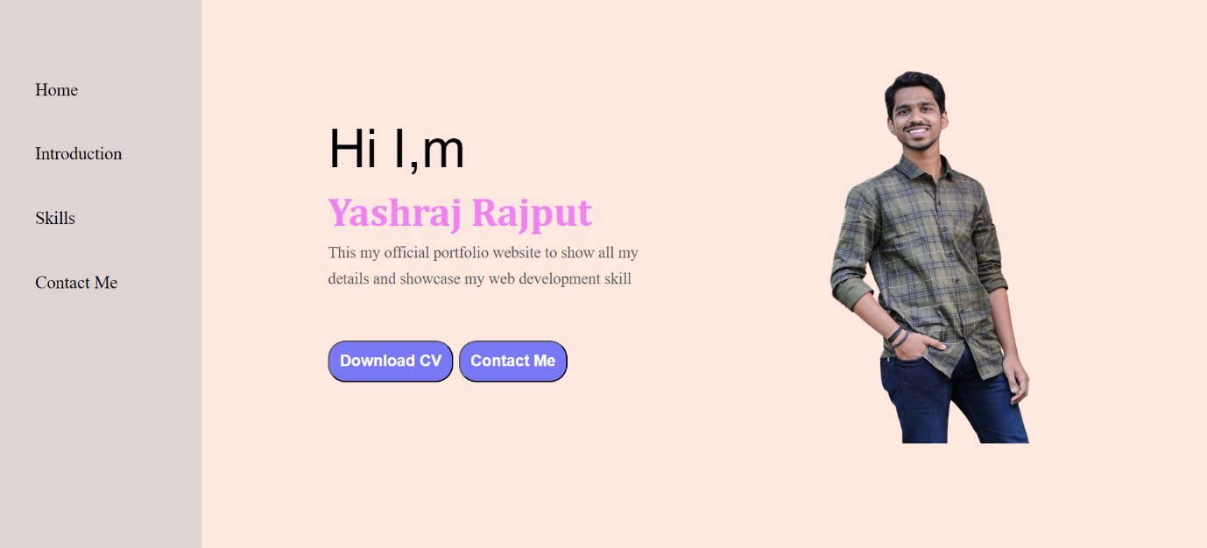

2. Introduction Page

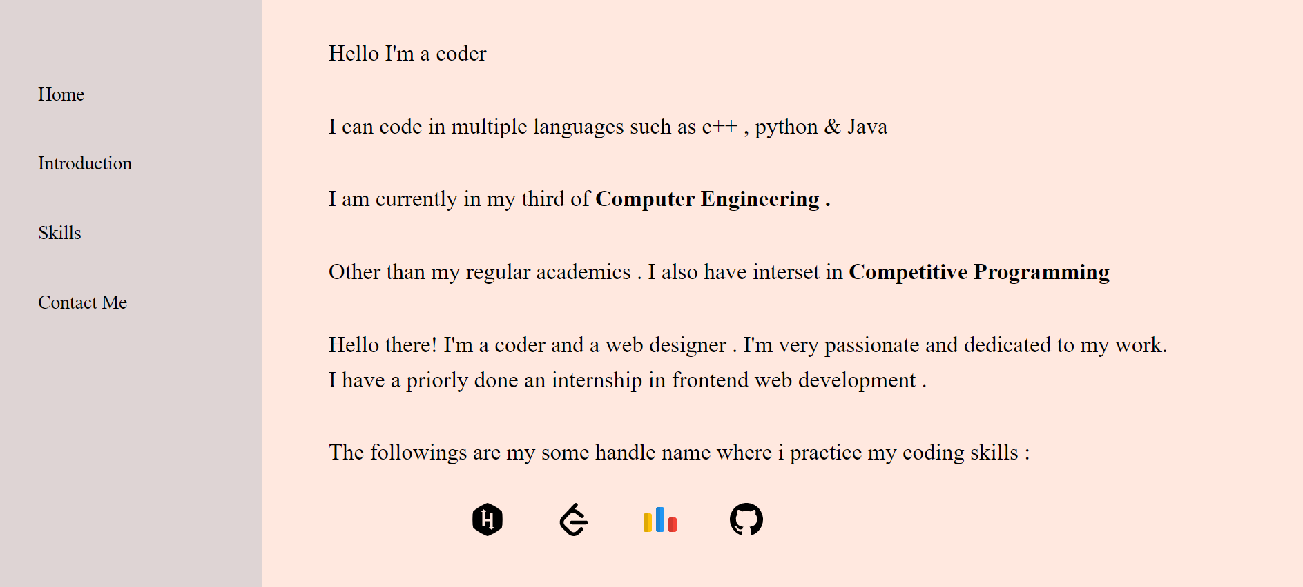

3. Skills / Certifications Page







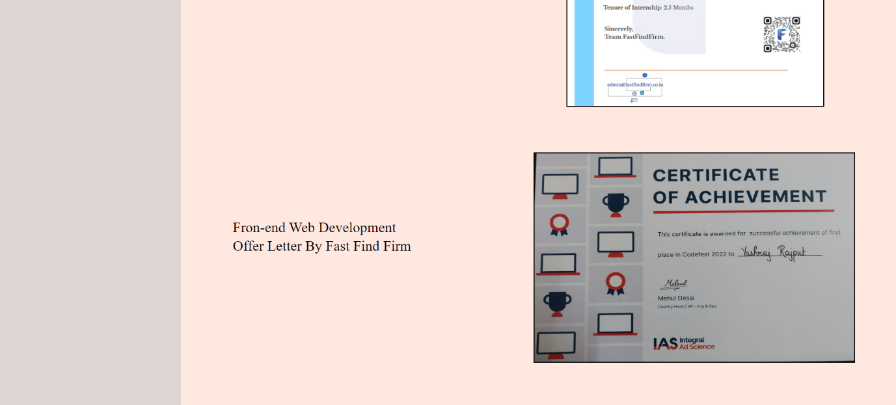

4. Contact Me Page

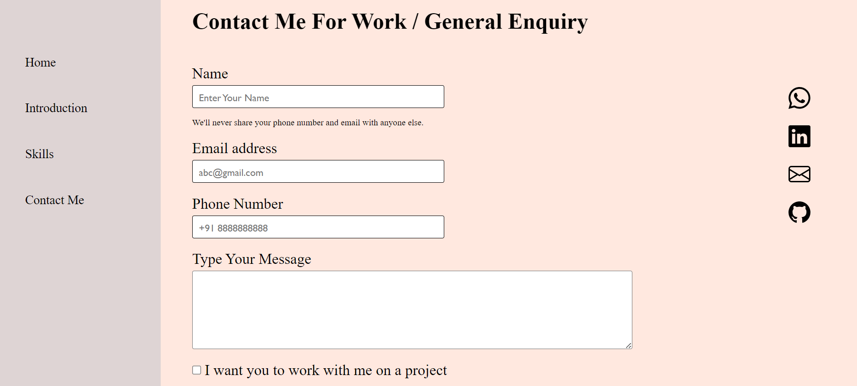

Acknowledgement : I would like to express my gratitude to everyone who has supported me in my creative journey and helped me bring this portfolio website to life.

Firstly, I want to thank my family and friends for their unwavering support and encouragement throughout the years. Without their love and belief in me, I would not be where I am today.

I am also grateful to my mentors, colleagues, and clients who have challenged me, pushed me to grow, and trusted me to bring their visions to life. Working with you has been a true privilege, and I appreciate the opportunities you have given me to develop my skills and explore my creativity.

Finally, I would like to thank the team behind the tools and resources that have made this website possible. From the developers who created the platform, to the designers who crafted the templates, to the writers who shared their knowledge and inspiration – thank you for making the web a more accessible and innovative space.

Thank you all for being part of my journey, and I look forward to the opportunities and challenges that lie ahead.

References :

[1] Indeed, Forecasting, [Online] Feb 2023. Available from:<https://www.indeed.com/career-advice/career-development/what-is-forecasting>.

[2] Windy.app, Weather forecast, [Online] 2023. Available from:<https://windy.app/blog/what-is-a-weather-forecast-and-how-it-works.html>.

[3] Study.com, Weather forecast, [Online] 2003- 2023. Available from:<https://study.com/learn/lesson/weather-forecasting-types-tools.html>.

[4] Goweatherforecast.com, Weather forecast, [Online] Feb 2020-2022.Available-from: <https://goweatherforecast.com/news/importance-of-weather-forecasting-235>

[5] Fortinet, API key, [Online] 2023. Available from: <https://www.fortinet.com/resources/cyberglossary/api-key>.

[6] Educative.io, Visual-studio code, [Online] 2023. Available from: <https://www.educative.io/answers/what-is-visual-studio-code>.