

|  |
| --- |
| Open Road Lane Detector  As a project work for course  ARTIFICIAL INTELLIGENCE{int-404}  BY:- REG. ROLL.  sonu 11805066 22  yashraj 11805096 04  gowhar 11805062 01 |

INTRODUCTION

We worked on the topic allotted to us by our mam. The work is equally divided among all the members thus every member will have his own responsibility. The name of the topic is “Open Road Lane Detector”.

In this we created the algorithm. the algorithm comprised of

“Lane following algorithm”.

Our group worked well under our teacher’s guidance. we were interested in doing this project because this was an essential topic nowadays. We faced some minor problems but still managed to do the project successfully and tested it.

AI Project : ORLD (Open Road Lane Detector)

ORLD is an Open Source project developed by Yashraj Shukla, so developers can use this as a module in their Self Driving Car projects. It uses OpenCV & Numpy Python libraries. We've tested our program on a Video.

ORLD Team : Yashraj Shukla, Sonu, Gowhar Bhatt

Dependecies : Numpy, Matplotlib, OpenCV, imutils

Usage : python3 ORLD.py

PROJECT CONTRIBUTION

Yashraj - Full coding part

Sonu - making report and collecting api

Gowhar - helped in module

PROPOSE

Our main propose is that developers can use this as a module in their Self Driving Car projects.

What Does It Mean to Be A Self Driving Car?

Many believe a self-driving or autonomous vehicle is just that a driverless car, truck or SUV that merely requires a destination to be entered and off you go, free to surf your phone or tablet while the car does all of the heavy lifting.

There are six level of self driving car :-

Level: 0

Automation: None

Level: 1

Automation: Driver Assistance

Level: 2

Automation: Partial

Level: 3

Automation: Conditional

Level: 4

Automation: High

Level: 5

Automation: Full

METHODOLOGY

Algorithm “Lane following algrothm”

A highway lane following system steers a vehicle to travel within a marked lane. It also maintains a set velocity or safe distance to a preceding vehicle in the same lane. The system typically uses vision processing algorithms to detect lanes and vehicles from a camera. The vehicle detections from the camera are then fused with detections from a radar to improve the ability to detect surrounding vehicles. The controller uses the lane detections, vehicle detections, and set speed to control steering and acceleration.

OpenCV:-

OpenCV (Open source computer vision) is a library of programming functions mainly aimed at real-time computer vision.

Here in our project we using OpenCV we solve simple lane detection Computer vision is an area of computer science devoted to the extraction and processing of structured information from mostly-unstructured image data. We are going to use OpenCV to process the input images to discover any lane lines held within and also for rendering out a representation of the lane. Additionally, images are really just dense matrix data, so we will use numpy and matplotlib to do transformations and rendering of image data. I’ve run all of this code within a Jupyter notebook, but you can run it in any environment that allows you to install the dependencies and execute python scripts.

By the end of this post, you will have learned how to write a program that can do the conversion below.

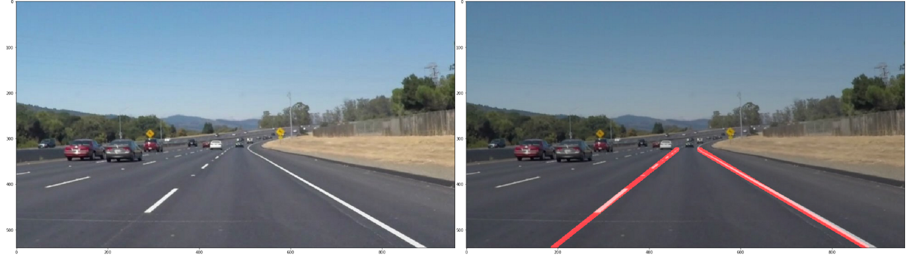

Result and Conclusion

First of all, one obvious way to make the problem easier is to work out our solution for a single image. A video is, after all, just a series of images. We can then move on to running our pipeline on an input video frame-by-frame as a final solution to the original problem of processing an entire video for lane detection.

Creating a Single Left and Right Lane Line

The final step in our pipeline will be to create only one line for each of the groups of lines we found in the last step. This can be done by fitting a simple linear model to the various endpoints of the line segments in each group, then rendering a single overlay line on that linear model.

Screenshots of outputs :-

