A Project Report
On
Domain-Aware Automatic Student Answer Grading Using Semantic Similarity and Machine Learning

Submitted by
Name: Yashraj Kalshetti (MIS: 712652071)

Under Guidance of
Dr. Yashodhara V. Haribhakta

In partial fulfillment for the award of the degree of
Master of Technology
IN
Data Sciences



COEP TECHNOLOGICAL UNIVERSITY
PUNE.
2026-2027

ABSTRACT

Automatic evaluation of student answers is an important application of Natural Language Processing (NLP) and Machine Learning, as manual grading can be time-consuming and may involve variations in evaluation. This project, “Domain-Aware Automatic Student Answer Grading Using Semantic Similarity and Machine Learning,” aims to develop a system that estimates the quality of students’ written answers by comparing them with reference answers. The proposed system uses semantic similarity, TF-IDF similarity, and lexical features such as answer length, common words, and word overlap to represent the relationship between student and reference answers. A TF-IDF-based baseline model is compared with a Random Forest regression model to evaluate the effectiveness of combining multiple text features. The project also explores domain-specific models for General/Theory, Machine Learning, and Data Engineering answers.
The system is implemented as a Streamlit web application that supports both individual answer evaluation and bulk grading through CSV and Excel files. It generates an estimated score on a 10-point scale, along with normalized scores and automated feedback. Experimental evaluation using Mean Absolute Error (MAE), Root Mean Squared Error (RMSE), and the coefficient of determination (R²)) shows that the feature-based Random Forest model performs better than the TF-IDF baseline on the same validation split. Additional testing on different categories of student answers identifies limitations, including incorrect answers receiving high scores and correct answers sometimes being underscored. The project demonstrates the potential of combining semantic and lexical features for automated answer grading while highlighting the need for further improvements in contradiction detection, key-concept verification, and human review to improve grading reliability.

INDEX
ABSTRACT 1
LITERATURE REVIEW………………… ……………………………………3
RESEARCH/APPLICATION GAPS 4
PROBLEM OF EXISTING SYSTEM ………………………………………...5
OBJECTIVE 6
PROPOSED METHODOLOGY ………………………………………………7
EXPECTED OUTCOME ………………………………………………………8
RESULTS …………………………………..……………………………………9
CONCLUSION ……………………………….…………………………………11
REFERENCES …………………………………………………..…………...…12

LITERATURE REVIEW
Sr.no | Author / Title | Methodology | Outcomes | Scope for Work
1 | Mohler et al. (2011) – Learning to Grade Short Answer Questions Using Semantic Similarity Measures and Dependency Graph Alignments | Used semantic similarity measures and dependency graph alignment to compare student answers with reference answers. | Demonstrated the potential of semantic similarity for automatic short-answer grading. | Improve grading using modern sentence embeddings and machine learning models.
2 | Sultan, Salazar and Sumner (2016) – Fast and Easy Short Answer Grading with High Accuracy | Applied lexical and semantic features with machine learning techniques for short-answer grading. | Showed that combining linguistic features can support effective automated grading. | Explore hybrid features and domain-specific grading models.
3 | Burrows, Gurevych and Stein (2015) – The Eras and Trends of Automatic Short Answer Grading | Reviewed methods, datasets, evaluation approaches and developments in automatic short-answer grading. | Identified major approaches and challenges in automatic assessment research. | Develop a practical grading system and evaluate its limitations systematically.
4 | Devlin et al. (2019) – BERT: Pre-training of Deep Bidirectional Transformers for Language Understanding | Introduced a transformer-based language representation model pretrained on large text corpora. | Improved contextual language understanding across several NLP tasks. | Use sentence-level semantic representations to compare student answers with reference answers.
5 | Reimers and Gurevych (2019) – Sentence-BERT: Sentence Embeddings using Siamese BERT-Networks | Generated semantically meaningful sentence embeddings using Siamese and triplet network structures. | Enabled efficient semantic comparison between sentences. | Apply sentence embeddings to capture meaning beyond exact word overlap.
6 | Project implementation – Domain-Aware Automatic Student Answer Grading Using Semantic Similarity and Machine Learning | Combined Sentence Transformer semantic similarity, TF-IDF similarity and lexical features with Random Forest regression; evaluated baseline and domain-specific models. | The overall Random Forest model achieved validation MAE of 0.2621, RMSE of 0.3240 and R² of 0.2637. | Improve detection of contradictions, missing key concepts and incorrect answers; validate across more questions and domains.

Research/Application Gaps & Objectives of the Proposed Project

1. Research/Application Gaps
1. Limitations of lexical similarity: Traditional methods such as TF-IDF mainly focus on word overlap and may fail to capture the complete meaning of a student's answer.
2. Difficulty identifying incorrect answers: Answers containing similar words to the reference answer may receive high scores even when they contain incorrect or contradictory information.
3. Limited domain adaptability: A single grading model may not perform equally well across different subject areas, such as General Theory, Machine Learning, and Data Engineering.
4. Inconsistent evaluation of partial answers: Student answers may contain some correct concepts but omit important information, making accurate partial-credit assignment challenging.
5. Need for practical grading tools: There is a need for an accessible application that supports individual answer evaluation as well as bulk grading and result export.

2. Objectives of the Proposed Project
1. To develop an automated student answer grading system using Natural Language Processing and Machine Learning techniques.
2. To combine semantic similarity, TF-IDF similarity, and lexical features to evaluate student answers against reference answers.
3. To compare a TF-IDF-based baseline model with a feature-based Random Forest regression model using MAE, RMSE, and R².
4. To implement domain-specific grading models for General/Theory, Machine Learning, and Data Engineering answers.
5. To develop a Streamlit-based application that provides scores out of 10, automated feedback, and bulk grading through CSV and Excel files.
6. To analyze grading errors and identify further improvements, including contradiction detection and key-concept verification, to enhance grading reliability.

Problem of Existing System
The existing student answer evaluation systems often rely on manual assessment or basic text-matching techniques to compare student answers with reference answers. Manual grading requires considerable time and effort, particularly when evaluating a large number of responses. Traditional automated methods, such as keyword matching and TF-IDF similarity, mainly focus on textual overlap and may fail to understand the actual meaning and correctness of an answer. Consequently, answers expressed in different words but having the same meaning may receive lower scores, while incorrect answers containing similar keywords may receive higher scores. Existing approaches may also struggle to assess partially correct answers consistently and adapt to different subject domains. Therefore, an improved system is needed that combines semantic similarity, lexical features, and machine learning to provide more efficient and informative answer evaluation.

Major Problems
1. Limited semantic understanding: Traditional methods may not fully capture the meaning and context of student answers.
2. Dependence on keyword matching: Answers with similar words may receive high scores even when their concepts are incorrect.
3. Difficulty evaluating paraphrased answers: Correct answers expressed using different wording may be underscored.
4. Inconsistent partial-credit assignment: Identifying partially correct answers and assigning appropriate scores remains challenging.
5. Limited domain adaptability: A model trained for one subject may not perform equally well across different academic domains.
6. Time-consuming manual grading: Evaluating large numbers of student responses manually requires significant time and effort.
7. Limited feedback and bulk processing: Some systems lack convenient interfaces for batch grading, result export, and reviewing grading outcomes.

OBJECTIVE
The primary objective of this project is to develop a Domain-Aware Automatic Student Answer Grading System using Natural Language Processing (NLP) and Machine Learning techniques. The system aims to automate the evaluation of students' written answers by comparing them with reference answers and predicting scores on a scale of 0 to 10. This approach is intended to reduce the time and effort required for manual assessment while providing consistent and efficient preliminary grading.
The second objective is to combine semantic similarity and textual features to improve answer evaluation. The system uses Sentence Transformer embeddings to capture semantic meaning, TF-IDF similarity to measure textual relationships, and lexical features such as answer length, common words, length ratio, and word overlap. These features are used to train a Random Forest regression model that estimates the quality of student responses.
Another objective is to develop and evaluate domain-specific grading models for General/Theory, Machine Learning, and Data Engineering answers. The performance of the proposed model is compared with a TF-IDF-based baseline using evaluation metrics such as Mean Absolute Error (MAE), Root Mean Squared Error (RMSE), and the coefficient of determination R². The evaluation also examines how the system handles correct, partially correct, incorrect, irrelevant, and blank answers.
Finally, the project aims to provide a user-friendly Streamlit web application for practical answer evaluation. The application supports individual answer grading and bulk evaluation through CSV and Excel files, displays predicted scores and automated feedback, and allows grading results to be exported. The project also seeks to identify the limitations of automated grading and potential improvements, such as contradiction detection and key-concept verification, to enhance the reliability of future versions.

PROPOSED METHODOLOGY
The proposed system follows a machine learning-based approach to evaluate student answers by comparing them with reference answers using semantic and textual features.
1. Dataset Collection and Preparation
The ASAG2024 dataset is used for overall answer grading and General/Theory and Data Engineering models. The DigiKlausur dataset is used for the Machine Learning domain. Missing values are removed, and the data is divided into training, validation, and testing splits as applicable.
2. Text Processing and Feature Extraction
Student answers and reference answers are processed to extract relevant features, including:
- Semantic similarity: Sentence embeddings generated using the Sentence Transformer model all-MiniLM-L6-v2.
- TF-IDF similarity: Measures textual similarity based on word importance.
- Lexical features: Reference-answer length, student-answer length, length ratio, common words, and word overlap.
3. Model Development
A TF-IDF-based cosine similarity baseline is developed and compared with a Random Forest regression model trained using the combined features. Separate models are also developed for General/Theory, Machine Learning, and Data Engineering domains.
4. Model Evaluation
The models are evaluated using Mean Absolute Error (MAE), Root Mean Squared Error (RMSE), and the coefficient of determination (\(R^2\)). Additional testing is performed on correct, partially correct, incorrect, irrelevant, and blank answers to analyze grading behaviour and identify limitations.
5. Application Development
A Streamlit-based web application is developed to accept questions, reference answers, and student answers. It predicts scores out of 10, generates automated feedback, supports bulk grading through CSV and Excel files, and allows users to export grading results.
6. Result Analysis and Future Improvement
The baseline and Random Forest results are compared to determine the effectiveness of combining semantic and lexical features. Errors such as incorrect answers receiving high scores are analyzed, and contradiction detection and key-concept verification are identified as future improvements to enhance grading reliability.

EXPECTED OUTCOMES

The proposed project is expected to provide an automated system for evaluating student answers using Natural Language Processing and Machine Learning techniques. By combining semantic similarity, TF-IDF similarity, and lexical features, the system aims to estimate answer scores out of 10 and generate automated feedback. It also provides a user-friendly Streamlit interface for individual and bulk answer grading.
The Random Forest regression model is expected to perform better than the TF-IDF-based baseline by combining multiple text features. The experimental results show a reduction in prediction errors on the same validation split. The system is also expected to support domain-specific grading for General/Theory, Machine Learning, and Data Engineering, while identifying limitations that require further improvement.

Model Performance Comparison
Evaluation Metric | TF-IDF Baseline | Random Forest Model
Mean Absolute Error (MAE) | 0.4904 | 0.2621
Mean Squared Error (MSE) | 0.3326* | 0.1050*
Root Mean Squared Error (RMSE) | 0.5767 | 0.3240
Coefficient of Determination (\(R^2\)) | -1.3323 | 0.2637
MAE Reduction | — | 46.6%
RMSE Reduction | — | 43.8%

NOTE: MSE values are calculated as RMSE² from the reported rounded values, so they are approximate.

The results indicate that the Random Forest model achieves lower MAE and RMSE than the baseline, suggesting improved prediction accuracy on the validation data. Its positive \(R^2\) value also indicates better performance in explaining score variation than the baseline on this split. However, testing revealed that some incorrect answers can still receive high scores. Therefore, contradiction detection, key-concept verification, and human review remain important for improving the reliability of the grading system.

RESULTS
- Home Page with all details

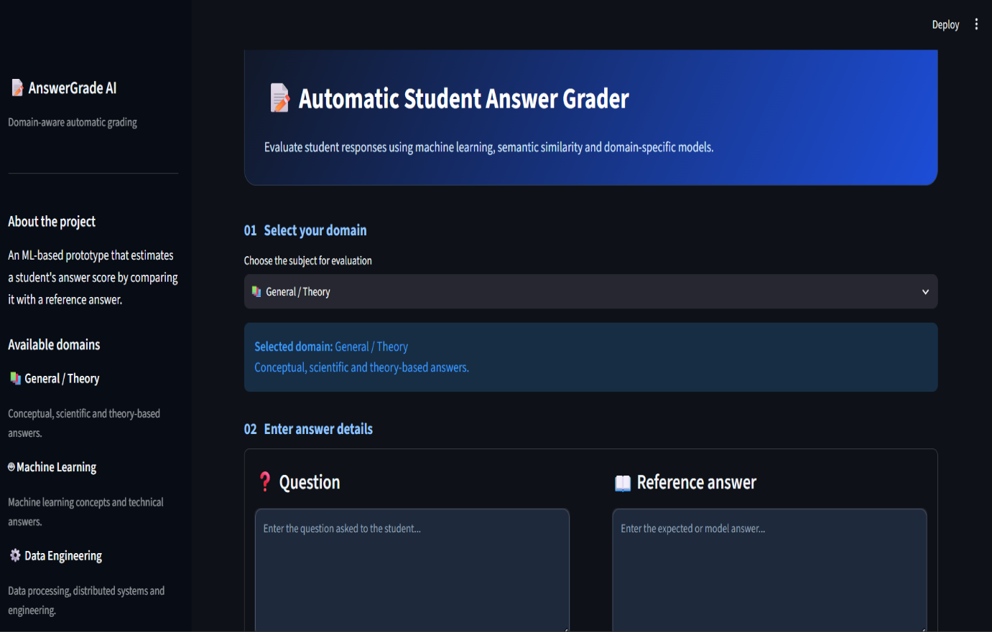

- Specific Student answer grading module

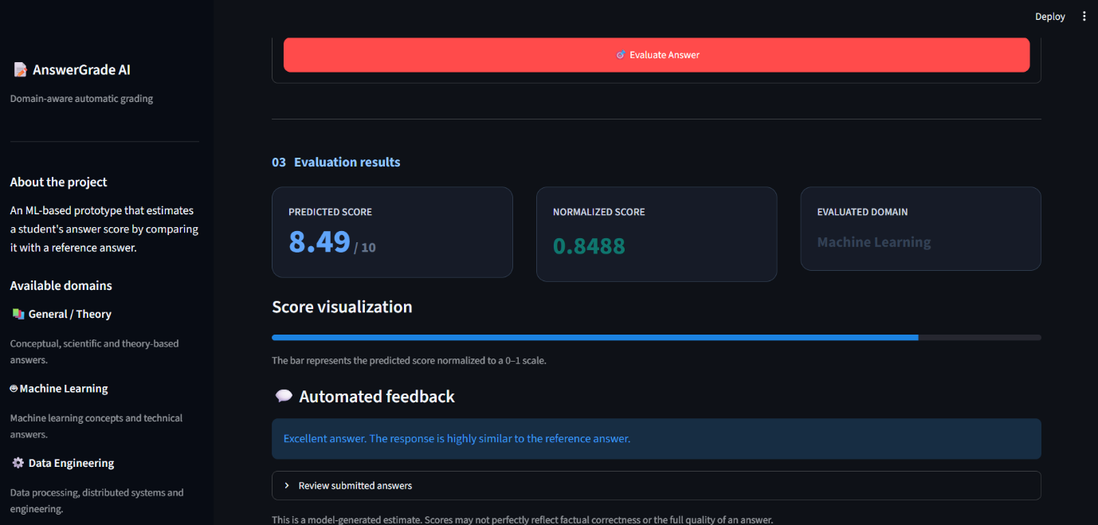

- Students Bulk answer grading module

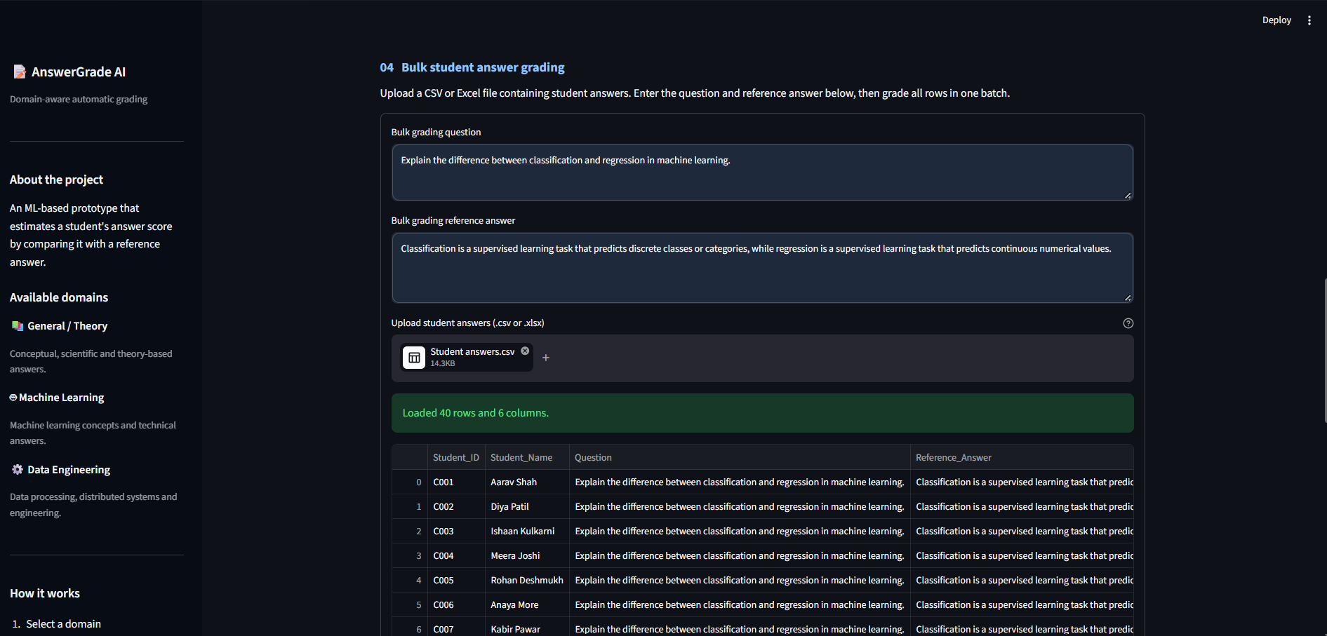

CONCLUSION
The project, “Domain-Aware Automatic Student Answer Grading Using Semantic Similarity and Machine Learning,” demonstrates the feasibility of automating student answer evaluation using Natural Language Processing and Machine Learning techniques. The system combines Sentence Transformer embeddings, TF-IDF similarity, and lexical features to estimate answer scores. A Random Forest regression model was developed and compared with a TF-IDF-based baseline, and a Streamlit application was implemented to support individual and bulk answer grading with automated feedback.
The experimental results show that the Random Forest model outperformed the baseline on the same validation split, reducing MAE from 0.4904 to 0.2621 and RMSE from 0.5767 to 0.3240. The project also explored domain-specific models for General/Theory, Machine Learning, and Data Engineering. However, testing identified limitations in detecting incorrect or contradictory answers, indicating that similarity alone is not sufficient to guarantee correctness. Future work will focus on incorporating contradiction detection, key-concept verification, and broader evaluation to improve grading reliability. The system can serve as a useful grading-assistance tool, with human review retained for dependable final assessment.

REFERENCES

1. Mohler, M., Bunescu, R., & Mihalcea, R. (2011). Learning to Grade Short Answer Questions Using Semantic Similarity Measures and Dependency Graph Alignments. Proceedings of the 49th Annual Meeting of the Association for Computational Linguistics: Human Language Technologies, 752–762. https://aclanthology.org/P11-1076/
2. Sultan, M. A., Salazar, C., & Sumner, T. (2016). Fast and Easy Short Answer Grading with High Accuracy. Proceedings of the 2016 Conference of the North American Chapter of the Association for Computational Linguistics: Human Language Technologies, 1070–1075. https://aclanthology.org/N16-1123/
3. Burrows, S., Gurevych, I., & Stein, B. (2015). The Eras and Trends of Automatic Short Answer Grading. International Journal of Artificial Intelligence in Education, 25, 60–117. https://doi.org/10.1007/s40593-014-0026-8
4. Reimers, N., & Gurevych, I. (2019). Sentence-BERT: Sentence Embeddings Using Siamese BERT-Networks. Proceedings of EMNLP-IJCNLP 2019, 3982–3992. https://aclanthology.org/D19-1410/
5. Devlin, J., Chang, M.-W., Lee, K., & Toutanova, K. (2019). BERT: Pre-training of Deep Bidirectional Transformers for Language Understanding. Proceedings of NAACL-HLT 2019, 4171–4186. https://aclanthology.org/N19-1423/
6. Pedregosa, F., et al. (2011). Scikit-learn: Machine Learning in Python. Journal of Machine Learning Research, 12, 2825–2830. https://jmlr.org/papers/v12/pedregosa11a.html
7. Reimers, N., & Gurevych, I. (2019). Sentence Transformers. Official documentation and pretrained sentence-embedding models. https://www.sbert.net/
8. ASAG2024 Dataset. Dataset used for training, validation, and testing in the proposed automatic student answer grading system. Include the original dataset publication or repository URL in the final report if available.

