Name: Vedant Balu Ghuge Date: 05.05.2026
Roll No.:20
Experiment No.: 10

AIML Mini Project – BI Report Details

TITLE
GRIDGUARD – AI-Based Transmission Project Delay & Risk Prediction

PROBLEM DEFINITION
Large-scale power transmission projects (lines/substations) frequently face schedule slippages due to multi-factor bottlenecks such as land/right-of-way issues, forest clearances, and vendor performance problems. Manual monitoring becomes difficult when the project portfolio grows.
Objective: Build a Business Intelligence (BI) dashboard that provides data-driven insights on: - Which projects are most likely to be delayed - What drivers (Vendor / Forest / RoW / schedule pace) are contributing to delay and high risk - How much “delay burden” different segments contribute (impact, not just averages) - Which projects should be prioritized for escalation (critical backlog)
The system should: - Analyze project portfolio behavior - Detect high-risk / high-delay patterns - Provide probability-style risk verdicts (Low/Medium/High labels in dataset) and delay magnitude (months) - Provide BI-ready KPIs, trends, and drilldowns to support fast decisions

SOFTWARE USED

Programming / Data Processing
- Python
- Pandas, NumPy, Shap, SciKit-Learn, Matplotlib, Streamlit

BI Tool
- Power BI Desktop (2.152.1279.0 64-bit, March 2026)

Supporting Tools
- VS Code
- Git/GitHub

DATASET USED
Dataset Name: GridGuard Dataset (70,000 projects)
File: dataset/GridGuard_Dataset_70000.csv

Dataset Characteristics (Observed)
- Rows: 70,000
- Target / Outcomes:
  - Actual_Delay_Months (delay magnitude)
  - Risk_Level (Low / Medium / High)
- Portfolio is heavily skewed toward High risk (typical in synthetic/operational risk labeling), so the dashboard focuses on prioritization and drivers rather than only class balance.

DESCRIPTION

a) Data Mining / Analytics Tasks Needed
This project performs the following analysis tasks for BI:
- Delay Analytics (Regression-style outcome)
- Goal: quantify how many months of delay exists.
- Field used: Actual_Delay_Months
- BI outputs:
  - Average delay
  - Percentile delay (P90)
  - Total delay months contribution (impact)
- Risk Analytics (Classification-style outcome)
- Goal: categorize projects into Low/Medium/High risk.
- Field used: Risk_Level
- BI outputs:
  - Risk distribution
  - High-risk percentage
  - High-risk segments and drivers
- Schedule Adherence & Pace Analysis
- Goal: detect whether projects are behind schedule based on elapsed time vs planned duration.
- Derived features used:
  - Schedule adherence ratio
  - Expected progress vs actual progress
  - Progress deficit
- Root Cause / Driver Analysis
- Goal: explain why delay and risk occur.
- Driver fields:
  - Vendor status
  - Forest clearance status
  - Land/RoW status
  - Bottleneck severity score
- BI outputs:
  - Key influencer explanation
  - Decomposition tree
  - Driver heatmaps and contribution analysis
- BI Decision Support (Backlog Prioritization)
- Goal: generate a “critical backlog” list for action.
- Uses combined logic (Critical Flag) such as:
  - High Risk + Insolvent vendor
  - High Risk + large progress deficit
  - High Risk + high bottleneck score

b) Important Features in Dataset
Feature | Description
Project_ID | Unique project identifier
Project_Type | Type of project (line/substation categories)
Region | Region of execution
Budget_Cr | Budget in Crore INR
Line_Length_CKM | Project length (CKM)
Planned_Duration_Months | Planned schedule duration
Time_Elapsed_Months | Time elapsed since start
Physical_Progress_Pct | Current physical progress (%)
Land_RoW_Status | Land / Right-of-Way status
Forest_Clearance_Status | Forest clearance stage
Vendor_Status | Vendor delivery/health status
Site_Engineer_Remark | Text remark about impediments
Actual_Delay_Months | Actual delay (months)
Risk_Level | Low / Medium / High risk label

c) Derived / Engineered Fields
- Schedule Adherence
- Schedule Adherence = Time_Elapsed_Months / Planned_Duration_Months
- Interpretation:
  - Higher values indicate higher consumption of planned schedule.
- Expected Progress Pct
- Expected Progress = min(100, Schedule Adherence * 100)
- Progress Deficit
- Progress Deficit = Expected Progress - Physical_Progress_Pct
- Interpretation:
  - Positive = behind schedule
  - Negative = ahead of schedule
- Bottleneck Score (0–6)
- Ordinal mapping of the three major impediment sources:
  - Land/RoW: Clear(0), Pending Local(1), Disputed(2)
  - Forest: Approved(0), Stage-II Awaited(1), Stage-I Awaited(2)
  - Vendor: On Track(0), Equipment Delayed(1), Insolvent(2)
- Bottleneck Score = Land Score + Forest Score + Vendor Score
- Critical Flag (Actionable Backlog) A rule-based escalation tag used in the dashboard for prioritization.

GRAPHS / IMPORTANT VISUALS
These are generated directly from the dataset.

1) Risk Mix
Risk mix donut
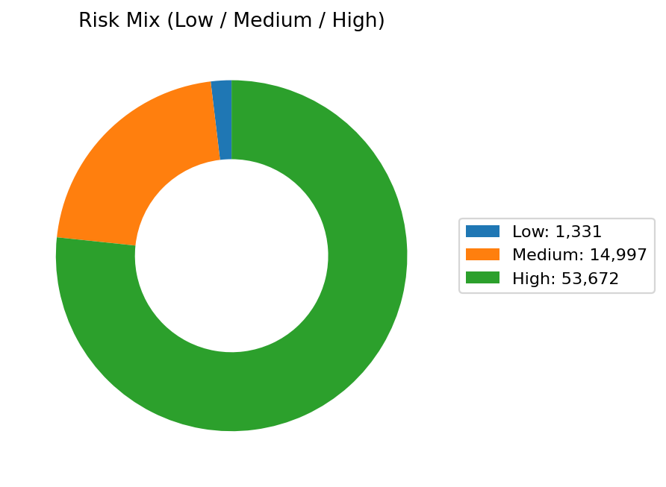

2) Delay Distribution
Delay distribution histogram

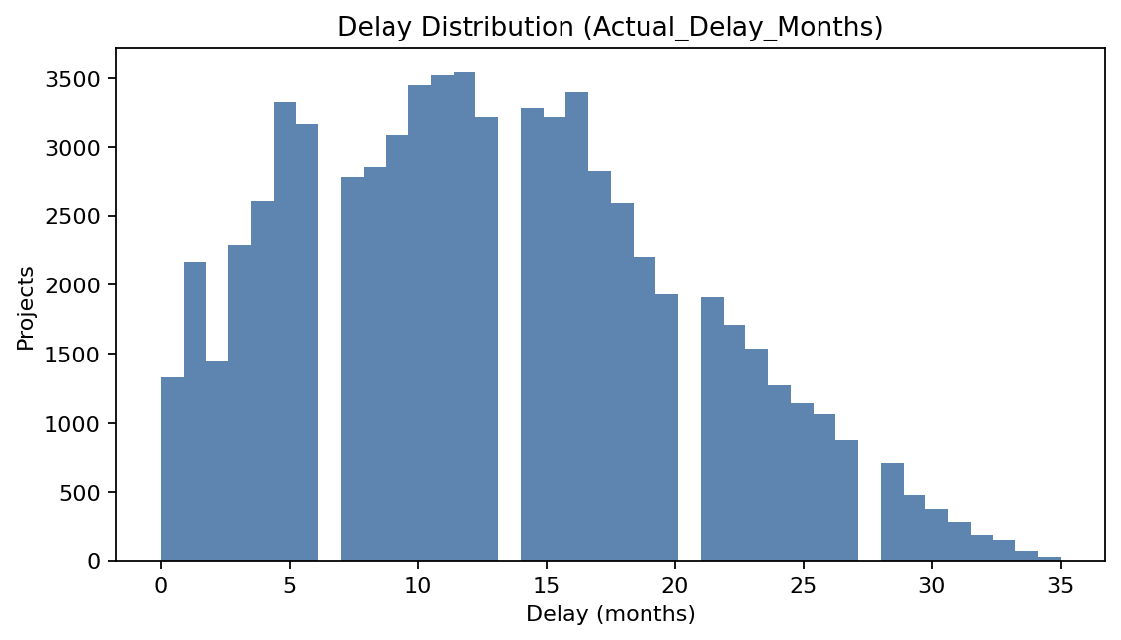

3) Average Delay by Region
Average delay by region

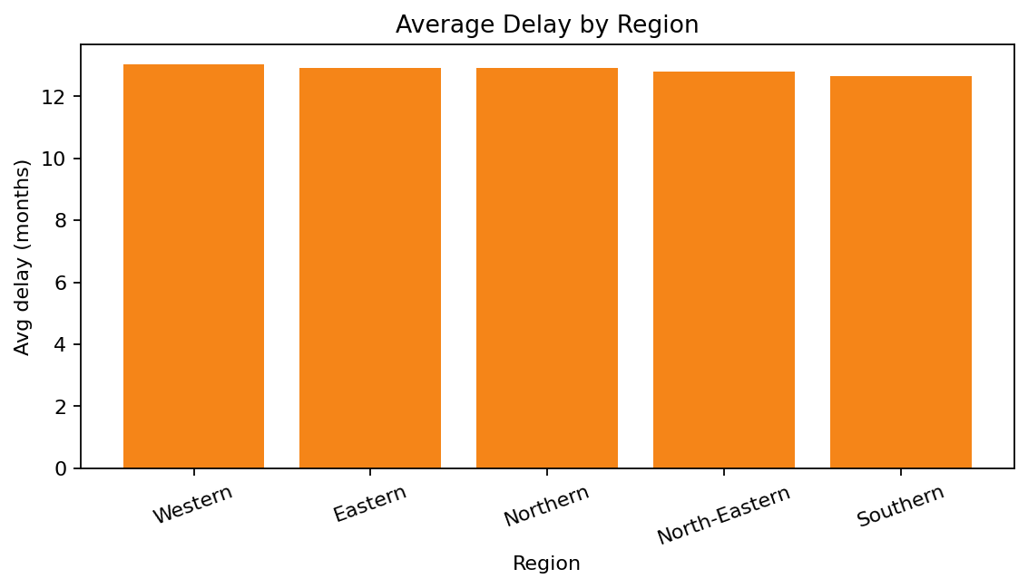

4) Bottleneck Severity Curve
Bottleneck severity curve
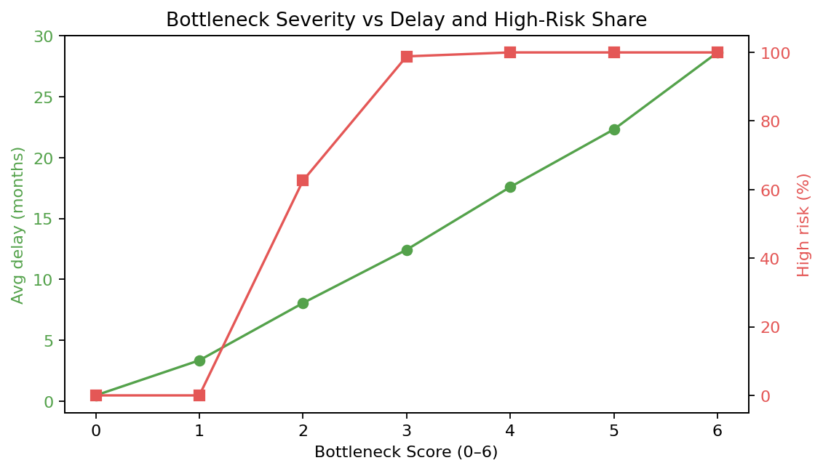

5) Waterfall (Style): Total Delay Contribution by Vendor
This represents the same idea as the Power BI waterfall: which segment contributes the most total delay months.
Waterfall delay contribution (vendor)

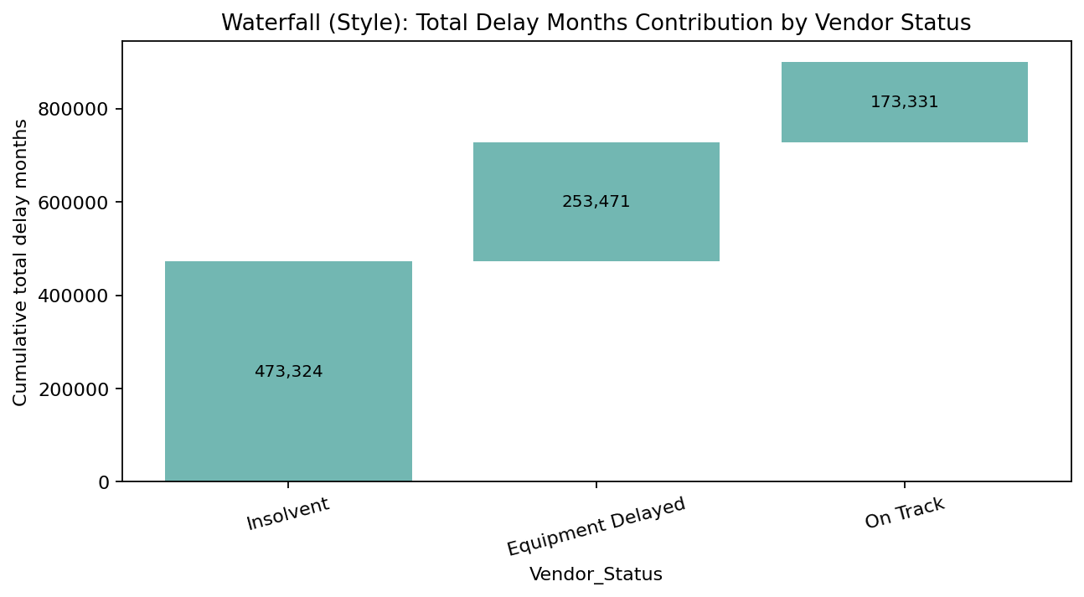

6) Driver Heatmap (Vendor × Forest)
Heatmap vendor vs forest avg delay
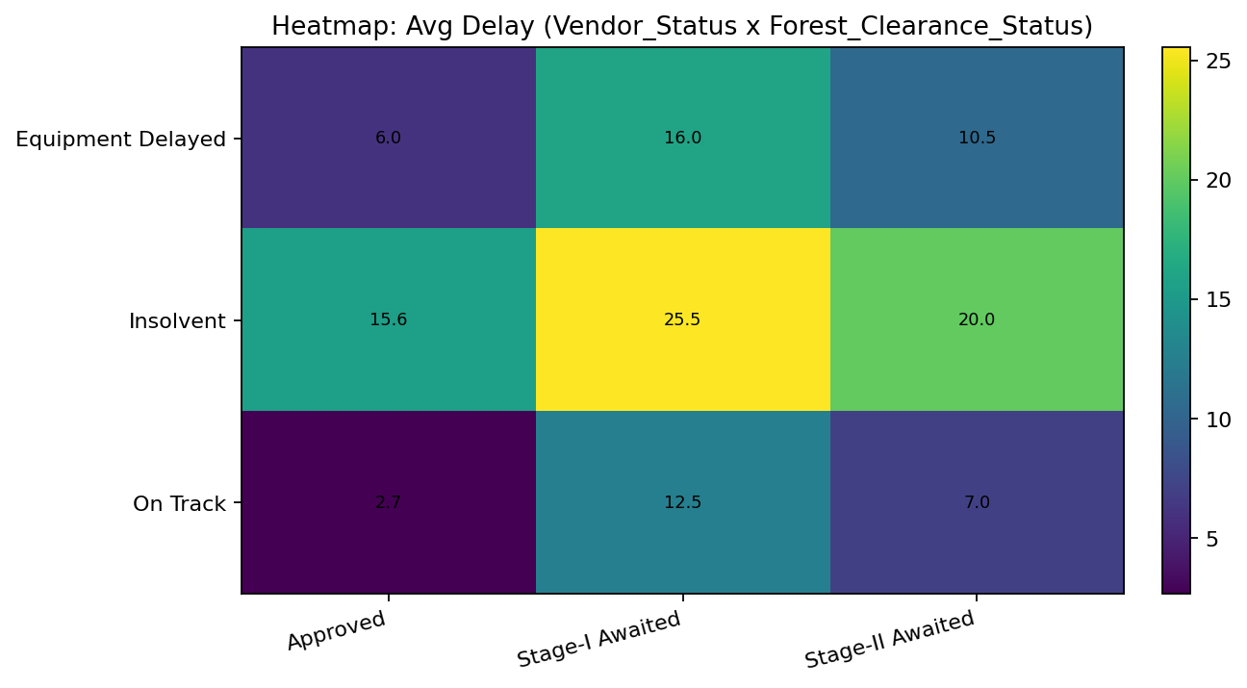

INTERPRETATION & VISUAL INSIGHTS (Examples)
- Progress Deficit vs Delay (Pace insight)
- Projects that are more behind schedule show higher average delay.
- Driver contribution vs averages
- Waterfall visual highlights which driver groups contribute the most total delay months across the portfolio.
- Bottleneck score effect
- As composite bottleneck severity increases (0 → 6), delay and high-risk share increase.
- Critical backlog
- BI allows focusing on a manageable subset of projects requiring escalation instead of scanning all 70k rows.

BI DECISIONS TAKEN FROM ANALYSIS
- Critical Project Escalation
- Use Critical Flag to identify projects that must be reviewed urgently.
- Driver-focused intervention
- Vendor insolvency: re-tendering / alternate vendor plan
- Stage-I forest pending: accelerate approvals / compliance documentation
- RoW disputed: district administration intervention
- Regional/portfolio monitoring
- Compare risk % and delay across regions with slicers and KPI cards.
- Execution pace monitoring
- Progress deficit and schedule adherence detect early warning signs.
- Management reporting
- Executive page supports weekly review; drilldown supports day-to-day follow-up.

IMPLEMENTATION SNAPSHOTS
- Simulation interface
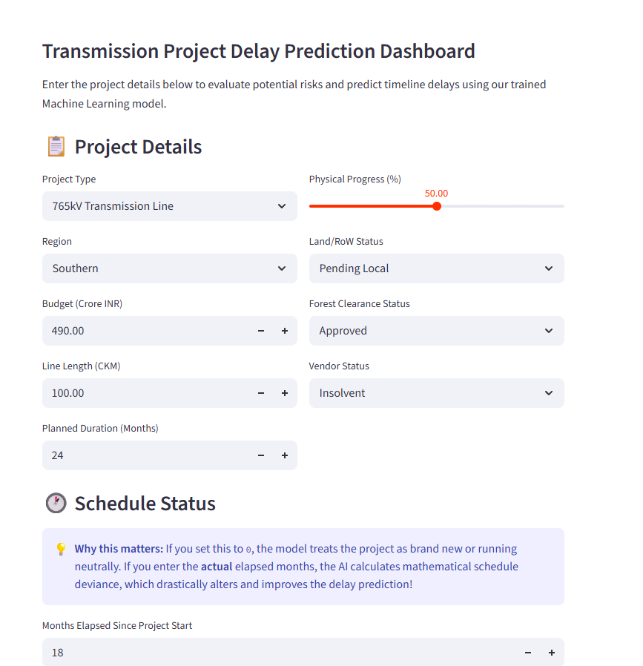

B) Waterfall Chart using XAI-SHAP
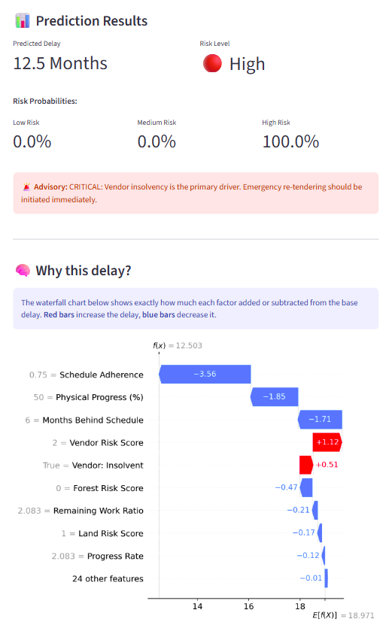

CODE SNAPSHOTS (KEY LOGIC)
These “snapshots” are the important code parts to show in the lab file (they explain how features and predictions are done).

Feature Engineering (Schedule + Bottleneck)
Source: feature_engineering.py
LAND_RISK_MAP = {
"Clear": 0,
"Pending Local": 1,
"Disputed": 2,
}
FOREST_RISK_MAP = {
"Approved": 0,
"Stage-II Awaited": 1,
"Stage-I Awaited": 2,
}
VENDOR_RISK_MAP = {
"On Track": 0,
"Equipment Delayed": 1,
"Insolvent": 2,
}
# Composite bottleneck severity (0–6)
df["composite_risk_score"] = (
df["land_risk_score"] + df["forest_risk_score"] + df["vendor_risk_score"]
)
# Schedule adherence ratio and progress deficit
df["schedule_adherence"] = np.where(
has_elapsed,
elapsed / planned,
progress / 100.0,
)
expected_pct = df["schedule_adherence"] * 100.0
df["progress_deficit"] = np.clip(expected_pct - progress, -100, 100)

Prediction Pipeline (One-hot alignment + scaling + outputs)
Source: predict.py
df_new = engineer_features(df_new)
df_encoded = pd.get_dummies(
df_new[num_cols + eng_cols + cat_cols],
columns=cat_cols,
)
for expected_col in train_columns:
if expected_col not in df_encoded.columns:
df_encoded[expected_col] = 0
df_encoded = df_encoded[train_columns]
X_new_scaled = scaler.transform(df_encoded.values)
delay_pred = float(best_reg.predict(X_new_scaled)[0])
risk_enc = int(best_clf.predict(X_new_scaled)[0])

SYSTEM / DATA FLOW DIAGRAM
flowchart LR
A[GridGuard_Dataset_70000.csv] --> B[Power Query Cleaning + Derived Columns]
B --> C[Power BI Data Model]
C --> D[DAX Measures + KPIs]
D --> E[3-Page Dashboard]
A --> F[Feature Engineering (Python)]
F --> G[Trained Model Bundle (.pkl)]
G --> H[Predictions: Delay + Risk]
H --> E

CONCLUSION
GridGuard demonstrates how BI + analytics-style features can convert raw portfolio data into actionable decision support. The dashboard not only shows risk and delay distribution, but also explains root causes via driver visuals (Key Influencers, Decomposition Tree), quantifies impact via delay contribution, and operationalizes decisions via a critical backlog list.

REFERENCES
[1] Liao Chenya, E. Aminudin, S. Mohd., and L. S. Yap, "Intelligent Risk Management in Construction Projects: Systematic Literature Review," IEEE Access, vol. 10, pp. 72936–72954, July 2022.
[2] A. Gondia, A. Siam, W. El-Dakhakhni, and A. H. Nassar, "Machine Learning Algorithms for Construction Projects Delay Risk Prediction," J. Constr. Eng. Manag., vol. 146, no. 1, p. 04019085, Jan. 2020.
[3] X. Li et al., "Transformer-Based Named Entity Recognition in Construction Supply Chain Risk Management," IEEE Access, vol. 9, pp. 120541-120553, 2021.
[4] T. Kim and S. Chi, "Accident Case Retrieval and Analyses: Using Natural Language Processing in the Construction Industry," J. Constr. Eng. Manag., vol. 145, no. 3, p. 04019004, Mar. 2019.
[5] L. Zhang, "Cost Control Management of Construction Projects Based on Machine Learning," IEEE Trans. Ind. Inform., vol. 16, no. 12, pp. 7821-7830, Dec. 2020.

