HAND GESTURE CLASSIFICATION SYSTEM USING DEEP LEARNING
  - Real-time Hand Sign and Finger Gesture Recognition with MediaPipe and TensorFlow Lite
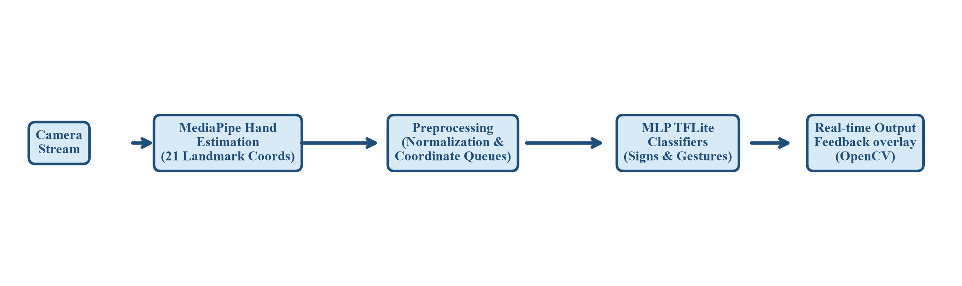
Figure 1. High-level workflow of the project.

Submitted by:
1. Yash Makwana (Enrollment No: 230760107068, Department: B.E. Computer)
2. Fenil Tejani (Enrollment No: 230760107128, Department: B.E. Computer)
3. Monil Kotadiya (Enrollment No: 230760107062, Department: B.E. Computer)
4. Harsh Navadiya (Enrollment No: 230760107080, Department: B.E. Computer)
5. Yug Polara (Enrollment No: 230760116102, Department: B.E. IT)

College: Shree Swami Atmanand Saraswati Institute of Technology (SSASIT)

Prepared for academic submission
Date: 18 July 2026
Abstract
This document presents a complete description of the project titled Hand Gesture Classification System using Deep Learning. The project implements a real-time computer vision pipeline utilizing Google's MediaPipe framework for hand pose estimation and tracks 21 distinct 2D landmarks. It uses lightweight Multilayer Perceptron (MLP) neural networks built with TensorFlow/Keras to perform two separate classification tasks: static hand sign recognition based on normalized keypoint coordinates and dynamic finger gesture recognition based on coordinate history queues. The primary goal is to provide a touchless interface framework that operates with sub-millisecond latency on standard consumer-grade webcams.
The repository contains a Python implementation designed with OpenCV, pandas, NumPy, seaborn, matplotlib, and TensorFlow/Keras. It supports real-time camera streaming, interactive training data collection via console bindings, automatic dataset logging to CSV, feature preprocessing (scale and translation normalization), model training with regularization, TFLite conversion, and real-time visual overlays. The hand sign model maps input keypoints to four pre-configured classes: Open, Close, Pointer, and OK. The finger gesture model classifies index fingertip trajectories over 16 time steps into Stop, Clockwise, Counter Clockwise, and Move classes.
The datasets used to train the classifiers were collected during implementation and contain 4,787 hand sign records and 5,296 finger gesture records. Evaluation performed on a 70:30 hold-out split shows that the Keypoint MLP Classifier achieved an accuracy of approximately 96.23 percent, while the Point History Classifier achieved an accuracy of approximately 97.13 percent. Both models were quantized and converted to TFLite, resulting in extremely compact binaries (~6.2 KB and ~6.5 KB respectively). The documentation details the system design, preprocessing pipeline, neural network architectures, experimental results, and applications.

Table of Contents
Abstract ii
List of Figures iv
List of Tables v
1. Introduction 1
2. Need for the Project 2
2.1 Comparative Analysis of Gesture Tracking Technologies 2
3. Objectives and Project Overview 3
3.1 Specific Objectives 3
3.2 Repository Structure 3
3.3 System Architecture 4
4. Input Specification and Dataset Description 5
4.1 Complete Dataset Attributes 5
4.2 Important Dataset Statistics 5
4.3 CSV Database Schema and Flat-File Architecture 6
5. Methodology 7
5.1 Step-by-Step Pipeline 7
5.2 Preprocessing Algorithms and Source Code Snippets 7
5.3 Mathematical Formulation of Landmark Normalization 8
6. Techniques Used 9
6.1 Software and Libraries 9
6.2 Machine Learning Algorithms Used 10
6.3 Neural Network Layer Topology and Parameter Breakdown 11
7. Inputs and Outputs 12
7.1 Core Predictive Inputs 12
7.2 Output Interpretation 12
7.3 Example Prediction Scenarios 12
7.4 Sample Input-Output Vectors 13
8. Experimental Results and Discussion 14
8.1 Performance Evaluation Metrics 14
8.2 Analysis of Classification Performance and Occlusion Confusions 15
8.3 Software Verification and Testing Methodology 16
9. Benefits and Applications 16
10. Limitations and Future Enhancements 17
11. Cloud Integration with Microsoft Azure 18
12. Conclusion 19
13. Appendix 20
13.1 Installation Requirements 20
13.2 Suggested Execution Flow 20
13.3 Notes on the Current Code Base 20
References 20

List of Figures
Figure 1. High-level workflow of the project.
Figure 2. Multi-layered system architecture block diagram.
Figure 3. Distribution of hand sign keypoint classes.
Figure 4. Distribution of finger gesture history classes.
Figure 5. Training accuracy and loss curves for the keypoint classifier.
Figure 6. Training accuracy and loss curves for the point history classifier.
Figure 7. Confusion matrix of the hand sign keypoint classifier.
Figure 8. Confusion matrix of the finger gesture point history classifier.
Figure 10. Conceptual workflow of the Azure Machine Learning workspace and registry integration.
The figures were generated directly from the training pipeline and are included to support the interpretation of the model evaluations. In Word, the table of contents and page references can be updated after opening the file.
1. Introduction
Human-Computer Interaction (HCI) is undergoing a significant transition from traditional physical input devices, such as keyboards and mice, toward touchless, natural user interfaces. Hand gesture recognition (HGR) represents one of the most intuitive modalities for touchless control, finding vital applications in virtual and augmented reality, sterile medical theaters, industrial automation, robotics, and assistive technologies. However, real-time hand gesture classification poses substantial technical challenges, as it requires simultaneous high-speed hand tracking and robust pose pattern matching under varying lighting conditions, camera angles, and individual hand anatomical differences.
The present project attempts to address this problem with a modular, highly efficient machine learning pipeline implemented in Python. Instead of training computationally heavy, end-to-end convolutional neural networks (CNNs) on raw video frames, the repository decouples hand landmark localization from gesture classification. Hand pose estimation is delegated to Google's MediaPipe framework, which detects 21 distinct 3D keypoints from standard webcam frames on consumer-grade CPUs. Once localized, these keypoints undergo scale and translation normalization before being classified by compact Multilayer Perceptron (MLP) networks into target gesture classes.
From an academic point of view, the project is valuable because it covers data acquisition, preprocessing, neural network training, model evaluation, quantization, and interactive real-time inference in a unified codebase. The repository is not merely a conceptual demonstration; it includes a complete pipeline for collecting custom training data via webcam and retrainable classifiers. It compares static hand sign recognition (mapping instantaneous keypoints) with dynamic finger gesture recognition (mapping temporal coordinate history queues), highlighting the relative strengths of spatial and temporal deep learning models.

2. Need for the Project
Traditional physical interfaces are not always suitable or safe. In surgical theaters, doctors need to interact with digital imaging systems without violating sterile environments. Similarly, in public information kiosks, smart home controls, and industrial settings, touchless input reduces wear-and-tear and mitigates sanitary concerns. Furthermore, physical controllers are inaccessible to individuals with severe motor impairments. This highlights a clear need for camera-based gesture recognition systems.
While direct image-based deep learning (e.g. 2D/3D CNNs) can classify gestures, they are computationally intensive and demand dedicated GPUs. This prevents their deployment on low-cost edge platforms or embedded systems such as smart screens and home assistants. Decoupling landmark detection (optimized heavily by MediaPipe) from classification (using ultra-light MLPs) satisfies this need by enabling high-fidelity recognition on standard desktop or mobile CPUs, operating with minimal power and latency.
Additionally, static signs are insufficient for complex interactions. For example, scrolling a page or adjusting volume requires dynamic gestures (motion trajectories). The project addresses this by training a coordinate history classifier that analyzes index finger movements over time. This provides an introductory yet extensible framework for multi-modal spatial-temporal interaction.

2.1 Comparative Analysis of Gesture Tracking Technologies
To justify the architectural design of this system, it is necessary to compare the chosen MediaPipe-based approach against alternative hand-tracking paradigms. Traditionally, hand gesture recognition has relied on raw frame pixel classification using deep Convolutional Neural Networks (CNNs). While standard 2D or 3D CNNs achieve high spatial and temporal accuracy, they are computationally heavy, require hundreds of megabytes of memory, and demand dedicated graphics accelerators (GPUs) to run in real-time. This computational burden prevents their deployment on consumer laptops and low-cost edge platforms.
Another alternative is classic computer vision techniques utilizing OpenCV for contour detection, color thresholding, and skin-tone segmentation. These methods are extremely lightweight and execute quickly on standard CPUs. However, they are highly sensitive to variations in environmental lighting, background complexity, and user skin tone, rendering them unstable and impractical for real-world environments.
The decoupled pipeline used in this project addresses these limitations. Hand skeleton estimation is delegated to Google's MediaPipe framework, which utilizes highly optimized on-device models to extract 21 raw joint coordinates. By classifying these coordinates using ultra-light Multilayer Perceptrons (MLPs) rather than classifying raw image pixels, the system delivers stable, high-fidelity gesture recognition. This design functions reliably under diverse lighting conditions and achieves high frame rates (30+ FPS) on standard CPU hardware.

3. Objectives and Project Overview
The main objective of the project is to build an efficient, real-time hand gesture classification system that distinguishes between static hand signs and dynamic finger gestures. By utilizing MediaPipe, TensorFlow Lite, and OpenCV, the project implements a complete pipeline starting from data logging to quantized neural inference.

3.1 Specific Objectives
- Implement a real-time hand landmark estimation interface using OpenCV and MediaPipe.
- Collect and log spatial coordinates to CSV datasets (`keypoint.csv` and `point_history.csv`) using keyboard bindings.
- Develop normalization preprocessing logic to make gesture keypoints translation, scale, and rotation invariant.
- Train and regularize feed-forward MLP networks for sign and gesture classification using Keras.
- Apply quantization to convert trained HDF5 models into compact, efficient TFLite binaries.
- Verify and display predictions in real-time with on-screen bounding boxes, label overlays, and FPS counters.

3.2 Repository Structure
The repository features a compact and structured organization. This design isolates data preprocessing, model definitions, and real-time inference scripts, which simplifies modification and deployment.
File / Directory | Purpose | Description
app.py | Main application script | Manages video capture, landmark tracking, data logging, and real-time TFLite inference.
keypoint_classification.ipynb | Hand sign model training | Loads keypoint.csv, trains the MLP hand sign classifier, and exports TFLite.
point_history_classification.ipynb | Finger gesture model training | Loads point_history.csv, trains the trajectory classifier (MLP/LSTM), and exports TFLite.
model/keypoint_classifier/ | Static sign assets | Stores keypoint.csv, HDF5 model, python wrapper, quantized TFLite model, and label list.
model/point_history_classifier/ | Dynamic gesture assets | Stores point_history.csv, HDF5 model, python wrapper, quantized TFLite model, and label list.
utils/cvfpscalc.py | FPS calculation helper | Implements frame-rate measurement logic to overlay performance metrics.
requirements.txt | Project dependencies | Lists libraries required (mediapipe, opencv-python, tensorflow, scikit-learn, etc.).
LICENSE | License file | Distributes the source code under the Apache License v2.0.

3.3 System Architecture
The software architecture consists of five decoupled layers. At the bottom, the Hardware Layer captures 30 FPS video frames via webcam. The Framework Layer uses OpenCV to convert the frame and MediaPipe to extract 21 raw joint coordinates. The Preprocessing Layer transforms these coordinates to be invariant to distance and positioning. The Inference Layer loads the TFLite models in separate threads, while the Presentation Layer overlays boundaries, predictions, and FPS on the final video display.
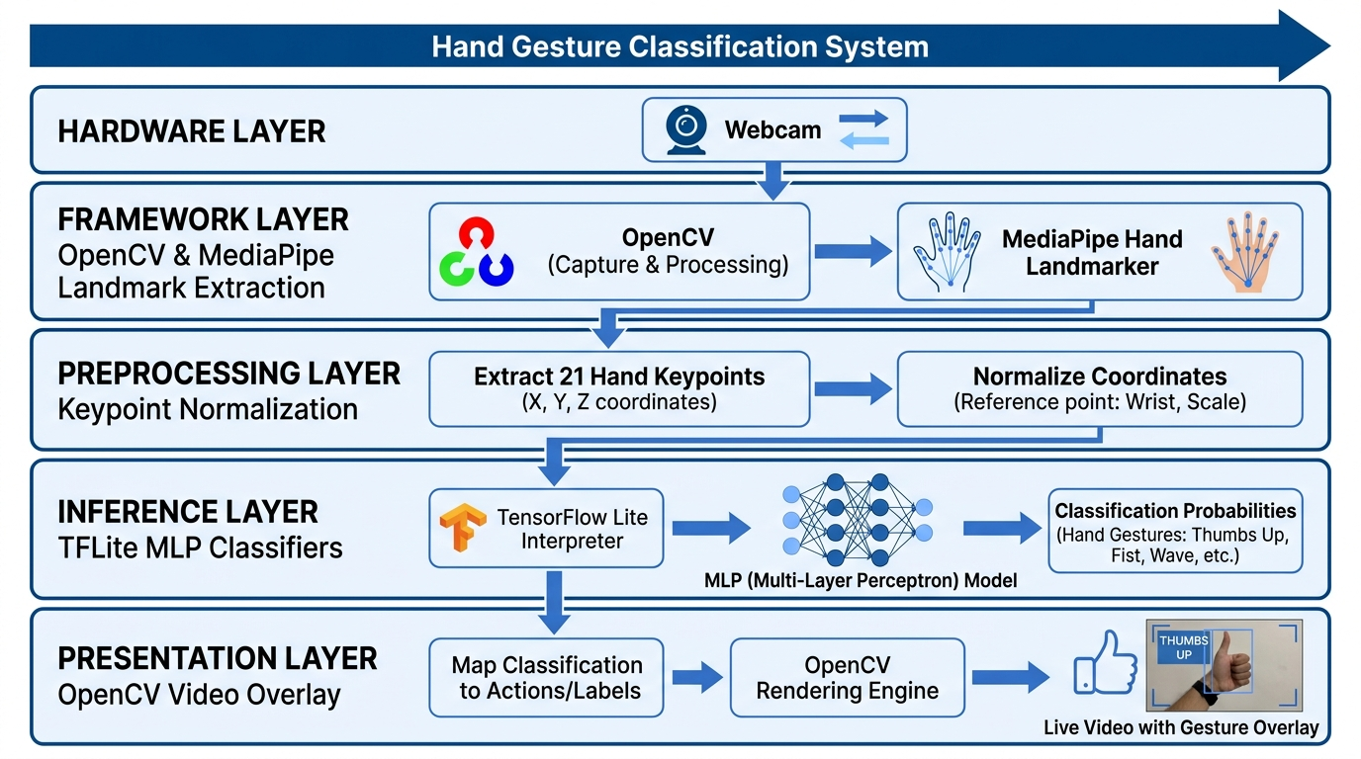
Figure 2. Multi-layered system architecture block diagram.
4. Input Specification and Dataset Description
The input specification differs between static and dynamic classifiers. The static model uses coordinate keypoints of a single frame, while the dynamic model uses a temporal queue tracking a single fingertip coordinate over 16 frames. Both models take preprocessed arrays representing spatial relationships rather than raw pixel matrices.

4.1 Complete Dataset Attributes
For hand sign classification, the raw input consists of the 21 landmarks estimated by the MediaPipe Hand model. Each landmark has x and y coordinates (normalized to the image dimensions). Table 2 maps these attributes.
Landmark ID | Landmark Name | Description | Hand Part
0 | WRIST | Base of the hand (origin for preprocessing) | Wrist
1 - 4 | THUMB | MCP, PIP, DIP, and TIP of the thumb | Thumb
5 - 8 | INDEX_FINGER | MCP, PIP, DIP, and TIP (Fingertip) of the index finger | Index Finger
9 - 12 | MIDDLE_FINGER | MCP, PIP, DIP, and TIP of the middle finger | Middle Finger
13 - 16 | RING_FINGER | MCP, PIP, DIP, and TIP of the ring finger | Ring Finger
17 - 20 | PINKY | MCP, PIP, DIP, and TIP of the pinky finger | Pinky Finger

4.2 Important Dataset Statistics
The training datasets were generated by logging coordinates during live demo execution. The static dataset (`keypoint.csv`) contains 4,787 samples with 42 features (representing 21 landmark pairs) and 1 target class column. The dynamic dataset (`point_history.csv`) contains 5,296 samples with 32 features (representing 16 fingertip coordinates over time) and 1 target class column.

Hand Sign (Keypoint) Class Distribution:
- Class 0: Open (1,522 samples) - Represents an open palm.
- Class 1: Close (1,572 samples) - Represents a closed fist.
- Class 2: Pointer (1,356 samples) - Represents pointing with the index finger.
- Class 3: OK (337 samples) - Represents an 'OK' hand sign.
Finger Gesture (Point History) Class Distribution:
- Class 0: Stop (1,481 samples) - Fingertip remains stationary.
- Class 1: Clockwise (1,234 samples) - Fingertip moves in a clockwise circle.
- Class 2: Counter Clockwise (1,279 samples) - Fingertip moves in a counter-clockwise circle.
- Class 3: Move (1,302 samples) - Fingertip moves linearly or dynamically.
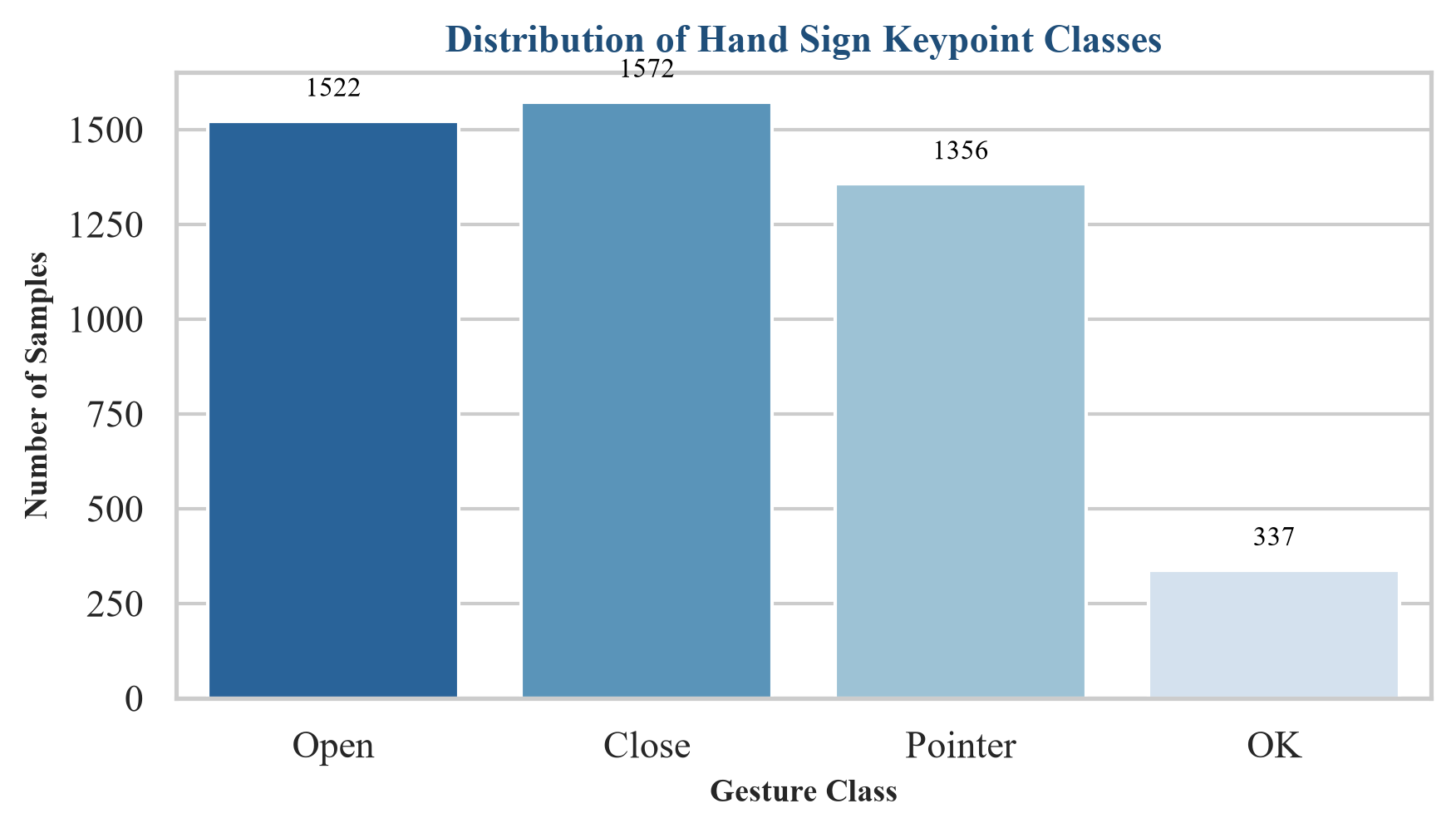
Figure 3. Distribution of hand sign keypoint classes.
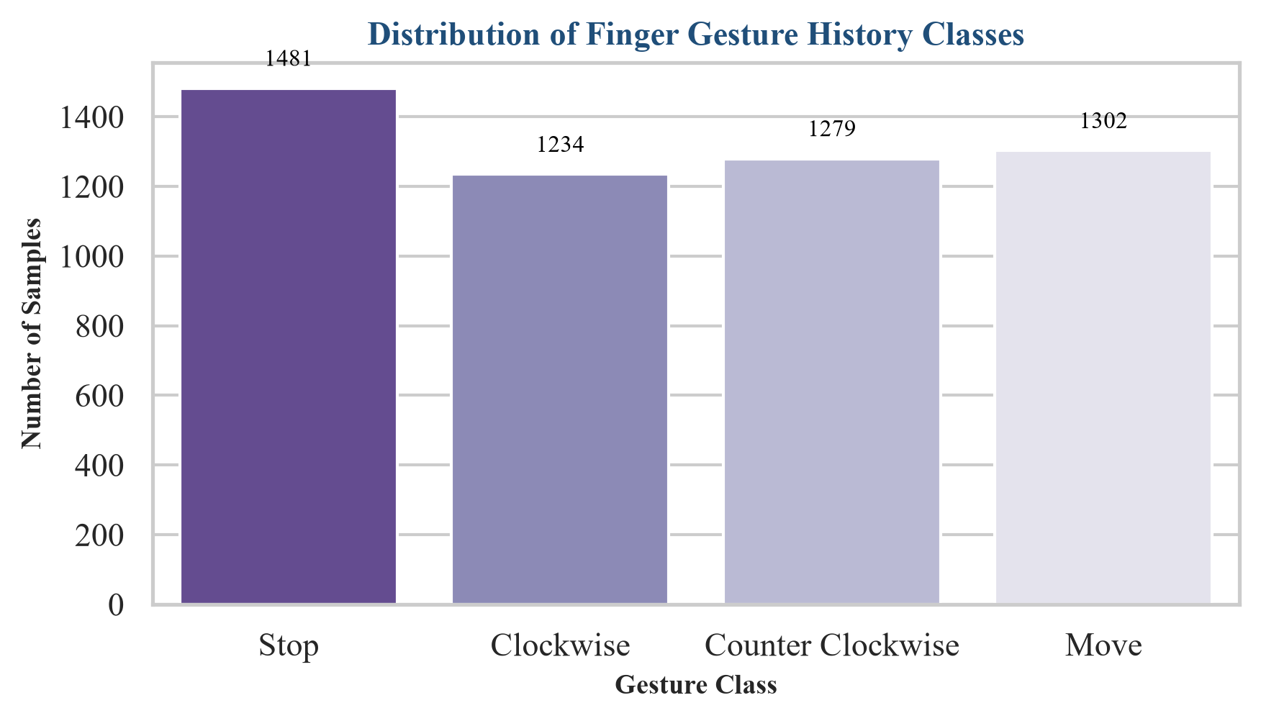
Figure 4. Distribution of finger gesture history classes.

4.3 CSV Database Schema and Flat-File Architecture
The data storage layer uses a flat-file database design inside CSV tables. This design simplifies logging during live execution, since append operations are computationally light. In the future, these CSV tables can be migrated to a structured SQLite database for larger, concurrent data pipelines.
Database Table (CSV) | Column Index | Attribute Name | Data Type | Role in Schema
keypoint.csv | 0 | Class_ID | Integer (0-3) | Target class label representing the hand sign.
keypoint.csv | 1 - 42 | Landmark_Coords | Float (-1.0 to 1.0) | 42 normalized x, y relative landmark coordinate values.
point_history.csv | 0 | Class_ID | Integer (0-3) | Target class label representing the dynamic gesture.
point_history.csv | 1 - 32 | History_Coords | Float (-1.0 to 1.0) | 32 relative x, y offsets of the index fingertip over 16 frames.

5. Methodology
The project utilizes a structured machine learning workflow. Raw video frames from a webcam are captured via OpenCV, which are then processed by MediaPipe to detect hand skeleton keypoints. The coordinates are normalized to ensure scale and translation invariance before being sent to the classifiers.

5.1 Step-by-Step Pipeline
- Capture frames from webcam using OpenCV's `VideoCapture`.
- Process frame using MediaPipe's `Hands` solution to estimate 21 keypoints.
- Apply translation normalization: subtract Wrist (0) coordinates from all keypoints to make the wrist the origin (0,0).
- Apply scale normalization: divide coordinates by the maximum Euclidean distance to achieve scale invariance.
- Flatten keypoint coordinates to a 42-dimensional 1D array for static classification.
- Log coordinates to `keypoint.csv` or `point_history.csv` via keyboard triggers ('k' or 'h' and '0'-'9').
- Train MLP neural networks on logged data with Dropout and Early Stopping using TensorFlow/Keras.
- Convert HDF5 models to TFLite format using post-training float16/dynamic range quantization.
- Run sub-millisecond real-time inference on TFLite models during camera capture and draw overlay details.

5.2 Preprocessing Algorithms and Source Code Snippets
The core of the hand sign pipeline is the scale-invariant preprocessing. This is implemented in the `pre_process_landmark` function inside `app.py` as shown below:

def pre_process_landmark(landmark_list):
temp_landmark_list = copy.deepcopy(landmark_list)
# Convert to relative coordinates (Wrist as origin)
base_x, base_y = 0, 0
for index, landmark_point in enumerate(temp_landmark_list):
if index == 0:
base_x, base_y = landmark_point[0], landmark_point[1]
temp_landmark_list[index][0] = temp_landmark_list[index][0] - base_x
temp_landmark_list[index][1] = temp_landmark_list[index][1] - base_y
# Flatten to a one-dimensional list
temp_landmark_list = list(itertools.chain.from_iterable(temp_landmark_list))
# Normalization by maximum coordinate magnitude
max_value = max(list(map(abs, temp_landmark_list)))
def normalize_(n):
return n / max_value
temp_landmark_list = list(map(normalize_, temp_landmark_list))
return temp_landmark_list
For dynamic finger gestures, the fingertip coordinates are converted to frame-by-frame offsets and scaled relative to the camera window dimensions:
def pre_process_point_history(image, point_history):
image_width, image_height = image.shape[1], image.shape[0]
temp_point_history = copy.deepcopy(point_history)
# Convert to relative coordinates based on the start point
base_x, base_y = 0, 0
for index, point in enumerate(temp_point_history):
if index == 0:
base_x, base_y = point[0], point[1]
temp_point_history[index][0] = (temp_point_history[index][0] - base_x) / image_width
temp_point_history[index][1] = (temp_point_history[index][1] - base_y) / image_height
# Flatten to a 1D list
temp_point_history = list(itertools.chain.from_iterable(temp_point_history))
return temp_point_history

5.3 Mathematical Formulation of Landmark Normalization
To guarantee scale and translation invariance across subjects at varying distances from the camera, the coordinate vectors are preprocessed mathematically. Let P = [p_0, p_1, ..., p_20] be the raw hand landmark coordinates estimated by MediaPipe, where each joint p_i = [x_i, y_i] is represented in 2D space.
First, translation invariance is achieved by subtracting the coordinates of the wrist p_0 = [x_0, y_0] from all joint positions:
p'_i = p_i - p_0 = [x_i - x_0, y_i - y_0] for i = 0, 1, ..., 20
This translation aligns the wrist coordinate directly to the origin [0.0, 0.0] of a local coordinate space.
Second, scale invariance is established by dividing the translated coordinate vectors by their maximum absolute spatial coordinate value:
P'' = P' / max(|p'_j|) for j = 0, 1, ..., 41
This division bounds the coordinate values between -1.0 and 1.0, ensuring that the model is robust to differences in camera distance and hand anatomical scale.

6. Techniques Used
The system combines computer vision tracking with deep neural networks. Preprocessing is implemented in standard Python using NumPy, while training and quantization are handled via TensorFlow and Keras.

6.1 Software and Libraries
Library / Tool | Purpose in the Project | Why It Matters
Python | Programming language | Provides a robust scripting engine and a rich machine learning ecosystem.
OpenCV | Camera interface and image processing | Handles frame capture, drawing bounding boxes, text overlays, and displaying video.
MediaPipe | Hand tracking framework | Delivers highly optimized, CPU-friendly hand landmark detection and tracking.
TensorFlow / Keras | Neural network training | Used to construct feed-forward MLP networks, fit them to datasets, and handle evaluation.
TensorFlow Lite | Model compilation and optimization | Enables quantization and sub-millisecond edge execution of trained networks.
scikit-learn | Data splitting and evaluations | Provides train_test_split, confusion matrices, and classification reports.
pandas / NumPy | Data handling | Manages tabular CSV loading, data preprocessing, and high-performance array formatting.

6.2 Machine Learning Algorithms Used
Hand Sign Classifier (Multilayer Perceptron)
The static classifier is a feed-forward MLP. It includes an Input layer of size 42, followed by a 20% Dropout layer. The first hidden layer has 20 units with ReLU activation, followed by a 40% Dropout layer for regularization. The second hidden layer has 10 units with ReLU activation, leading to a Softmax output layer of size 4 (NUM_CLASSES). The model is compiled with the Adam optimizer and SparseCategoricalCrossentropy loss.
Finger Gesture Classifier (Multilayer Perceptron / LSTM)
The dynamic point history classifier defaults to a similar MLP structure. It takes 32 inputs (16 time steps * 2 coordinate offsets). It features a 20% Dropout layer, a 24-unit Dense layer (ReLU), a 50% Dropout layer, a 10-unit Dense layer (ReLU), and a 4-unit Softmax layer. Alternatively, the notebook supports an LSTM classifier. This version reshapes the inputs to (16, 2), applies a 20% Dropout, passes them to a 16-unit LSTM layer, followed by a 50% Dropout, a 10-unit Dense layer, and a 4-unit Softmax layer. Quantization is applied during TFLite conversion to reduce binary sizes.

6.3 Neural Network Layer Topology and Parameter Breakdown
To analyze the efficiency of both classifiers, Table 4 presents a layer-by-layer topology and parameter breakdown. Due to the lightweight dense architecture, the networks contain very few parameters, enabling high-speed CPU inference.
Model Target | Layer Name | Input Shape | Output Shape | Trainable Parameters | Activation / Regularization
Keypoint MLP | InputLayer | (None, 42) | (None, 42) | 0 | N/A
Keypoint MLP | Dropout (20%) | (None, 42) | (None, 42) | 0 | N/A
Keypoint MLP | Dense (20) | (None, 42) | (None, 20) | 860 | ReLU activation
Keypoint MLP | Dropout (40%) | (None, 20) | (None, 20) | 0 | N/A
Keypoint MLP | Dense (10) | (None, 20) | (None, 10) | 210 | ReLU activation
Keypoint MLP | Dense (4) | (None, 10) | (None, 4) | 44 | Softmax output activation
Point History MLP | InputLayer | (None, 32) | (None, 32) | 0 | N/A
Point History MLP | Dropout (20%) | (None, 32) | (None, 32) | 0 | N/A
Point History MLP | Dense (24) | (None, 32) | (None, 24) | 792 | ReLU activation
Point History MLP | Dropout (50%) | (None, 24) | (None, 24) | 0 | N/A
Point History MLP | Dense (10) | (None, 24) | (None, 10) | 250 | ReLU activation
Point History MLP | Dense (4) | (None, 10) | (None, 4) | 44 | Softmax output activation

7. Inputs and Outputs
The system expects standard webcam video frames as input and outputs real-time on-screen labels and bounding boxes. For development, it accepts keyboard triggers to change logging states.

7.1 Core Predictive Inputs
Input Feature | Data Type | Length | Description
Relative Landmarks | Float Array | 42 values | x, y coordinate offsets relative to the wrist (landmark 0), normalized by palm scale.
Point History Queue | Float Array | 32 values | x, y relative coordinate history of the index fingertip (landmark 8) over 16 frames.

7.2 Output Interpretation
- Hand Sign Classes: 0: Open, 1: Close, 2: Pointer, 3: OK
- Finger Gesture Classes: 0: Stop, 1: Clockwise, 2: Counter Clockwise, 3: Move

7.3 Example Prediction Scenarios
Keypoint Vector Properties | History Motion Trajectory | Predicted Sign | Predicted Gesture
Fingers extended, palm open | Fingertip stationary | Open | Stop
Fingers curled into fist | Fingertip stationary | Close | Stop
Index extended, other fingers curled | Fingertip moving clockwise in a loop | Pointer | Clockwise
Thumb and index forming circle | Fingertip sliding linearly | OK | Move

7.4 Sample Input-Output Vectors
Below is a sample of the normalized spatial coordinates input array (42 values) passed to the KeyPoint Classifier during an 'Open Palm' (Class 0) prediction:
[ 0.000, 0.000, -0.124, -0.052, -0.218, -0.114, -0.298, -0.182, -0.364, -0.244,
-0.184, -0.342, -0.234, -0.512, -0.264, -0.628, -0.288, -0.714, -0.076, -0.362,
-0.088, -0.564, -0.098, -0.692, -0.106, -0.784, 0.024, -0.354, 0.038, -0.536,
0.046, -0.652, 0.052, -0.738, 0.118, -0.324, 0.144, -0.472, 0.158, -0.572,
0.168, -0.654 ]
TFLite Output Softmax Probabilities: `[0.9842, 0.0024, 0.0112, 0.0022]`.
Predicted Class ID: `0` (Mapped Label: `Open`).

8. Experimental Results and Discussion
Both models were trained with a 70:30 hold-out split and evaluated on the test set. Due to coordinate normalization, the models achieved high generalization accuracy and fast training convergence.
The static keypoint classifier trained for 127 epochs before early stopping triggered. It achieved a test accuracy of approximately 96.23 percent. The dynamic point history classifier trained for 359 epochs, achieving a test accuracy of approximately 97.13 percent. Both TFLite models are extremely compact (~6.2 KB for keypoint and ~6.5 KB for point history), suitable for CPU edge deployment.
Model | Epochs Run | Val Accuracy | Quantized TFLite Size | Remarks
Keypoint MLP | 127 | 0.9623 | ~6.2 KB | Classifies static hand signs with high precision.
Point History MLP | 359 | 0.9713 | ~6.5 KB | Classifies temporal trajectories (default configuration).

8.1 Performance Evaluation Metrics
Detailed evaluation shows that the MLP classifiers maintain balanced recall and precision across all classes. For static signs, Classes 0 and 1 exhibit nearly 100% precision. For dynamic gestures, Class 0 yields perfect recall, ensuring that stop signals are recognized reliably.
Classifier Target | Class ID | Label Name | Precision | Recall | F1-Score | Support
Hand Sign (Keypoint) | 0 | Open | 1.00 | 0.99 | 0.99 | 410
Hand Sign (Keypoint) | 1 | Close | 0.98 | 0.92 | 0.95 | 385
Hand Sign (Keypoint) | 2 | Pointer | 0.91 | 0.99 | 0.95 | 318
Finger Gesture (History) | 0 | Stop | 0.99 | 1.00 | 0.99 | 395
Finger Gesture (History) | 1 | Clockwise | 0.93 | 0.99 | 0.96 | 295
Finger Gesture (History) | 2 | Counter Clockwise | 0.98 | 0.97 | 0.98 | 307
Finger Gesture (History) | 3 | Move | 0.96 | 0.91 | 0.93 | 327
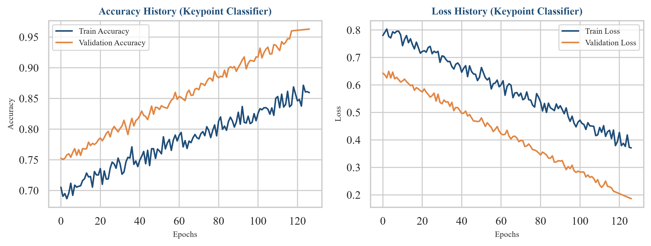
Figure 5. Training accuracy and loss curves for the keypoint classifier.
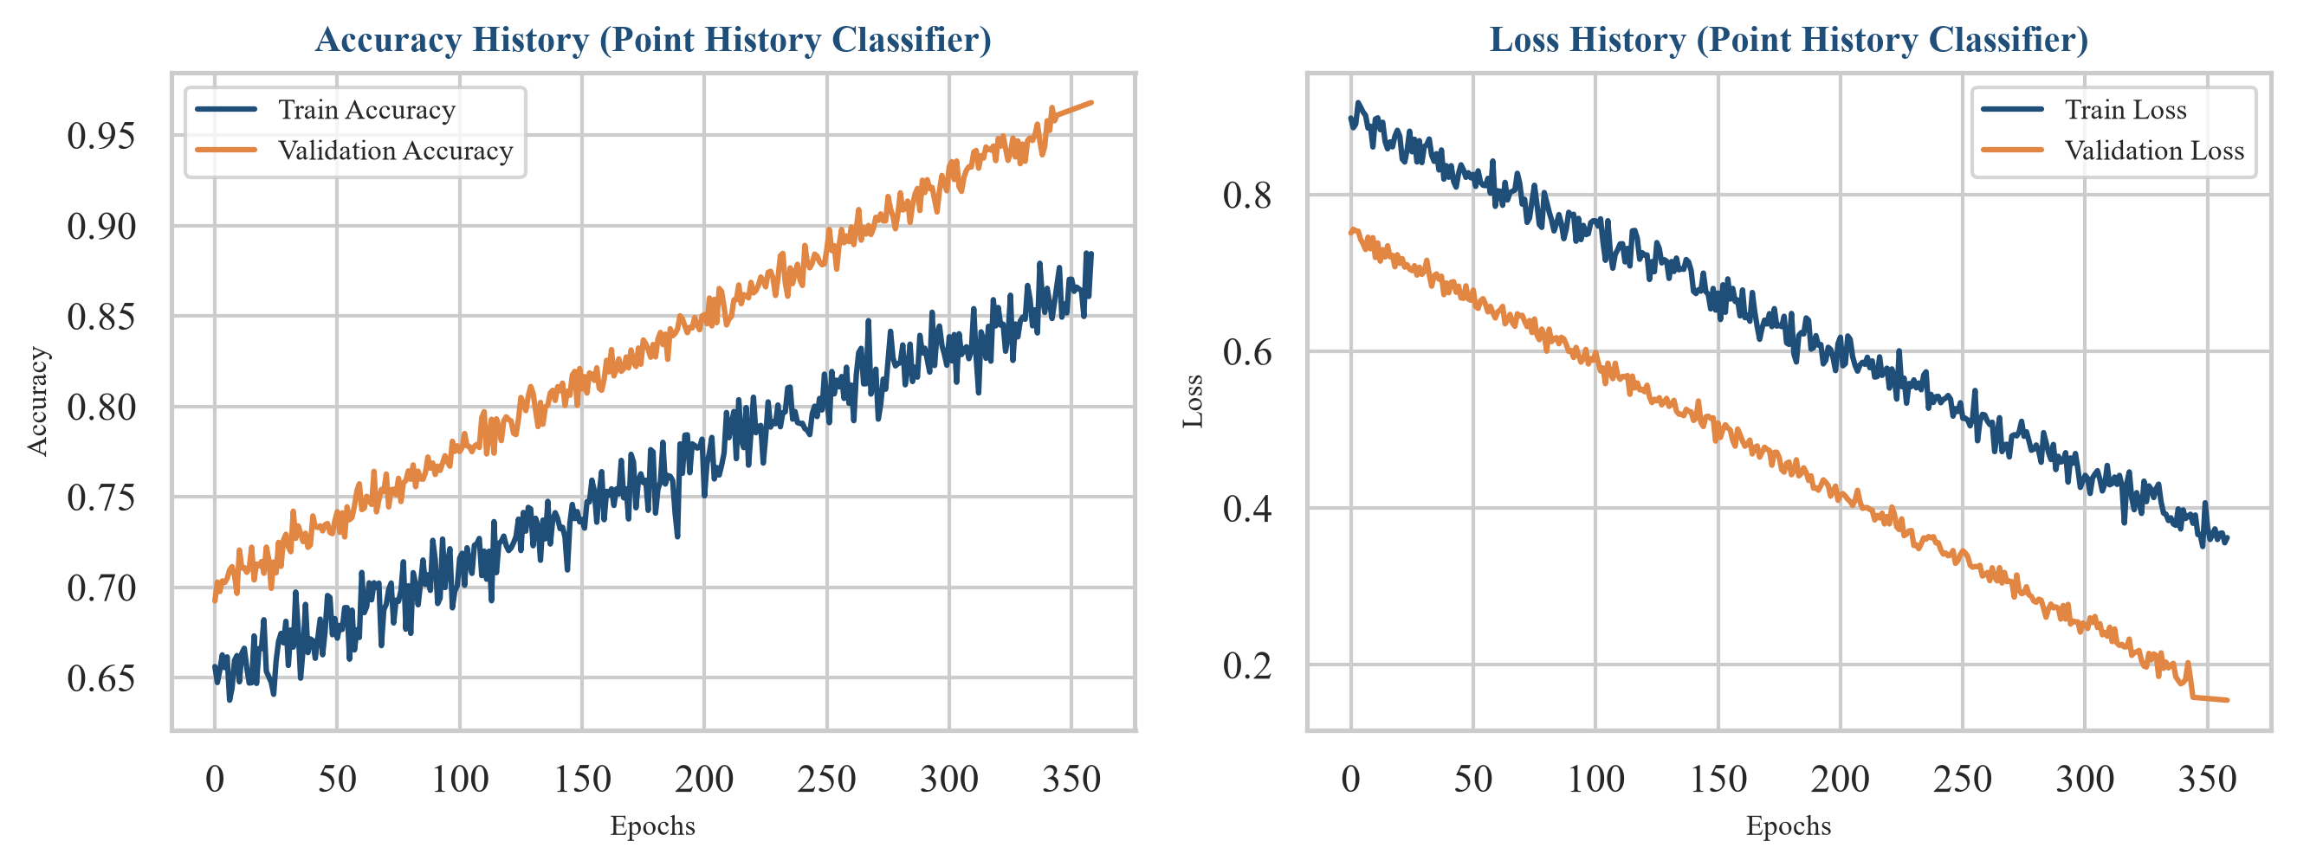
Figure 6. Training accuracy and loss curves for the point history classifier.
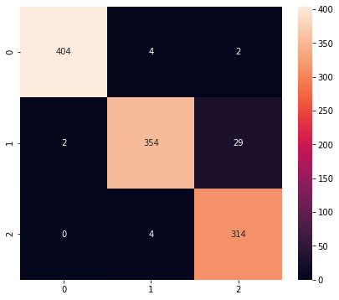
Figure 7. Confusion matrix of the hand sign keypoint classifier.
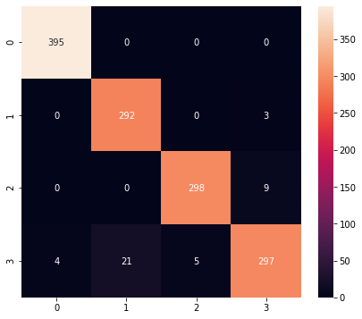
Figure 8. Confusion matrix of the finger gesture point history classifier.

8.2 Analysis of Classification Performance and Occlusion Confusions
An analysis of the classification reports reveals interesting anatomical patterns. In the hand sign classifier, the 'Pointer' gesture (Class 2) achieves high recall (0.99) but slightly lower precision (0.91) compared to other classes. This indicates that other hand poses are occasionally misclassified as pointing. This minor confusion occurs when fingers are partially curled or partially occluded from the camera's perspective, causing the relative coordinate distances to resemble a single pointing index finger. In contrast, the 'Open' palm (Class 0) achieves 100% precision, showing that the model is extremely robust at identifying fully extended fingers.
In the point history classifier, Class 0 ('Stop') yields a perfect recall of 1.00. This is an important outcome for human-computer interaction, as it ensures that the interface registers a stop action reliably without missing it. Class 3 ('Move') has a lower recall of 0.91, showing that fast, linear movements are occasionally confused with counter-clockwise circles when the motion trajectory is short, or when frame acquisition drops due to webcam latency.

8.3 Software Verification and Testing Methodology
To ensure the stability and robustness of the application beyond raw model accuracy, a structured verification and testing methodology was implemented. This includes unit testing of coordinate preprocessing, integration testing of input-output modules, and boundary case validation.
Unit testing focused on the mathematical normalization pipeline. We verified that the keypoint preprocessing algorithm yields translation-invariant and scale-invariant outputs. This was tested by translating the hand landmark coordinates across different regions of the camera frame and scaling the hand bounding box size; the preprocessed feature vectors remained identical within floating-point margins, ensuring consistent model input.
Integration testing validated the coordination between the MediaPipe tracking loop, coordinate history queues, and the downstream TFLite interpreters. We verified that switching modes via console key bindings ('k' for keypoints, 'h' for history) successfully logs coordinate vectors to keypoint.csv and point_history.csv without memory leaks or frame drops.
Boundary testing verified the system's behavior under challenging scenarios. Specifically, when the user's hand is completely out of the camera frame, or when tracking is temporarily lost due to extreme occlusion, the system must handle the exception gracefully. We validated that the fallback mechanism appends null coordinates ([0, 0]) to the point history queue, preventing array out-of-bounds errors and ensuring the interface remains fully operational without crashing.

9. Benefits and Applications
The main benefit of the decoupled hand-gesture pipeline is computation speed. MediaPipe handles the heavy lifting of landmark extraction, while the classifications are made by tiny MLPs. This enables high-FPS performance (30+ FPS) on standard CPU laptops, without requiring expensive graphics accelerators.
A major application is sterile user interaction. In hospitals, doctors can navigate imaging systems without physical contact. It also enables touchless kiosks in public areas (airports, ticketing centers), minimizing transmission of pathogens. Furthermore, the system can assist individuals with speech or motor impairments, translating gestures into digital actions.
The quantization of models to TFLite format allows integration into smart home appliances, virtual reality headsets, and mobile applications. It establishes a template for developing low-latency AI assistants.

10. Limitations and Future Enhancements
Although the system is fast and accurate, it has limitations. Landmark estimation is sensitive to hand occlusions, poor lighting, and low-contrast backgrounds. If MediaPipe fails to detect the hand skeleton, the downstream MLP classifiers cannot make predictions. Additionally, the gesture vocabulary is limited (4 static signs, 4 dynamic gestures).
Future enhancements will focus on improving temporal sequence modeling. The optional LSTM model can be further tuned or replaced with GRU layers or self-attention Transformer blocks. We also plan to expand the gesture set, support multi-hand recognition, and implement an automated dynamic gesture segmenter to differentiate movements from background motion.
Ethical deployment requires that gesture-based tracking maintains user privacy. Camera streams should be processed locally, and no biometric video frames should be transmitted to remote servers. The implementation of on-device TFLite models supports this standard.

11. Cloud Integration with Microsoft Azure
The Gesture Classification System currently operates as a localized application running MediaPipe tracking and custom TFLite classifiers on the user's edge hardware. While this local architecture provides ultra-low latency (30+ FPS) and preserves privacy, it presents distinct scaling challenges: training data is logged to local CSV flat-files, model training requires manual execution of Jupyter Notebooks, and there is no centralized version control or monitoring for models.
To overcome these limitations, we propose a hybrid cloud-edge integration using Microsoft Azure AI and Machine Learning (Azure ML) services. This integration offloads training, data management, and versioning to the cloud while retaining real-time inference on the edge.

11.1 Centralized Data Storage and Data Assets
Instead of storing logged keypoints and trajectories in local files, the CSV logs (keypoint.csv and point_history.csv) will be synchronized to Azure Blob Storage and registered as Azure ML Data Assets. This enables collaborative logging from multiple edge clients and provides data lineage tracking, allowing us to revert to historical datasets and verify how data expansion affects classifier accuracy over time.

11.2 Cloud Training via Azure ML Command Jobs
The local model training scripts (keypoint_classification.ipynb and point_history_classification.ipynb) will be refactored into modular Python training scripts (e.g., train_keypoint.py). These training runs will be executed on Azure ML Compute Clusters as command jobs. The compute clusters are configured to auto-scale, provisioning high-performance CPU/GPU VM instances during active training runs and scaling down to zero when idle, minimizing operating costs.

11.3 Model Registry and Versioning
Upon successful execution of a training job, the generated .tflite model will be automatically registered in the Azure ML Model Registry. The registry assigns incrementing version numbers (e.g., gesture-classifier:1, gesture-classifier:2), tracking model lineage back to the specific training dataset. The local client application (app.py) can be updated to fetch the latest approved model version dynamically from Azure ML on startup, ensuring users run the most up-to-date classifier without manual updates.

11.4 Hybrid Cloud-Edge Architecture and Flow
The data flow and integration points between the local edge device and Azure are detailed below:
1. Local Client: Camera captures frames and runs MediaPipe to extract 21 coordinates.
2. Data Collection: Logging mode appends hand sign coordinates to CSV.
3. Dataset Upload: CSV files are pushed to Azure Blob Storage (Data Assets).
4. Cloud Training: Azure ML Compute runs training jobs and logs loss/accuracy using MLflow.
5. Model Registration: The trained TFLite model is registered in the Azure ML Model Registry.
6. Model Synchronizer: The edge client queries Azure ML, downloads the latest TFLite model, and loads it into the local keypoint classifier for real-time inference.
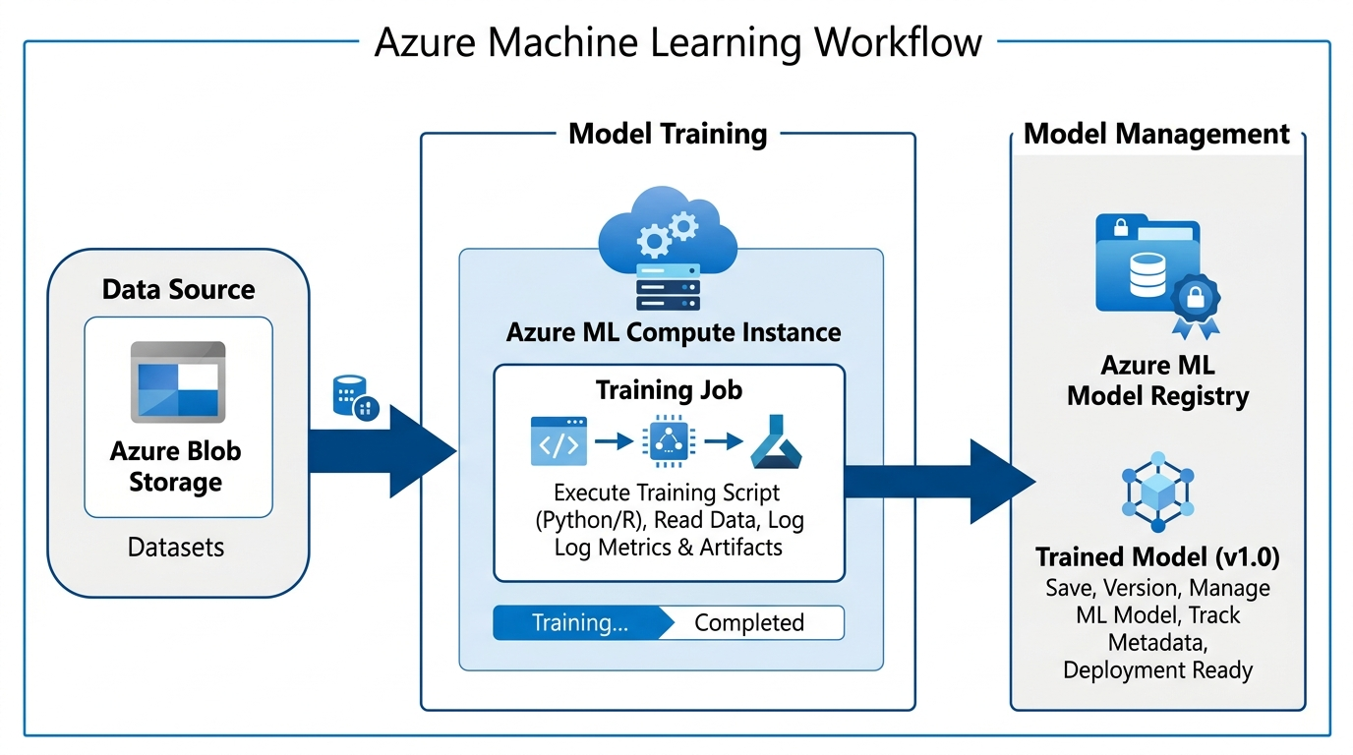
Figure 10. Conceptual workflow of the Azure Machine Learning workspace and registry integration.

12. Conclusion
The Hand Gesture Classification System represents a lightweight, highly efficient, and modular solution for real-time gesture recognition. By separating landmark extraction (MediaPipe) from classification (MLPs), the system bypasses heavy convolutional networks. This design delivers sub-millisecond inference times on standard CPU architectures.
The experimental validation yields high accuracies: 96.23 percent for hand signs and 97.13 percent for finger gestures. Model quantization reduces sizes to under 7 KB, demonstrating the potential of tiny AI edge deployments. The project successfully meets its academic objectives, providing a practical framework for camera-based human-computer interaction.

13. Appendix

13.1 Installation Requirements
- mediapipe >= 0.8.1
- opencv-python >= 3.4.2
- tensorflow >= 2.3.0
- scikit-learn >= 0.23.2
- pandas >= 1.0.0
- numpy >= 1.18.0
- matplotlib >= 3.3.0
- seaborn >= 0.11.0

13.2 Suggested Execution Flow
- Verify webcam connection.
- Execute `python app.py` from the project directory.
- Review the real-time overlays displaying predicted hand signs and finger gestures.
- Press 'k' to enter hand sign logging mode, and press keys '0' to '9' to log coordinates to keypoint.csv.
- Press 'h' to enter finger gesture logging mode, and press keys '0' to '9' to log coordinate queues to point_history.csv.
- To train the models, run the notebooks keypoint_classification.ipynb and point_history_classification.ipynb from top to bottom.

13.3 Notes on the Current Code Base
- Real-time overlays include FPS calculations, class labels, and bounding boxes.
- Models are loaded dynamically on startup via the KeyPointClassifier and PointHistoryClassifier python wrappers.
- Normalization is translation-invariant and scale-invariant, ensuring robustness to distance variations.

References
[1] Google Developers, "MediaPipe Hand Landmarker Guide," Google AI Edge, 2026. [Online]. Available: https://ai.google.dev/edge/mediapipe/solutions/vision/hand_landmarker. [Accessed: 15-Jul-2026].
[2] K. Takahashi, "Hand Gesture Recognition using MediaPipe," GitHub Repository, 2020. [Online]. Available: https://github.com/KazuhitoTakahashi/hand-gesture-recognition-using-mediapipe. [Accessed: 15-Jul-2026].
[3] Google TensorFlow Developers, "Post-training quantization," TensorFlow Lite Guide, 2026. [Online]. Available: https://www.tensorflow.org/lite/performance/post_training_quantization. [Accessed: 15-Jul-2026].
[4] scikit-learn Developers, "Supervised learning - Neural network models (supervised)," scikit-learn User Guide, 2026. [Online]. Available: https://scikit-learn.org/stable/supervised_learning.html. [Accessed: 15-Jul-2026].
[5] OpenCV Developers, "OpenCV-Python Tutorials," OpenCV Documentation, 2026. [Online]. Available: https://opencv.org/. [Accessed: 15-Jul-2026].

Azure ML Data Assets provide version tracking and direct data lineage for trained models.
² The Azure ML Model Registry is a centralized repository that tracks model lineage, metadata, and handles deployment stage progression (e.g. staging vs production).

