

State-Specific Textile Subsidy Calculator

### AN INTERNSHIP REPORT

***Submitted by***

**YASH KUMAR SRIWASTAV**

**2260468**

***in partial fulfillment of the requirements for the degree of***

**BACHELOR OF TECHNOLOGY**

**IN**

COMPUTER SCIENCE AND ENGINEERING

### UNDER THE GUIDANCE OF

Mr. T. VIGNESHWARAN

**Department of Computer Science and Engineering School of Engineering and Technology**

**CHRIST (Deemed to be University) Kumbalgodu, 560 074**

### August 2025



**Department of Computer Science and Engineering School of Engineering and Technology**

**CHRIST (Deemed to be University)**

**BONAFIDE CERTIFICATE**

This is to certify that **YASH KUMAR SRIWASTAV (2260401)** has successfully completed his/her summer internship work entitled **“State-Specific Textile Subsidy Calculator”** in **REQUIP DIGITAL PRIVATE LIMITED** located Plot no. 702 , 251A Lakhan, Borivali West , Mumbai , 400091 from **01-04-2025 to 31-05-2025** *for a* duration of 60 Days and submitted on **09-08-2025** in partial fulfillment for the award of **Bachelor of Technology in Computer Science and Engineering** during the academic year **2025-2026**.

**GUIDE**

**Mr. T. VIGNESHWARAN**

**(Signature with date)**

**EXAMINER 1 EXAMINER 2**

**(Name & Signature with Date) Name & Signature with Date)**

### ABSTRACT

State-Specific Textile Subsidy Calculator with Flask, Firebase, and Automated Financial Analysis is a robust yet easy-to-use platform designed to help textile businesses determine subsidy eligibility and calculate benefits based on their state-specific policies. Traditional subsidy information is often scattered, outdated, or difficult for small manufacturers to access. This solution solves that problem by offering a clean interface backed by a fast, reliable backend that automates data handling and financial calculations.

The frontend is built using HTML, CSS, and JavaScript, delivering a responsive and intuitive experience for users. Interactive forms, dynamic tables, and real-time feedback make subsidy estimation straightforward. The system uses Firebase for hosting and authentication, ensuring quick load times and secure user management, while Firestore stores subsidy data and user inputs for fast retrieval.

On the backend, the application is powered by Python with Flask, deployed in a containerized environment for consistent performance across platforms. State subsidy rules, calculation formulas, and eligibility logic are handled through modular APIs, ensuring easy updates as policies change. Data validation and financial computation modules ensure accurate, real-world results for each request.

To streamline development and deployment, GitHub Actions manages automated builds and updates, while Docker ensures reproducibility across testing and production. Integrated logging and error tracking make maintenance simple and efficient. The architecture is designed to scale with increased user demand, ensuring reliability for both small workshops and large manufacturers.

By combining modern web technologies with automated financial logic, this platform delivers a production-ready solution that empowers textile businesses with instant, accurate subsidy information — all in one place.

### PREFACE

My internship at Requip Digital Private Limited, focused on developing a state-specific Textile Subsidy Calculator web application, took place from April 1, 2025, to May 31, 2025, during the course of my B.Tech in Computer Science and Engineering. This two-month experience was both challenging and rewarding, allowing me to move beyond academic concepts and work on a fully functional, real-world project.

The internship gave me the opportunity to design and implement a solution tailored for the Gujarat state, using Python Flask for backend logic, HTML/CSS for the frontend, Firebase Authentication for secure user login and signup, and Firestore for data storage. The platform enables users to check subsidy eligibility, enter basic project details, and instantly view calculated results, including capital, interest, power tariff, and electricity benefits.

I am sincerely grateful to Requip Digital for this opportunity to contribute, learn, and grow in a professional environment. The mentorship, resources, and guidance I received significantly enhanced my technical proficiency, problem-solving abilities, and collaborative skills.

With appreciation, I present this report as a reflection of my technical journey, professional development, and commitment to creating impactful software solutions.

### INDEX

| **CONTENT** | | | | **PAGE NO.** |
| --- | --- | --- | --- | --- |
|  | **Abstract** | | | I |
|  | **Preface** | | | II |
|  | **List of Symbols and Abbreviations** | | | III |
|  | **List of Figures** | | | IV |
|  | **List of Tables** | | | V |
| **1** | **Introduction** | | | 1 - 2 |
|  | 1.1. | Objectives | | 1 |
|  | 1.2. | Company Profile | | 2 |
| **2** | **Technical Description & Implementation** | | | 3 - 11 |
|  | 2.1. | Actual Work | | 3 |
|  |  | 2.1.1. | Prerequisites | 3 - 4 |
|  |  | 2.1.2. | Responsibilities | 5 - 6 |
|  |  | 2.1.3. | Challenges | 7 |
|  |  | 2.1.4 | Implementation Description | 8 - 9 |
|  | 2.2. | Learning outcomes & Key Takeaway | | 10 - 11 |
| **3** | **Conclusion & Future Scope** | | | 12 - 13 |
|  | 3.1. | Conclusion | | 12 |
|  | 3.2. | Future Scope | | 13 |
| **4** | **Appendixes** | | | 14 - 21 |
|  | A | Acceptance letter | | 14 |
|  | B | Completion Certificate | | 15 |
|  | C | Code and screenshots | | 16-21 |
| **5** | **References** | | | 22 |

**LIST OF SYMBOLS AND ABBREVIATIONS**

| **S. No.** | **Abbreviation /**  **Symbol** | **Full Form / Description** |
| --- | --- | --- |
| 1 | **AI** | Artificial Intelligence |
| 2 | **API** | Application Programming Interface |
| 3 | **CSS** | Cascading Style Sheets |
| 4 | **DBMS** | Database Management System |
| 5 | **EDP** | Entrepreneurship Development Program |
| 6 | **HTML** | HyperText Markup Language |
| 7 | **IoT** | Internet of Things |
| 8 | **MSME** | Micro, Small, and Medium Enterprises |
| 9 | **UI** | User Interface |
| 10 | **URL** | Uniform Resource Locator |

**LIST OF FIGURES**

| **Figure No** | **Description** | **Page No** |
| --- | --- | --- |
| 2.1 | Flow Diagram | 8 |
| 4.1 | Acceptance Letter | 14 |
| 4.2 | Completion Certificate | 15 |
| 4.3 | Output Screenshots | 19 - 21 |

**LIST OF TABLES**

| **Table No** | **Description** | **Page No** |
| --- | --- | --- |
| 2.1 | Tools and Libraries Used | 4 |

# CHAPTER 1 INTRODUCTION

In today’s technology-driven world, industries such as textiles increasingly rely on smart, automated, and user-friendly digital platforms to access government benefits and streamline business operations. This project introduces a state-specific Textile Subsidy Calculator designed exclusively for the Gujarat state, built using modern full-stack technologies — HTML/CSS/JavaScript for the frontend, and Python Flask for the backend logic. The platform is hosted using Vercel for global delivery, while Firebase Authentication ensures secure login/signup processes and Firestore serves as a reliable and scalable database for storing user and subsidy data.

The application simplifies the process of determining subsidy eligibility by allowing users to enter essential project details, such as whether the initiative is a new project, expansion, or modernization. Based on this input, the platform calculates and displays detailed subsidy components, including capital investment subsidy, interest subsidy, power tariff subsidy, and electricity duty benefits. This automated system eliminates manual calculations and provides instant, accurate results tailored to state policies.

The project not only demonstrates the integration of frontend, backend, and cloud-based services but also delivers a real-world, production-ready solution for the textile industry — bridging the gap between academic learning and practical, industry-level development.

### OBJECTIVE

* **Build a State-Specific Textile Subsidy Calculator**

Develop a responsive and user-friendly web application for Gujarat-based textile businesses to check subsidy eligibility and receive instant benefit calculations.

* **Develop a Robust Backend Logic System**Use Python Flask to create secure, efficient APIs for handling eligibility checks, financial computations, and data validation.
* **Integrate Secure Authentication & Cloud Storage**Implement Firebase Authentication for secure login/signup and Firestore for storing user profiles, inputs, and subsidy data.
* **Deploy for Global Accessibility**Host the application on Vercel to ensure high performance, quick access, and easy scalability.
* **Deliver Real-Time Financial Calculations**Enable users to input project type and investment details to instantly view calculated subsidy amounts across multiple benefit categories.
* **Provide a Seamless User Experience**Design a clean, intuitive interface that works across devices, ensuring accessibility for all types of users in the textile sector.

### COMPANY PROFILE

Requip Digital Private Limited is a technology-driven company focused on delivering innovative digital solutions to streamline business processes across industries. Leveraging modern web technologies and cloud infrastructure, Requip Digital develops platforms that are scalable, secure, and user-centric. The company emphasizes transforming traditional workflows into automated systems that improve efficiency, reduce errors, and enhance accessibility.

In addition to offering technology consulting and product development services, Requip Digital specializes in creating custom software solutions tailored to industry-specific needs. With a mission to empower businesses through smart digital tools, the company combines technical expertise, design innovation, and a commitment to delivering reliable, high-performance applications.

# CHAPTER 2

**TECHNICAL DESCRIPTION & IMPLEMENTATION**

### ACTUAL WORK

* + 1. **PREREQUISITES**
       - **Proficiency in Python and Flask**: A strong understanding of Python and its Flask framework was essential to develop the backend logic for eligibility checks, financial computations, and result generation.
       - **Experience with Web Development**: Familiarity with HTML, CSS, and JavaScript was required to build the responsive and user-friendly frontend.
       - **Understanding of Firebase Services**: Knowledge of Firebase Authentication for secure login/signup and Firestore for cloud-based, real-time data storage.
       - **Research & Data Analysis Skills**: The project required detailed research into every stage of textile production in Gujarat, including market prices, cost structuring, subsidy policies, and profit margins.
       - **Version Control Expertise**: Proficiency with Git and GitHub for collaborative development, including branching, merging, and maintaining clean commit histories.
       - **Deployment Knowledge**: Understanding of Vercel hosting for deploying and maintaining the application with global accessibility.
       - **Presentation & Documentation Skills**: Ability to prepare a professional pitch deck and documentation for demonstrating the solution to stakeholders.

Table 2.1: Tools and Libraries Used

| **Component** | **Technology Used** | **Purpose** |
| --- | --- | --- |
| Frontend | HTML, CSS, JavaScript | Responsive UI for data input and results display |
| Backend API | Python Flask | Business logic, eligibility checks, and financial calculations |
| Authentication | Firebase Authentication | Secure login and signup |
| Database | Firebase Firestore | Store user details, project data, and subsidy calculations |
| Hosting | Vercel | Fast and globally accessible deployment |
| Version Control | Git, GitHub | Branching, merging, and collaborative development |
| Documentation & Pitch | Google Slides, MS Word | Research Presentation and final report preparation |

### RESPONSIBILITIES

**Research & Data Collection**

* Conducted an in-depth study of each stage of textile production in Gujarat, including raw material sourcing, spinning, weaving, dyeing, and finishing.
* Collected and analyzed market pricing, cost structures, subsidy policies, and profit margin data from government publications, industry reports, and official schemes.
* Created structured datasets to be used in backend logic for subsidy calculations.

**Backend Development**

* Designed and implemented Flask-based APIs to handle user inputs, validate data, and perform real-time subsidy calculations.
* Integrated business rules for Gujarat’s textile subsidy policies, including **capital subsidy**, **interest subsidy**, **power tariff subsidy**, and **electricity duty exemption**.
* Modularized computation functions for maintainability and scalability.

**Frontend Development**

* Created responsive web pages using HTML, CSS, and JavaScript for input forms, eligibility check steps, and result display.
* Integrated dynamic elements to instantly update calculation outputs without page reloads.

**Authentication & Security**

* Configured Firebase Authentication for secure user login/signup processes.
* Implemented data validation on both frontend and backend to prevent invalid or malicious inputs.

**Database Integration**

* Set up Firebase Firestore to store user profiles, project data, and calculation history.
* Ensured efficient querying and data retrieval for fast response times.

**Deployment**

* Deployed the frontend and backend on **Vercel**, ensuring global access and minimal downtime.
* Configured environment variables for secure connection to Firebase services.

**Collaboration & Version Control**

* Managed codebase using **GitHub**, maintaining separate branches for features, bug fixes, and deployment.
* Regularly merged tested code into the main branch and documented commits with clear messages.

**Presentation & Pitch Deck**

* Designed and presented a detailed pitch deck showcasing the problem, solution, research findings, technical implementation, and expected business impact.

### CHALLENGES

Challenges that I faced during the project were

* **Policy Data Interpretation** Interpreting intricate government subsidy guidelines involved breaking down legal and financial terminology into logical conditions. This process required multiple reviews and cross-verification with official sources to ensure policy accuracy in the application.
* **Dynamic Calculation Logic** The subsidy calculator was designed to process multiple factors like project type, investment amount, and production scale simultaneously. Optimizing this logic ensured instant results without lag, even with complex conditional checks.
* **Firestore Data Structuring** Data was stored in Firestore using a well-planned hierarchy of collections and documents, ensuring easy scalability. The structure also enabled efficient queries, reducing read/write costs while improving application speed.
* **Authentication Flow** Multiple user states—guest, logged-in, and returning users—were handled with a secure authentication mechanism. Role-based access controls and session handling ensured both data privacy and a seamless user experience.
* **Deployment Configuration** Deployment to Vercel involved securely managing Firebase credentials and environment variables. Proper configuration prevented accidental exposure of sensitive keys while maintaining smooth build processes.
* **GitHub Branch Conflicts** Working in a collaborative multi-branch environment occasionally led to merge conflicts. These were resolved by carefully reviewing changes, preserving code integrity, and following Git best practices.

### IMPLEMENTATION AND DESCRIPTION

**Procedure Flowchart:**

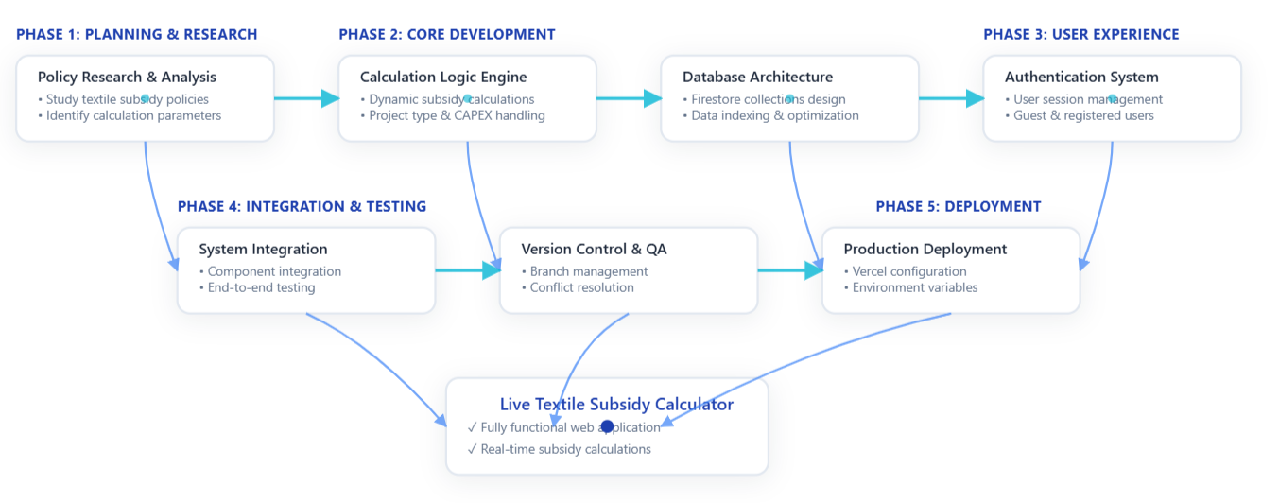

Figure 2.1: Flow Diagram

The development process begins in **Phase 1: Planning & Research**, where the team conducts comprehensive **Policy Research & Analysis**. During this phase, developers study existing textile subsidy policies, identify key calculation parameters, and translate complex government regulations into logical business rules that can be programmed into the application.

The process then moves to **Phase 2: Core Development**, where two critical components are built in parallel. The **Calculation Logic Engine** is developed to handle dynamic subsidy calculations based on various project types, CAPEX investments, and production capacity inputs. Simultaneously, the **Database Architecture** is designed using **Firestore collections**, with careful attention to data indexing and query optimization to ensure fast retrieval of subsidy information and user data.

**Phase 3: User Experience** focuses on implementing the **Authentication System**, which manages user sessions for both guest users and registered accounts. This system ensures that users can save their calculations, track application history, and access personalized features while maintaining security and data privacy.

The development converges in **Phase 4: Integration & Testing**, where **System Integration** brings all components together through comprehensive end-to-end testing. Concurrently, **Version Control & QA** processes manage branch merging, resolve code conflicts, and ensure code quality through systematic review processes using Git workflows.

**Phase 5: Deployment** handles the **Production Deployment** configuration, setting up the application on **Vercel** with proper environment variables, secure Firebase API keys, and production-ready settings. This phase ensures the application is properly configured for public access with optimal performance.

All these phases culminate in the **Live Textile Subsidy Calculator**—a fully functional web application that provides real-time subsidy calculations. The system ensures seamless data flow between the frontend user interface, backend calculation engine, and Firestore database, offering textile manufacturers and businesses an accurate, responsive, and secure platform for determining their eligibility and amounts for government textile subsidies. The application handles complex policy interpretations automatically, transforming what was once a manual, time-consuming process into an instant, accurate calculation tool.

* 1. **LEARNING OUTCOME AND KEY TAKEAWAY**

## Learning Outcome

During my internship, I successfully designed and developed a Textile Subsidy Calculator web application, gaining hands-on experience in the end-to-end software development process. The project deepened my technical understanding of web application architecture, frontend-backend integration, and dynamic data processing for industry-specific use cases.

I learned how to collect and interpret government subsidy policies for the textile sector and translate them into precise, rule-based calculation logic within a web-based system. The process enhanced my skills in financial data modeling, conditional eligibility checks, and multi-scheme comparison.

I gained practical exposure to creating interactive and responsive user interfaces that cater to different user profiles, from small textile business owners to financial consultants. My ability to design clear form structures, apply real-time validations, and ensure instant result updates improved significantly.

Furthermore, I learned to troubleshoot real-world challenges, such as managing complex conditional branching, ensuring calculation accuracy, and handling responsive design issues. This project also improved my capacity to think critically about user workflows, data accuracy, and application scalability, while reinforcing my proficiency in HTML, CSS (with custom dark theme), JavaScript, and backend integration.

## Key Takeaways

* **Deep Industry Understanding:** Gained knowledge of the textile sector’s financial structure, including how different government subsidy schemes work and the criteria businesses must meet to qualify.
* **Specialized Calculator Development:** Built a web tool that processes detailed cost inputs, applies subsidy rules, and provides a transparent breakdown of benefits, helping users make informed decisions.
* **Real-Time Dynamic Processing:** Designed the backend logic to instantly compute eligibility for multiple subsidies in parallel, reducing manual calculation errors and saving time for users.
* **Advanced Form Handling:** Applied complex input validation rules to ensure accurate financial data entry and prevent logical inconsistencies.
* **Optimized User Experience:** Created a visually appealing, **custom dark theme** for better readability, coupled with a layout that adapts seamlessly across devices.
* **Full-Stack Integration:** Worked across the frontend (HTML, CSS, JavaScript) and backend layers to connect user inputs with live calculation results.
* **Workflow Design & Testing:** Developed, tested, and refined the eligibility-checking process to ensure every scenario was covered, including borderline eligibility cases.
* **Problem-Solving Skills:** Resolved issues related to calculation mismatches, layout distortions, and form responsiveness during development.
* **Practical Deployment Skills:** Learned the process of hosting and making the tool accessible online, enabling real users to benefit from the application.
* **Professional Collaboration:** Communicated with stakeholders to understand requirements, clarify subsidy rule interpretations, and ensure the application met real-world needs.

# CHAPTER 3 CONCLUSION & FUTURE SCOPE

### CONCLUSION

The design and development of the Textile Subsidy Calculator represent a significant step toward simplifying the complex process of determining subsidy eligibility for textile industry stakeholders. The project successfully translated intricate government policies into accurate, automated computational logic, enabling users to receive real-time, reliable results.

By integrating a user-friendly frontend with HTML, CSS (custom dark theme), and JavaScript, and combining it with a backend powered by Firebase Firestore, the application ensures both usability and performance. The implementation of secure authentication flows guarantees safe handling of sensitive business data, while dynamic calculation logic allows for flexibility in accommodating various project parameters, investment ranges, and subsidy conditions.

The deployment on Vercel, with secure environment variable handling and optimized Firestore structuring, provided a scalable and efficient hosting solution. This experience not only enhanced technical skills in full-stack development and cloud integration but also deepened the understanding of how technology can bridge the gap between policy complexity and real-world business applicability.

Overall, the internship provided valuable exposure to real-time problem-solving, cloud-based deployment, database optimization, and collaborative development workflows, preparing for future roles in software development and domain-specific application design.

### 

### 

### 

### Future Scope

As the Textile Subsidy Calculator continues to evolve, there are several opportunities for enhancement:

1. **AI-Driven Policy Interpretation** – Integrate natural language processing (NLP) models to automatically interpret new or updated government subsidy policies, reducing manual updates.
2. **Predictive Analytics for Eligibility** – Implement machine learning models to predict potential subsidy benefits based on historical industry data, investment trends, and market conditions.
3. **Multi-Language Support** – Add regional language options to make the tool accessible to a wider range of users across India’s textile sector.
4. **Offline Mode** – Enable offline calculations with local data storage for regions with low internet connectivity.
5. **Enhanced Reporting** – Introduce downloadable PDF and Excel reports summarizing subsidy eligibility, calculation breakdown, and application steps.
6. **Integration with Government Portals** – Automate submission of subsidy applications by directly linking the calculator to official textile department platforms.
7. **Scalable Backend** – Upgrade to multi-region hosting and implement load balancing for high-traffic environments.
8. **Mobile Application Version** – Develop a cross-platform mobile app to increase accessibility for small-scale textile business owners.

# CHAPTER 4

## Appendixes

### ACCEPTANCE LETTER

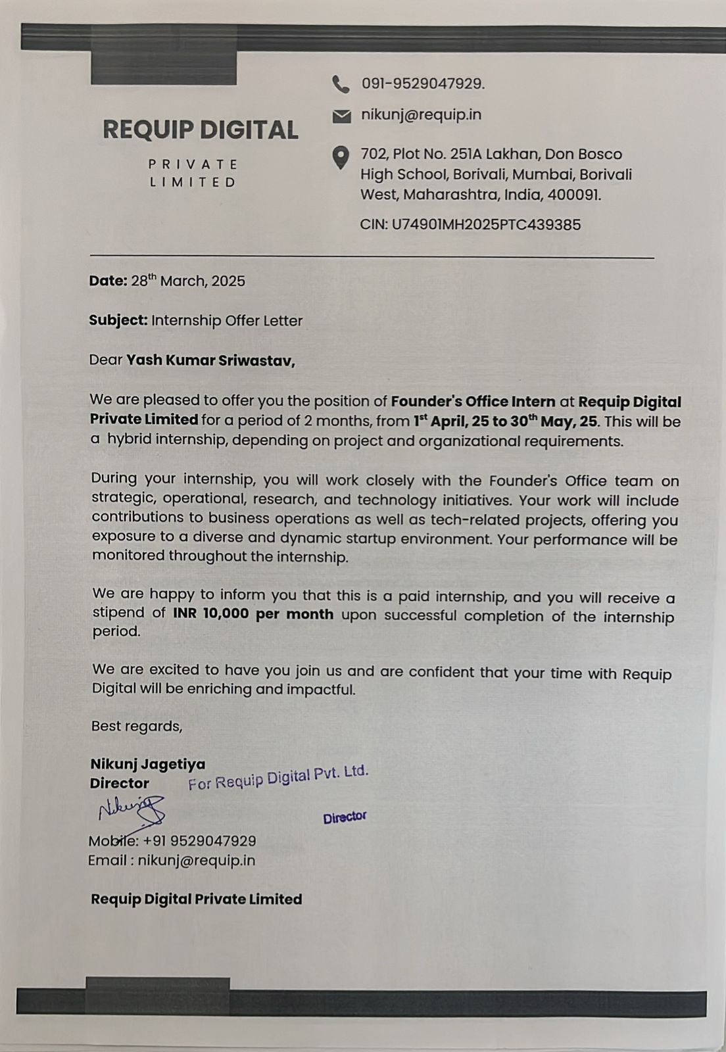

Figure 4.1 Acceptance Letter

### COMPLETION CERTIFICATE

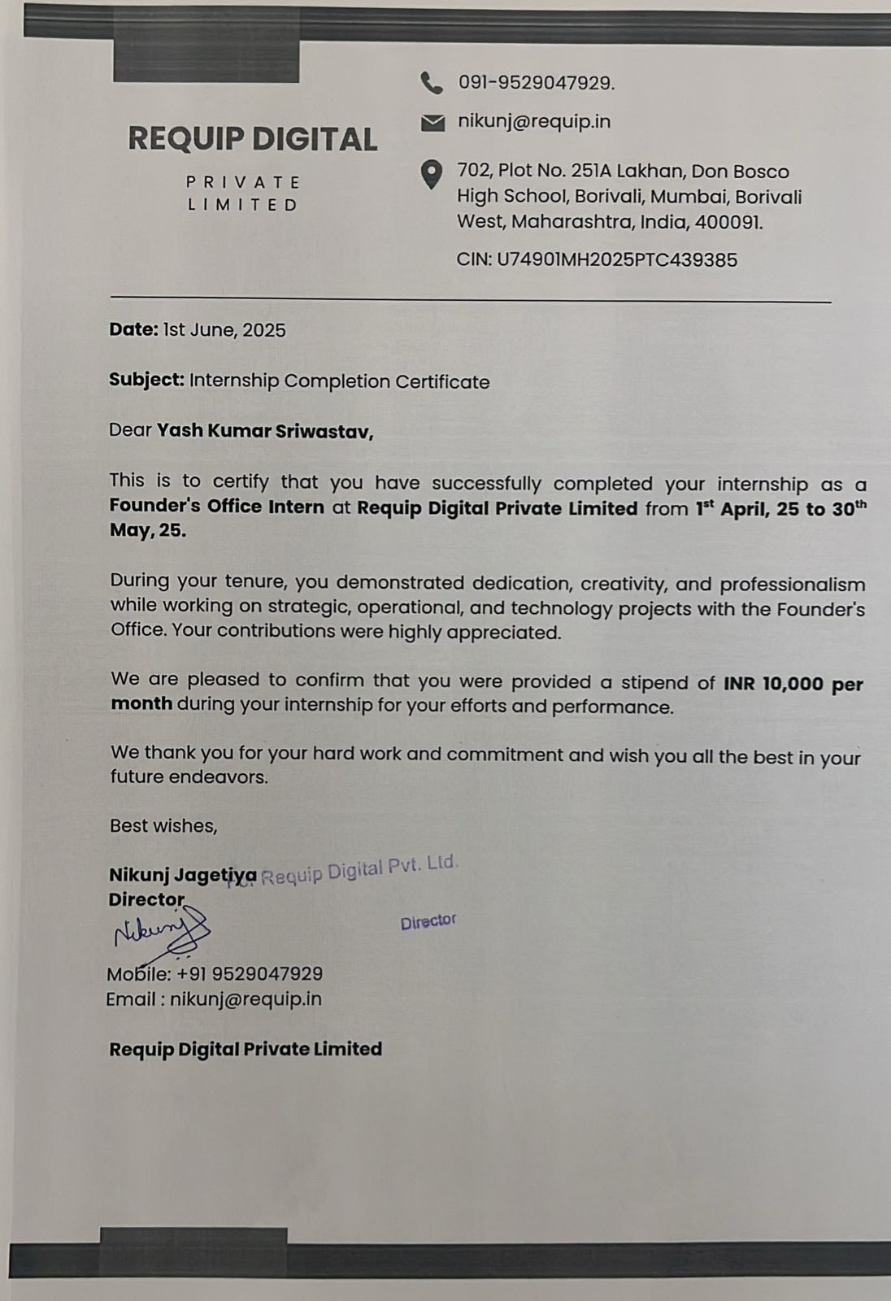

Figure 4.2: Completion Certificate

### CODE SNIPPETS AND OUTPUT SCREENSHOTS

#### CODE:

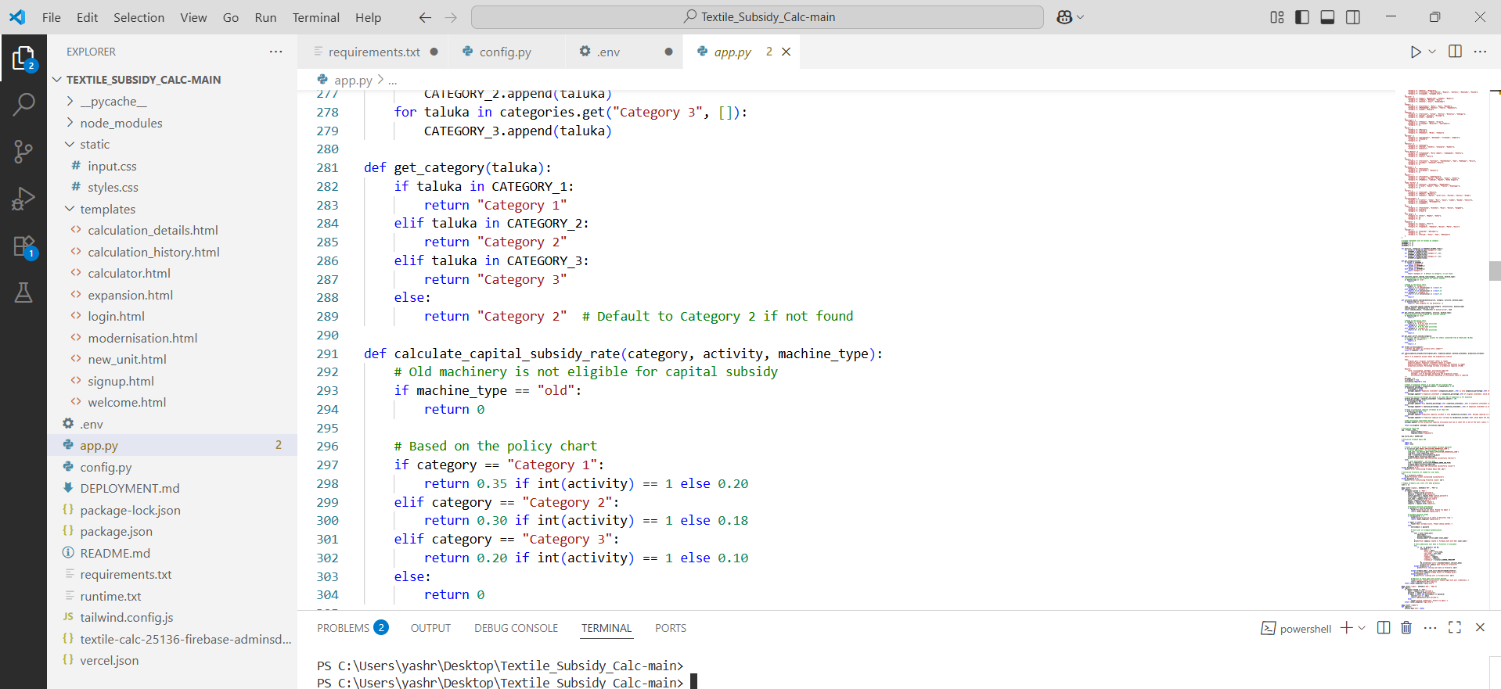

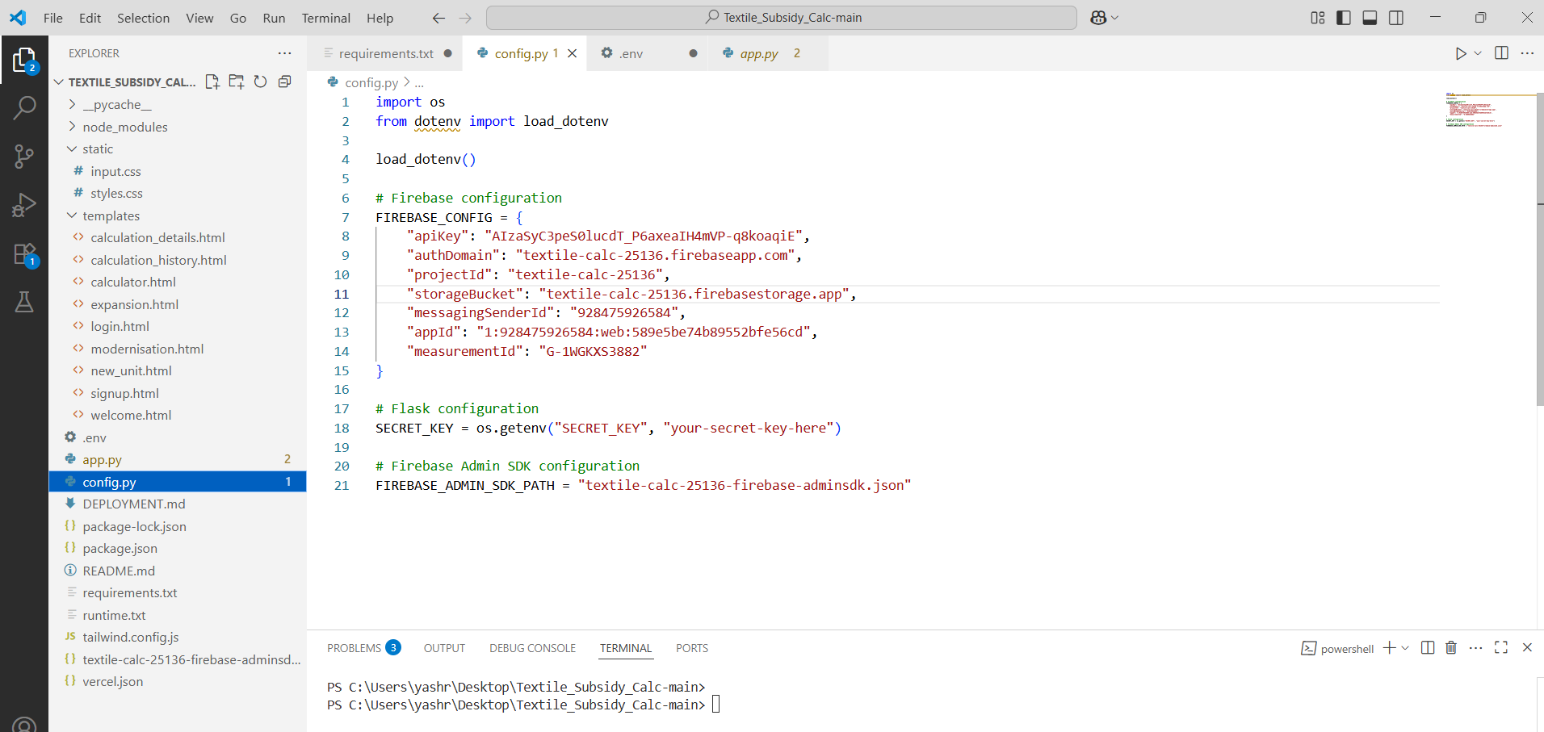

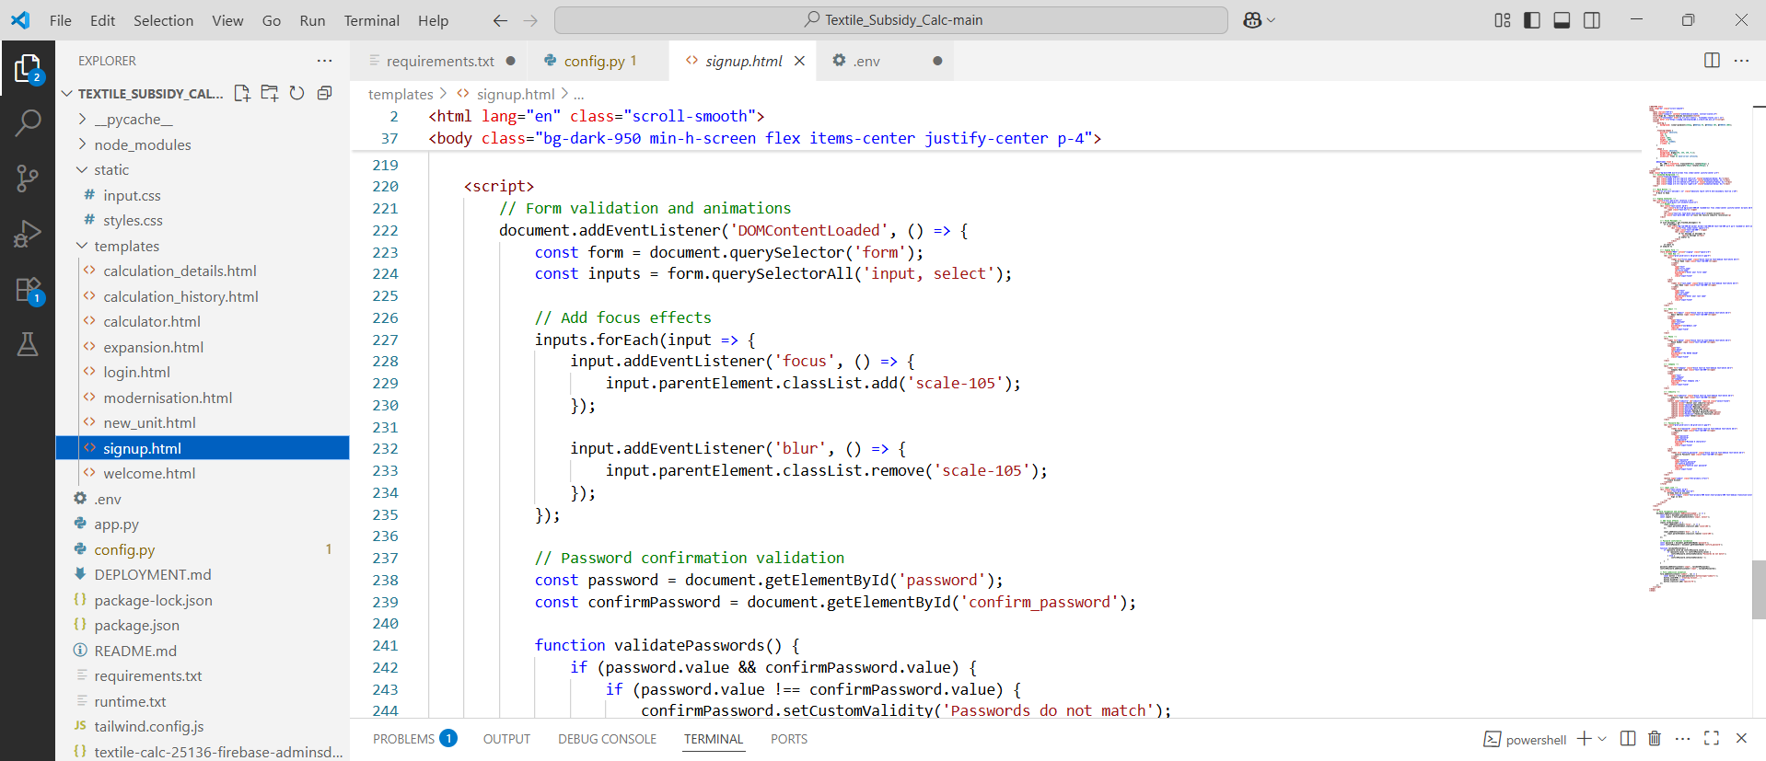

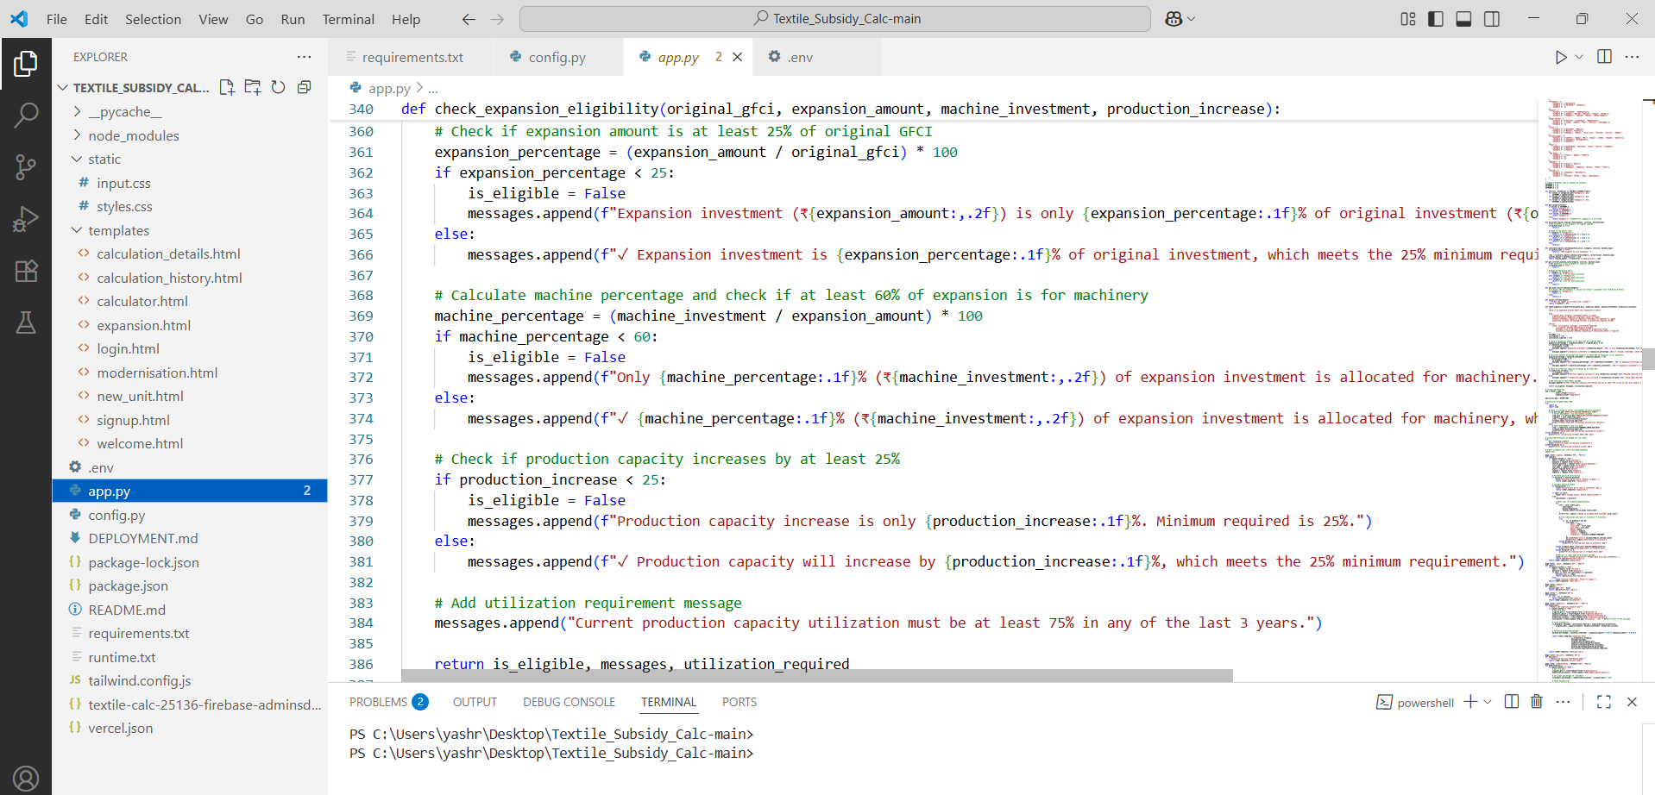

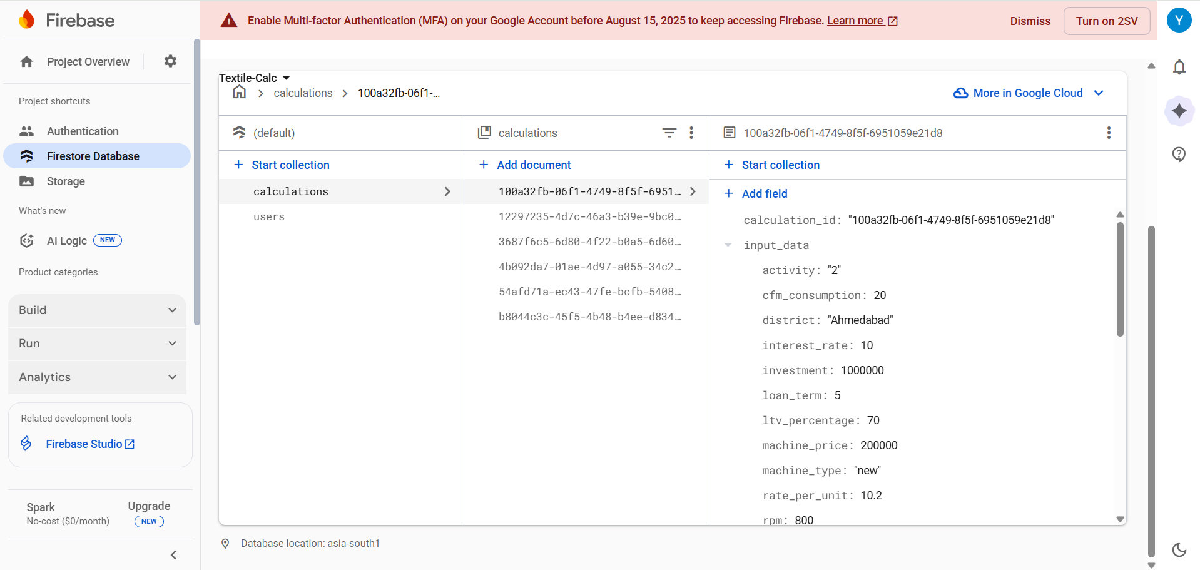

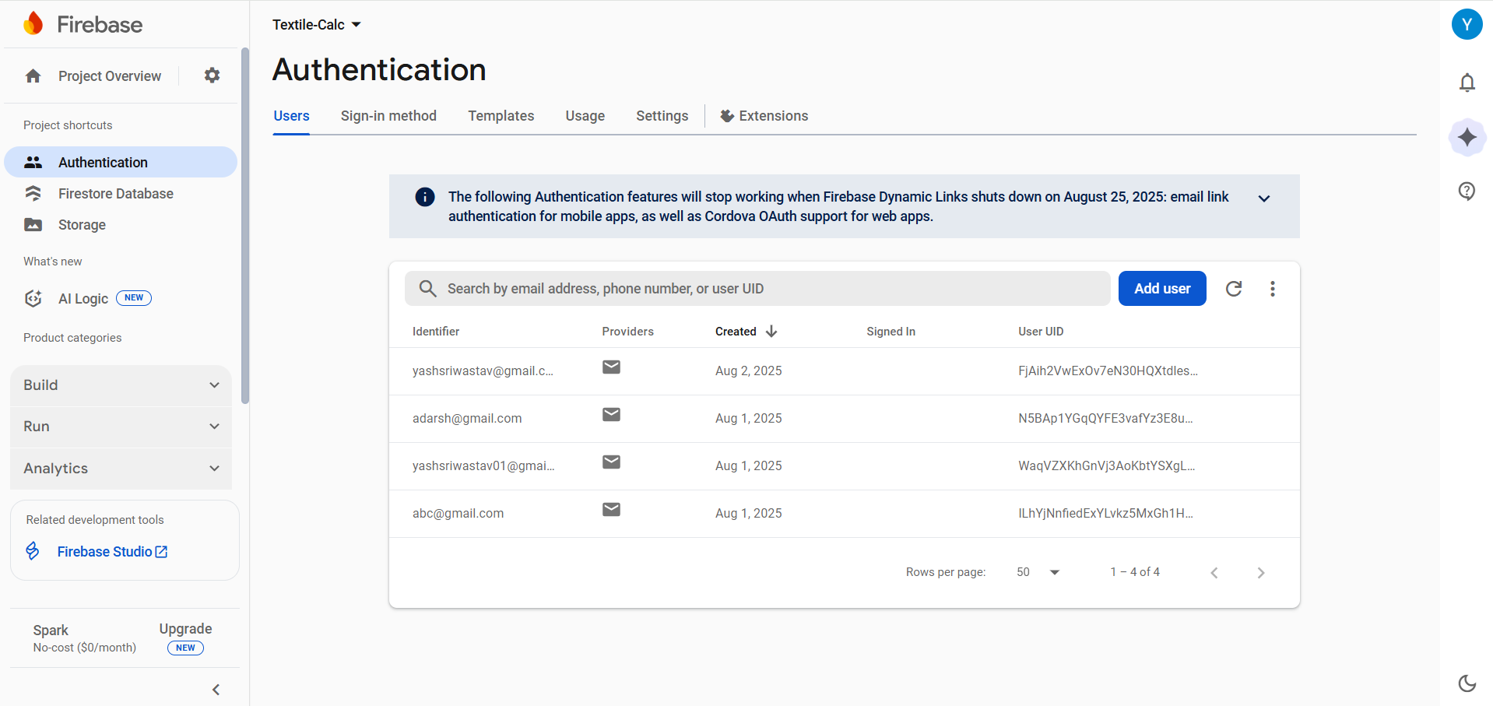

**OUTPUT SCREENSHOT:**

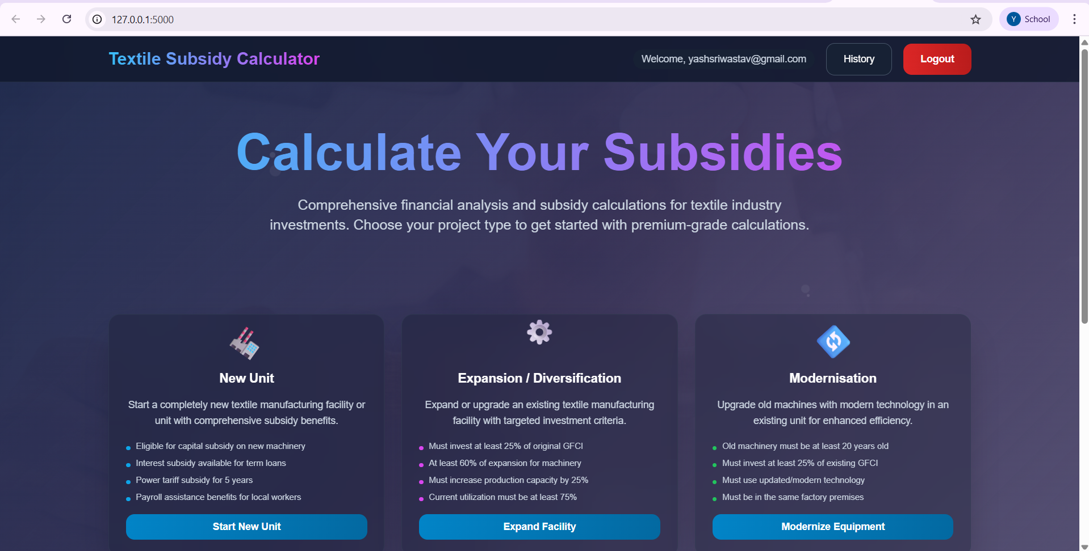

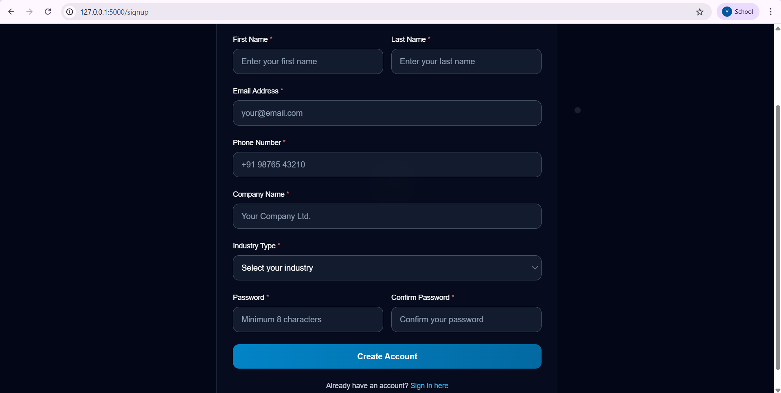

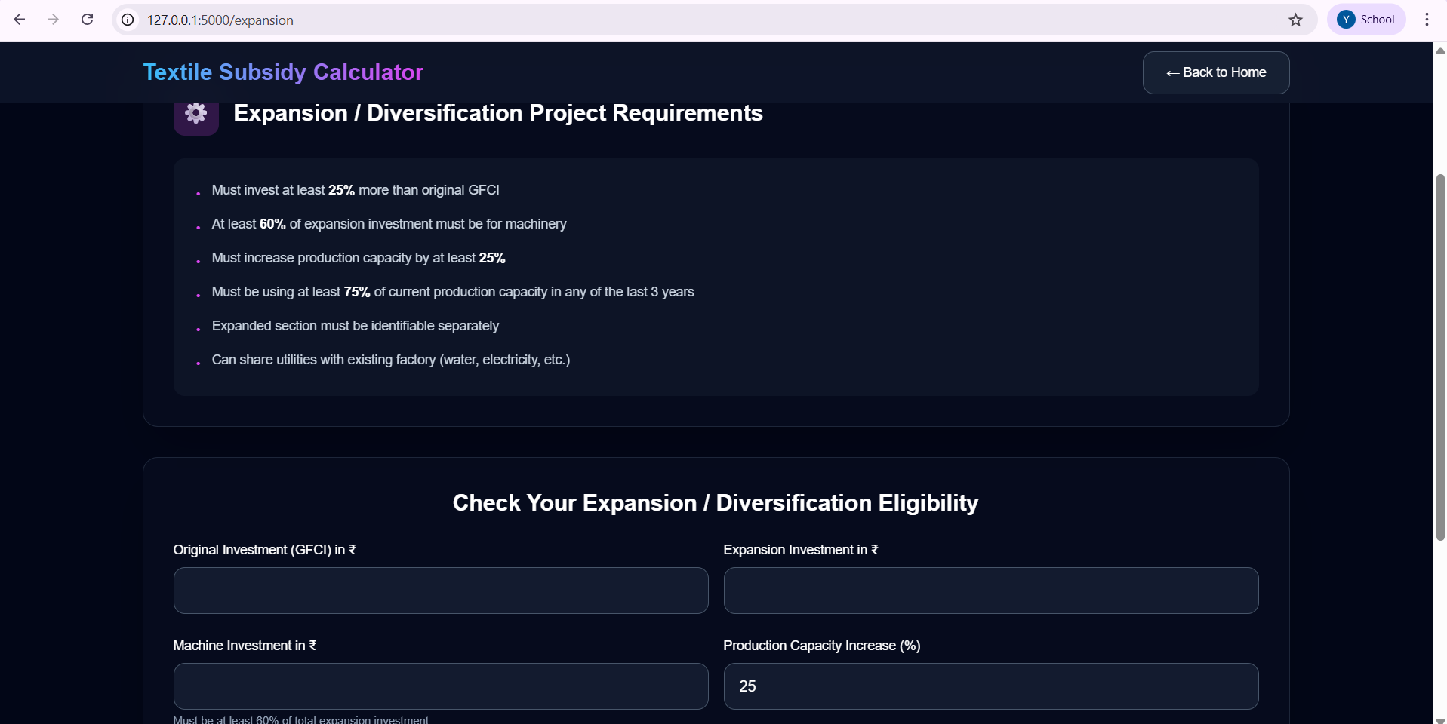

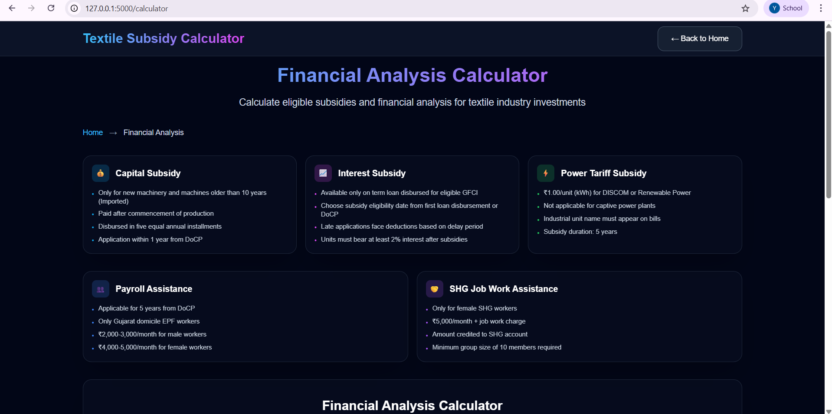

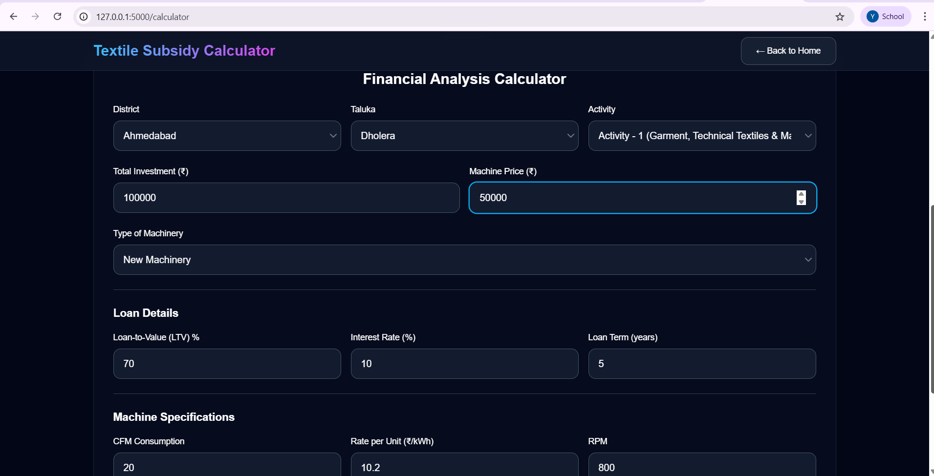

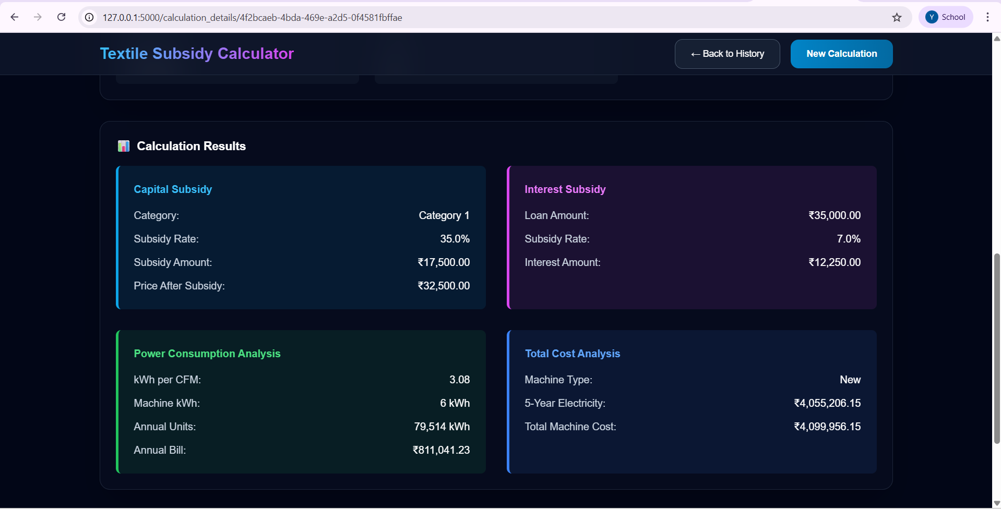

Figure 4.3 Output screenshot

# REFERENCES

1. S. J. Patel and R. K. Sharma, “Digitalization in Textile Industry: Scope and Challenges,” *International Journal of Textile Science and Technology*, vol. 9, no. 2, pp. 45–53, Apr. 2023.
2. A. R. Mehta, “Government Subsidy Schemes for Textile Sector in India: An Overview,” *Journal of Policy and Development Studies*, vol. 15, no. 1, pp. 12–20, Jan. 2022.
3. P. K. Nair, “Application of Web-Based Tools for Policy Implementation,” *International Journal of Computer Applications*, vol. 175, no. 18, pp. 25–30, Oct. 2020.
4. K. S. Verma, “Role of ICT in Transforming Public Service Delivery,” *IEEE Access*, vol. 8, pp. 177912–177920, 2020.
5. R. D. Gupta and S. R. Jain, “Cloud-Based Data Management for Public Schemes,” *International Conference on Data Engineering and Applications (IDEA)*, pp. 314–319, Aug. 2021.
6. T. R. Suresh and H. L. Kumar, “Leveraging Firebase for Scalable Web Applications,” *International Conference on Advances in Computing, Communication, and Control (ICAC3)*, pp. 101–107, Feb. 2022.
7. V. K. Sharma, “Impact of Automation on Subsidy Disbursement Processes,” *Journal of E-Governance and Policy*, vol. 14, no. 3, pp. 67–74, Sep. 2021.
8. Ministry of Textiles, Government of India, “Textile Industry Schemes and Guidelines,” 2023.
9. P. S. Rao and A. Chatterjee, “Integrating Policy Frameworks with Web Applications for SMEs,” *International Conference on Emerging Trends in Information Technology (ICETIT)*, pp. 221–227, July 2021.
10. Directorate of Textiles, “Operational Manual for Technology Upgradation Fund Scheme (TUFS),” 2022