Entity Relationship (ER) Diagram

The ER Diagram of FinRelief AI illustrates the relationships between Users, Loan Profiles, and Negotiation History, ensuring efficient data management and personalized financial planning.

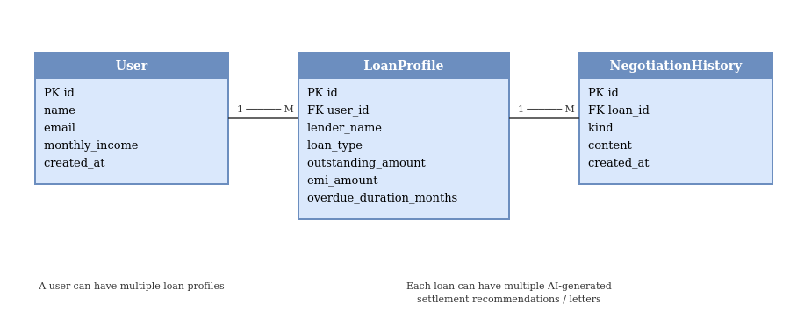

Relationships:
User (1) — LoanProfile (Many): a borrower can hold multiple loan profiles.
LoanProfile (1) — NegotiationHistory (Many): each loan can have multiple AI-generated settlement recommendations and negotiation letters over time.

