Neural Networks Deep Learning

Name: Yashwanth Nalamasa

700#: 700747715

GitHub: https://github.com/Yashu2507/CS5720ICP2

Video Link: https://drive.google.com/file/d/1FrBXjGRPFKzG5eu05SA50wohBSX8Sksr/view?usp=sharing

1st Program:

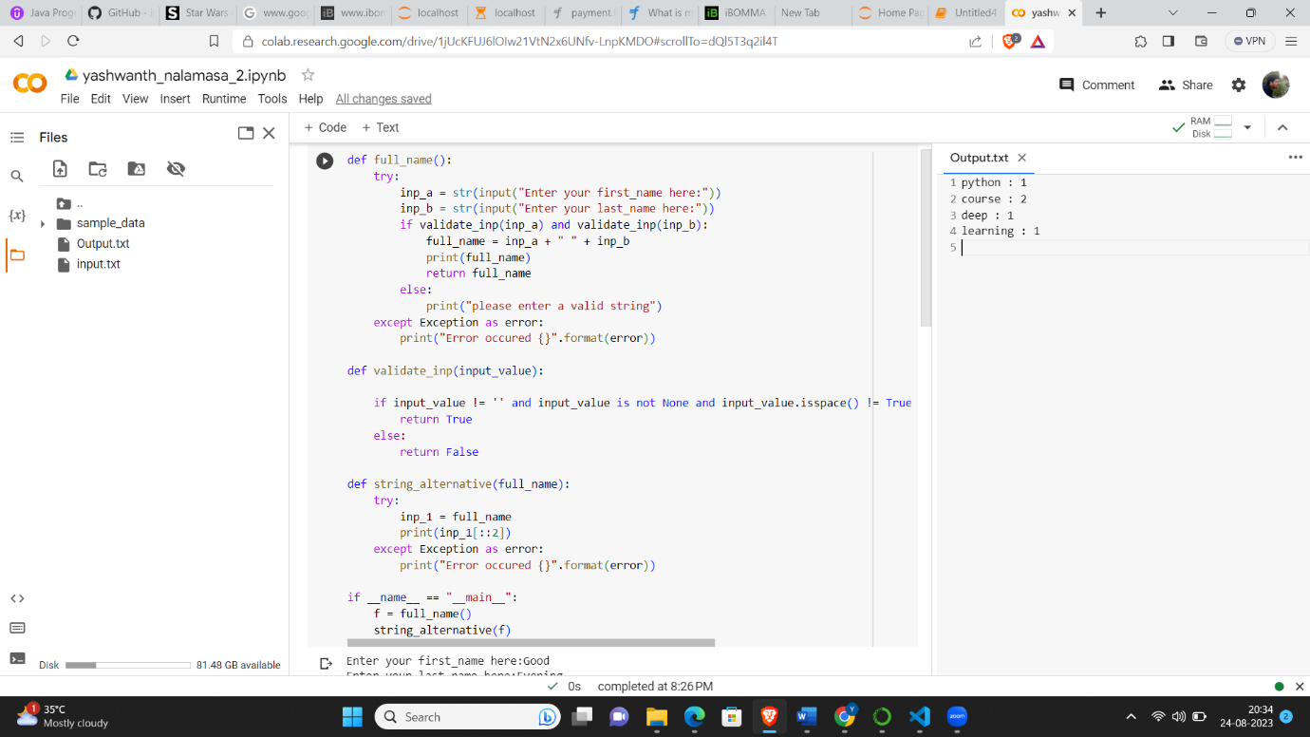

1st Program Output:

2nd Program with Output(On the Right hand side):

3rd Program:

