**NEURAL NETWORKS AND DEEP LEARNING**

Yashwanth Nalamasa

700747715

GITHUB: https://github.com/Yashu2507/CS5720ICP4

VIDEO RECORDING: https://drive.google.com/file/d/1TcAwfOM_09RfP4K24zzOguwmyJ4YW1KG/view?usp=sharing

**Question 1:** Data Manipulation a. Read the provided CSV file ‘data.csv’.

Read_csv(*args) is used to read csv file. Info() is used to print type of variables

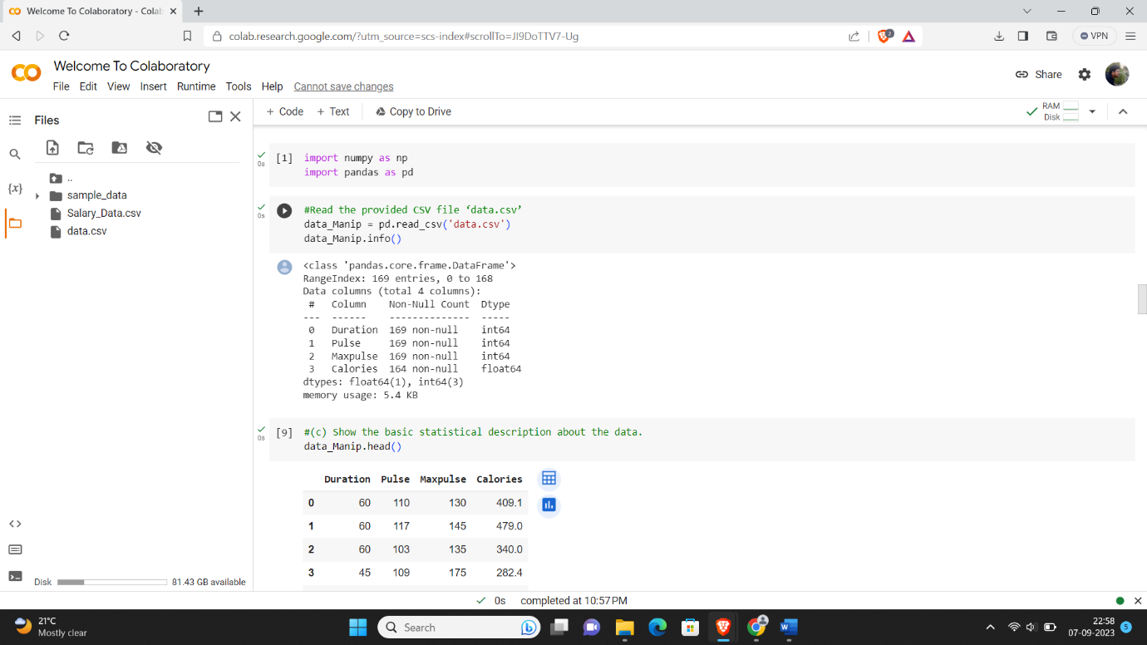

**Question2:**

