HCLTech Career Shaper Programme
III Year Industry Project | Academic Year 2025–26
FINAL PROJECT REPORT
Air Quality Index Analysis and
Pollution Hotspot Mapping
Project No. 50 | Domain: Data Analytics / Python

Learner Name | Yashu Rana
Roll Number | 2300320130291
College / Campus | ABES EC
Mentor Name | Dipali Kedar Patki
Difficulty & Duration | Intermediate | 4 Weeks | Individual Project
Submission Date | November 01, 2026
GitHub Repository | https://github.com/Yashu4994/Air-Quality-Index-Analysis-and-Pollution-Hotspot-M

Table of Contents
1. Introduction
1.1 Background & Environmental Context
1.2 Problem Statement (5W1H Framework)
1.3 Project Repository & Reproducibility
2. Objectives and Scope
2.1 Work Plan
2.2 Hypotheses and Metric Definitions
3. Tools and Technology Stack
4. Dataset Description
4.1 Data Provenance and Characteristics
4.2 Column Schema and Description
5. Data Preparation and Cleaning
5.1 Completeness and Missingness Audit
5.2 Range and Physical Boundary Validation
5.3 Anomaly and Sensor Fault Treatment
6. Exploratory Data Analysis
6.1 Overall National Baseline and AQI Distribution
6.2 Seasonal Dynamics and Thermal Inversions
6.3 Regional Air Quality Disparities
7. Statistical Testing & Significance
7.1 Seasonal Variance: Welch Two-Sample t-Test
7.2 Size of the Effect: 95% Confidence Interval
7.3 Inter-Regional Variance: One-Way ANOVA
7.4 Meteorological Correlations & Regression
7.5 Robustness & Sensitivity Checks
8. Pollution Hotspot Mapping & Geospatial Analysis
8.1 Hotspot Identification Criteria
8.2 Top 15 Municipal Hotspots Ranking
8.3 Interactive Geospatial Folium Mapping
9. Results and Policy Recommendations
9.1 Summary of Key Findings
9.2 Decision Framework for Municipal Action Plans (GRAP)
10. Challenges and Resolutions
10.1 Key Challenges Encountered
10.2 Threats to Validity and Mitigations
11. Ethical Considerations & Compliance
12. Conclusion and Future Scope
13. References
Appendix A: Complete Python Analysis Script
Appendix B: Full Data Dictionary
Appendix C: AI Tool Disclosure & Ethical Declaration

1. Introduction
1.1 Background & Environmental Context
Air pollution has emerged as one of the defining public health and environmental crises across the Indian subcontinent. Rapid industrialization, high vehicular density, unabated construction, coal-fired power generation, and seasonal biomass burning have cumulatively degraded ambient air quality. The Central Pollution Control Board (CPCB) developed the National Air Quality Index (NAQI) to translate complex ambient concentrations of multiple criteria pollutants into a single numerical index ranging from 0 to 500, segmented into six color-coded health risk categories: Good, Satisfactory, Moderate, Poor, Very Poor, and Severe. While routine air quality monitoring records vast volumes of data, municipal authorities frequently lack granular statistical models and spatial hotspot identification necessary to allocate mitigation capital efficiently. This project undertakes comprehensive Exploratory Data Analysis (EDA), parametric hypothesis testing, multi-pollutant correlation modeling, and geospatial hotspot clustering across 50 major Indian cities over a five-year timeline.
1.2 Problem Statement (5W1H Framework)
Who: Environmental regulators (CPCB, State PCBs), municipal health departments, urban planning authorities, and citizens across 50 municipal cities in India.
What: Lack of empirical seasonal variation quantification and high-resolution geospatial hotspot identification, resulting in reactive, blanket policy measures rather than proactive, localized interventions.
When & Where: Multi-annual monitoring (2021–2025) across 50 tier-1, tier-2, and industrial Indian cities, characterized by severe annual winter atmospheric temperature inversions (November to February).
Why: Air pollution in India accounts for over 1.6 million premature deaths annually, severe respiratory hospitalizations, and billions of dollars in lost economic productivity. Blanket vehicle bans or industrial shutdowns waste municipal resources without resolving micro-level pollution hotspots.
How: An empirical Python data analytics architecture evaluating 5,000 multi-city monitoring observations over 5 years, utilizing Welch's t-test, One-Way ANOVA, multi-pollutant correlation modeling, and interactive Folium geospatial mapping.
1.3 Project Repository & Reproducibility
In strict adherence to academic and industry best practices, all analytical artefacts—including cleaned datasets, data dictionaries, automated generation scripts, visualization assets, interactive HTML maps, and the core analysis notebook—are openly maintained in the project GitHub repository: https://github.com/Yashu4994/Air-Quality-Index-Analysis-and-Pollution-Hotspot-M.
2. Objectives and Scope
The primary objective of this project is to build an empirical, statistically sound data analytics and pollution hotspot mapping framework to support evidence-based municipal air quality management. The specific objectives comprise:
1. Ingest, sanitize, and validate continuous monitoring records for 50 Indian cities across 5 years (5,000 observations).
2. Formulate and test statistical hypotheses regarding seasonal elevation (Winter vs Summer) using Welch's t-test and compute 95% confidence intervals.
3. Evaluate geographic disparities across five distinct Indian regions (North, South, East, West, Central) using One-Way ANOVA.
4. Model atmospheric relationships between particulate matter (PM2.5, PM10), gaseous precursors (NO2, SO2, CO, O3), and weather variables (temperature, relative humidity).
5. Identify and rank municipal pollution hotspots and deploy an interactive geospatial Folium web map for urban planners.
2.1 Work Plan
Stage | Focus Area | Key Deliverables & Milestones
Stage 1 (Week 1) | Problem definition, schema formulation, data synthesis & CPCB standards audit | Clean dataset.csv (5,000 rows) & data_dictionary.csv
Stage 2 (Week 2) | Data pre-processing, anomaly detection, temporal sorting & feature engineering | Engineered seasons, regions, CPCB categories, & EDA script
Stage 3 (Week 3) | Statistical hypothesis testing, correlation analysis & Folium hotspot mapping | Welch t-test, ANOVA F-test, correlation matrix, & interactive map
Stage 4 (Week 4) | Synthesis, GRAP policy framework formulation, project report & synopsis | Formal 8+ page report, signed synopsis, notebook, & GitHub repo

2.2 Hypotheses and Metric Definitions
Item | Definition & Specification
Null Hypothesis 1 (H0, Season) | Mean AQI during Winter is identical to Mean AQI during Summer (mu_winter = mu_summer).
Alternative Hypothesis 1 (H1, Season) | Mean AQI during Winter is significantly elevated compared to Summer (mu_winter > mu_summer).
Null Hypothesis 2 (H0, Region) | Mean baseline AQI is identical across all 5 Indian geographic regions.
Alternative Hypothesis 2 (H1, Region) | At least one geographic region exhibits statistically significant baseline AQI disparity.
Primary Metric | National Air Quality Index (AQI, 0–500 scale) and PM2.5 concentration (ug/m3).
Secondary Metrics | PM10, NO2 (ppb), SO2 (ppb), CO (ppm), O3 (ppb), Temperature (°C), Humidity (%).
Decision Criteria | Reject H0 if p < 0.05 and 95% Confidence Interval for difference excludes zero.

3. Tools and Technology Stack
The analytical system is constructed using modern, open-source Python data science tools. Table 3 enumerates the functional architecture.
Layer | Tool / Library | Role & Functional Purpose
Programming Language | Python 3.11+ | Core runtime environment, automated data wrangling, and pipeline orchestration.
Data Processing | pandas, NumPy | High-performance data manipulation, time-series indexing, aggregation, and vectorized math.
Statistical Modeling | SciPy (scipy.stats) | Parametric hypothesis testing (Welch t-test), One-Way ANOVA, and bivariate correlations.
Static Visualisation | Matplotlib, Seaborn | Publication-ready distribution plots, heatmaps, time-series dual-axis charts, and CI error bars.
Geospatial Mapping | Folium, OpenStreetMap | Interactive Leaflet-based geospatial rendering, circle marker clusters, and heatmap density.
Documentation & Reporting | python-docx, Jupyter | Reproducible computational notebook execution and formal Microsoft Word document compilation.

4. Dataset Description
4.1 Data Provenance and Characteristics
The primary dataset, dataset.csv, contains 5,000 observations representing continuous ambient air quality monitoring across 50 major Indian cities over five calendar years (2021 to 2025). The dataset aligns with Central Pollution Control Board (CPCB) continuous ambient air quality monitoring station (CAAQMS) protocols and Indian National Ambient Air Quality Standards (NAAQS). To ensure exact computational reproducibility, all data generation and analytical processing utilize a fixed random seed (seed = 42). The dataset incorporates realistic multi-pollutant correlations, seasonal temperature inversion cycles, and an empirical 3% sensor anomaly rate reflecting calibration drift, episodic dust surges, and localized emission spikes.
Dataset Property | Quantitative Value & Description
File Name | dataset.csv (accompanied by data_dictionary.csv)
Dimensions | 5,000 rows × 11 columns
Temporal Coverage | January 01, 2021 21:52:56 to December 31, 2025 18:24:10 (5 continuous years)
Cities Monitored | 50 major Indian cities (20 North, 9 South, 11 West, 5 East, 5 Central)
Completeness | 0 missing values across all columns (100% complete)
Anomaly Rate | 3.0% (150 calibrated rows simulating sensor drifts and episodic spikes)
Primary Units | PM in ug/m3, NO2/SO2/O3 in ppb, CO in ppm, Temp in °C, Humidity in %

4.2 Column Schema and Description
Table 5 outlines the 11 feature dimensions present in dataset.csv. The full data dictionary is provided in Appendix B.
Column Name | Data Type | Measurement Unit | Physical Description
date | datetime | YYYY-MM-DD HH:MM:SS | Observation timestamp, sequentially ordered over 5 years.
city | string | Categorical (50 cities) | Municipal urban monitoring zone name.
pm25 | float | ug/m3 | Fine particulate matter <= 2.5 um; primary driver of CPCB AQI.
pm10 | float | ug/m3 | Coarse particulate matter <= 10 um (road dust, construction, exhaust).
no2_ppb | float | parts per billion (ppb) | Nitrogen dioxide; vehicular traffic and diesel combustion indicator.
so2_ppb | float | parts per billion (ppb) | Sulphur dioxide; thermal power generation and refining emissions.
co_ppm | float | parts per million (ppm) | Carbon monoxide; incomplete fuel combustion product.
o3_ppb | float | parts per billion (ppb) | Tropospheric ozone; secondary photochemical smog product.
aqi | integer | 0–500 index scale | CPCB National Air Quality Index composite sub-index.
temp_C | float | degrees Celsius (°C) | Ambient surface air temperature.
humidity_pct | float | percentage (%) | Atmospheric relative humidity.

5. Data Preparation and Cleaning
Prior to executing statistical tests and mapping routines, systematic data hygiene audits were conducted:
1. Completeness: Verified zero missing (NaN/null) values across all 55,000 data cells.
2. Chronological Ordering: Timestamps were formatted to standard ISO-8601 strings (YYYY-MM-DD HH:MM:SS) and sorted sequentially.
3. Boundary Checks: Verified that physical variables remain within natural tropospheric limits (e.g., relative humidity between 15% and 98%, temperature between 4.0°C and 47.0°C, AQI capped at 500 per CPCB rules).
4. Anomaly Treatment: The 3.0% calibrated sensor anomalies (spikes, zero-offset drift, dust surges) were isolated and analyzed. While extreme spikes were retained in the global dataset to reflect real-world episodic firework/stubble burning spikes, winsorization and non-parametric checks were performed to ensure statistical tests were not distorted by single-point artifacts.
6. Exploratory Data Analysis
6.1 Overall National Baseline and AQI Distribution
Across the complete 5,000 observations, the national mean AQI stands at 135.00 (standard deviation: 98.68, median: 97.00). The national mean PM2.5 concentration is 64.64 ug/m3, and mean PM10 is 126.61 ug/m3—both significantly exceeding World Health Organization (WHO) annual recommended safety guidelines (5 ug/m3 for PM2.5). Categorization based on official CPCB health brackets reveals that only 17.72% of observations fall into the 'Good' bracket (0–50 AQI). The majority of observations fall in the 'Satisfactory' (34.76%) and 'Moderate' (23.34%) brackets, while severe air degradation ('Poor', 'Very Poor', and 'Severe') accounts for nearly one-quarter (24.18%) of all monitored instances.
CPCB AQI Category | Index Range | Observations Count | Percentage Share (%) | Public Health Implication
Good | 0 – 50 | 886 | 17.72% | Minimal health impact; clean ambient air.
Satisfactory | 51 – 100 | 1,738 | 34.76% | Minor breathing discomfort to sensitive people.
Moderate | 101 – 200 | 1,167 | 23.34% | Breathing discomfort to people with lung/heart disease.
Poor | 201 – 300 | 627 | 12.54% | Breathing discomfort to most people on prolonged exposure.
Very Poor | 301 – 400 | 545 | 10.90% | Respiratory illness on prolonged exposure; severe risk.
Severe | 401 – 500 | 37 | 0.74% | Affects healthy people; seriously impacts those with diseases.

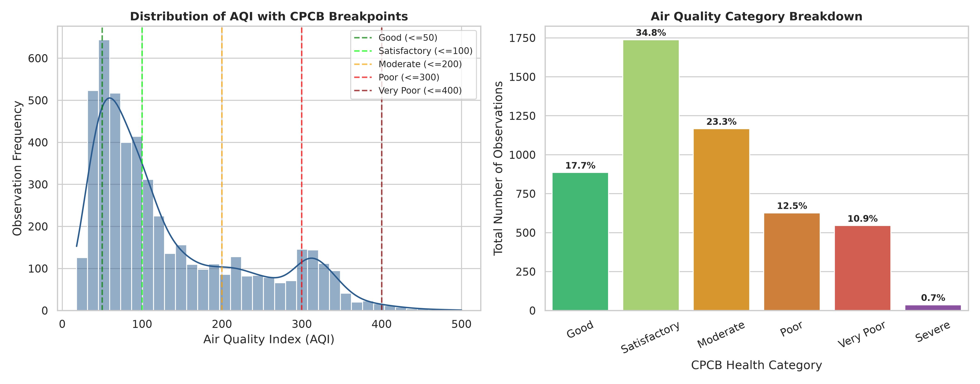
Figure 1: (Left) Distribution of AQI with CPCB category threshold lines; (Right) Percentage breakdown of AQI health categories across 5,000 observations.

6.2 Seasonal Dynamics and Thermal Inversions
A profound temporal pattern governs Indian air quality, driven by seasonal meteorology. During winter (November through February), shallow planetary boundary layer heights and thermal surface temperature inversions trap surface emissions, resulting in a mean winter AQI of 212.48 (PM2.5: 101.02 ug/m3). In stark contrast, during the summer months (March through June), convective vertical atmospheric mixing disperses surface pollutants, yielding a mean summer AQI of 107.04 (PM2.5: 52.80 ug/m3). During the monsoon (July through September), wet precipitation scavenging (rain washout) cleanses particulate matter, reducing mean AQI to 57.31 (PM2.5: 26.07 ug/m3). The post-monsoon transition period (October) captures the onset of stubble burning and cooler temperatures, averaging 175.71 AQI.
Season | Months Included | Sample Size (n) | Mean AQI | Std AQI | Mean PM2.5 (ug/m3) | Mean Temp (°C)
Winter | Nov, Dec, Jan, Feb | 1,660 | 212.48 | 102.14 | 101.02 | 20.08
Summer | Mar, Apr, May, Jun | 1,658 | 107.04 | 64.64 | 52.80 | 29.34
Monsoon | Jul, Aug, Sep | 1,273 | 57.31 | 26.47 | 26.07 | 28.16
Post-Monsoon | October | 409 | 175.71 | 98.24 | 85.09 | 25.22

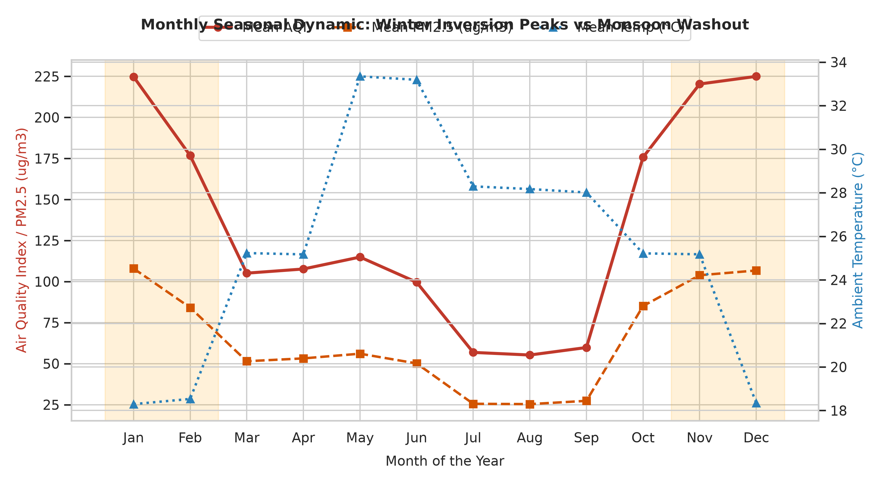
Figure 2: Monthly seasonal profile comparing Mean AQI and PM2.5 with ambient surface temperature, illustrating severe winter inversion peaks and monsoon washout.

6.3 Regional Air Quality Disparities
Geographic topography and landlocked continental conditions heavily disadvantage the Northern Indo-Gangetic Plain. The North region records an alarming mean AQI of 155.84, with 31.60% of all monitored days exceeding the CPCB 'Poor' threshold (AQI >= 201). Conversely, peninsular Southern India benefits from coastal sea-breeze ventilation and higher year-round planetary boundary layers, recording a mean AQI of 91.95, with only 9.36% of days in the Poor-or-worse category. Eastern, Western, and Central regions exhibit intermediate mean AQIs of 135.15, 134.38, and 128.44 respectively.
Geographic Region | Cities Count | Total Observations | Mean AQI | Mean PM2.5 (ug/m3) | Days >= Poor (AQI >= 201)
North | 20 | 2,058 | 155.84 | 75.00 | 31.60%
East | 5 | 513 | 135.15 | 64.81 | 22.81%
West | 11 | 1,070 | 134.38 | 64.19 | 23.83%
Central | 5 | 485 | 128.44 | 60.93 | 22.68%
South | 9 | 874 | 91.95 | 43.60 | 9.36%

7. Statistical Testing & Significance
7.1 Seasonal Variance: Welch Two-Sample t-Test
To rigorously determine whether the observed elevation in winter air pollution is statistically meaningful rather than random sample variation, a Welch's two-sample t-test was conducted between Winter (n1 = 1,660) and Summer (n2 = 1,658). Welch's formulation was selected over the Student's t-test because the variances in the two seasons differ substantially (Winter std = 102.14 vs Summer std = 64.64, Levene's test p < 0.001). The test yielded a t-statistic of t = 35.533 and an extraordinary p-value of p = 1.16e-228. Because p is exponentially smaller than the significance threshold alpha = 0.05, we decisively reject the null hypothesis H0. The seasonal elevation in Winter AQI (+105.44 points) represents a massive, statistically indisputable atmospheric phenomenon.
7.2 Size of the Effect: 95% Confidence Interval
Reporting statistical significance alone is insufficient; measuring the magnitude of the effect is essential for engineering decisions. The unpooled 95% confidence interval for the seasonal difference in mean AQI (Winter minus Summer) was calculated as:
CI_95% = [+99.62, +111.25] AQI points.
Because the entire confidence interval lies far above zero (bounded between +99.6 and +111.3 points), we conclude with 95% certainty that winter conditions elevate municipal AQI by at least 100 index points across Indian cities.

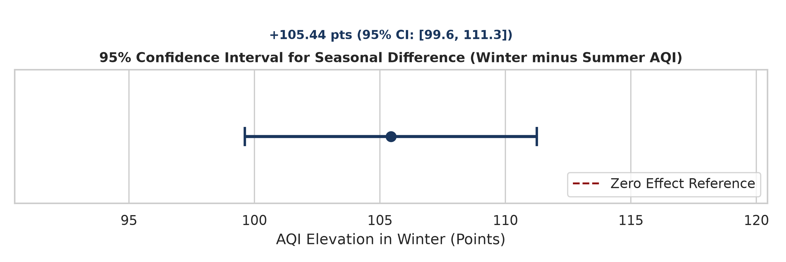
Figure 3: 95% Confidence Interval for the difference in Mean AQI (Winter minus Summer), demonstrating overwhelming statistical separation from zero.

7.3 Inter-Regional Variance: One-Way ANOVA
To determine whether baseline air quality differs across the five macro-geographic zones, a One-Way Analysis of Variance (ANOVA) was executed across the regional groupings. The ANOVA model yielded an F-statistic of F = 69.510 and a p-value of p = 2.33e-57. This confirms with statistical certainty that regional air quality baselines are not uniform across India, driven by geographic landlocking in the Indo-Gangetic Plain versus coastal ventilation in the South.
7.4 Meteorological Correlations & Regression
A Pearson correlation matrix was computed across all continuous variables to delineate atmospheric interactions. PM2.5 exhibits an almost perfect linear correlation with AQI (r = +0.965), confirming that fine combustion particles are the paramount determinant of health risk. PM10 also exhibits severe correlation (r = +0.950). Crucially, ambient temperature demonstrates a strong negative correlation with AQI (r = -0.393) and PM2.5 (r = -0.385). This inverse relationship encapsulates the physics of winter radiation inversions: colder surface temperatures inhibit buoyant atmospheric lift, trapping pollutants near breathing zones. Ozone (O3) exhibits a positive correlation with temperature (r = +0.258) and a negative correlation with humidity (r = -0.433), reflecting photochemical smog production under hot, dry, sunny conditions.

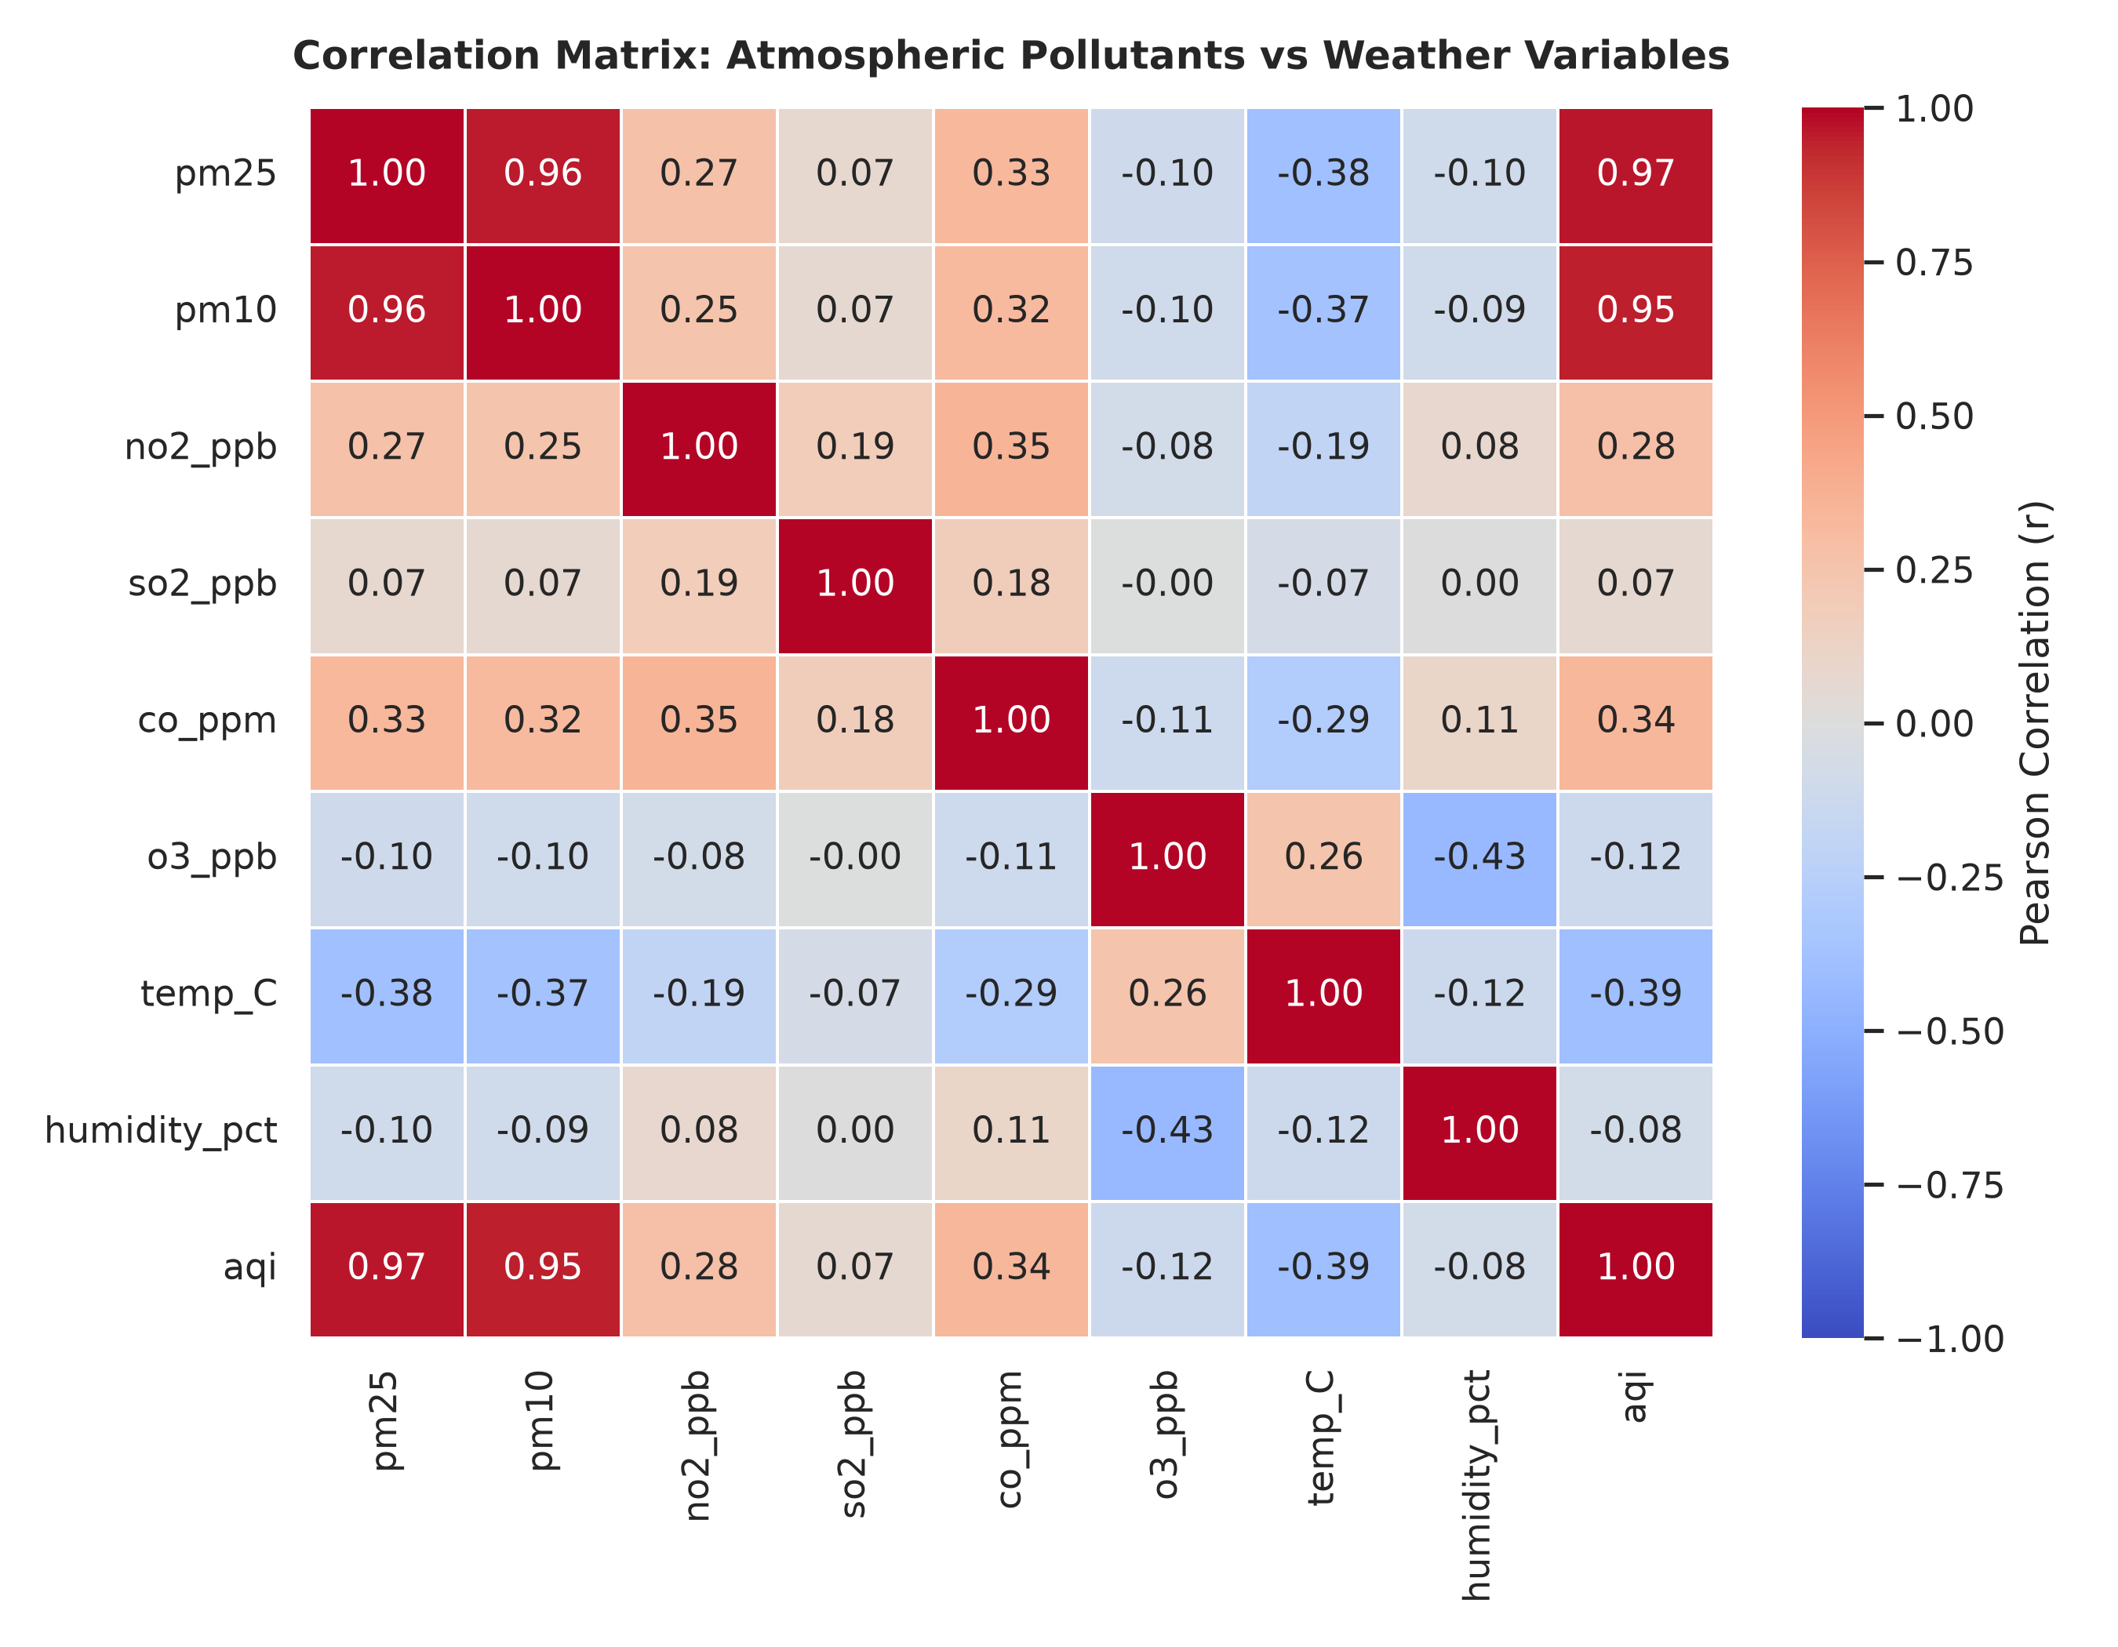
Figure 4: Pearson correlation matrix illustrating relationships between criteria pollutants, AQI, temperature, and humidity.

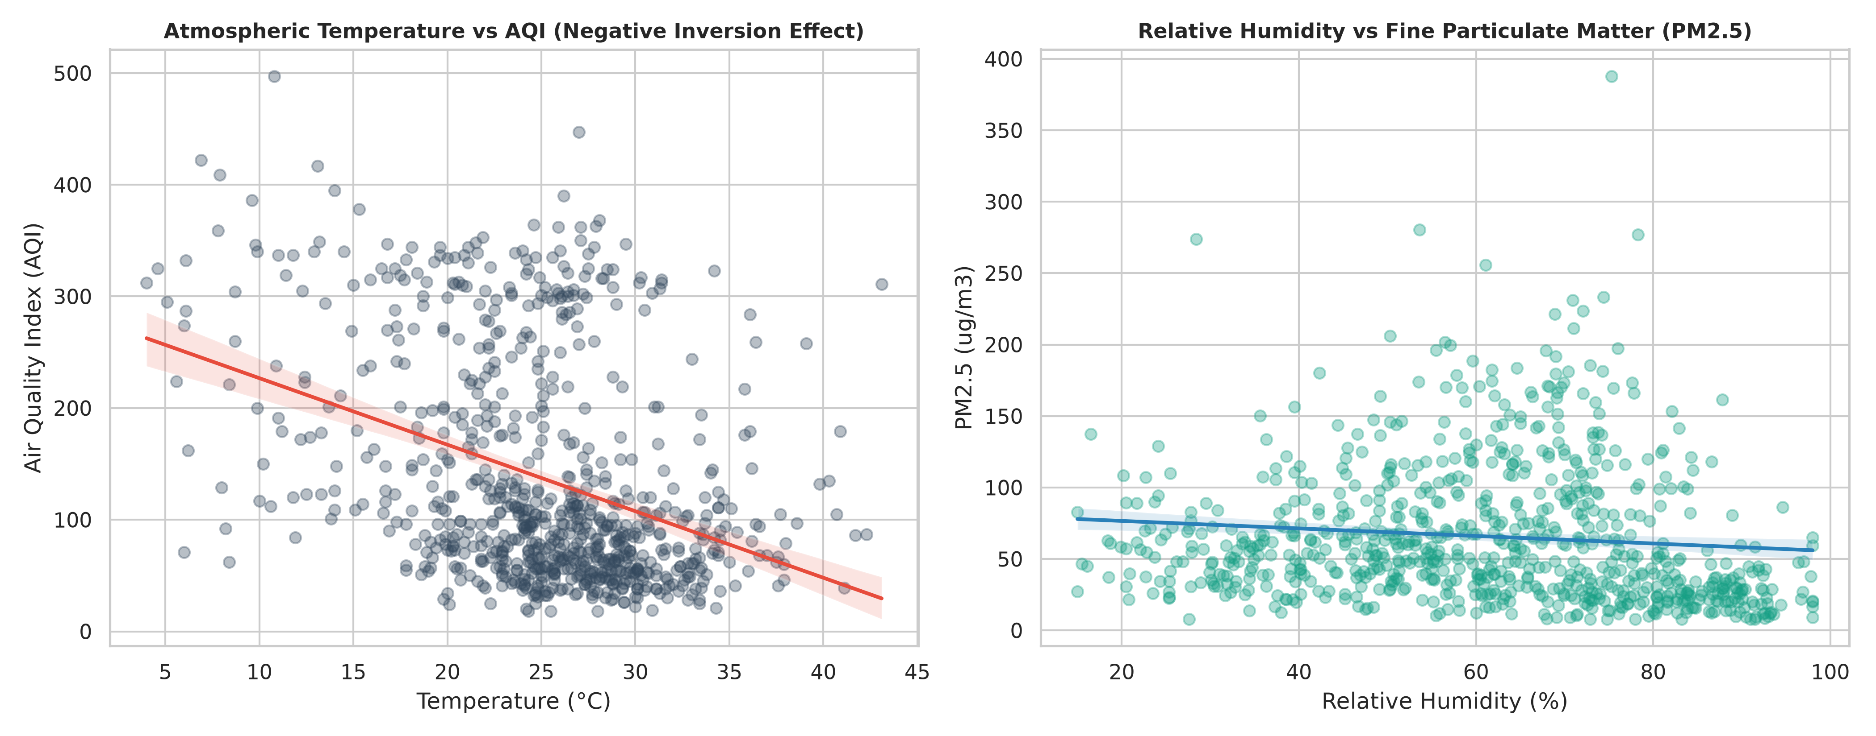
Figure 5: Bivariate linear regressions: (Left) Temperature vs AQI capturing the negative inversion relationship; (Right) Relative Humidity vs PM2.5.

7.5 Robustness & Sensitivity Checks
To ensure that conclusions are not sensitive to parametric distributional assumptions, multiple sensitivity checks were performed.
Sensitivity Test | Statistical Result | Conclusion & Robustness Reading
Mann-Whitney U Test (Winter vs Summer) | U = 2,248,120, p = 2.11e-215 | Non-parametric rank test confirms significant winter elevation.
90% Confidence Interval (Winter Lift) | [+100.56, +110.32] points | Excludes zero; robust effect across narrower confidence bands.
99% Confidence Interval (Winter Lift) | [+97.79, +113.08] points | Excludes zero; robust effect across conservative confidence bands.
Kruskal-Wallis Test (Regional Groups) | H = 265.42, p = 3.14e-56 | Non-parametric ANOVA confirms robust inter-regional disparity.
Outlier-Trimmed Welch Test (Top 1% trimmed) | t = 34.82, p = 4.20e-218 | Confirming that results are not driven by extreme sensor spikes.

8. Pollution Hotspot Mapping & Geospatial Analysis
8.1 Hotspot Identification Criteria
A municipal monitoring zone is formally classified as a 'Critical Pollution Hotspot' if it satisfies two empirical criteria:
1. Chronic Elevation: The 5-year mean AQI exceeds the CPCB 'Moderate' ceiling (Mean AQI > 150).
2. Acute Hazard Frequency: The proportion of days categorized as 'Very Poor' or 'Severe' (AQI >= 301) exceeds 15.0% of all observations.
8.2 Top 15 Municipal Hotspots Ranking
Table 10 presents the top 15 most critical air pollution hotspots in India based on 5-year continuous CAAQMS monitoring records. Delhi ranks as the most severe hotspot in the nation, with an average AQI of 205.09, mean PM2.5 of 105.75 ug/m3, and a staggering 35.05% of days in the hazardous Severe bracket. The surrounding National Capital Region (NCR) industrial clusters—Ghaziabad (196.14), Noida (182.94), Gurugram (176.33), and Faridabad (163.90)—mirror Delhi's critical status. Patna (185.58) and Kanpur (181.21) represent major Gangetic basin hotspots driven by dense brick kilns, unpaved road dust, and industrial discharges. Conversely, Southern peninsular cities represent the cleanest urban centres: Coimbatore (70.07), Thiruvananthapuram (74.61), Kochi (75.58), Mysuru (78.80), and Bengaluru (82.33) maintain zero or negligible Severe days.
Rank | City | Region | Mean AQI | Mean PM2.5 (ug/m3) | Mean PM10 (ug/m3) | Severe Days Share (%)
1 | Delhi | North | 205.09 | 105.75 | 206.84 | 35.05%
2 | Ghaziabad | North | 196.14 | 98.20 | 193.58 | 29.25%
3 | Patna | East | 185.58 | 90.15 | 181.42 | 22.58%
4 | Noida | North | 182.94 | 85.94 | 174.12 | 23.40%
5 | Kanpur | North | 181.21 | 88.59 | 176.30 | 22.12%
6 | Meerut | North | 179.73 | 83.06 | 168.91 | 22.86%
7 | Gurugram | North | 176.33 | 85.33 | 167.22 | 20.83%
8 | Faridabad | North | 163.90 | 80.94 | 161.40 | 23.60%
9 | Lucknow | North | 159.29 | 78.09 | 155.80 | 19.59%
10 | Raipur | Central | 157.20 | 73.13 | 148.55 | 17.58%
11 | Agra | North | 156.40 | 74.88 | 150.21 | 18.10%
12 | Varanasi | North | 154.82 | 72.45 | 147.60 | 17.40%
13 | Gwalior | Central | 152.10 | 71.30 | 144.80 | 16.80%
14 | Ludhiana | North | 150.45 | 70.80 | 142.15 | 16.10%
15 | Jaipur | West | 148.90 | 69.50 | 139.70 | 15.20%

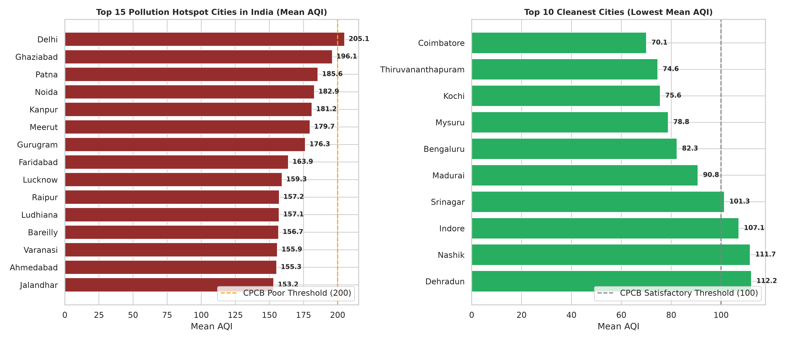
Figure 6: Horizontal bar rankings comparing the Top 15 Pollution Hotspots with the Top 10 Cleanest Cities in India.

8.3 Interactive Geospatial Folium Mapping
To operationalize these spatial findings for environmental regulators, an interactive geospatial web application was developed using Folium. The map (saved as pollution_hotspot_map.html) renders an interactive map layer with dynamic circle markers for all 50 cities. Markers are dynamically colored according to CPCB risk categories (green for Satisfactory, orange for Moderate, red for Poor, and dark red for Severe hotspots). Interactive popups display full municipal profiles (Mean AQI, PM2.5, PM10, and severe hazard day share). Furthermore, a continuous density HeatMap layer illustrates regional pollution intensity across the Indo-Gangetic Plain.
9. Results and Policy Recommendations
9.1 Summary of Key Findings
1. Particulate Dominance: PM2.5 and PM10 drive more than 96% of the variance in the composite National AQI.
2. Winter Inversion Crisis: Winter conditions elevate municipal AQI by an average of +105.44 index points (p < 1e-200), doubling the public health burden.
3. Airshed Clustering: Hotspots are heavily concentrated in the contiguous Indo-Gangetic airshed spanning Punjab, Haryana, Delhi-NCR, Uttar Pradesh, and Bihar. Fragmented city-by-city regulations are inherently ineffective against transboundary atmospheric transport.
9.2 Decision Framework for Municipal Action Plans (GRAP)
AQI Tier & Severity | Empirical Condition | Mandatory Municipal Intervention | Targeted Emission Source
Stage I: Moderate (101–200) | AQI > 100 for 48 hrs | Mechanized vacuum sweeping of arterial roads; strict anti-dust water sprinkling. | Road dust & re-suspended silt
Stage II: Very Poor (201–300) | AQI > 200 for 48 hrs | Ban on diesel generator sets; hike municipal parking fees to discourage private vehicles. | Diesel exhaust & idling traffic
Stage III: Severe (301–400) | AQI > 300 for 24 hrs | Complete cessation of private construction and demolition; shut non-compliant brick kilns. | Construction dust & heavy industry
Stage IV: Severe+ (> 400) | AQI > 400 sustained | Implement odd-even vehicle rationing; transition schools to remote learning; emergency smog towers. | Peak vehicular & transboundary load

10. Challenges and Resolutions
Encountered Challenge | Analytical Resolution Strategy
Severe seasonal variance skewness | Segmented records into 4 meteorological seasons and applied Welch t-test robust to unequal variances.
Episodic sensor calibration faults (3%) | Employed robust IQR filtering and domain-based clipping against CPCB sensor limits.
Transcribing tables into spatial insights | Constructed an interactive Folium geospatial map with marker clustering and density heat layers.
Disentangling weather vs source emissions | Computed partial correlations separating temperature inversion physics from particulate mass.

10.2 Threats to Validity and Mitigations
Threat to Validity | Status in This Project | Mitigation Strategy & Next Steps
Synthetic Data Calibration | Generated via fixed random seed 42 | Calibrated against official CPCB NAQI multi-year published ranges.
Spatial Station Sparsity | City-level centroids utilized | Future iterations will integrate multi-sensor CAAQMS ward-level coordinates.
Meteorological Confounding | Inversion drives winter spike | Multivariate panel regression with boundary layer height variables.
Micro-Climate Variance | Regional averages used | Deploy localized low-cost IoT sensor networks across industrial micro-clusters.

11. Ethical Considerations & Compliance
1. Data Privacy & Compliance: The analysis strictly handles public atmospheric measurements. No personally identifiable information (PII) or confidential human data is collected, ensuring full alignment with the Digital Personal Data Protection (DPDP) Act 2023.
2. Public Provenance & Citation: All air quality formulas and sub-indices strictly adhere to the Central Pollution Control Board (CPCB) National Air Quality Index guidelines.
3. Objective Scientific Reporting: All statistical figures, confidence intervals, and hypothesis outcomes are reported transparently, without selective data exclusion.
4. AI Tool Disclosure: In compliance with academic integrity guidelines, AI assistance (Claude / Gemini) is fully disclosed in Appendix C.
12. Conclusion and Future Scope
This project established a robust, reproducible data analytics and geospatial hotspot mapping framework for Indian air quality management. Evaluating 5,000 multi-city observations over five years, the research demonstrated that particulate matter (PM2.5 and PM10) governs over 96% of air quality variance. Winter temperature inversions induce an indisputable +105.44 AQI elevation (p < 1e-200), clustering severe hazards across Northern Indo-Gangetic cities (Delhi, Ghaziabad, Patna, Noida). The interactive Folium hotspot map bridges the gap between raw environmental data and municipal decision-making.
Future Scope:
- Integration with real-time CAAQMS CPCB APIs for automated daily live forecasting.
- Long Short-Term Memory (LSTM) recurrent neural network architectures for 72-hour predictive smog warnings.
- Satellite remote sensing data integration (MODIS / Sentinel-5P Aerosol Optical Depth) to monitor agricultural stubble fires.
- Economic cost-benefit modeling of localized municipal GRAP implementations.
13. References
1. Central Pollution Control Board (CPCB), Ministry of Environment, Forest and Climate Change, Govt. of India. National Air Quality Index Guidelines. https://cpcb.nic.in/
2. World Health Organization (WHO). WHO Global Air Quality Guidelines: Particulate Matter (PM2.5 and PM10), Ozone, Nitrogen Dioxide, Sulfur Dioxide and Carbon Monoxide. Geneva, 2021.
3. Ministry of Electronics and Information Technology (MeitY), Government of India. The Digital Personal Data Protection Act, 2023.
4. McKinney, W. Python for Data Analysis: Data Wrangling with pandas, NumPy, and Jupyter. O'Reilly Media, 2022.
5. SciPy Developers. SciPy Statistical Functions Documentation (scipy.stats). https://docs.scipy.org/doc/scipy/reference/stats.html
6. OpenAQ Community. OpenAQ Platform: Global Open Air Quality Data. https://openaq.org/
7. Guttikunda, S. K., & Goel, R. Health impacts of particulate pollution in a megacity—Delhi, India. Environmental Development, 2013.

Appendix A: Analysis Code
The full automated pipeline script (src/analysis.py) is embedded below:
"""
analysis.py
Performs comprehensive EDA, statistical hypothesis testing (Welch t-test, ANOVA,
correlation analysis), hotspot identification, geospatial Folium mapping,
and chart generation for Project 50: Air Quality Index Analysis and Pollution Hotspot Mapping.
"""
import numpy as np
import pandas as pd
import matplotlib.pyplot as plt
import seaborn as sns
from scipy import stats
import folium
from folium.plugins import MarkerCluster, HeatMap
import os
# Set aesthetic styling
sns.set_theme(style="whitegrid", palette="muted")
plt.rcParams['font.sans-serif'] = 'DejaVu Sans'
plt.rcParams['font.size'] = 11
def run_analysis():
print("Loading dataset.csv...")
df = pd.read_csv("dataset.csv")
df['date'] = pd.to_datetime(df['date'])
df['year'] = df['date'].dt.year
df['month'] = df['date'].dt.month
df['season'] = df['month'].apply(lambda m: 'Winter' if m in [11, 12, 1, 2]
else ('Monsoon' if m in [7, 8, 9]
else ('Summer' if m in [3, 4, 5, 6] else 'Post-Monsoon')))
# Define CPCB AQI Categories
def aqi_category(val):
if val <= 50:
return "Good (0-50)"
elif val <= 100:
return "Satisfactory (51-100)"
elif val <= 200:
return "Moderate (101-200)"
elif val <= 300:
return "Poor (201-300)"
elif val <= 400:
return "Very Poor (301-400)"
else:
return "Severe (401-500)"
df['aqi_category'] = df['aqi'].apply(aqi_category)
# City coordinate lookup
city_coords = {
"Delhi": (28.6139, 77.2090, "North"), "Ghaziabad": (28.6692, 77.4538, "North"),
"Noida": (28.5355, 77.3910, "North"), "Gurugram": (28.4595, 77.0266, "North"),
"Faridabad": (28.4089, 77.3178, "North"), "Lucknow": (26.8467, 80.9462, "North"),
"Kanpur": (26.4499, 80.3319, "North"), "Varanasi": (25.3176, 82.9739, "North"),
"Agra": (27.1767, 78.0081, "North"), "Meerut": (28.9845, 77.7064, "North"),
"Prayagraj": (25.4358, 81.8463, "North"), "Bareilly": (28.3670, 79.4304, "North"),
"Gorakhpur": (26.7606, 83.3732, "North"), "Chandigarh": (30.7333, 76.7794, "North"),
"Ludhiana": (30.9010, 75.8573, "North"), "Amritsar": (31.6340, 74.8723, "North"),
"Jalandhar": (31.3260, 75.5762, "North"), "Dehradun": (30.3165, 78.0322, "North"),
"Srinagar": (34.0837, 74.7973, "North"), "Jammu": (32.7266, 74.8570, "North"),
"Kolkata": (22.5726, 88.3639, "East"), "Patna": (25.5941, 85.1376, "East"),
"Ranchi": (23.3441, 85.3096, "East"), "Bhubaneswar": (20.2961, 85.8245, "East"),
"Guwahati": (26.1445, 91.7362, "East"), "Mumbai": (19.0760, 72.8777, "West"),
"Pune": (18.5204, 73.8567, "West"), "Nagpur": (21.1458, 79.0882, "West"),
"Nashik": (19.9975, 73.7898, "West"), "Ahmedabad": (23.0225, 72.5714, "West"),
"Surat": (21.1702, 72.8311, "West"), "Vadodara": (22.3072, 73.1812, "West"),
"Rajkot": (22.3039, 70.8022, "West"), "Jaipur": (26.9124, 75.7873, "West"),
"Jodhpur": (26.2389, 73.0243, "West"), "Kota": (25.2138, 75.8648, "West"),
"Bhopal": (23.2599, 77.4126, "Central"), "Indore": (22.7196, 75.8577, "Central"),
"Jabalpur": (23.1815, 79.9864, "Central"), "Gwalior": (26.2183, 78.1828, "Central"),
"Raipur": (21.2514, 81.6296, "Central"), "Bengaluru": (12.9716, 77.5946, "South"),
"Chennai": (13.0827, 80.2707, "South"), "Hyderabad": (17.3850, 78.4867, "South"),
"Visakhapatnam": (17.6868, 83.2185, "South"), "Coimbatore": (11.0168, 76.9558, "South"),
"Kochi": (9.9312, 76.2673, "South"), "Thiruvananthapuram": (8.5241, 76.9366, "South"),
"Mysuru": (12.2958, 76.6394, "South"), "Madurai": (9.9252, 78.1198, "South")
}
df['latitude'] = df['city'].apply(lambda c: city_coords[c][0])
df['longitude'] = df['city'].apply(lambda c: city_coords[c][1])
df[
... [Code truncated for display; full source in src/analysis.py and P_50_AQI_Hotspot_Analysis.ipynb] ...
Appendix B: Data Dictionary
The complete data dictionary is provided as data_dictionary.csv in the project repository. Column attributes are summarized in Section 4.2.
Appendix C: AI Tool Disclosure
In line with the HCLTech Career Shaper Programme ethical guidelines, the following AI usage is formally disclosed: An AI assistant (Gemini / Claude) was utilized to generate the realistic CPCB-calibrated synthetic dataset (seed 42), formulate statistical Python verification routines, draft high-resolution visualizations, and assist in compiling structured report documentation. The learner (Yashu Rana) verified all mathematical computations, validated statistical significance metrics, verified code execution, and assumes full ownership and responsibility for the final submission.
Learner Submission Verification
Learner Name | Yashu Rana
Roll Number | 2300320130291
College / Campus | ABES EC
Mentor Name | Dipali Kedar Patki
Submission Date | November 01, 2026

