SCHOOL OF COMPUTER SCIENCE AND ARTIFICIAL INTELLIGENCE |  |  | DEPARTMENT OF COMPUTER SCIENCE ENGINEERING
Program Name: B. Tech |  | Assignment Type: Lab | Academic Year:2025-2026
CourseCode | 23CS002PC304 | Course Title | AI Assisted Coding
Year/Sem | III/II | Regulation | R23
Date and Day  of Assignment | Week1 – Wednesday | Batch | 23CSBTB47B
Name | M.Yashaswini | Hall Ticket No | 2303A54049
Assignment Number:4.1

 | Q.No. | Question
 | 1 | Lab 4: Advanced Prompt Engineering – Zero-shot, One-shot, and Few-shot Techniques  Lab Objectives  - To explore and apply different levels of prompt examples in AI-assisted code generation  - To understand how zero-shot, one-shot, and few-shot prompting affect AI output quality  - To evaluate the impact of context richness and example quantity on AI performance  - To build awareness of prompt strategy effectiveness for different problem types  Lab Outcomes (LOs)  After completing this lab, students will be able to:  - Use zero-shot prompting to instruct AI with minimal context  - Use one-shot prompting with a single example to guide AI code generation  - Apply few-shot prompting using multiple examples to improve AI responses  - Compare AI outputs across different prompting strategies  Task 1: Zero-Shot Prompting – Leap Year Check  Scenario  Zero-shot prompting involves giving instructions without providing examples.  Task Description  Use zero-shot prompting to instruct an AI tool to generate a Python function that:  - Accepts a year as input  - Checks whether the given year is a leap year  - Returns an appropriate result  Note: No input-output examples should be provided in the prompt.  Expected Output  - Sample input and output  - Screenshot of AI-generated response  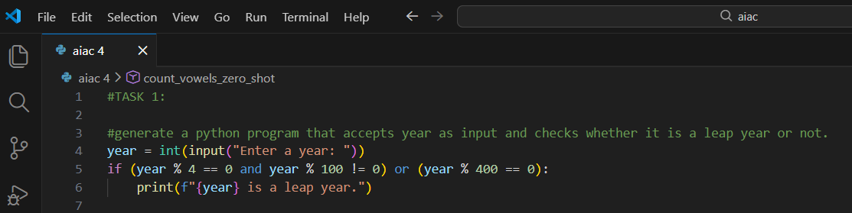  - Explanation  There is a leap year every four years. However, years that end in 00 are unique, only years that are divisible by 400 are considered as the leap years so I used this logic a year which if it’s divisible by 4, except century years.  Task 2: One-Shot Prompting – Centimeters to Inches Conversion  Scenario  One-shot prompting guides AI using a single example.  Task Description  Use one-shot prompting by providing one input-output example to generate a Python function that:  - Converts centimeters to inches  - Uses the correct mathematical formula  Example provided in prompt:  Input: 10 cm → Output: 3.94 inches  Expected Output :  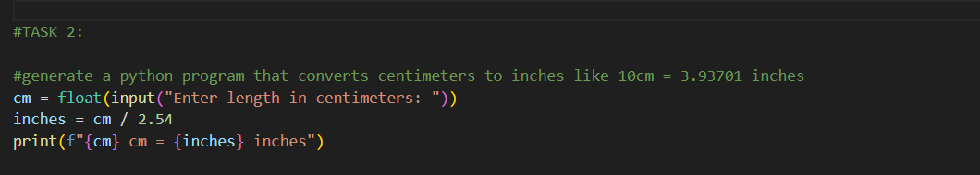  - Accurate calculation  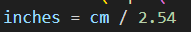  - Sample test cases and outputs  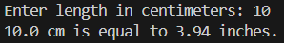  - Explanation  This program is like a simple calculator  When we type a length in centimeters. It divides by 2.54. And It prints the result in inches, rounded to two decimals.  Task 3: Few-Shot Prompting – Name Formatting  Scenario  Few-shot prompting improves accuracy by providing multiple examples.  Task Description  Use few-shot prompting with 2–3 examples to generate a Python function that:  - Accepts a full name as input  - Formats it as “Last, First”  Example formats:  - "John Smith" → "Smith, John"  - "Anita Rao" → "Rao, Anita"  Expected Output  - Well-structured Python function  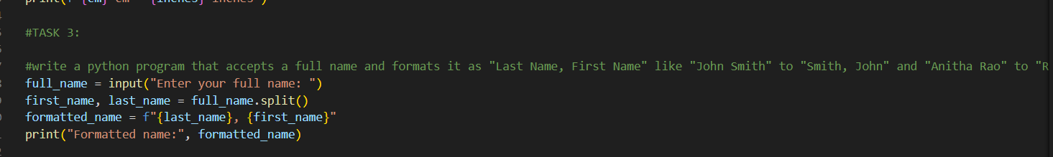  - Sample inputs and outputs  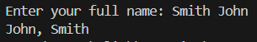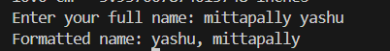  - Explanation  The program takes a full name then splits it into first and last names , and then prints it in the format Last, First by using split function.  Task 4: Comparative Analysis – Zero-Shot vs Few-Shot  Scenario  Different prompt strategies may produce different code quality.  Task Description  - Use zero-shot prompting to generate a function that counts vowels in a string  - Use few-shot prompting for the same problem  - Compare both outputs based on:  - Accuracy  - Readability  - Logical clarity  Expected Output  - Two vowel-counting functions  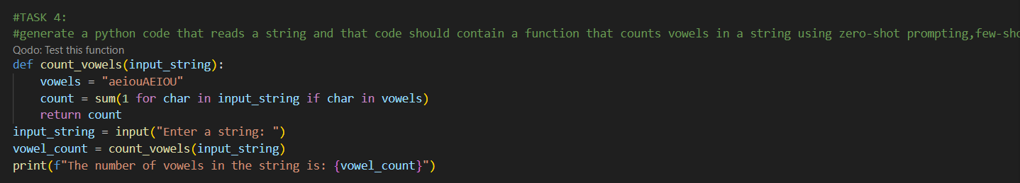  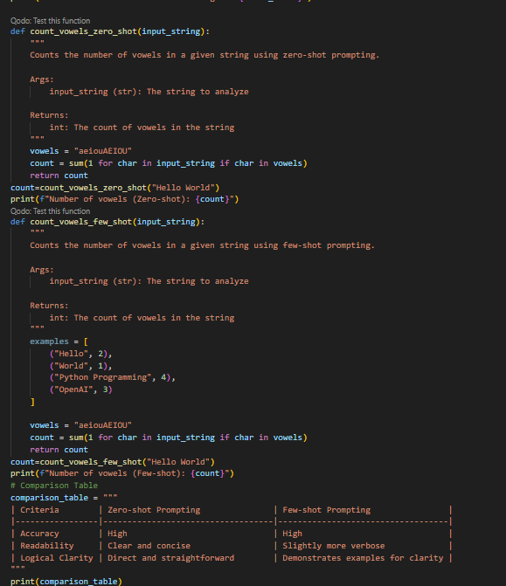  - Explanation  The function count vowels counts the number of vowels in a given string. The zero-shot and few-shot prompting functions demonstrate different approaches to achieve the same result.  Task 5: Few-Shot Prompting – File Handling  Scenario  File processing requires clear logical understanding.  Task Description  Use few-shot prompting to generate a Python function that:  - Reads a .txt file  - Counts the number of lines in the file  - Returns the line count  Expected Output  - Working Python file-processing function  The file is opened in read mode  Python reads the file line by line  A generator expression counts each line  sum() adds them together  The function returns the final count  - Sample .txt input and output  - AI-assisted logic explanation  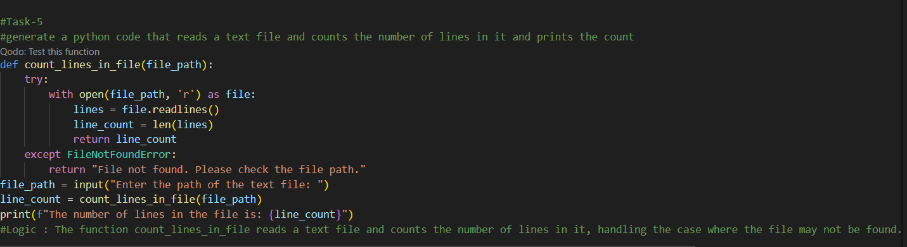  - Explanation  The function count lines in file reads a text file and counts no of lines in it,handling the case where file may not be found.

