Q1)

#include<iostream>

using namespace std;

int main(){

int arr[100];

int n=0;

int choice;

do{

cout<<"\n Menu \n";

cout<<"1. Create\n";

cout<<"2. Display\n";

cout<<"3.Insert\n";

cout<<"4.Delete\n";

cout<<"5.Linear Search\n";

cout<<"6. Exit\n";

cout<<"enter your choice: ";

cin>>choice;

if(choice==1){

cout<<"enter the number of elements: ";

cin>>n;

cout<<"the elements";

for(int i=0;i<n;i++){

cin>>arr[i];

}

}

else if(choice==2){

if(n==0) cout<<"enpty\n";

else{

cout<<"array elements: ";

for(int i=0;i<n;i++){

cout<<arr[i]<<" ";

}

}

}

else if(choice==3){

int pos, val;

cout<<"enter the value: ";

cin>>val;

cout<<"enter the position: ";

cin>>pos;

if(pos<0||pos>n)

cout<<"invalid";

else{

for(int i=n;i>pos;i--){

arr[i]=arr[i-1];

}

arr[pos]=val;

n++;

}

}

else if(choice==4){

int pos;

cout<<"enter the position: ";

cin>>pos;

if(pos<0||pos>n)

cout<<"error";

else{

for(int i=pos; i<n-1;i--){

arr[i]=arr[i+1];

}

n--;

}

}

else if(choice==5){

int key, found =0;

cout<<"enter element to search ";

cin>>key;

for(int i=0;i<n;i++){

if(arr[i]== key){

cout<<"element found here!!"<<i<<endl;

found=1;

break;

}

}

if(found==0)

cout<<"not found";

}

else if(choice==6){

cout<<"exit\n";

}

else{

cout<<"invalid choice\n";

}

} while(choice !=6);

return 0;

}

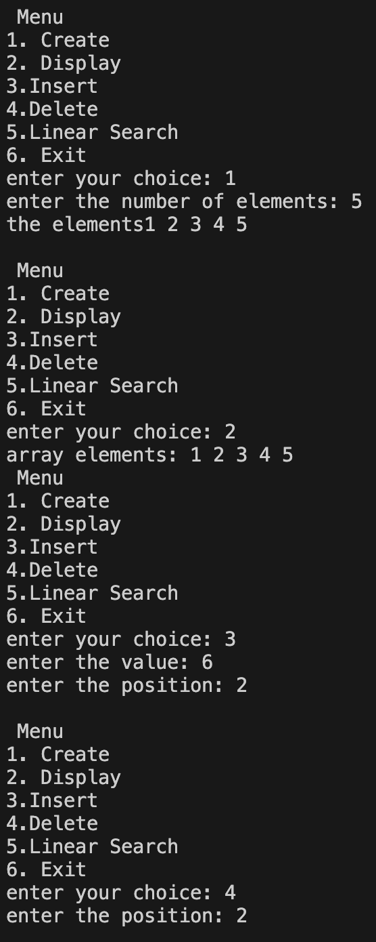 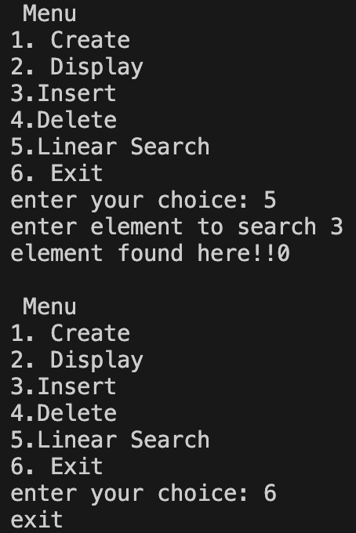

Q2

#include<iostream>

using namespace std;

int main() {

int arr[10], n;

cout << "Enter the number of elements: ";

cin >> n;

cout << "Enter the elements: ";

for (int i = 0; i < n; i++) {

cin >> arr[i];

}

for (int i = 0; i < n; i++) {

for (int j = i + 1; j < n; ) {

if (arr[i] == arr[j]) {

for (int k = j; k < n - 1; k++) {

arr[k] = arr[k + 1];

}

n--;

} else {

j++;

}

}

}

cout << "Array after removing duplicates: ";

for (int i = 0; i < n; i++) {

cout << arr[i] << " ";

}

return 0;

}

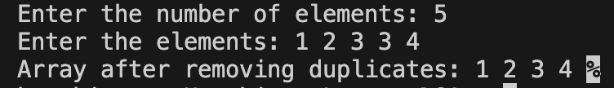

Q3)

#include<iostream>

using namespace std;

int main(){

int i;

int arr[5]={1};

for(i=0;i<5;i++){

cout<<arr[i];

}

return 0;

}



Q4 a)

#include<iostream>

using namespace std;

int main(){

int arr[10],n;

cout<<"enter the size of the array: ";

cin>>n;

cout<<"enter the elements: \n";

for(int i=0;i<n;i++){

cin>>arr[i];

}

cout<<"the reversed array is: ";

for(int i=n-1;i>=0;i--){

cout<<arr[i]<<" ";

}

return 0;

}

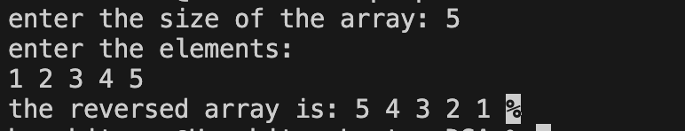

Q4b)

#include<iostream>

using namespace std;

int main() {

int arr[10][10], brr[10][10], res[10][10];

int r1, c1, r2, c2;

cout << "Enter number of rows for 1st matrix: ";

cin >> r1;

cout << "Enter number of columns for 1st matrix: ";

cin >> c1;

cout << "Enter number of rows for 2nd matrix: ";

cin >> r2;

cout << "Enter number of columns for 2nd matrix: ";

cin >> c2;

if (c1 != r2) {

cout << "Matrix multiplication not possible!" << endl;

return 0; // exit the program

}

cout << "Enter elements of 1st matrix:\n";

for (int i = 0; i < r1; i++) {

for (int j = 0; j < c1; j++) {

cin >> arr[i][j];

}

}

cout << "Enter elements of 2nd matrix:\n";

for (int i = 0; i < r2; i++) {

for (int j = 0; j < c2; j++) {

cin >> brr[i][j];

}

}

for (int i = 0; i < r1; i++) {

for (int j = 0; j < c2; j++) {

res[i][j] = 0;

for (int k = 0; k < c1; k++) { // or k < r2

res[i][j] += arr[i][k] \* brr[k][j];

}

}

}

cout << "\nResultant Matrix:\n";

for (int i = 0; i < r1; i++) {

for (int j = 0; j < c2; j++) {

cout << res[i][j] << " ";

}

cout << endl; // move to next row

}

return 0; }

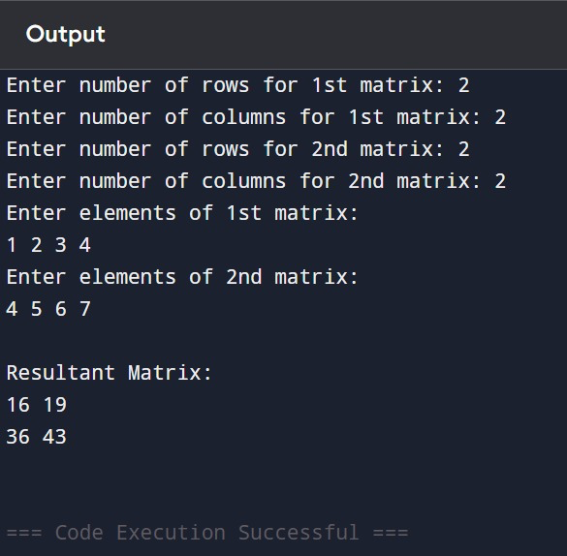

Q4c

#include<iostream>

using namespace std;

int main(){

int arr[10][10], transpose[10][10];

int rows, cols;

cout<<"enter the rows and columns: ";

cin>>rows>>cols;

cout<<"enter the elements of matrix: ";

for(int i=0;i<rows;i++){

for(int j=0;j<cols;j++){

cin>>arr[i][j];

}

}

for(int i=0;i<rows;i++){

for(int j=0;j<cols;j++){

transpose[j][i]= arr[i][j];

}

}

cout<<"the transpose is: ";

for(int i=0;i<cols;i++){

for(int j=0;j< rows;j++){

cout<<transpose[i][j]<<" ";

}

}

return 0; }

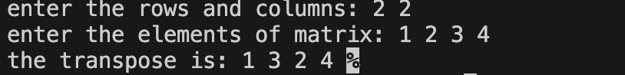

Q5)

#include<iostream>

using namespace std;

int main() {

int rows, cols;

cout << "Enter number of rows and columns: ";

cin >> rows >> cols;

int arr[100][100];

cout << "Enter elements of the matrix:\n";

for (int i = 0; i < rows; i++) {

for (int j = 0; j < cols; j++) {

cin >> arr[i][j];

}

}

cout << "\nSum of each row:\n";

for (int i = 0; i < rows; i++) {

int rowSum = 0;

for (int j = 0; j < cols; j++) {

rowSum += arr[i][j];

}

cout << "Sum of Row " << i + 1 << " = " << rowSum << endl;

}

cout << "\nSum of each column:\n";

for (int j = 0; j < cols; j++) {

int colSum = 0;

for (int i = 0; i < rows; i++) {

colSum += arr[i][j];

}

cout << "Sum of Column " << j + 1 << " = " << colSum << endl;

}

return 0;

}

