PL/SQL Exercise
Scenario 1: The bank wants to apply a discount to loan interest rates for customers above 60 years old.

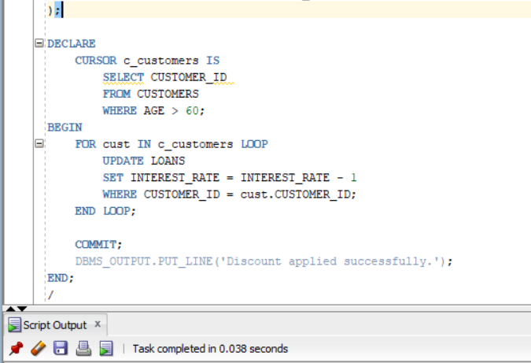
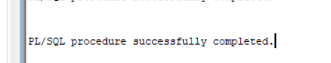
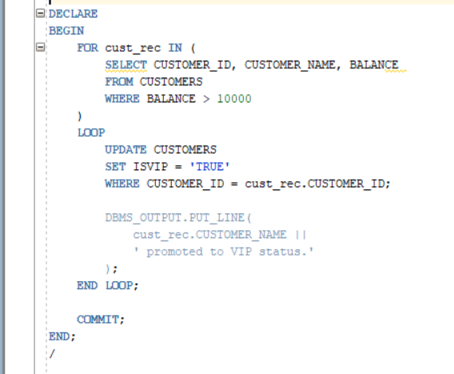
Scenario 2: A customer can be promoted to VIP status based on their balance.
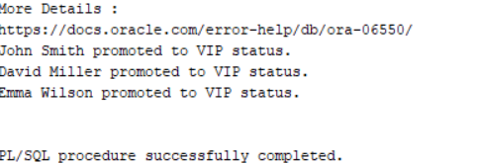
Output

Question: Fetch all loans due within the next 30 days and print a reminder message.
