**Assignement Address Book**

**Module Used:**

* + **SQLAlchemy==1.4.41**
  + **uvicorn==0.18.3**
  + **pydantic==1.10.2**

**File structure:-**

**main.py-**Entry point of the Project , Api are written in this file

**db.py**-Database configuration (sqlite)

**crud.py**-logic of crud is added in this file

**models.py**-model is define to database table creation and interaction

**Commands:-**

* Run the development server (like uvicorn main:app --reload).

**API’S Result:-**

API-> <http://localhost:8000/docs#/>

* Get All Addresses

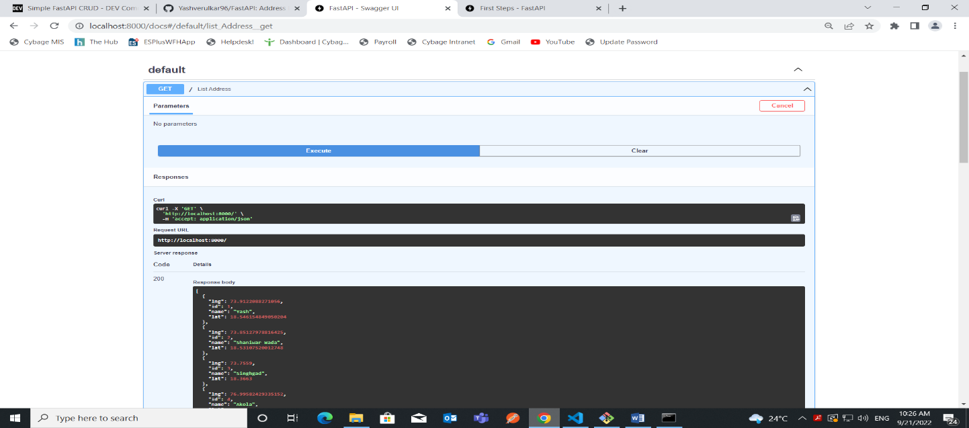

* Creating new Address

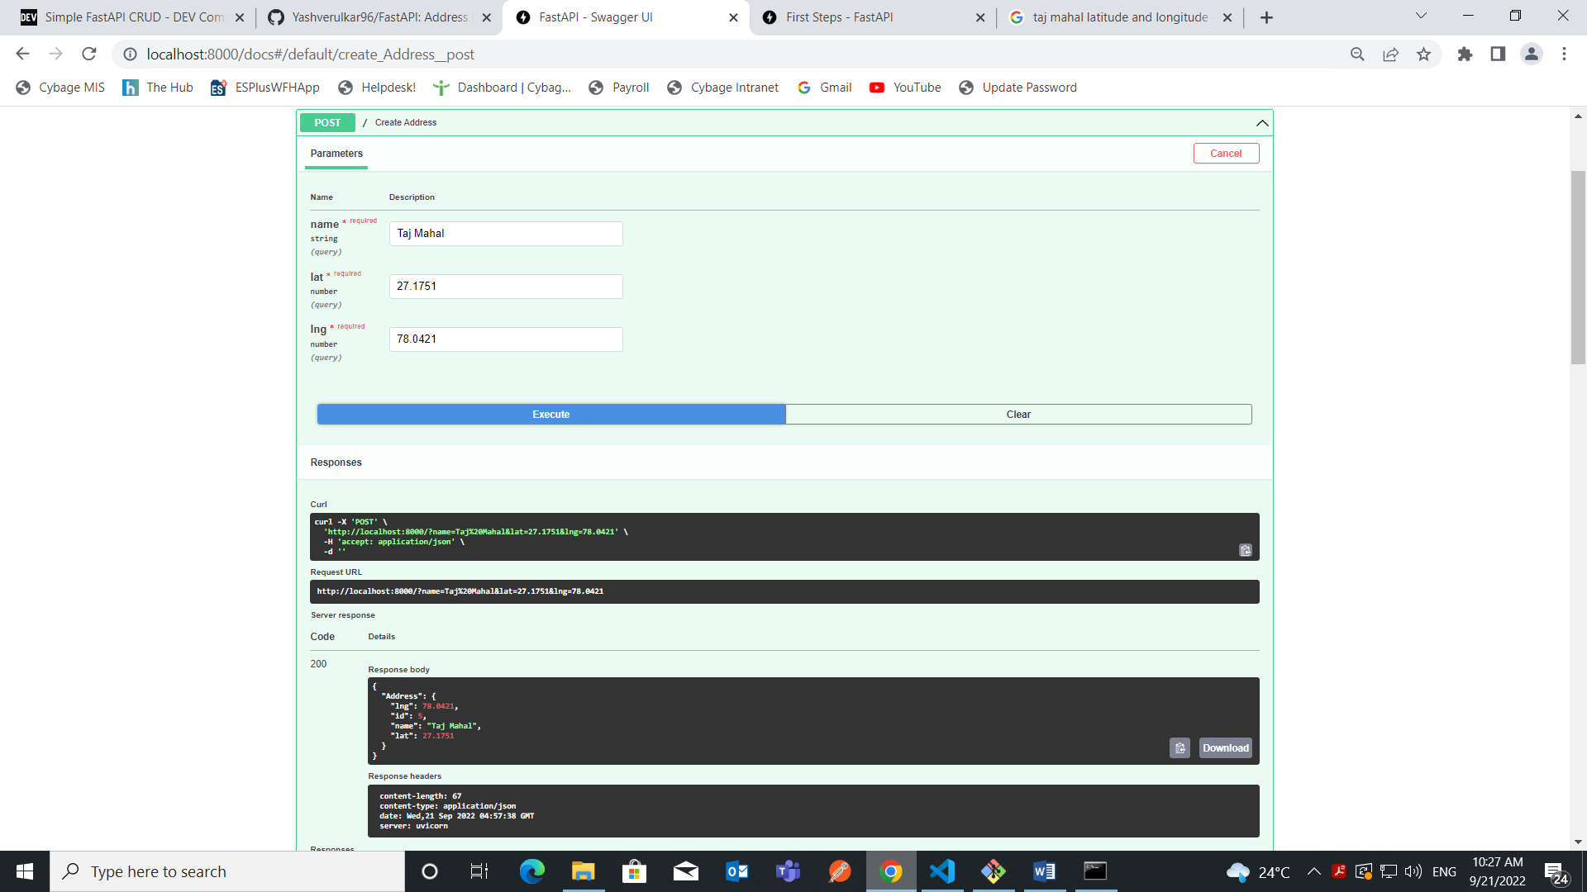

* Fetching Address Based on Distance from given Co-ordinates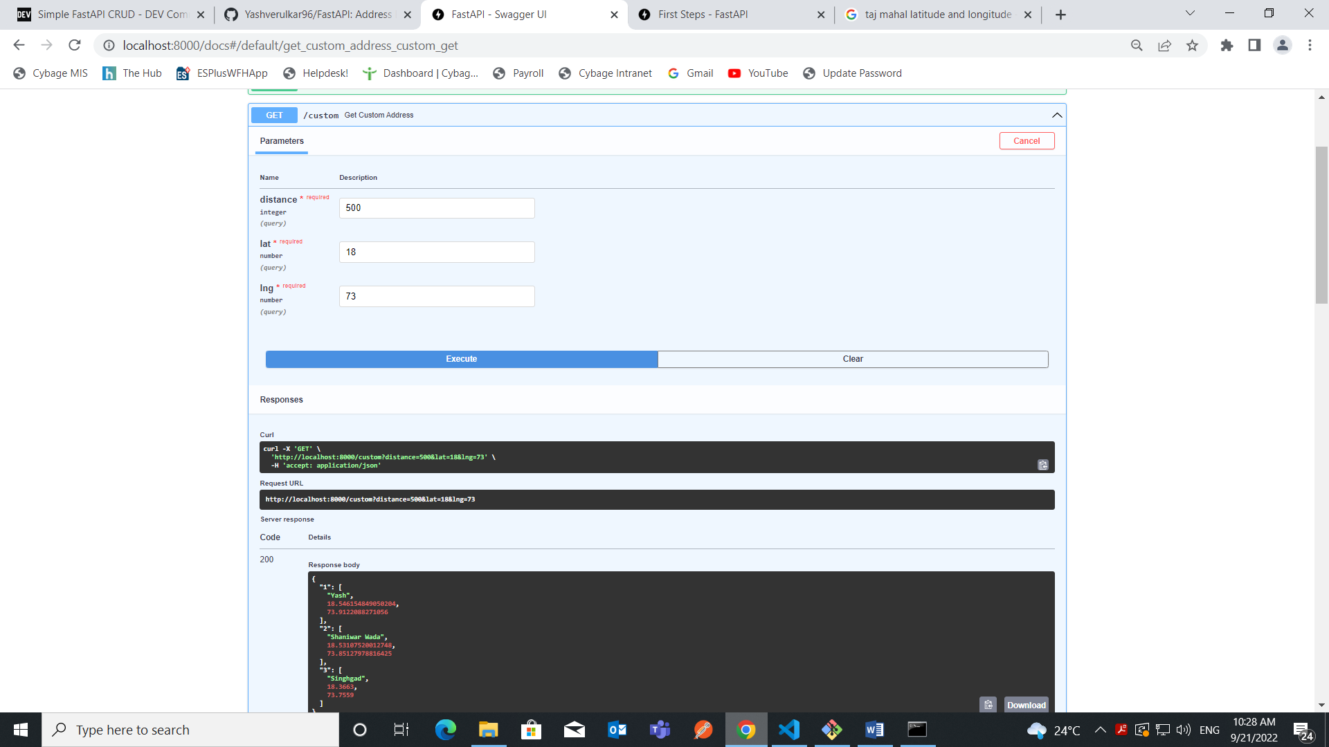
* Updating Address with given id

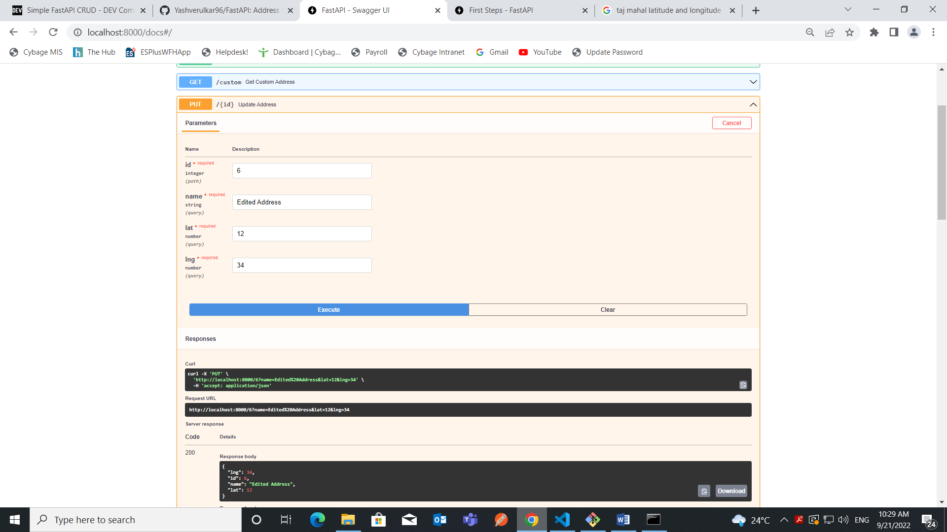

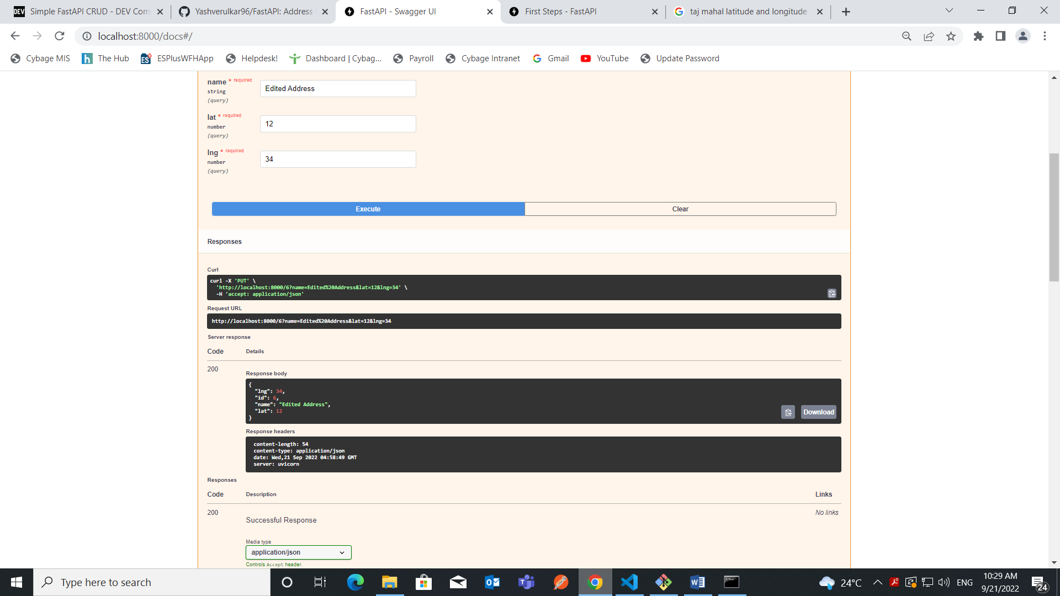

* Deleting Address based on id

