
Case Study Report
Automated Failure Detection & Alert Routing in Containerized Microservices using Prometheus & Alertmanager
by
16010123341 Yashasvi Gupta
16010123329 Shweta Karandikar
16010123018 Aditi Agrawal
For the subject
DevOps
Department of Computer Engineering
Academic Year 2026-27

Table of Contents
1. Abstract 3
2. Introduction 3
2.1 The problem 3
2.2 Objectives 4
3. Tool selection 4
3.1 What we needed 4
3.2 Candidates 5
3.3 Why Prometheus and Alertmanager 5
4. Understanding the tool 5
4.1 Prometheus 5
4.2 Alertmanager 6
5. Practical demonstration 7
5.1 Architecture & Stack Setup 7
5.2 Three Angles of Monitoring 8
5.3 Alerting Rules & Logic 10
5.4 Alertmanager Pipeline & Noise Control 10
5.5 Failure Injection & Operational Dashboards 11
6. Comparison and evaluation 15
6.1 Detection and Recovery Performance 15
6.2 Noise Reduction & Alert Suppression 17
6.3 False-Positive Resilience 18
6.4 Resource Footprint 19
6.5 Comparative Tool Analysis 19
6.6 Strengths and Limitations 20
7. Testing and Continuous Integration 20
8. Project Links and Artifacts 22
9. Conclusion 22
10. References 23

1. Abstract
Containers fail in subtle ways that traditional infrastructure monitoring frequently misses: a web process hangs while its container status remains "Up", memory leaks gradually until the Linux kernel terminates the process, or a backend database dies while the web API keeps returning internal server errors. This case study evaluates Prometheus and Alertmanager as an automated observability and incident notification stack for containerized microservices.
We built OrderFlow, a containerized food ordering service backed by a Redis database, and encapsulated it within a ten-container production-grade monitoring architecture: white-box application metrics, black-box HTTP probing, kernel-level container metrics via cAdvisor, a dedicated Redis exporter, Prometheus with recording and alerting rules, and Alertmanager routing notifications to an on-call email inbox and an operations chat webhook.
We systematically injected nine real-world container failure modes and evaluated detection latency, notification routing, and noise suppression. All nine failures were detected automatically: first notifications arrived between 16 and 90 seconds after fault onset (median 60 seconds), with critical alerts reaching the on-call engineer's inbox in 26 to 59 seconds. Alertmanager's inhibition mechanism suppressed cascade alerts during a database outage, reducing four potential alarm floods to a single actionable root-cause page, while a 10-second transient blip produced zero false alarms. We compare Prometheus and Alertmanager against Nagios, Zabbix, Datadog, Grafana Alerting, and AWS CloudWatch, and discuss their operational trade-offs.

2. Introduction

2.1 The problem
Modern microservices architectures make deploying containerized applications straightforward, but they also make failures quiet and difficult to diagnose. Consider an online food delivery platform like OrderFlow. Day and night, hungry customers place orders that must be processed immediately. At 2:00 AM, a critical dependency or worker process fails silently. Customers continue placing orders that never reach the restaurant, money is deducted, and the engineering team only learns about the catastrophe hours later when customer complaints flood support channels.
Containers make this nightmare especially easy to overlook because Docker CLI tools such as docker ps can still report a container as Up (running) while inside:
- The web process hangs: Incoming requests block indefinitely and user connections time out, yet the container process exists.
- A critical dependency crashes: Redis fails or becomes unreachable, causing order creation to fail with HTTP 500 errors.
- Memory leaks accumulate: Application memory gradually expands until the Linux kernel's Out-Of-Memory (OOM) killer abruptly kills the process.
- CPU quota is saturated: High compute loads hit CPU quotas and cause heavy thread throttling, severely degrading user latency.
- Containers crash and restart silently: The process crashes and Docker restarts it immediately, hiding a recurring underlying defect.
An engineering team requires an automated monitoring architecture that notices these failures within approximately one minute, notifies the correct engineer without requiring anyone to stare at dashboards, prevents alert fatigue by suppressing symptom storms, and confirms resolution when services recover.

2.2 Objectives
- Tool Justification: Select an open-source monitoring and alerting stack suited for dynamic containerized workloads and justify the choice.
- Multi-Angle Observability: Instrument OrderFlow from three complementary monitoring perspectives: white-box metrics, black-box health probing, and container-level cgroup metrics.
- Automated Alert Rules: Author expressive PromQL alert rules for all major failure modes and test them systematically via automated unit testing.
- Noise Reduction & Multi-Channel Routing: Configure Alertmanager with grouping, inhibition, silence handling, and a watchdog heartbeat delivering critical alerts to email and chat.
- Empirical Chaos Evaluation: Inject nine real failure scenarios, benchmark exact time-to-detect and recovery durations, and compare the solution against industry alternatives.

3. Tool selection

3.1 What we needed
Requirement | Why it matters
Native container compatibility | Containers are ephemeral; static host lists cannot keep up
Multi-dimensional metrics with labels | Ability to compute rates, percentiles, and ratios rather than simple up/down checks
Expressive alert conditions | Fine-grained logic such as "HTTP error ratio > 10% sustained for 30 seconds"
Noise suppression & routing | Distinct delivery channels by severity, symptom inhibition, and de-duplication
Configuration as code | Alert rules and routing version-controlled in Git and verified in CI
Free and self-hosted | Lightweight footprint capable of running locally or on edge nodes without recurring SaaS costs

3.2 Candidates
We evaluated Nagios Core, Zabbix, Datadog, Grafana Alerting, AWS CloudWatch, and Prometheus paired with Alertmanager (detailed comparison in Section 6.5). Commercial SaaS offerings like Datadog and AWS CloudWatch incur per-host or per-metric billing and introduce vendor lock-in. Nagios Core is centered around static physical hosts and lacks native container discovery. Zabbix is powerful but traditionally configured through a manual web interface backed by a relational database. Grafana Alerting offers strong visualization but relies on an external data collection engine like Prometheus.

3.3 Why Prometheus and Alertmanager
- Cloud-Native Design: Prometheus is a CNCF graduated project built ground-up for microservices and dynamic container environments, featuring native Docker and Kubernetes service discovery.
- Expressive PromQL Engine: A unified query language powering dashboards, recording rules, and alerts that natively evaluates moving averages, percentile latencies, and container resource limits.
- Separation of Concerns with Alertmanager: Prometheus detects what is broken, while Alertmanager manages how and to whom alerts are delivered via grouping, inhibition, silences, and multi-receiver routing.
- Monitoring as Code: Configuration and alert rules are defined in declarative YAML, allowing automated linting and unit testing with promtool and amtool inside CI/CD pipelines.
- Resource Efficiency: Fully open-source (Apache 2.0) with an ultra-lightweight operational footprint (~180 MiB RAM for the entire monitoring stack).

4. Understanding the tool

4.1 Prometheus
Prometheus operates primarily via a pull model: at configured scrape intervals (5 seconds in our stack), the Prometheus server initiates HTTP GET requests to each target's /metrics endpoint. If a target fails to answer within the scrape timeout, Prometheus automatically registers up = 0, making scrape failures a first-class alerting signal.
Every metric sample consists of a timestamp, a float64 value, and multi-dimensional key-value labels:
http_requests_total{route="/api/orders", status="500", method="POST"} 142
Metrics are persisted in Prometheus's append-only time-series database (TSDB). Third-party services that do not natively provide Prometheus endpoints are monitored using dedicated exporters that bridge native telemetry into Prometheus metrics:
Metric Type | Operational Behavior | Example in OrderFlow
Counter | Monotonically increasing value; queried via rate() or increase() | http_requests_total, orders_created_total
Gauge | Value that fluctuates up and down | app_dependency_up, container_memory_working_set_bytes
Histogram | Samples observations into cumulative buckets | http_request_duration_seconds (calculates p95 latency)
Recording rules precompute expensive PromQL queries on a schedule and persist the results as new time series, optimizing query performance. Alerting rules specify a PromQL condition combined with a for duration: when the condition evaluates to true, the alert enters the pending state; once it remains continuously true for the duration, it transitions to firing and is pushed to Alertmanager.

4.2 Alertmanager
Alertmanager ingests alerts from one or more Prometheus instances and processes them through an ordered pipeline:
- Inhibition: Suppresses symptom alerts if a known root-cause alert is already firing.
- Silences: Suppresses notifications for alerts that match an active scheduled maintenance window.
- Grouping: Aggregates related alerts sharing common labels into a single bundled notification after a configurable group_wait.
- Routing: Traverses an alert routing tree based on label matchers to select destination receivers.
- Notification & Resolution: Formats messages using custom templates, dispatches to receivers (email, chat webhooks), repeats unacknowledged alerts after repeat_interval, and sends a resolved notification when the incident clears.

5. Practical demonstration

5.1 Architecture & Stack Setup
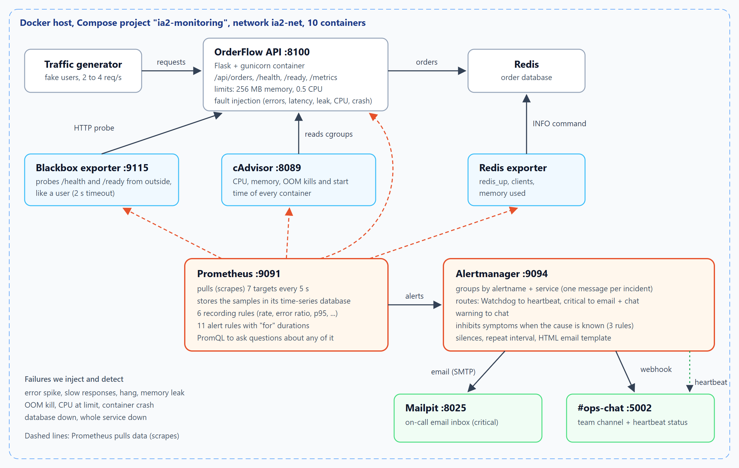
Architecture of the demonstration
The complete solution is launched with a single standard command: docker compose up -d --build. The topology consists of ten microservices:
Container | Role & Resource Constraints
ia2-shop-api | OrderFlow web service (Flask + Gunicorn), resource-constrained to 256 MB RAM and 0.5 CPU
ia2-redis | In-memory key-value database storing customer food orders
ia2-traffic | Synthetic customer traffic generator simulating realistic ordering patterns
ia2-prometheus | Prometheus server scraping 7 targets every 5 s with 6 recording and 11 alert rules
ia2-alertmanager | Alert notification engine handling grouping, inhibition, silences, and dispatch
ia2-blackbox | External synthetic prober verifying /health and /ready endpoints
ia2-cadvisor | Container Advisor gathering kernel cgroup metrics (CPU, RAM, throttles, OOMs, restarts)
ia2-redis-exporter | Extracts internal Redis engine telemetry (redis_up, connected clients, memory)
ia2-mailpit | Local SMTP server and responsive webmail inbox capturing on-call alert pages
ia2-ops-chat | Custom operational chat receiver rendering webhook alerts and a live watchdog heartbeat
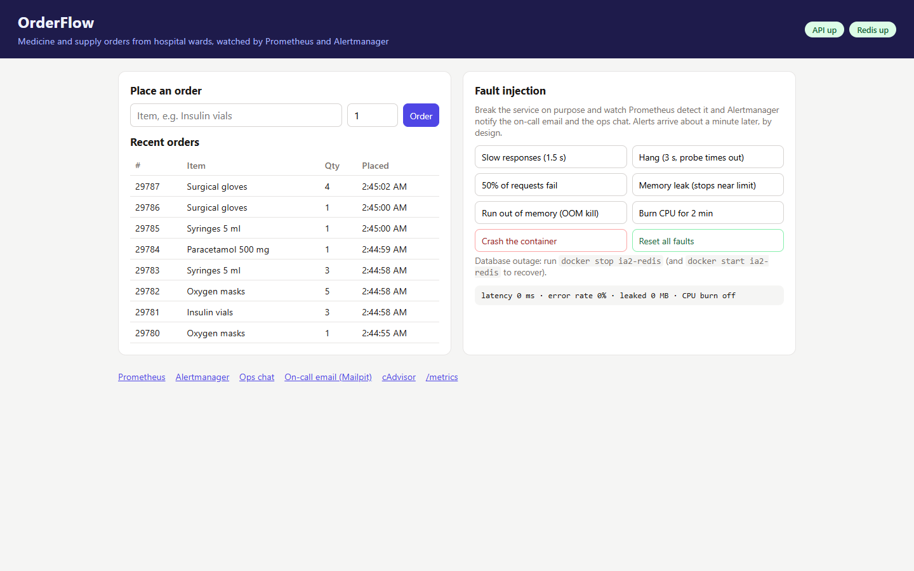
OrderFlow with its fault-injection panel
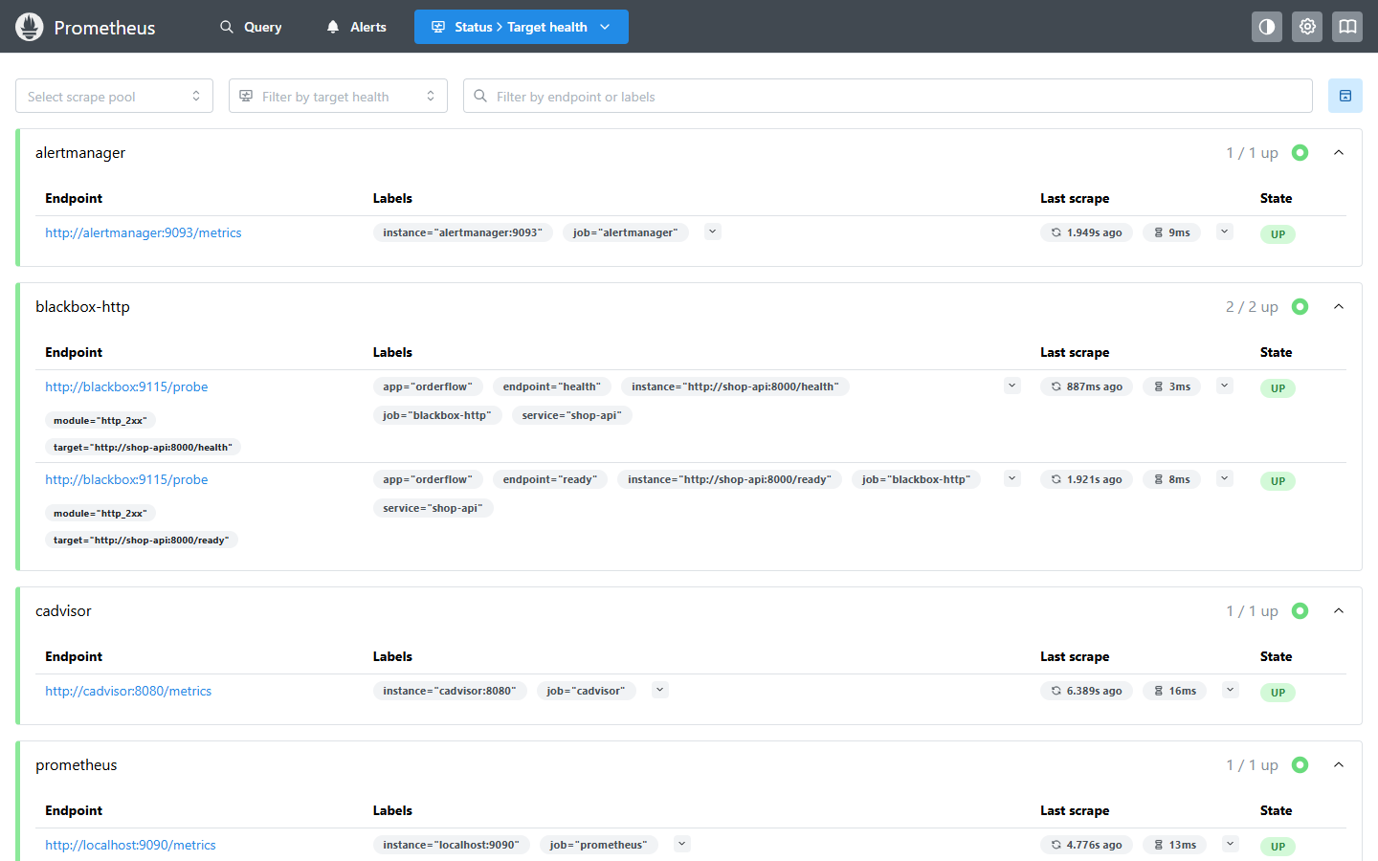
Prometheus scraping all seven targets

5.2 Three Angles of Monitoring
Effective microservice observability requires monitoring across three distinct operational layers:
1. White-box Application Telemetry:
OrderFlow embeds the official prometheus_client Python SDK to expose application-internal telemetry at /metrics: request counters by route and HTTP status, request duration histograms, order creation totals, and dependency availability. Importantly, simulated application faults leave the /metrics endpoint responsive. This accurately mirrors real-world hangs where the web process accepts TCP connections but fails user requests.
2. Black-box Synthetic Probing:
The Prometheus Blackbox Exporter probes /health (liveness) and /ready (readiness) from the outside network every 5 seconds with a 2-second timeout, recording probe_success. If OrderFlow hangs, the blackbox probe fails while internal Prometheus scraping still succeeds, making black-box probing essential for capturing real user impact:
- job_name: blackbox-http
metrics_path: /probe
params: { module: [http_2xx] }
static_configs:
- targets: ["http://shop-api:8000/health"]
relabel_configs:
- { source_labels: [__address__], target_label: __param_target }
- { source_labels: [__param_target], target_label: instance }
- { target_label: __address__, replacement: blackbox:9115 }
3. Container-Level Kernel Metrics:
Google's cAdvisor reads Linux cgroup statistics directly from the host kernel. It tracks memory consumption against container limits, CPU throttling against quota allocations, OOM kill events, and container start timestamps—even for off-the-shelf images without application metrics. A relabeling filter restricts scraping to containers prefixed with ia2-*.
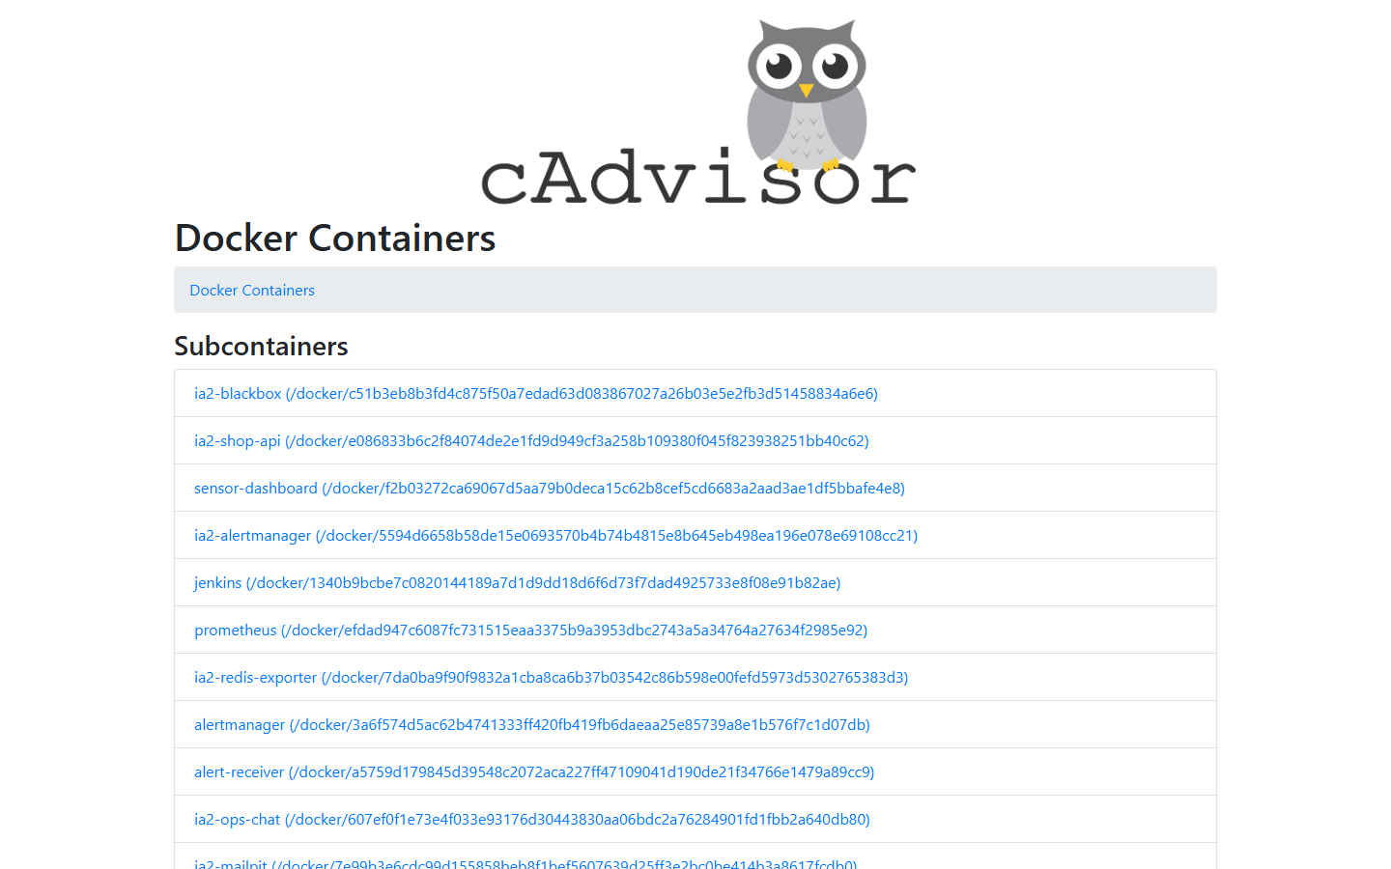
cAdvisor finds every container on the machine, including other projects', hence the ia2-* filter

5.3 Alerting Rules & Logic
We defined precomputed recording rules for high-cardinality error ratios:
- record: service:http_errors:ratio_rate1m
expr: |
( sum by (app, service) (rate(http_requests_total{job="shop-api", status=~"5.."}[1m]))
or
sum by (app, service) (rate(http_requests_total{job="shop-api"}[1m])) * 0 )
/ sum by (app, service) (rate(http_requests_total{job="shop-api"}[1m]))
The or ... * 0 syntax ensures that in healthy states when zero HTTP 5xx errors exist, the expression evaluates to 0% rather than returning an empty vector (no data).
Alert Rule | Evaluation Condition | Wait (for) | Severity
ServiceDown | up == 0 | 30 s | critical
EndpointDown | probe_success{job="blackbox-http"} == 0 | 40 s | critical
DependencyDown | redis_up == 0 or up{job="redis"} == 0 | 15 s | critical
HighErrorRate | HTTP 5xx error ratio > 10% | 30 s | critical
ContainerOOMKilled | increase(container_oom_events_total[5m]) > 0 | 0 s | critical
ServiceNotReady | Blackbox /ready probe fails | 45 s | warning
HighLatencyP95 | 95th percentile latency > 500 ms | 1 m | warning
ContainerMemoryNearLimit | Working set memory > 80% of limit | 15 s | warning
ContainerCPUThrottled | Throttled CPU periods > 50% | 30 s | warning
ContainerRestarted | Container start timestamp changed in 5m | 0 s | warning
Watchdog | vector(1) (Always firing) | 0 s | none
Every alert definition includes structured summary, description, and actionable runbook instructions detailing exact remediation steps for on-call personnel.

5.4 Alertmanager Pipeline & Noise Control
route:
receiver: ops-chat
group_by: [alertname, service]
group_wait: 10s
group_interval: 30s
repeat_interval: 3h
routes:
- matchers: ['alertname="Watchdog"']
receiver: heartbeat
- matchers: ['severity="critical"']
receiver: oncall-email
group_wait: 5s
continue: true
- matchers: ['severity=~"critical|warning"']
receiver: ops-chat
Alertmanager routes alerts based on severity: critical alerts dispatch instantly to both on-call email and ops chat (continue: true), warnings post exclusively to ops chat, and the constant Watchdog routes to a dead man's snitch heartbeat receiver.
To prevent alert fatigue, Alertmanager implements three inhibition rules: - When DependencyDown (Redis failure) fires, it suppresses HighErrorRate, HighLatencyP95, and ServiceNotReady. - When ServiceDown fires, it suppresses EndpointDown and derivative warnings. - When EndpointDown fires, it suppresses downstream latency and readiness alerts.
Crucially, inhibition requires that the root cause alert fires before secondary symptom alerts. We deliberately configured the root cause (DependencyDown) with a shorter wait duration (for: 15s) than the downstream symptoms (HighErrorRate with for: 30s).

5.5 Failure Injection & Operational Dashboards
Failures were injected systematically using OrderFlow's built-in chaos endpoints, PowerShell automation scripts (scripts/chaos.ps1), and direct container lifecycle events:
Failure Mode | Injection Mechanism | Detection Mechanism
API Error Spike | 50% of requests return HTTP 500 | HighErrorRate from white-box counters
High Latency | Injects 1.5 s artificial delay | HighLatencyP95 from histogram buckets
Web Service Hang | Injects 3.0 s delay exceeding probe timeout | EndpointDown via blackbox probe (up stays 1)
Memory Leak | Allocates RAM at 5 MB/s up to 85% limit | ContainerMemoryNearLimit from cAdvisor
Out of Memory (OOM) | Rapid allocation at 40 MB/s exceeding limit | ContainerOOMKilled via kernel OOM counter
CPU Exhaustion | Spawns two busy compute threads | ContainerCPUThrottled via cgroup quota counter
Container Crash | Immediate process termination and restart | ContainerRestarted via cAdvisor start time
Database Outage | docker stop ia2-redis | DependencyDown via Redis exporter
Total Service Outage | docker stop ia2-shop-api | ServiceDown via Prometheus scrape failure
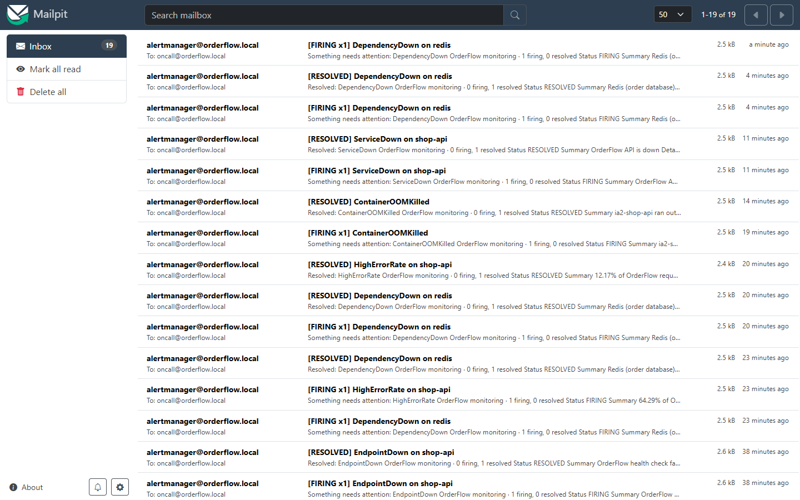
The on-call inbox: one email per incident, firing and resolved
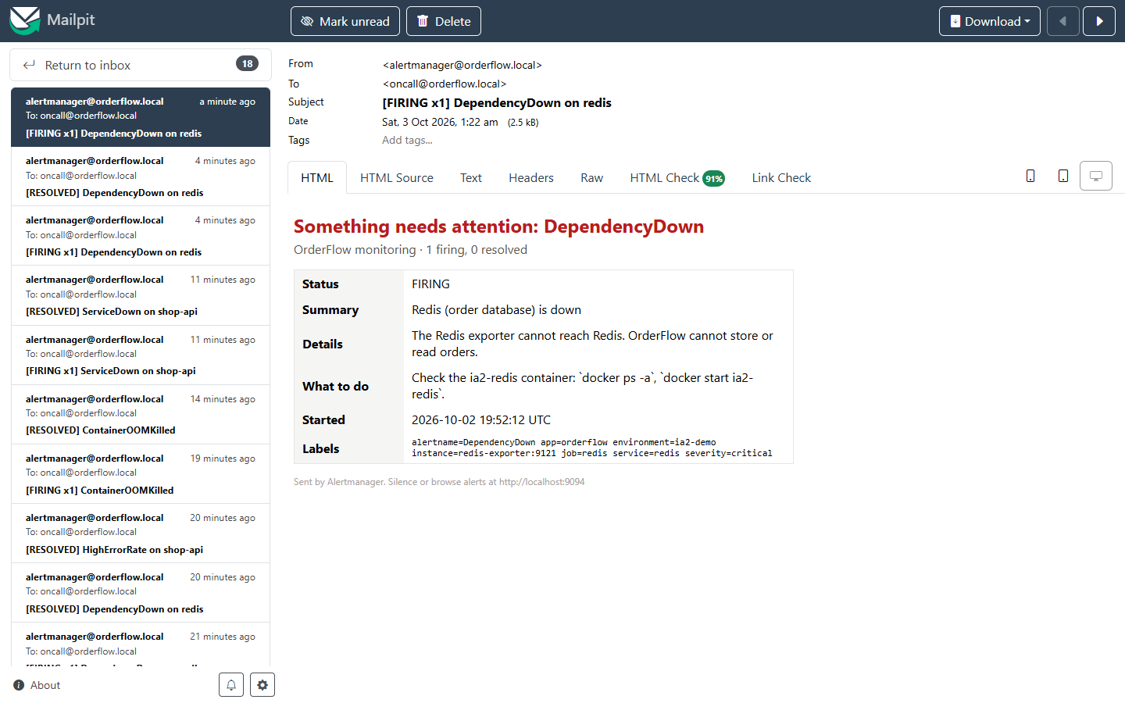
An alert email built from our template, with a "what to do" line
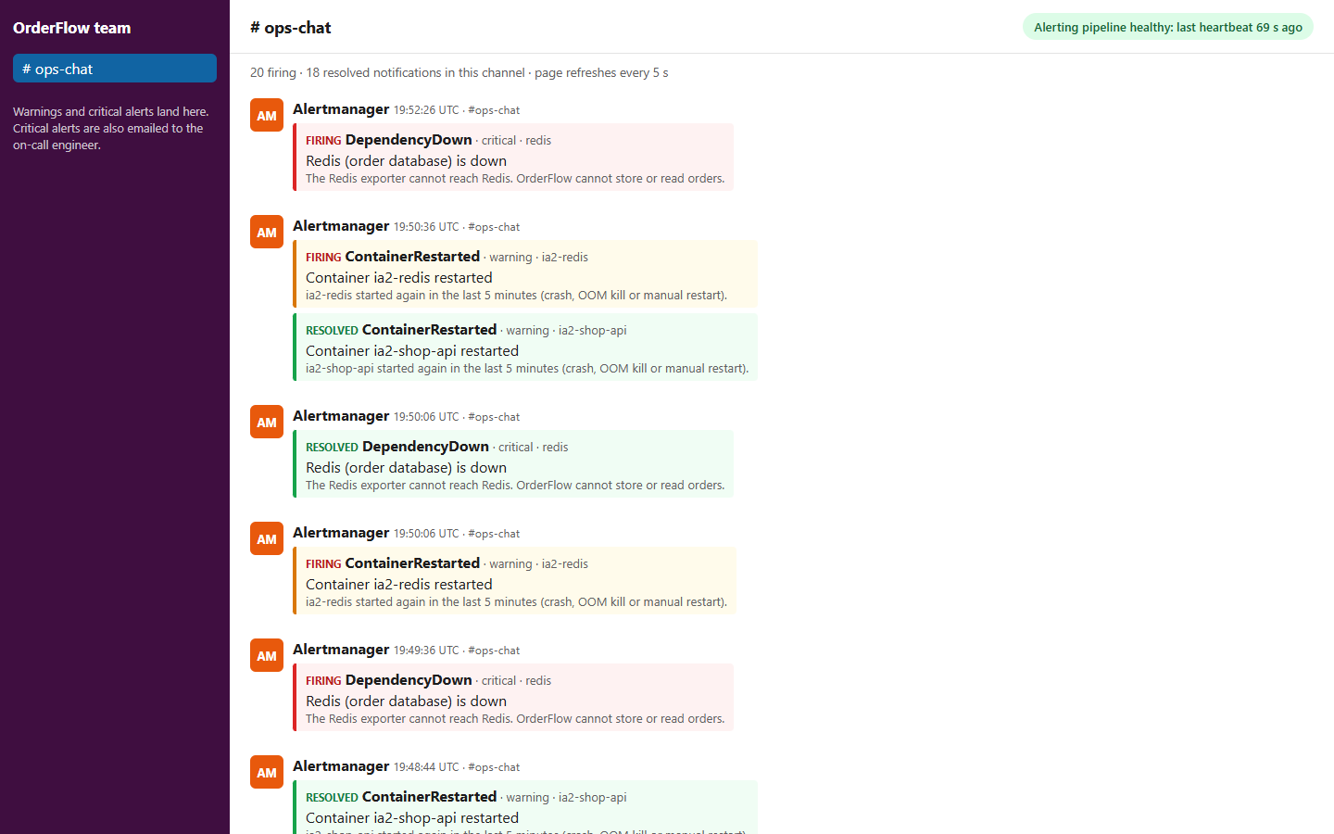
The ops chat: alert messages and the heartbeat badge (top right)
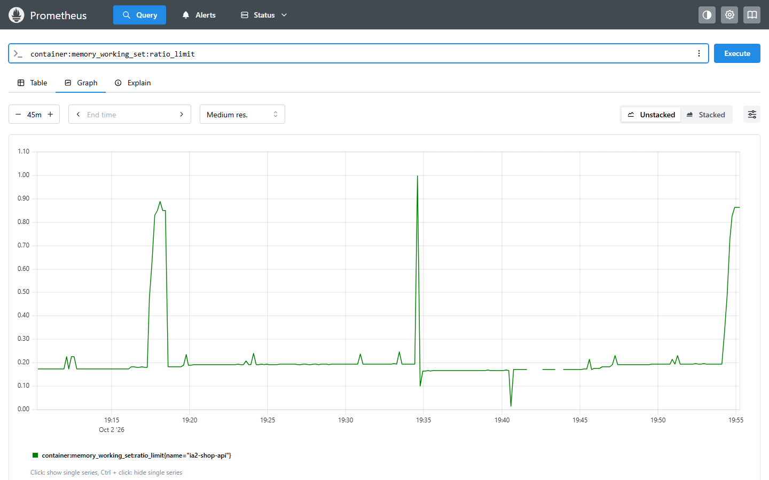
Memory of the OrderFlow container as a share of its limit: the leak plateaus near 85%, and the spike to 100% is the OOM kill
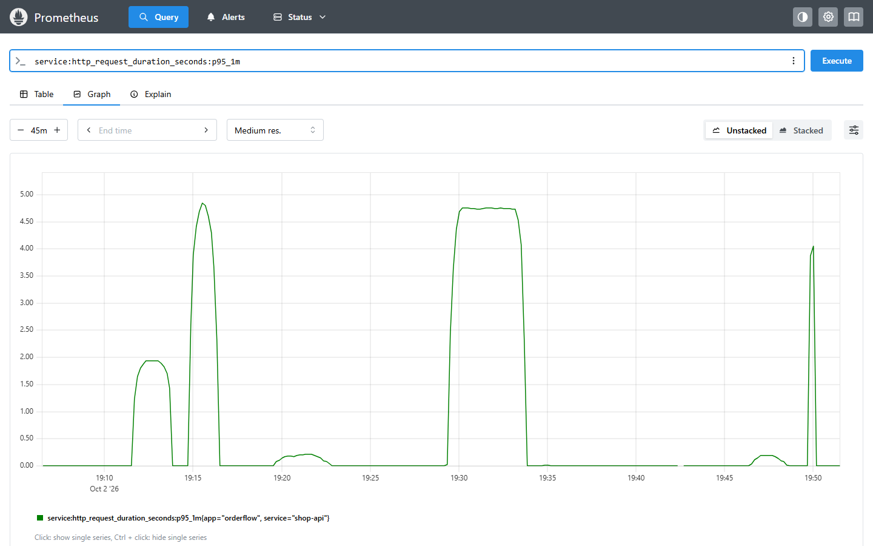
p95 latency over the test runs: the slow and hang scenarios stand out
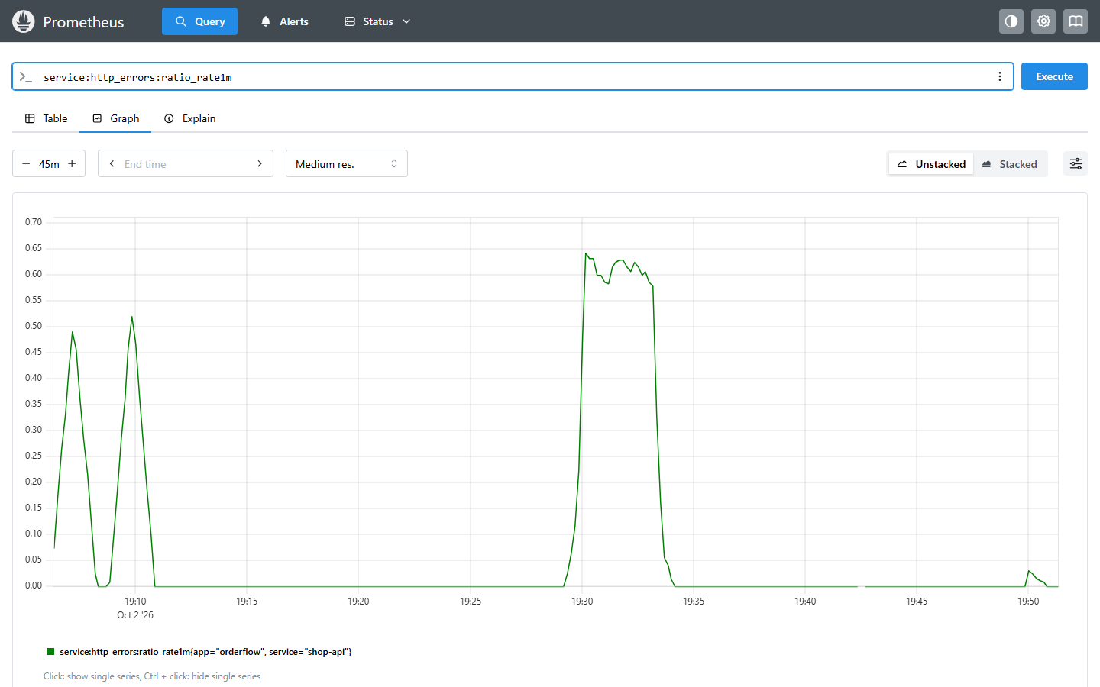
Share of failed requests over the test runs
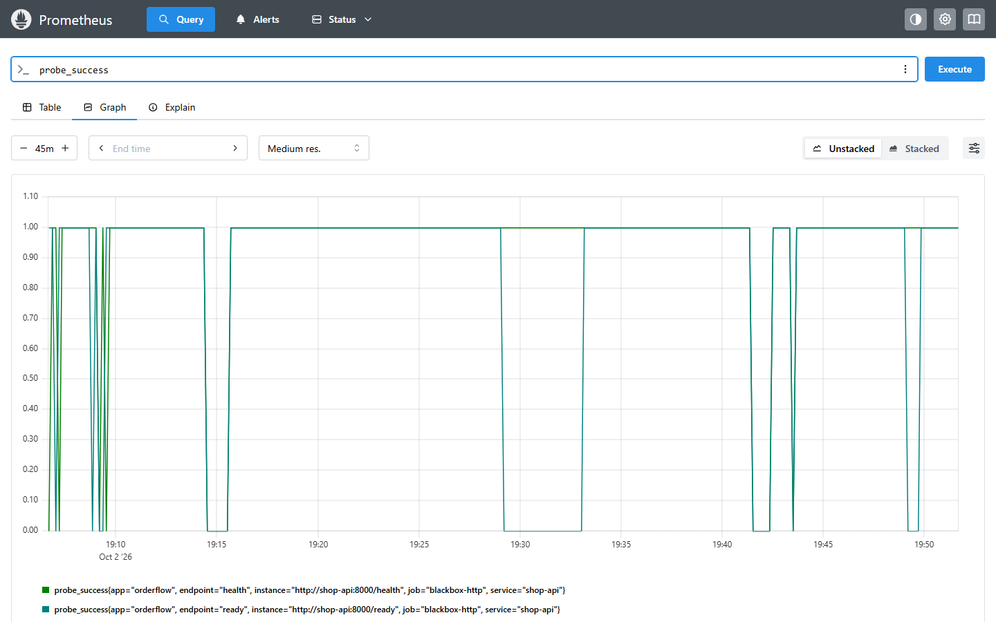
Black-box probe results for /health and /ready
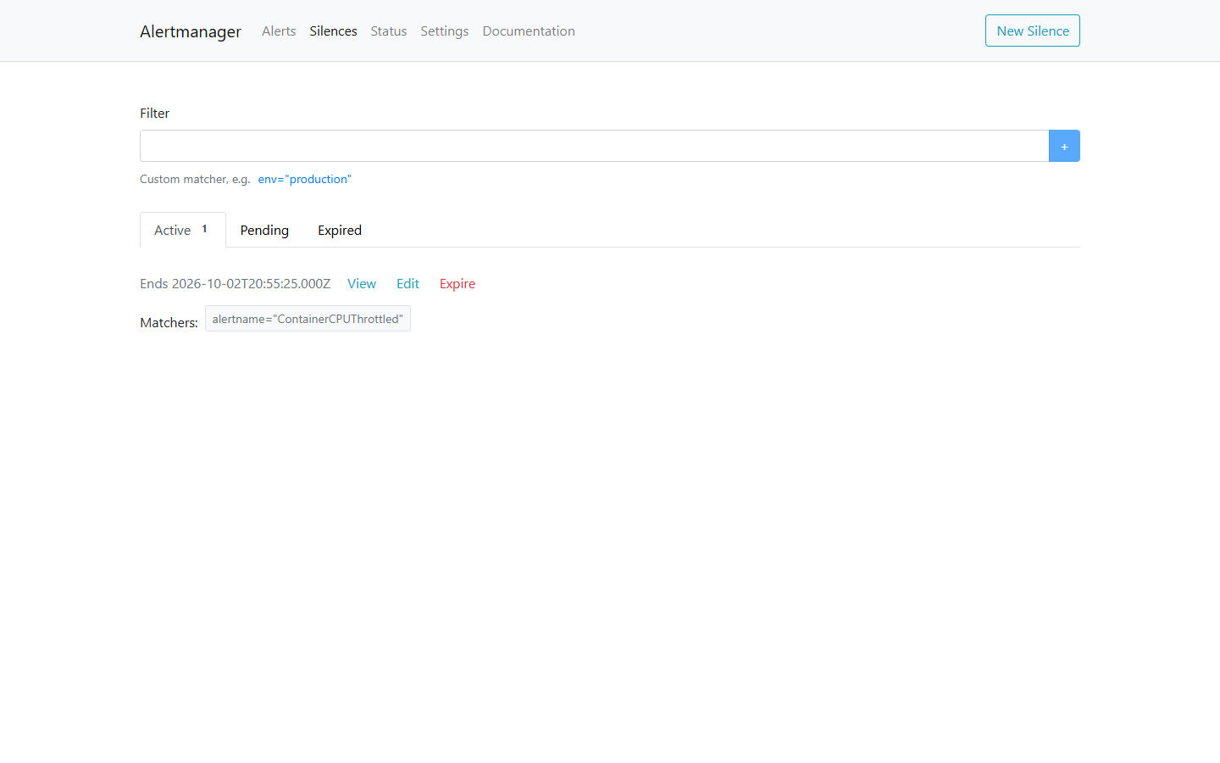
A silence muting ContainerCPUThrottled during a planned load test

6. Comparison and evaluation

6.1 Detection and Recovery Performance
We executed scripts/measure_detection.py to benchmark end-to-end detection latency across all nine failure modes on a standard developer workstation (Docker Desktop, 20 vCPUs, 8 GB memory allocation). The benchmark measured the exact duration from fault injection to the first alert notification in Ops Chat and Mailpit, as well as the duration to the RESOLVED notification following remediation.
Failure Mode Injected | Triggered Alert | Severity | Ops Chat Latency | On-Call Email Latency | Recovery Notification
API Error Spike (50% failure rate) | HighErrorRate | critical | 64 s | 59 s | 57 s
High Response Latency (1.5 s delay) | HighLatencyP95 | warning | 90 s | — | 56 s
Service Hang (Probe timeout) | EndpointDown | critical | 60 s | 55 s | 26 s
Gradual Memory Leak (~85% RAM) | ContainerMemoryNearLimit | warning | 72 s | — | 26 s
CPU Exhaustion (Saturated quota) | ContainerCPUThrottled | warning | 76 s | — | 56 s
Database Outage (docker stop ia2-redis) | DependencyDown | critical | 32 s | 27 s | 26 s
Out Of Memory (OOMKilled) | ContainerOOMKilled | critical | 31 s | 26 s | 296 s ¹
Process Crash & Restart | ContainerRestarted | warning | 16 s | — | — ²
Full Outage (docker stop ia2-shop-api) | ServiceDown | critical | 52 s | 47 s | 27 s
¹ ContainerOOMKilled computes events over a 5-minute sliding window; it naturally clears 5 minutes after the incident.
² Container restarts are discrete point-in-time events; the warning clears automatically after 5 minutes.
All nine failure types were detected reliably. Total time-to-detect corresponds to the mathematical sum of four intentional latency stages: the scrape interval (5 s), the moving average smoothing window (e.g. 1-minute rate()), the rule's for pending duration, and Alertmanager's group_wait.
- Fastest Detection: Container restart (16 s) because restarts represent factual discrete events requiring no for duration.
- Controlled Latency: P95 latency alerts require 90 s to allow metric windows to reflect true user impact rather than transient blips.
- Priority Dispatch: Critical alerts reached the on-call inbox 5 seconds earlier than Ops Chat due to a prioritized group_wait: 5s.
- Automatic Incident Resolution: All remediated failures dispatched RESOLVED notifications within 26 to 57 seconds.
Engineering Lessons from Initial Test Runs: Our initial test run (docs/results/run1.log) identified two real-world failure dynamics that shaped our final configuration: 1. CPU Alert Flapping: Comparing raw CPU rate against container quota resulted in volatile values (fluctuating between 40% and 100%) due to scrape jitter. We replaced raw utilization with cgroup throttled period ratios (container_cpu_cfs_throttled_periods_total / container_cpu_cfs_periods_total), which provided a stable 100% reading during saturation. 2. Exporter Scrape Timeout: During the Redis outage, the Redis exporter blocked for 15 seconds attempting connection, exceeding Prometheus's 4-second scrape timeout. Instead of reporting redis_up = 0, the scrape returned no data, causing the alert to flap. We reduced the exporter connection timeout to 1 second and updated the PromQL expression to redis_up == 0 or up{job="redis"} == 0, ensuring missing metrics trigger alerting.

6.2 Noise Reduction & Alert Suppression
Alertmanager's inhibition rules successfully prevented notification floods during multi-symptom failures:
Incident | Alerts Firing in Prometheus | Notifications Dispatched | Suppressed Symptoms
Redis Database Outage | DependencyDown, HighErrorRate, ServiceNotReady, HighLatencyP95 | DependencyDown only (1 email, 1 chat) | HighErrorRate, ServiceNotReady, HighLatencyP95
OrderFlow Full Outage | ServiceDown, EndpointDown, ServiceNotReady, ContainerRestarted | ServiceDown (email + chat); ContainerRestarted (chat) | EndpointDown, ServiceNotReady
Application Process Hang | EndpointDown, ServiceNotReady | EndpointDown (email + chat) | ServiceNotReady
Instead of receiving four disjointed alarm messages, the on-call engineer received exactly one clear email identifying the root cause: the database dependency failure.
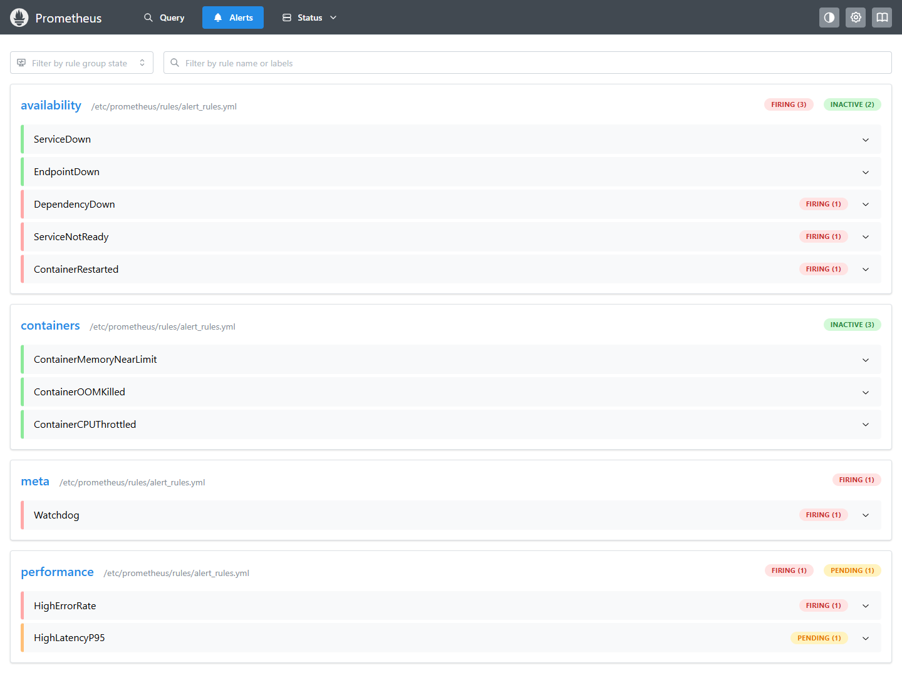
Prometheus during the Redis outage: three alerts firing, one pending
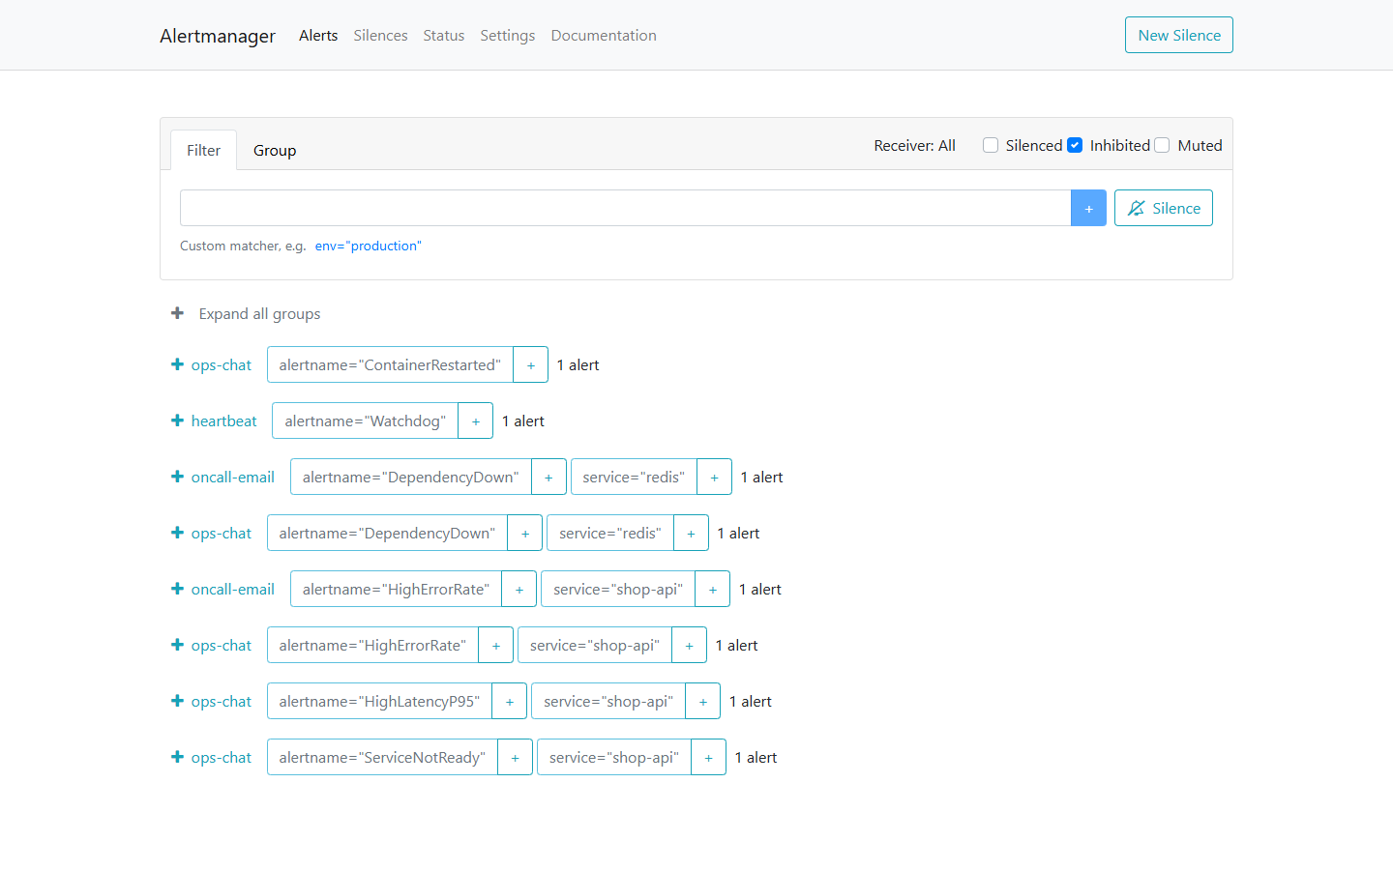
Alertmanager with "Inhibited" ticked: the symptoms are held back

6.3 False-Positive Resilience
To evaluate resilience against transient spikes, we stopped OrderFlow for exactly 10 seconds and immediately resumed it. Zero critical alerts were dispatched. The 30-second for wait window absorbed the temporary disruption, while a single informational ContainerRestarted warning logged the event in Ops Chat. This behavior is formally enforced in our CI pipeline via a promtool unit test asserting that 10-second outages never page engineers.

6.4 Resource Footprint
Resource utilization was measured using docker stats under active customer traffic:
Container | CPU Utilization | Memory Usage
ia2-prometheus | 2.2% | 77 MiB
ia2-shop-api | 2.8% | 46 MiB
ia2-alertmanager | 0.4% | 34 MiB
ia2-cadvisor | 3.4% | 30 MiB
ia2-blackbox | 1.0% | 26 MiB
ia2-mailpit | 0.0% | 24 MiB
ia2-ops-chat | 0.0% | 14 MiB
ia2-traffic | 1.2% | 14 MiB
ia2-redis-exporter | 0.8% | 13 MiB
ia2-redis | 0.7% | 10 MiB
The entire observability infrastructure (Prometheus, Alertmanager, cAdvisor, and exporters) consumed less than 180 MiB of RAM and approximately 8% of one CPU core while indexing over 3,080 active time series, demonstrating that robust observability requires minimal overhead.

6.5 Comparative Tool Analysis
Evaluation Metric | Prometheus + Alertmanager | Nagios Core | Zabbix | Datadog | Grafana Alerting | AWS CloudWatch
Licensing & Cost | Open Source (Apache 2.0) | Open Source (GPL) | Open Source (AGPL) | Commercial SaaS (Host-based) | Open Source / Cloud | Commercial Pay-per-Metric
Telemetry Ingestion | Pull over HTTP + Exporters | Active Plugin Checks | Agent Push/Pull, SNMP | Agent Push to SaaS | Querying Existing Sources | AWS Agent Push
Container Native | Native Service Discovery | Poor (Static Hosts) | Moderate (Agent 2) | High (Auto-discovery) | Dependent on Source | Container Insights (ECS/EKS)
Alert Expressiveness | PromQL (Ratios, p95) | Static Thresholds | Trigger Expressions | Metric Query Language | Multi-datasource Queries | Metric Math & Alarms
Noise Suppression | Inhibition, Grouping, Silences | Escalation Trees | Trigger Dependencies | Downtimes & Monitors | Notification Policies | Alarm SNS Topics
Config as Code | Declarative YAML in Git | Text Config Files | Database / UI / API | Terraform / API | Provisioning Files | CloudFormation / Terraform
Logs & Tracing | Metrics only (Pair with Loki/Tempo) | None | Limited | Fully Integrated | Integrated via Loki/Tempo | CloudWatch Logs & X-Ray
Long-Term Storage | Local TSDB (Thanos/Mimir) | External RDBMS | SQL Database | Managed Cloud Storage | Dependent on Source | Managed AWS Storage
For self-hosted container failure detection with zero software licensing costs and Git-based rule validation, Prometheus and Alertmanager represent the industry standard.

6.6 Strengths and Limitations
Strengths Observed: - Unified PromQL Engine: A single mathematical query language powers dashboards, recording rules, and alert thresholds. - Alerting as Tested Code: Alert rules are versioned in Git, verified with promtool unit tests, and smoke-tested in CI before deployment. - Intelligent Noise Suppression: Hierarchical inhibition rules turn cascade failures into a single root-cause notification. - Lightweight Operational Footprint: Full containerized monitoring operates comfortably within ~180 MiB of RAM.
Limitations & Trade-offs: - Metrics Only: Prometheus captures numerical trends but requires supplementary tools like Loki or Jaeger to inspect raw logs and distributed traces. - Intentional Detection Latency: Detection takes 15–90 seconds due to scrape cycles and wait durations designed to prevent false alarms. - High Availability Complexity: Redundancy requires deploying dual Prometheus servers scraping identical targets and clustered Alertmanagers. - PromQL Learning Curve: Complex vector matching, label joining, and handling empty sets require deep operational familiarity.

7. Testing and Continuous Integration
We treated alerting configuration with the same rigor as production application code. An untested alert rule or misconfigured routing pipeline is as dangerous as a software bug: if an alert fails to fire or route correctly, the team will not learn about the next outage until users report it.
Every commit and pull request triggers our automated GitHub Actions CI/CD pipeline (.github/workflows/ci.yml), which executes three defensive validation stages:
- Unit & Syntax Validation: Runs Python unit tests for OrderFlow (20 tests) and the alert receiver (6 tests), checks rule syntax with promtool check rules, and statically validates Alertmanager routing syntax with amtool config check.
- Alert Rule Unit Testing: Executes promtool test rules against monitoring/prometheus/alert_rules_test.yml. These tests inject synthetic time-series data and assert that alert rules trigger exactly as expected, including edge cases:
  - Proving that a 10-second outage does not fire ServiceDown (absorbing transient network blips).
  - Proving that unconstrained containers without memory limits do not trigger false ContainerMemoryNearLimit alerts.
  - Asserting routing decisions with amtool config routes test for critical, warning, and heartbeat alerts.
- End-to-End Smoke Test: Deploys all 10 containers in GitHub Actions runners via docker compose up -d, polls all 7 targets until healthy, waits for the initial Watchdog heartbeat, injects a 50% API error rate fault, and verifies programmatically that Alertmanager dispatches the HighErrorRate alert to both the Mailpit email inbox and the Ops Chat webhook.
Validation Layer | Tool / Scope | What is Verified
OrderFlow Application | pytest (20 tests) | In-memory store API endpoints, /health and /ready probes, Prometheus metric exposition, and fault injection hooks
Prometheus Rules | promtool check rules & test rules (8 test suites) | PromQL syntax, recording rule math, alert firing logic, label evaluation, and suppression of transient blips
Alertmanager Routing | amtool config check & routes test | Notification tree traversal, severity routing, grouping keys, and template syntax
Ops Chat Receiver | unittest (6 tests) | Webhook payload parsing, severity filtering, and Watchdog heartbeat detection
End-to-End Stack | GitHub Actions CI runner | Full Docker Compose spin-up, synthetic traffic generation, live fault injection, and alert delivery to email and chat
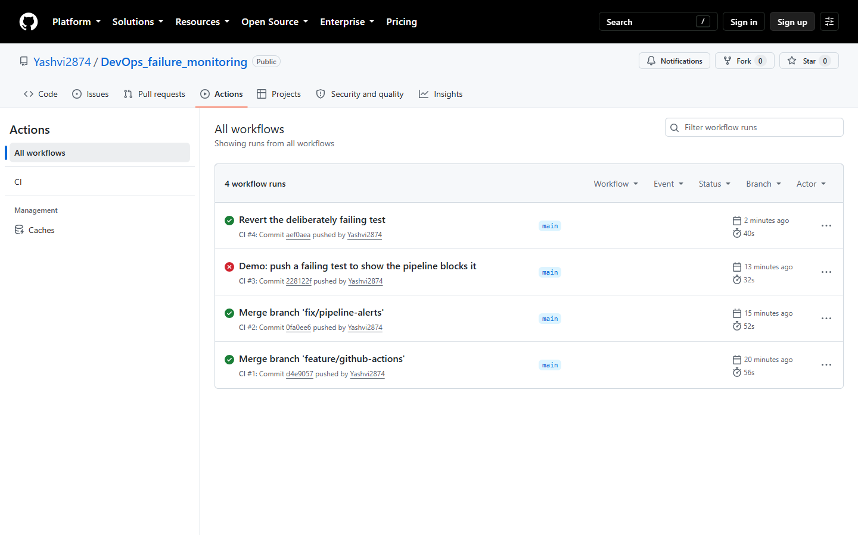
Automated GitHub Actions CI/CD pipeline executing unit tests, PromQL rule verification, container deployment, fault injection, and alert delivery checks

8. Project Links and Artifacts
All project artifacts, including source code, configuration files, automated test suites, and the recorded video demonstration, are publicly accessible at the following repositories:
- GitHub Repository: https://github.com/Yashvi2874/DevOps_IA2 Contains the complete source code of the OrderFlow microservice, Docker Compose configuration (docker-compose.yml), Prometheus rules and scrape configs, Alertmanager routing and templates, synthetic traffic generator, chaos fault injection scripts, and GitHub Actions CI workflow.
- Demonstration Video & Presentation (Google Drive): https://drive.google.com/drive/folders/11pqw2HeYxWI5QLId-3zkHv1x-a_rm6BP?usp=sharing Contains the recorded presentation slides and live 4-minute demonstration showcasing failure injection, metrics visualization in Prometheus, silence management, symptom inhibition in Alertmanager, and real-time alert delivery in Mailpit and Ops Chat.

9. Conclusion
Prometheus and Alertmanager successfully detected every failure injected across our containerized microservice stack, from total service shutdowns and hung processes to memory leaks, CPU quota saturation, and database crashes hidden behind running web containers. Every failure was converted into an actionable alert notification delivered to the appropriate channel within 90 seconds, followed by automatic recovery confirmations.
The central insight of this case study is that raw failure detection is insufficient on its own. In production environments, noise suppression through intelligent grouping, hierarchical inhibition, and deliberate evaluation wait times represents the difference between a high-signal alerting system and debilitating alert fatigue. Supported by configuration as code, automated unit testing with promtool, and end-to-end CI verification, Prometheus and Alertmanager provide a battle-tested foundation for container observability.

10. References
- Prometheus Authors, Prometheus Documentation: Concepts, Querying, and Alerting, 2026. https://prometheus.io/docs/
- Prometheus Authors, Alertmanager Notification Architecture and Routing Configuration, 2026. https://prometheus.io/docs/alerting/latest/alertmanager/
- Prometheus Community, Blackbox Exporter: HTTP, HTTPS, DNS, TCP and ICMP Probing, https://github.com/prometheus/blackbox_exporter
- Google Inc., cAdvisor: Core Architecture and Container Metrics Collection, https://github.com/google/cadvisor
- Oliver006, Redis Exporter for Prometheus Metrics, https://github.com/oliver006/redis_exporter
- Prometheus Authors, Official Python Client for Prometheus Telemetry, https://github.com/prometheus/client_python
- Axllent, Mailpit: Email Testing and SMTP Inspection Tool, https://mailpit.axllent.org/
- B. Beyer, C. Jones, J. Petoff, and N. R. Murphy, Site Reliability Engineering: How Google Runs Production Systems, O'Reilly Media, 2016: Chapter 6, "Monitoring Distributed Systems".
- Industry Observability Specifications: Nagios Core, Zabbix Enterprise, Datadog Cloud Telemetry, Grafana Alerting, and AWS CloudWatch documentation (accessed October 2026).

