Automated CI/CD and Real-Time Failure Monitoring of a Containerized Environmental Sensor Dashboard Using Jenkins, Docker, Prometheus and Alertmanager
DevOps Lab CA – Mini Project Report
Yashasvi Gupta (16010123341)
Shubhpreet Kaur (16010123328)
Aditi Agrawal (16010123018)
October 2026

1. Abstract
We built a small web application, an environmental sensor dashboard, and then automated everything that happens to it after a developer commits code. Every push to GitHub is picked up by Jenkins, which runs the unit tests inside a Docker container, validates the monitoring configuration, builds a new image, deploys it with Docker Compose and smoke-tests the result. If the tests fail, nothing is deployed; if the smoke test fails, the previous working image is restored automatically. The running system is watched by Prometheus, which scrapes the application every five seconds and evaluates seven alert rules. Alertmanager groups, routes and de-duplicates the resulting alerts and delivers them to a webhook receiver that stands in for Slack or email. Failed pipeline runs are reported through the same channel. We tested the whole loop with real failure scenarios: overheating and offline sensors, a pollution spike, an API returning errors, a crashed process, a stopped container, a commit with a broken test and a release that fails its health check. In every case the problem was either blocked before deployment or detected and reported within about 30 to 50 seconds, and each alert was marked resolved once the problem was fixed.
Source code: https://github.com/Yashvi2874/DevOps_failure_monitoring

2. Introduction

2.1 Background
A DevOps workflow closes the gap between writing code and running it. Instead of a person copying files to a server and hoping nothing breaks, the steps from commit to production are written down as code and run by machines, and the running system is measured continuously so that problems are found by monitoring rather than by users.
Our application is deliberately simple: a dashboard that shows temperature, humidity, CO₂ and PM2.5 readings from three sensors placed in a lab, a server room and outdoors. The readings are simulated, because the subject of the project is the delivery pipeline and the monitoring around the app, not the sensor hardware. A simple app also makes it easy to break things on purpose and watch how the system reacts.

2.2 Problem statement
Without automation, a team faces three recurring problems:
- Untested code reaches users. Someone forgets to run the tests before deploying, and a bug goes live.
- “It works on my machine.” The app behaves differently on the developer’s laptop, the tester’s machine and the server, because each has different library versions.
- Failures are noticed late. A sensor stops reporting or the server room overheats, and nobody finds out until someone happens to look.

2.3 Objectives
- Keep all code and configuration in Git, using feature branches.
- Build the application into a Docker image so it runs identically everywhere.
- Run automated tests on every change and stop the pipeline if any fail.
- Deploy automatically with Jenkins, and roll back automatically if the new version is unhealthy.
- Collect metrics from the running app with Prometheus.
- Define alert rules for application and sensor failures, and deliver alerts through Alertmanager with sensible grouping, routing and noise suppression.
- Demonstrate each failure scenario and measure how long detection takes.

3. Tools and technologies
Area | Tool (version) | Why we used it
Version control | Git, GitHub | History of every change; Jenkins and GitHub Actions read the code from here
Application | Python 3.12, Flask 3.1, gunicorn 23 | Small, readable web stack
Metrics library | prometheus_client 0.23 | Exposes app and sensor metrics in Prometheus format
Testing | pytest 8.4, pytest-cov, flake8 7.3, promtool, unittest | Unit tests, coverage, lint, and tests for the alert rules themselves
Containers | Docker Engine 29, Docker Compose plugin | Packaging and running all five services
CI/CD | Jenkins 2.580.1 LTS (declarative pipeline, Configuration as Code, Job DSL) | Automates test → build → deploy → verify
CI on GitHub | GitHub Actions | A second, independent check on every push
Monitoring | Prometheus 3.13.4 | Pull-based metrics collection and alert rule evaluation
Alerting | Alertmanager 0.34.1 | Grouping, routing, inhibition and delivery of alerts

4. System architecture
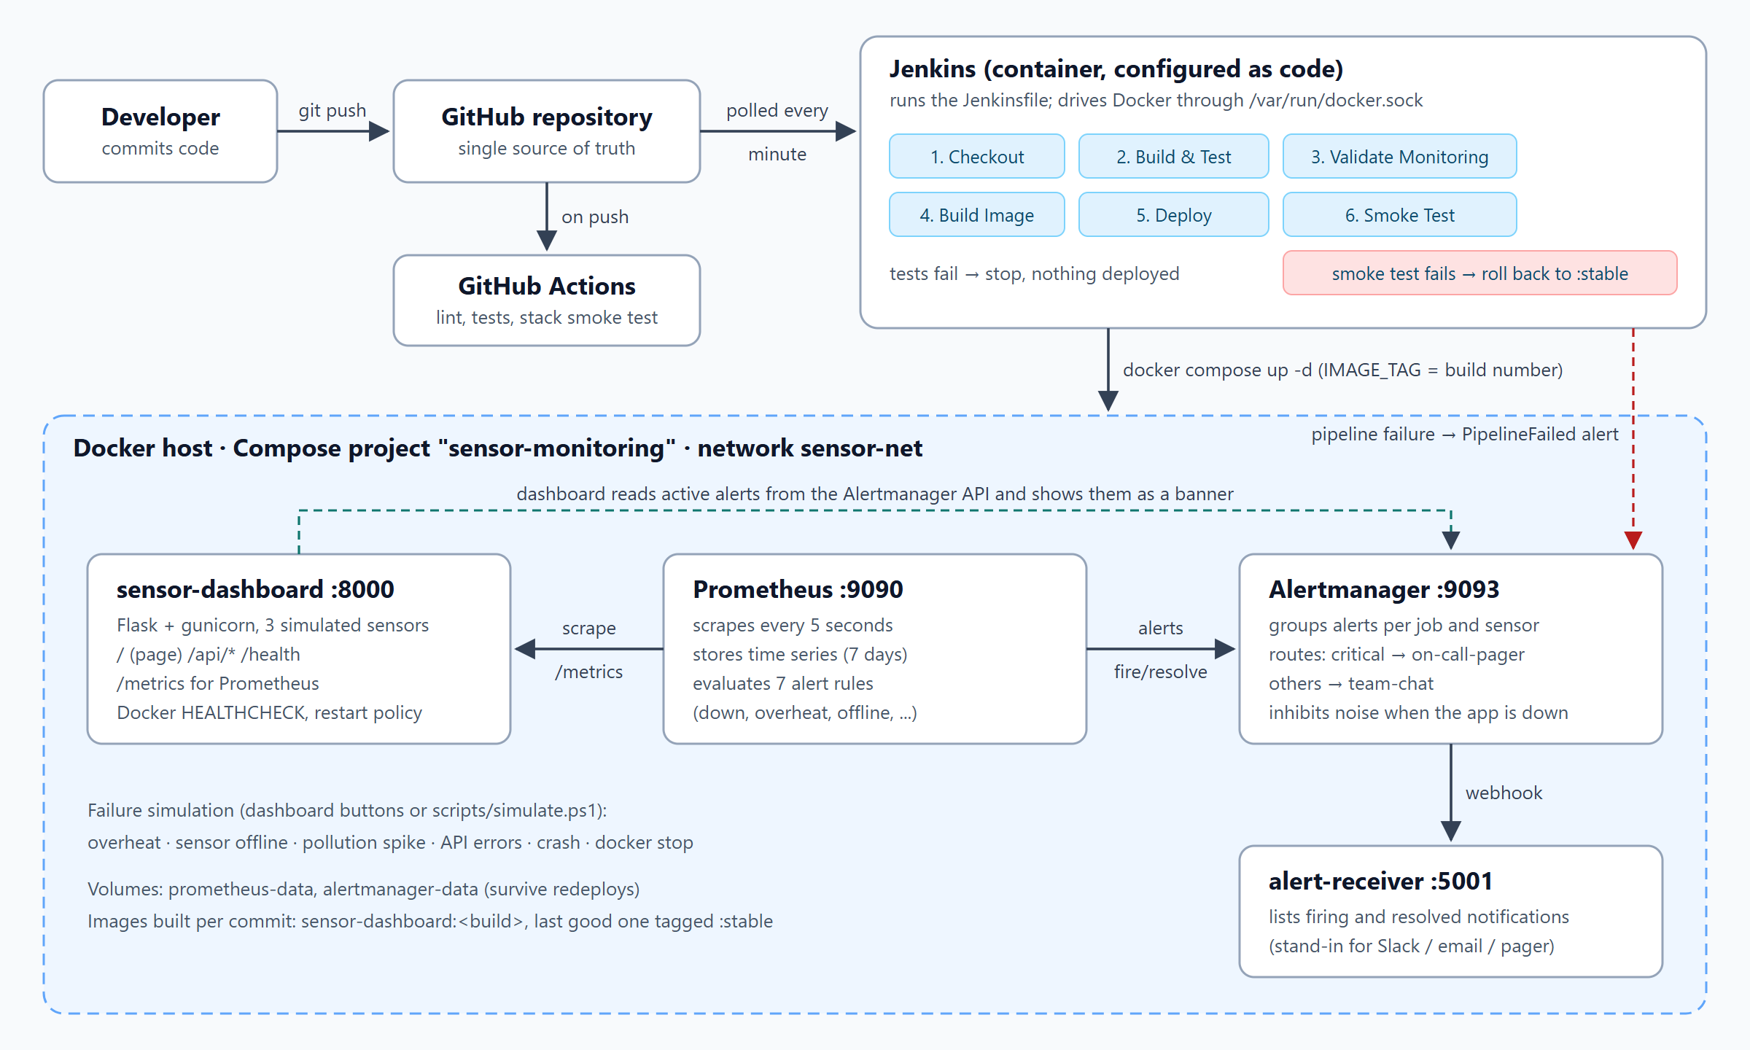
Overall architecture of the project
The system has two halves.
The delivery half starts with the developer. Code is pushed to GitHub, where GitHub Actions runs a quick check and Jenkins picks the change up by polling the repository every minute. Jenkins itself runs in a Docker container. It has the Docker command-line tools installed and the host’s Docker socket mounted, so every pipeline step (building images, running tests, starting containers) is carried out by the host’s Docker engine.
The running half is a Docker Compose project called sensor-monitoring with four containers on a private network named sensor-net:
Container | Port | Role
sensor-dashboard | 8000 | The Flask app: dashboard page, JSON API, /health, /metrics
prometheus | 9090 | Scrapes /metrics every 5 s, stores the time series, evaluates alert rules
alertmanager | 9093 | Receives alerts from Prometheus (and Jenkins), groups and routes them
alert-receiver | 5001 | Shows every notification Alertmanager delivers
Containers find each other by service name: Prometheus scrapes dashboard:8000, and the dashboard reads active alerts from alertmanager:9093 so it can show them as a banner on the page.

5. Implementation

5.1 The application
The sensor simulator (app/sensor_dashboard/sensors.py) keeps three sensors, each with its own baseline. On every tick (every two seconds) each value moves a little towards its baseline plus some random noise, which gives realistic, slowly drifting readings. Each sensor can be switched into a failure scenario:
- overheat: the temperature drifts towards 45 °C;
- offline: the sensor stops producing readings and every attempted read counts as an error;
- pollution: CO₂ and PM2.5 climb towards unhealthy levels.
The Flask app (app.py) serves the dashboard page, which refreshes itself every two seconds, and a small JSON API. Two more endpoints matter for operations:
- /health returns the app’s status and the build number that is running. The Jenkins smoke test uses the build number to make sure the new version is the one answering.
- /metrics exposes the readings and the app’s own behaviour in Prometheus format:
Metric | Meaning
sensor_temperature_celsius, sensor_humidity_percent, sensor_co2_ppm, sensor_pm25_ugm3 | Latest reading per sensor
sensor_last_seen_timestamp_seconds | When each sensor last reported (used to detect offline sensors)
sensor_up, sensor_read_errors_total | Sensor status and failed reads
dashboard_http_requests_total, dashboard_http_request_duration_seconds | Request count and latency per endpoint and status code
dashboard_build_info | Which build and commit are running
process_start_time_seconds | When the process started (used to detect restarts)
A failure simulation panel on the dashboard (and the scripts scripts/simulate.ps1 and simulate.sh) can trigger each scenario, make the API return HTTP 500 errors, or crash the app.

5.2 Version control workflow
Each feature was developed on its own branch and merged into main with a merge commit, so the history shows where each feature began and ended: feature/sensor-simulator, feature/dashboard, feature/docker, feature/monitoring, feature/jenkins-pipeline, feature/github-actions, and a later fix/pipeline-alerts. Secrets such as the Jenkins admin password live in jenkins/.env, which is listed in .gitignore and never committed.
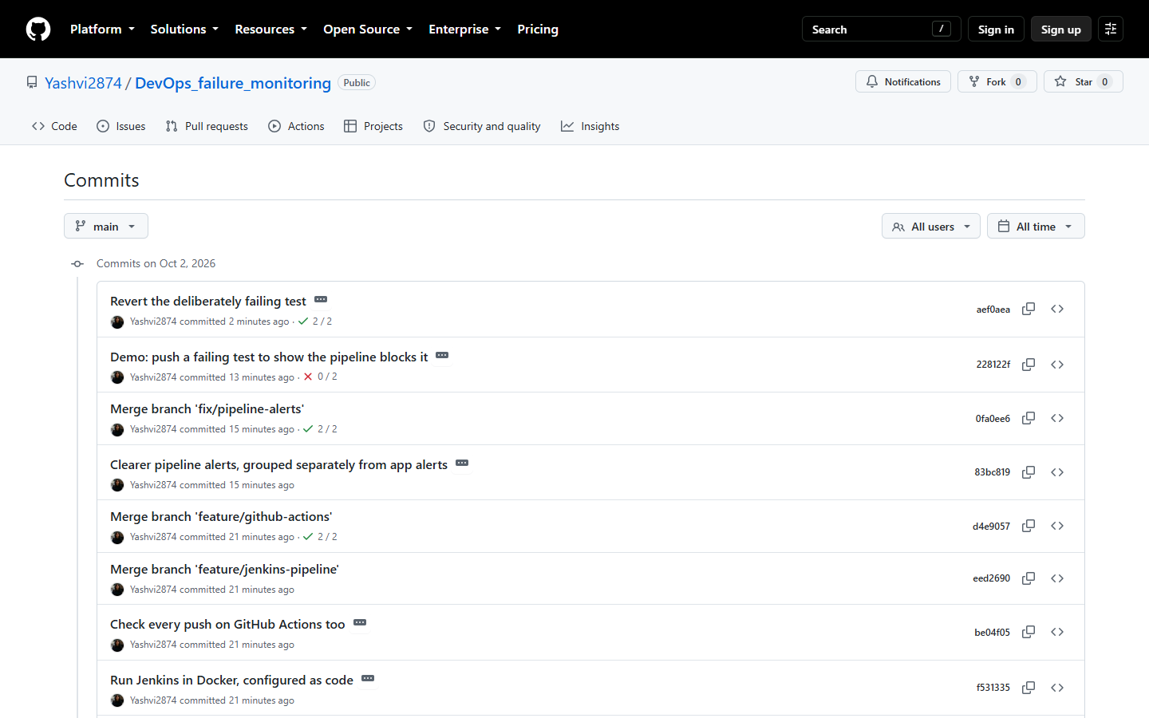
Commit history on GitHub

5.3 Containerization
app/Dockerfile is a multi-stage build:
FROM python:3.12-slim AS base # Python + runtime libraries
...
FROM base AS test # + pytest and flake8; runs the tests when started
...
FROM base AS runtime # the image that gets deployed
RUN useradd --create-home --uid 10001 appuser
USER appuser
HEALTHCHECK --interval=10s CMD python -c "import urllib.request; urllib.request.urlopen('http://127.0.0.1:8000/health')"
CMD ["gunicorn", "--bind", "0.0.0.0:8000", "--workers", "1", "--threads", "4", "sensor_dashboard.wsgi:app"]
The requirements.txt file is copied and installed before the source code, so Docker can reuse the cached dependency layer when only the code changes. The runtime image runs as a non-root user, and has a health check that Docker uses to mark the container healthy or unhealthy. The Compose file sets restart: unless-stopped, so a crashed container is started again automatically.
The Prometheus and Alertmanager configuration files are copied into small custom images rather than mounted from the host. This was a deliberate choice (see section 8): it lets Jenkins deploy the stack even though Jenkins runs in its own container, and it means a change to an alert rule is built, tested and deployed exactly like a change to the code.

5.4 CI/CD pipeline (Jenkins)
The pipeline is defined in the Jenkinsfile at the root of the repository:
Stage | What it does | On failure
Checkout | Fetches the commit and records its hash and message | —
Build & Test | Builds the test image and runs flake8 and 23 pytest tests inside a container; publishes the JUnit report | Pipeline stops, nothing is deployed
Validate Monitoring | Checks the Prometheus config, runs the alert-rule unit tests, checks the Alertmanager config and its routing, runs the receiver’s tests | Pipeline stops
Build Image | Builds sensor-dashboard:<build number> with the version, commit hash and build number baked in | Pipeline stops
Deploy | docker compose up -d with IMAGE_TAG=<build number>; only containers whose image changed are replaced | Pipeline stops
Smoke Test | From a throwaway container on sensor-net: /health is OK and reports this build, the API returns three sensors, /metrics works, and Prometheus is scraping the new container | rollback.sh redeploys sensor-dashboard:stable and checks it
When the smoke test passes, the image is also tagged sensor-dashboard:stable, which marks it as the last known good build for future rollbacks. At the end, the pipeline sends its result to Alertmanager: a failed build raises a PipelineFailed alert and the next successful build resolves it. This way, broken deployments and broken builds reach the team through the same channel as application failures.
Jenkins is set up entirely from files in jenkins/. The Dockerfile adds the Docker CLI, the Compose plugin and the required Jenkins plugins. casc.yaml (Jenkins Configuration as Code) creates the admin user and, through the Job DSL plugin, the sensor-dashboard-pipeline job, which polls GitHub every minute. There is no setup wizard. The whole CI server can be rebuilt with one docker compose up command.
GitHub Actions (.github/workflows/ci.yml) runs lint, the unit tests, the rule tests and a full stack smoke test on GitHub’s own machines for every push, as an independent second check.
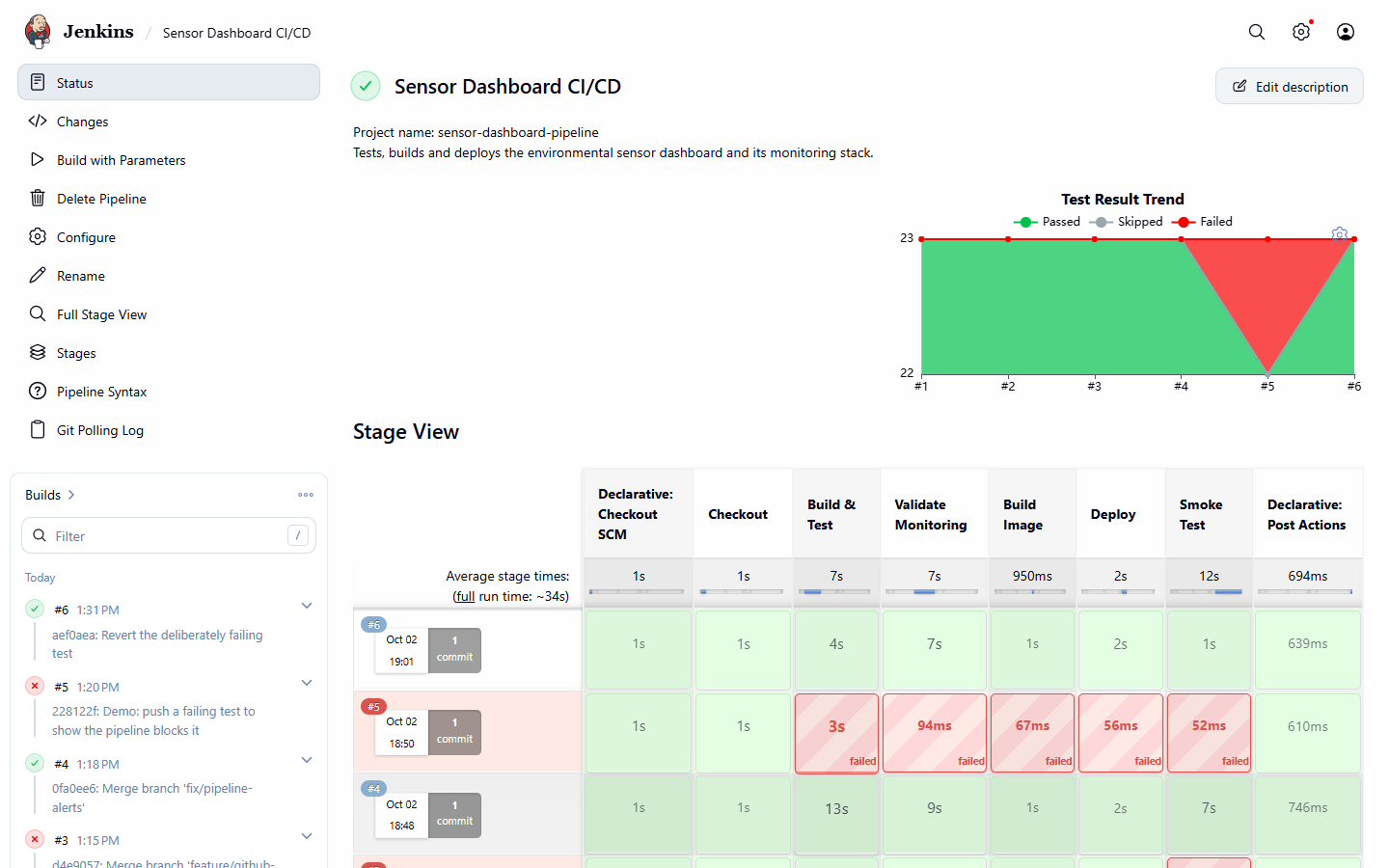
Jenkins stage view: builds #1–#6

5.5 Monitoring with Prometheus
Prometheus scrapes three targets every five seconds: the dashboard, itself and Alertmanager. It evaluates the rules in alert_rules.yml at the same interval. Each rule is a PromQL query plus a for duration, which means the condition has to hold for that long before the alert fires. This avoids alerts for momentary blips.
Alert | Condition | Severity
SensorDashboardDown | up == 0 for 30 s | critical
HighApiErrorRate | more than 20% of /api/* requests are 5xx, for 30 s | critical
SensorDashboardRestarted | process_start_time_seconds changed in the last 5 min | info
SensorOverheat | temperature > 35 °C for 15 s | warning
SensorOffline | no reading for more than 10 s, for 10 s | warning
HighCO2Level | CO₂ > 1500 ppm for 20 s | warning
HighPM25Level | PM2.5 > 100 µg/m³ for 20 s | warning
The rules have their own unit tests (monitoring/prometheus/tests/alert_rules_test.yml), run with promtool test rules. Each test feeds Prometheus a made-up time series and checks which alerts are firing at a given moment, including the exact alert text. For example, one test checks that a 10-second outage does not page anyone. We confirmed the tests are real by changing one expected value and watching the test fail.
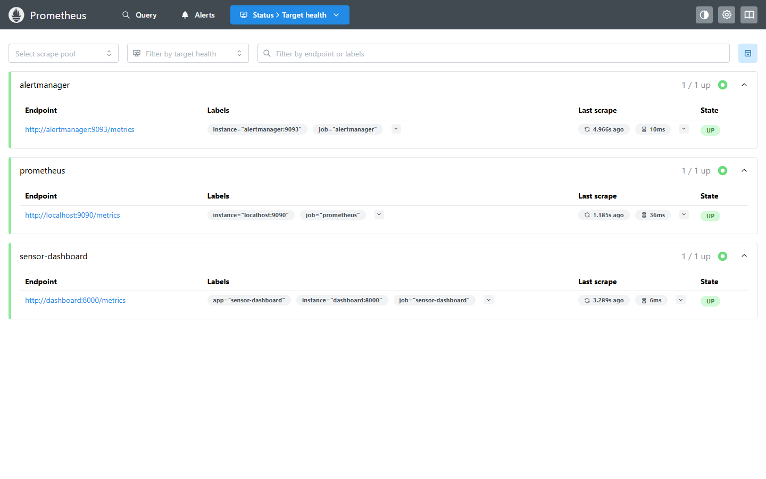
Prometheus target health: all three targets up

5.6 Alerting with Alertmanager
Alertmanager decides who hears about an alert, when, and how often:
- Routing. Critical alerts go to an on-call-pager receiver and are sent after 5 seconds; everything else goes to team-chat.
- Grouping. Alerts are grouped by job and sensor. A pollution spike on Sensor 3 raises both HighCO2Level and HighPM25Level, but they arrive as a single notification.
- Inhibition. While SensorDashboardDown is firing, the app’s warning and info alerts are held back, because they are symptoms of the same outage. An offline sensor’s last temperature is stale, so SensorOffline also suppresses SensorOverheat for that sensor.
- Resolution. send_resolved: true means a second notification is sent when a problem clears.
Both receivers are webhooks pointing at our alert-receiver service, a small Python program (standard library only) that stores the notifications and lists them on a web page. In a real team this would be Slack, email or a paging service. Only the receiver section of alertmanager.yml would change.

6. Testing
Level | What is tested | Where it runs
Lint | Code style and obvious mistakes (flake8) | Jenkins, GitHub Actions
Unit tests (23) | Sensor simulation, failure scenarios, every API endpoint, metrics output, request counting, simulation switches, alert formatting. Coverage is 91% | Jenkins (inside Docker), GitHub Actions
Alert rule tests (6 scenarios) | Each alert fires at the right time with the right labels and text, and short blips don’t fire | Jenkins, GitHub Actions
Config validation | Prometheus config, Alertmanager config, routing of critical vs warning alerts | Jenkins, GitHub Actions
Receiver tests (5) | Parsing, formatting, HTML escaping, the HTTP endpoints | Jenkins, GitHub Actions
Smoke test | The deployed container is healthy, is the expected build, serves data and is being scraped | Jenkins (after every deploy), GitHub Actions

7. Results

7.1 Pipeline runs
Build | Trigger | What we did | Result
#1 | Polling (first commit) | Normal run | Success in 54 s, build 1 deployed
#2 | Manual | Normal run | Success in 22 s (layers cached), build 2 deployed
#3 | Manual, SIMULATE_BAD_DEPLOY=true | Deployed a build whose /health returns 503 | Smoke test failed; build 2 automatically restored and verified; PipelineFailed alert sent
#4 | Polling, after a push | Normal run | Success, deployed automatically within a minute of the push
#5 | Polling, after a push | Commit with a deliberately failing test | Stopped at Build & Test (1 failed, 22 passed); the next four stages were skipped; build 4 stayed live; PipelineFailed alert sent
#6 | Polling, after a push | Reverted the bad test | Success, build 6 deployed; PipelineFailed resolved (“Pipeline is green again”)
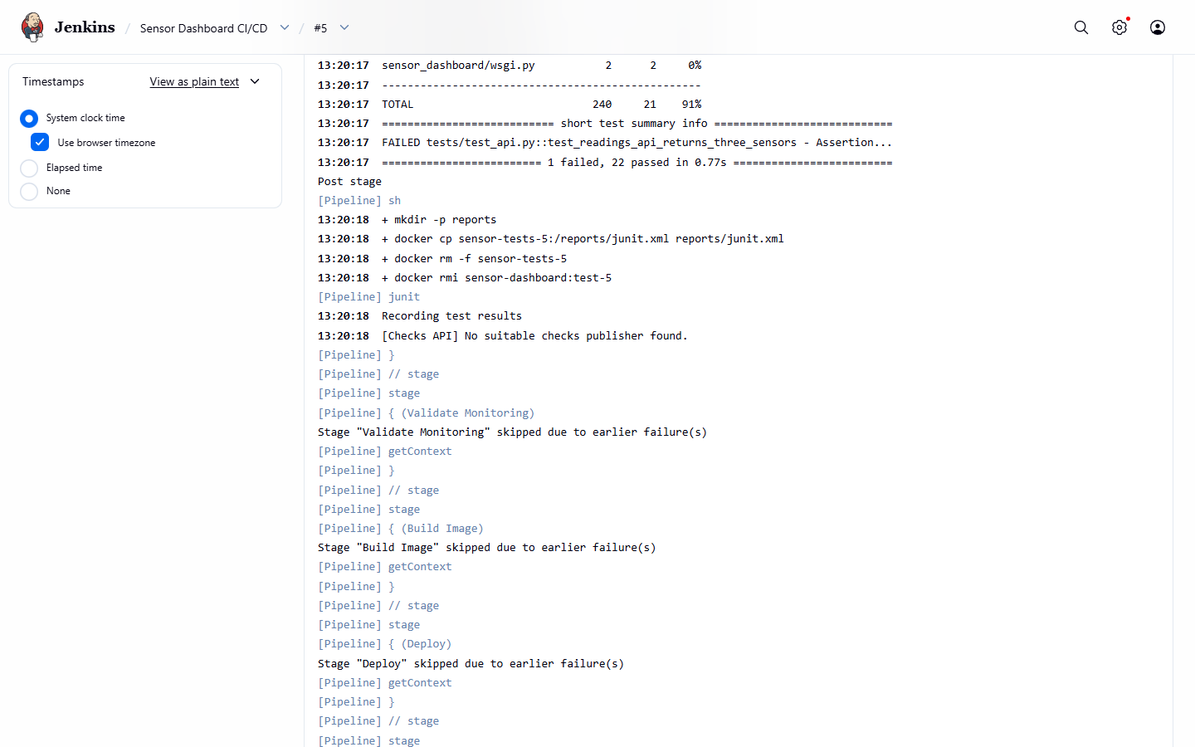
Build #5: the failing test blocked the deployment
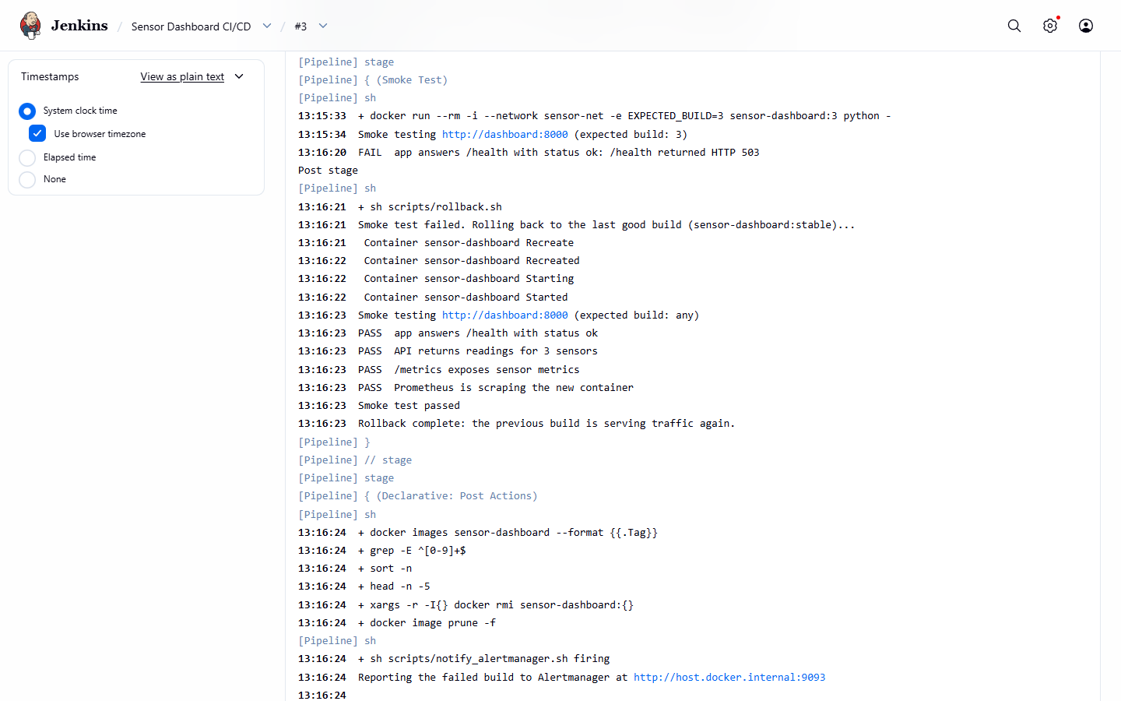
Build #3: failed smoke test and automatic rollback
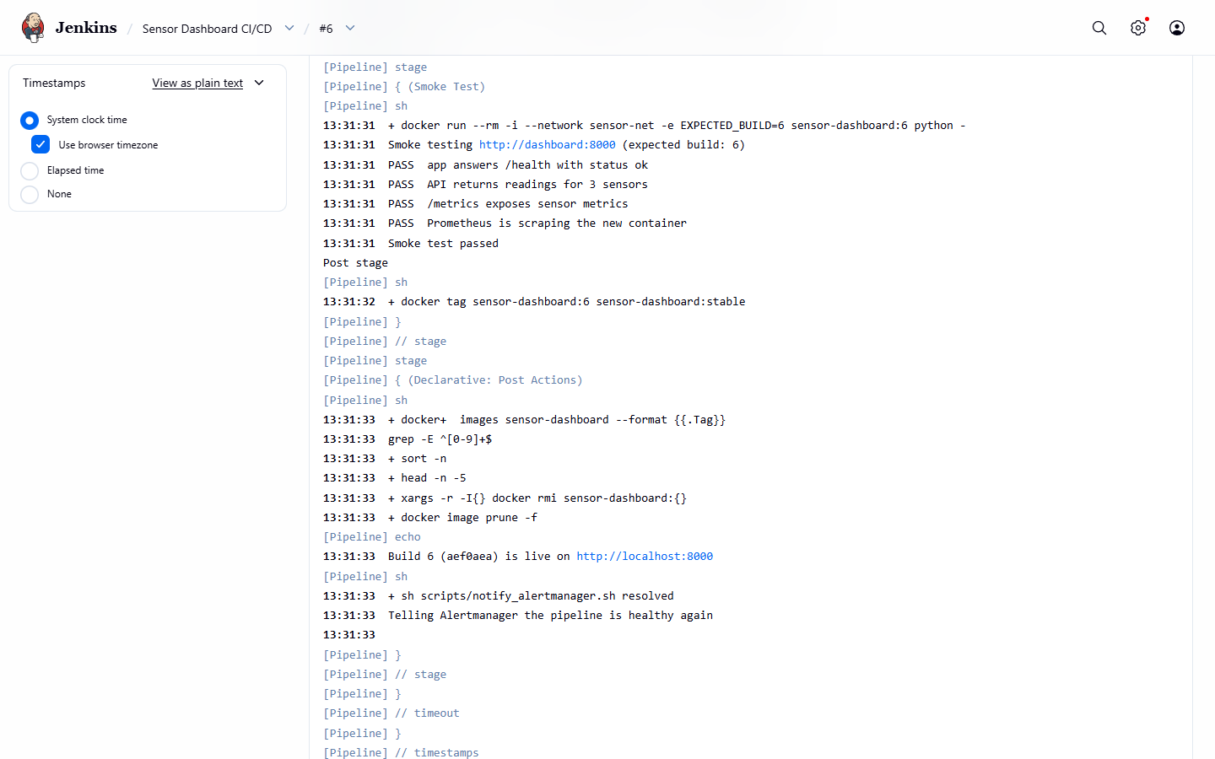
Build #6: smoke test passing after a deploy
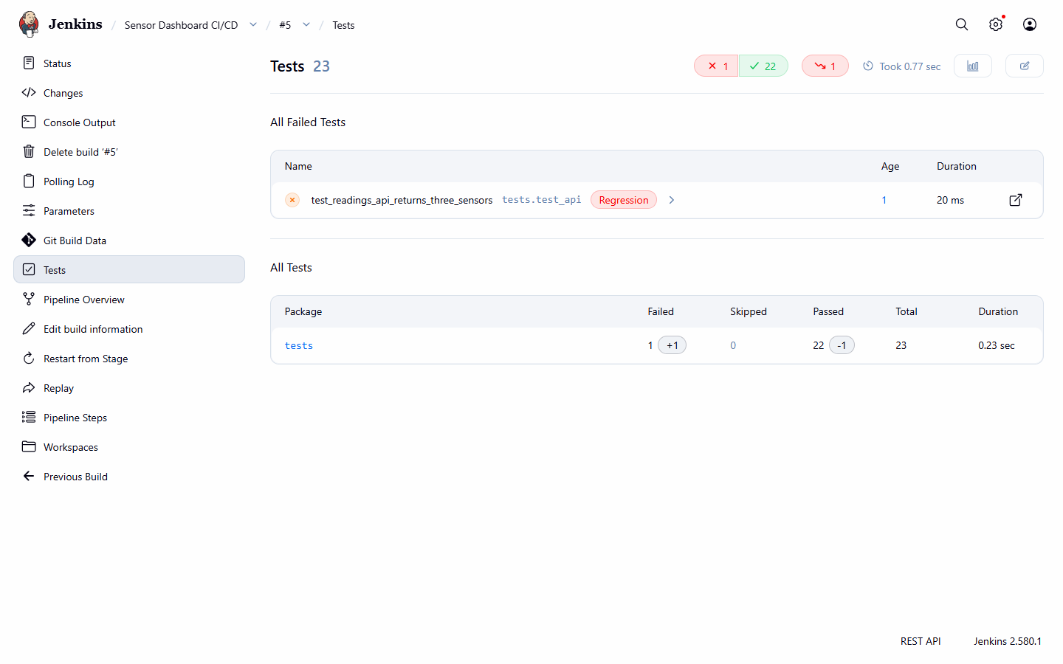
Jenkins test report for build #5
GitHub Actions independently passed or failed the same commits:
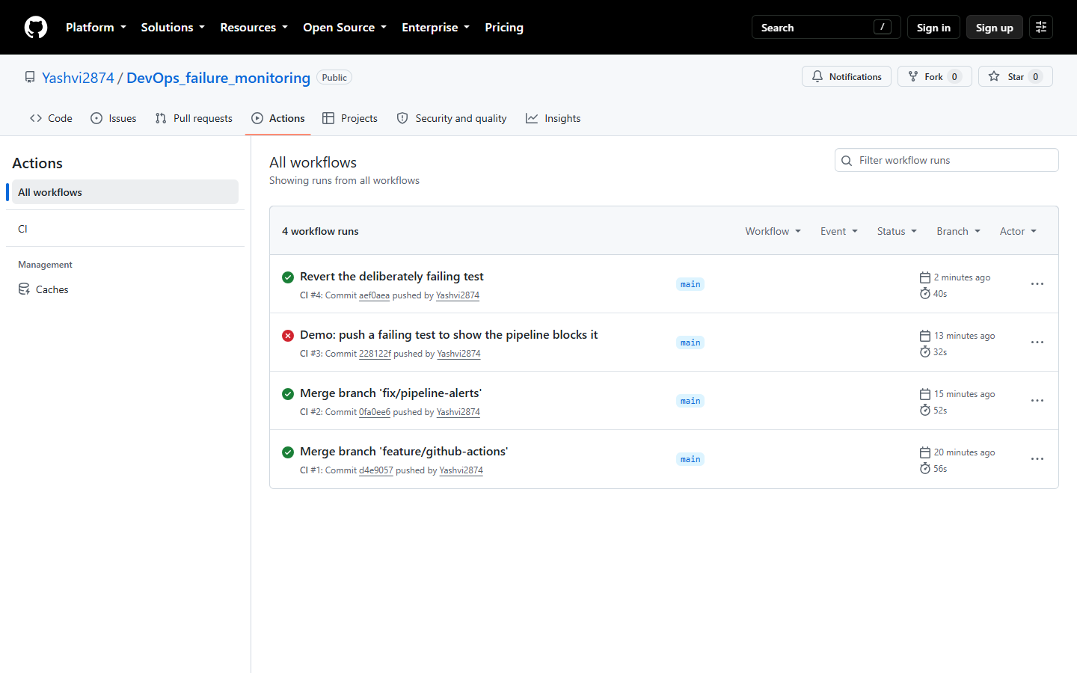
GitHub Actions runs

7.2 Failure detection
Times are measured from triggering the failure to the notification appearing in the alert receiver.
Scenario | Alert(s) | Channel | Time to notify
Sensor 1 overheats | SensorOverheat | team-chat | 30–41 s
Sensor 2 goes offline | SensorOffline | team-chat | 30 s
Pollution spike on Sensor 3 | HighCO2Level + HighPM25Level (one notification) | team-chat | ~45 s
API returns HTTP 500 | HighApiErrorRate | on-call-pager | 53 s
App process crashes | Docker restarts it; SensorDashboardRestarted | team-chat | 10 s
Container stopped | SensorDashboardDown (restart alert inhibited) | on-call-pager | 44–48 s
Container started again | SensorDashboardDown resolved | on-call-pager | 24–29 s
Each delay is the sum of the scrape interval (5 s), the rule’s for duration (10 to 30 s), the evaluation interval (5 s) and Alertmanager’s group_wait (5 s). Shorter durations would notify faster but would also fire on harmless blips; these values suit a demo while still filtering one-off spikes.
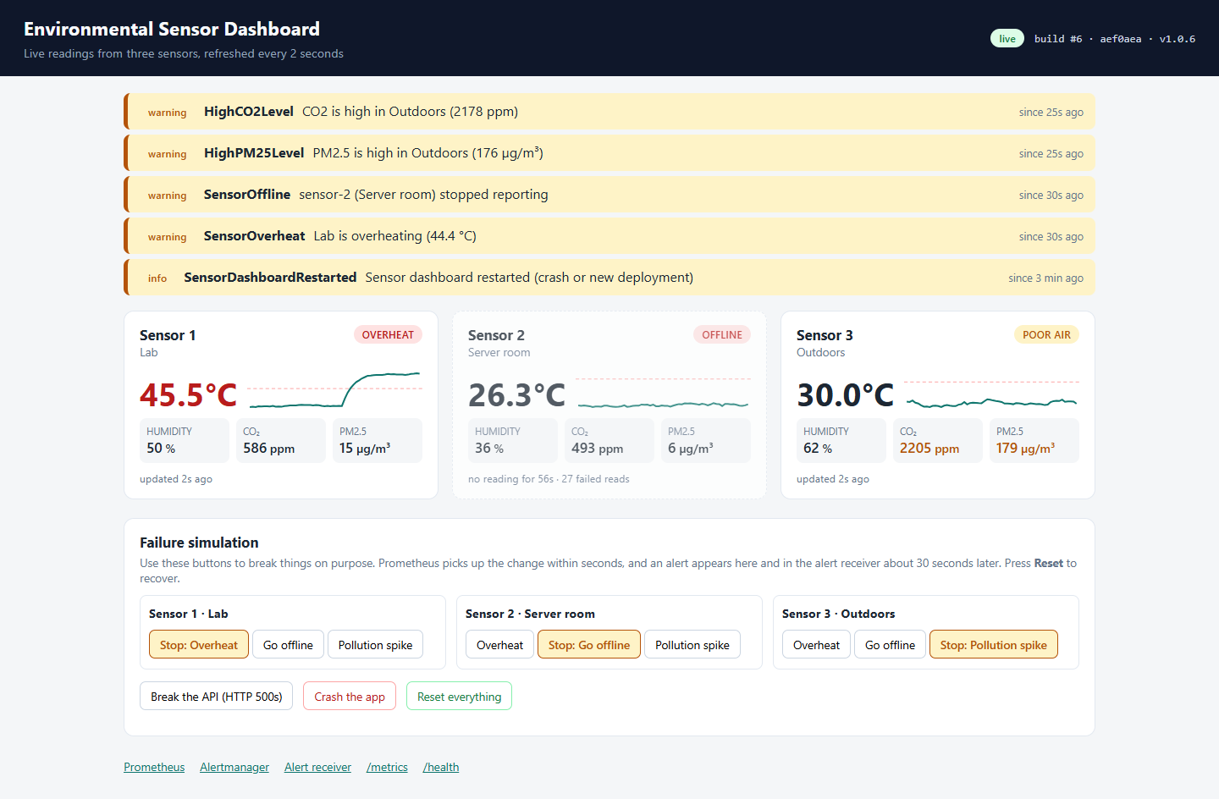
Dashboard during an incident: three sensors misbehaving, alerts shown as a banner
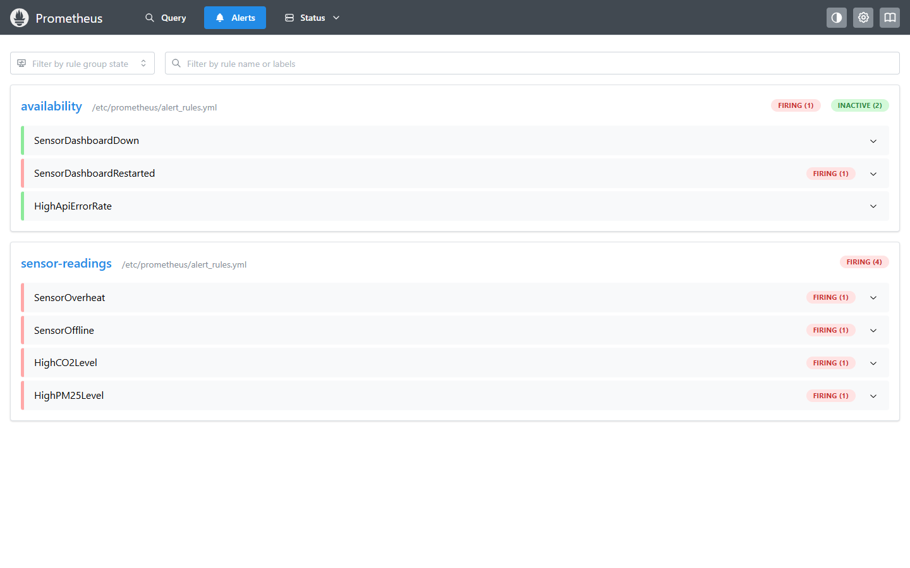
Prometheus alert rules while the incident is active
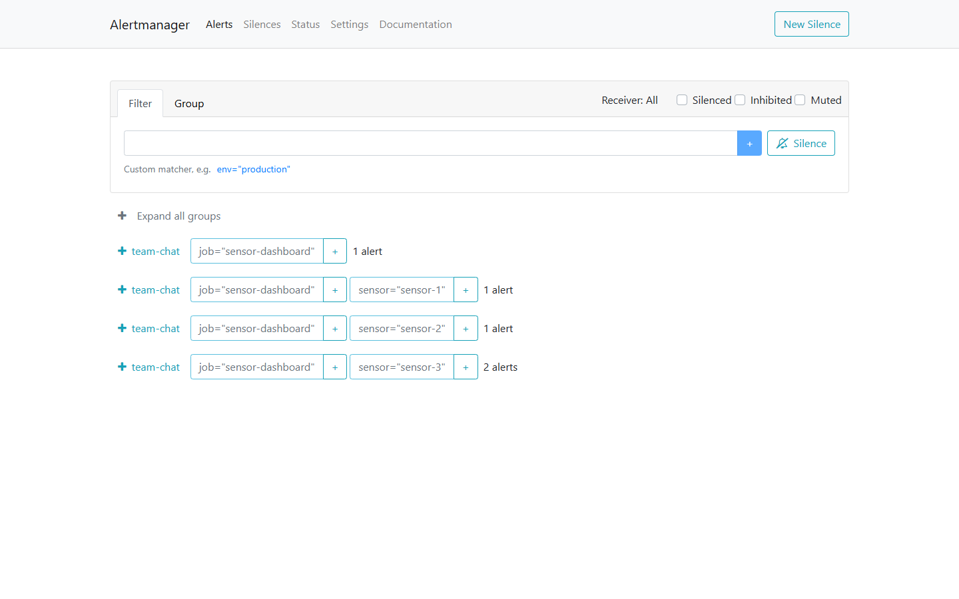
Alertmanager grouping alerts per sensor (Sensor 3 has two)
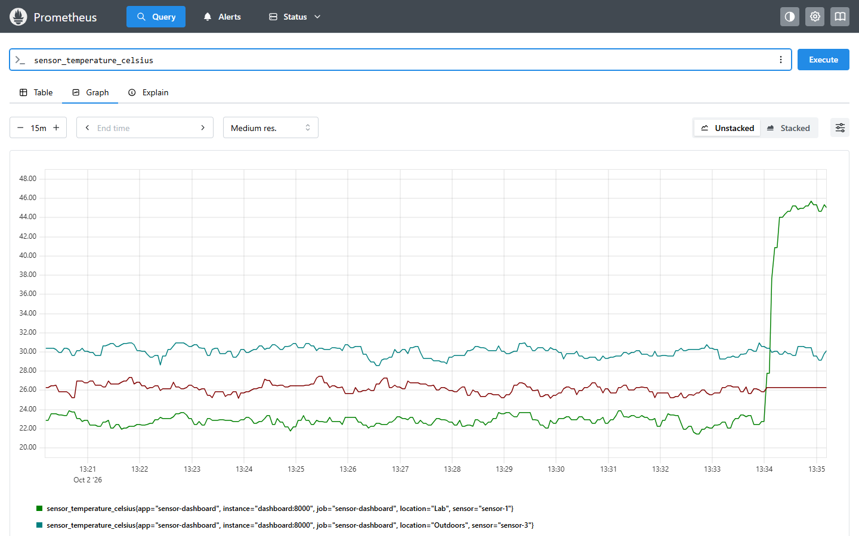
Temperature history in Prometheus: Sensor 1 overheating
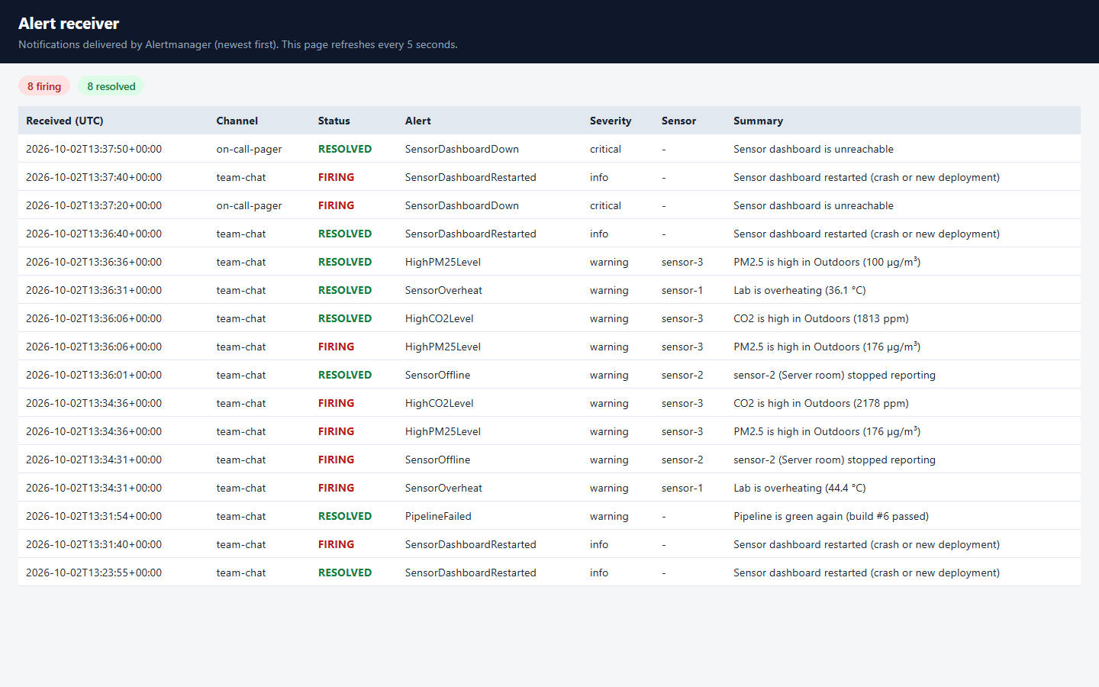
Alert receiver: notifications on both channels, firing and resolved
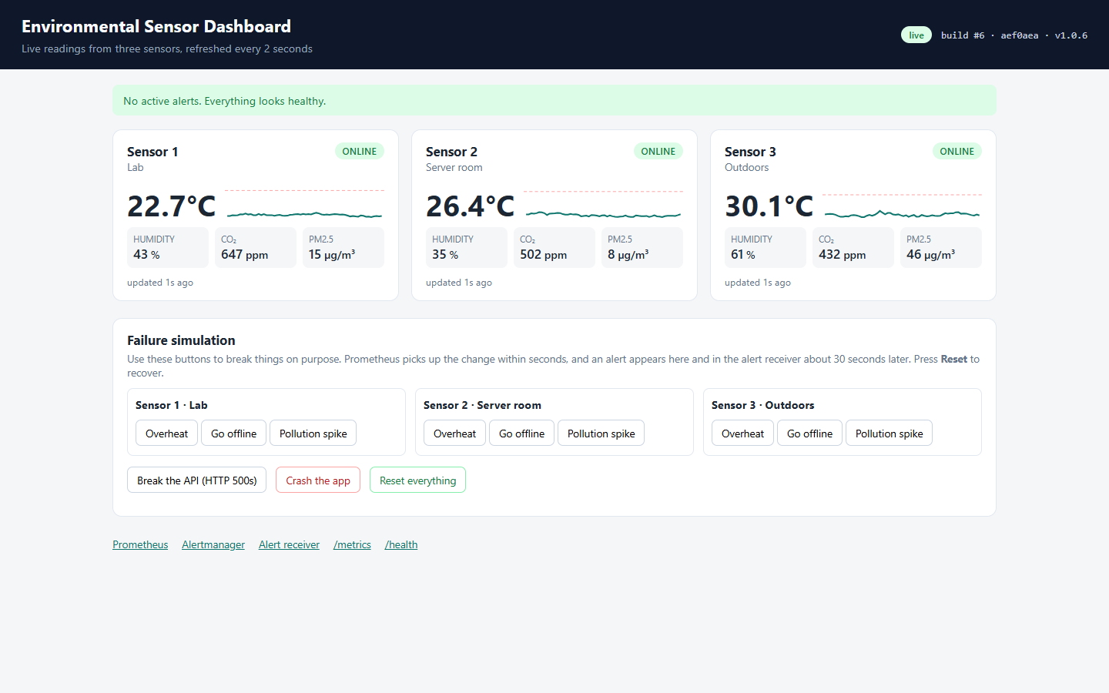
The dashboard in its normal state

8. Challenges and how we solved them
- Deploying from inside a Jenkins container. Our first idea was to mount prometheus.yml into the Prometheus container from the project folder. That fails when Jenkins runs the deployment: Jenkins’s workspace is inside the Jenkins container, and the host’s Docker engine can’t see that path. We copied the config files into small custom images instead, which also puts config changes through the same pipeline as code.
- Docker socket permissions. The socket inside the Jenkins container belongs to the root group, so the jenkins user couldn’t use it. We added that group to the container (group_add) instead of running Jenkins as root. The group id is a setting, because it differs on Linux hosts.
- Alertmanager remembers what it sent. When we restarted Alertmanager in the middle of an active alert, it treated the same alert as already delivered and stayed silent. We now redeploy Alertmanager only when its configuration changes, and noted this in the troubleshooting guide.
- Everything restarted on the first Jenkins deploy. The stack had first been started from our own working copy. The images Jenkins built from its checkout were not byte-for-byte the same (different line endings and file timestamps), so Compose replaced every container once. From then on only services whose image really changed are replaced. We also added a .gitattributes file so shell scripts and configs always keep Unix (LF) line endings, because a script with Windows line endings fails on Linux.
- Port clash. Port 8080 was already used by another program on our machine, so the Jenkins port is configurable (JENKINS_PORT).
- Tests could not import the app inside the container. pytest started from the container’s working directory did not add it to the import path. Setting pythonpath = . in setup.cfg fixed it for every environment.

9. Conclusion
The project covers the whole DevOps loop: code → build → test → deploy → monitor → alert. Every change goes through version control and an automated pipeline that refuses to deploy untested code and undoes a bad release on its own. Docker makes the app run the same way on every machine, from a developer’s laptop to GitHub’s test machines. Prometheus and Alertmanager turn failures into clear, grouped notifications within about half a minute, and confirm when the problem is fixed. Each of these behaviours was demonstrated with a real failure, not only described.

10. Future scope
- Replace the simulator with real sensors (for example an ESP32 publishing over MQTT) without changing the pipeline or the monitoring.
- Add Grafana dashboards on top of Prometheus for long-term trends.
- Send notifications to Slack, email or Telegram by editing the Alertmanager receivers.
- Deploy to a cloud server (for example Linode) over SSH, pushing images to a private registry such as Nexus instead of building on the target machine.
- Use a GitHub webhook (through a public Jenkins URL) instead of polling.
- Run Jenkins builds on separate agents instead of on the controller, and move to Kubernetes for zero-downtime rolling updates.

11. References
- Jenkins documentation: Pipeline syntax and Configuration as Code. https://www.jenkins.io/doc/
- Prometheus documentation: configuration, alerting rules and unit testing rules. https://prometheus.io/docs/
- Alertmanager documentation: routing, grouping and inhibition. https://prometheus.io/docs/alerting/latest/alertmanager/
- Docker documentation: multi-stage builds and Compose. https://docs.docker.com/
- prometheus_client for Python. https://github.com/prometheus/client_python
- Flask documentation. https://flask.palletsprojects.com/

