Game Design Document

Fill up the Following document

1. Write the title of your project.

MACD SURFER

1. What is the goal of the game?

The goal of the game will be that, that aloo have to caught the thief.

1. Write a brief story of your game?

Once upon the time in the village there was girl .Her name was “Aloo” .so one day aloo was going to his job and she earn money from there and at evening she get back to home and put the money in the basket and she go for sleep and at night one thief came at her home and he stole all the money from aloo’s house and then aloo start running behind the thief

1. Which are the playing characters of this game?

* Playing characters are the ones which respond to the user based on the input from the user
* Cars, monkeys, dinos, wizards etc, are the playing characters in the game.

|  |  |  |
| --- | --- | --- |
| Number | Character Name | What can this character do? |
| 1 | ALOO | Aloo is a girl name who is trying catch the theif. |
| 2 |  |  |
| 3 |  |  |
| 4 |  |  |
| 5 |  |  |
| 6 |  |  |
| 7 |  |  |
| 8 |  |  |

1. Which are the Non Playing Characters of this game?

* Non Playing characters are the ones which don't have an action or a behaviour when the user interacts with the game.
* Hurdles, stones, bananas, coins, etc are non playing characters in the game.

|  |  |  |
| --- | --- | --- |
| Number | Character Name | What can this character do? |
| 1 | Enemy | Enemy is a thief which is taking money of aloo. |
| 2 |  |  |
| 3 |  |  |
| 4 |  |  |
| 5 |  |  |
| 6 |  |  |
| 7 |  |  |
| 8 |  |  |

Draw your imagination of this game. What does this game look like?

* Draw the game either on your computer or on paper,
* Add images of scenes of the game to show each of the playing and non-playing characters at least once.

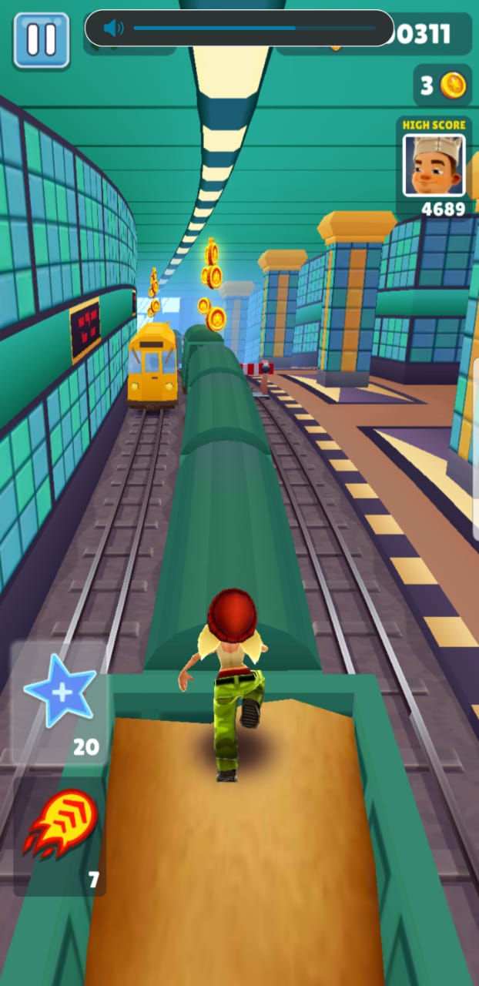

How do you plan to make your game engaging?