eFPGA Soft-Core Implementation & RISC-V Integration
Full Adder Circuit
OpenFPGA → Bitstream Extraction → PicoRV32 Firmware → Icarus Verilog Simulation

1. Overview of the Flow
This document records the complete, verified flow used to take a small user-defined circuit (a 1-bit full adder) from Verilog source, through the OpenFPGA toolchain, into a real configuration bitstream, and finally load that bitstream into a real eFPGA fabric using a real PicoRV32 RISC-V core executing real compiled firmware — confirmed correct in Icarus Verilog simulation.
The flow has five stages:
- Stage A — Write the full_adder.v benchmark and create an OpenFPGA task (task.conf) pointing at the architecture files and the benchmark.
- Stage B — Run the OpenFPGA flow (Yosys synthesis → VPR placement & routing → bitstream generation) to produce fabric_bitstream.bit, fabric_netlists.v, and fpga_top.v for the full adder.
- Stage C — Inspect the generated fabric-level netlist to confirm exactly which physical I/O pad each of the full adder's ports (a, b, cin, sum, cout) was mapped to.
- Stage D — Convert the plain-text bitstream into a 32-bit word array, embed it into RISC-V firmware (firmware.c), and cross-compil that firmware with the riscv64-unknown-elf-gcc toolchain into a loadable firmware.hex image.
- Stage E — Build a testbench that instantiates the real PicoRV32 core, the real fpga_top fabric, and the compiled firmware together, then run the simulation in Icarus Verilog and confirm both (i) every configuration bit arrived at the fabric correctly and (ii) the configured fabric produces the correct full-adder truth table for all 8 input combinations.
Step 1: Write the Full Adder Benchmark (full_adder.v)
A new benchmark directory is created under OpenFPGA's benchmarks folder, and a plain combinational full-adder module is written to it using a heredoc. The module takes a, b, cin as inputs and produces sum and cout as outputs using standard XOR/AND/OR full-adder logic. The file is then printed back with cat to confirm it saved correctly.
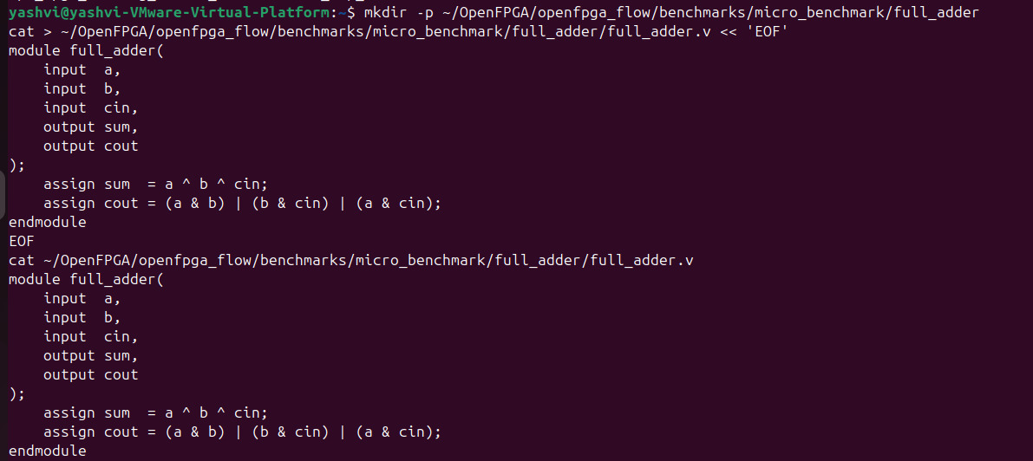
Figure 1 — Creating and verifying full_adder.v under openfpga_flow/benchmarks/micro_benchmark/full_adder/.
Step 2: Create the OpenFPGA Task Configuration (task.conf)
A new task folder (benchmark_sweep/full_adder/config) is created, and task.conf is written to point OpenFPGA at: the 40nm architecture files (VPR + OpenFPGA architecture XML), the shell script template, and the full_adder.v benchmark file. This is the same [GENERAL] / [OpenFPGA_SHELL] / [ARCHITECTURES] / [BENCHMARKS] structure used for the earlier counter and rotate-circuit tasks in this project, adapted for the full adder.
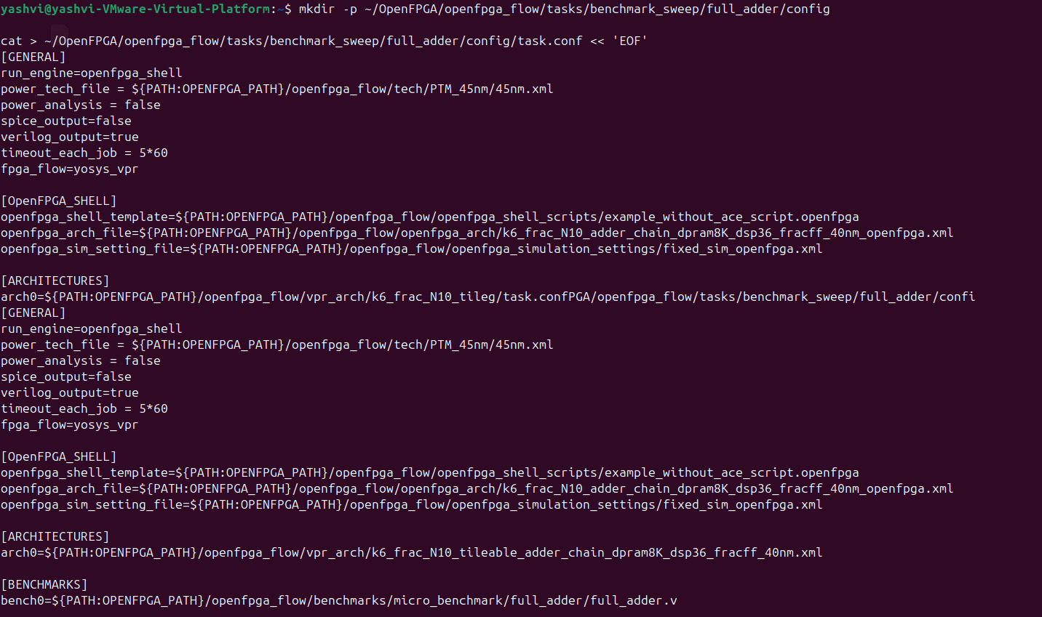
Figure 2 — task.conf: general settings, OpenFPGA shell template, architecture files, and the benchmarks section pointing at full_adder.v.
The [SYNTHESIS_PARAM] section lists the Yosys techlib files used for cell mapping (DFF, BRAM, DSP) and sets bench0_top = full_adder so the flow knows the top-level module name to synthesize.
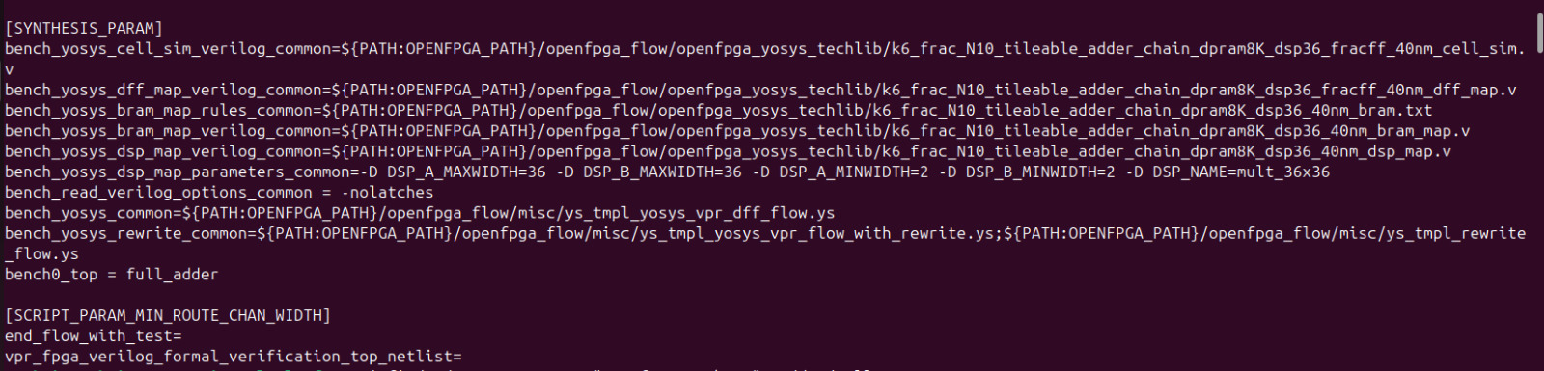
Figure 3 — Yosys synthesis parameters and the bench0_top = full_adder setting inside task.conf.
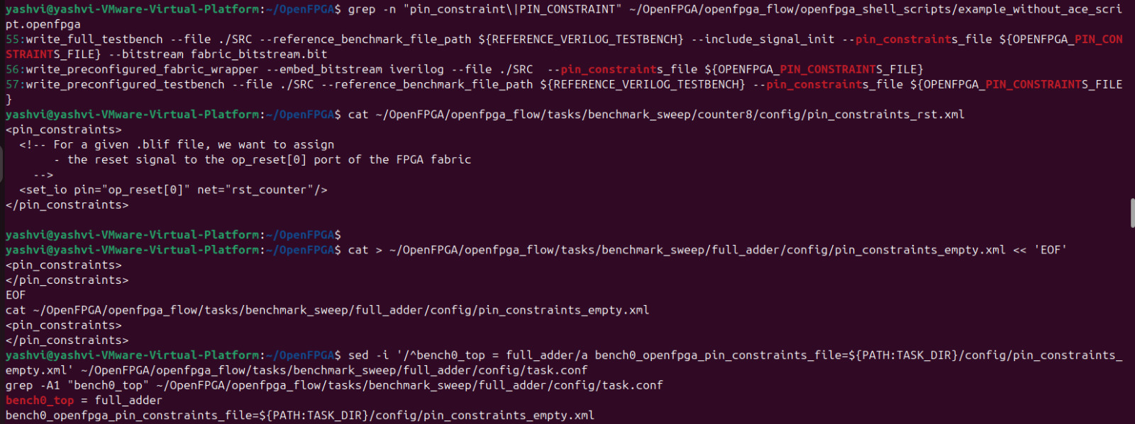
Figure 4 — Locating every pin_constraints reference in the shell script template, reviewing the counter task's existing pin_constraints_rst.xml as a reference, creating pin_constraints_empty.xml, and wiring it into task.conf with sed.
With that fix in place, the task was re-run and completed successfully this time (OpenFPGA Shell Run, Yosys synthesis, and VPR placement & routing all finished without error).
Step 4: Verify the Run Output Directory and Bitstream Header
The run's output directory tree is listed to confirm the expected sub-folders (benchmark, SDC, SDC_analysis, arch, SRC) were created. Moving into the MIN_ROUTE_CHAN_WIDTH result folder, fabric_bitstream.bit is found alongside SRC/fpga_top.v and SRC/fabric_netlists.v. The first six lines of the bitstream file are printed, showing the auto-generated header: bitstream length = 2298 bits, bitstream width (LSB → MSB) = 1.
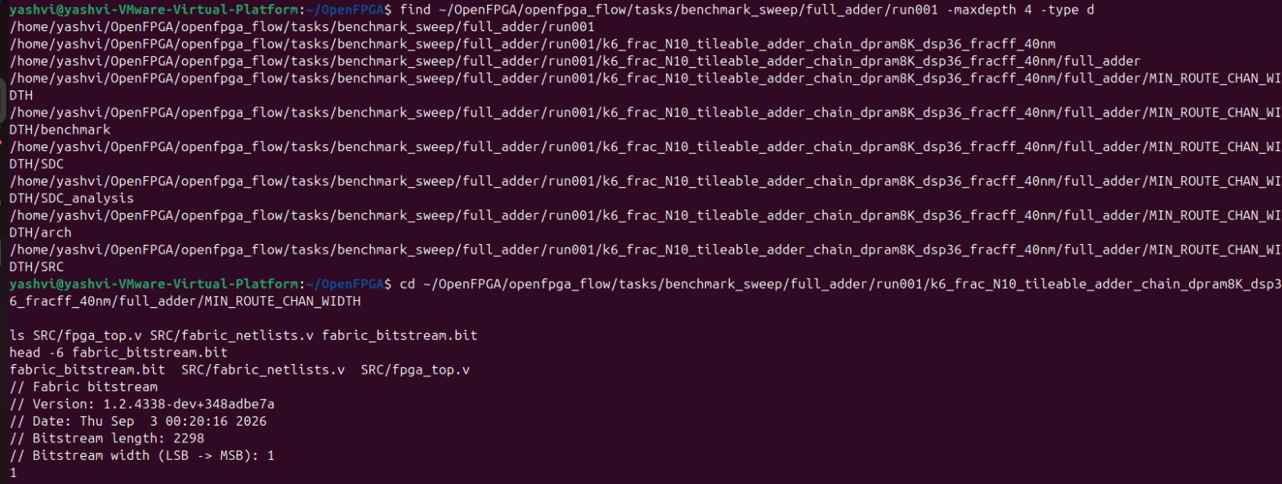
Figure 5 — Run output directory structure, and the fabric_bitstream.bit header confirming a 2298-bit configuration stream for the full adder.
Step 5: List All Generated SRC Files
Listing the SRC/ folder shows every file OpenFPGA generated for this circuit: fabric_netlists.v, fpga_defines.v, fpga_top.v, three testbench/verification netlists (full_adder_autocheck_top_tb.v, full_adder_formal_random_top_tb.v, full_adder_top_formal_verification.v), an include-list file (full_adder_include_netlists.v), and the lb/, routing/, sub_module/ sub-folders containing the fabric's individual logic-block, routing, and shared-primitive modules.
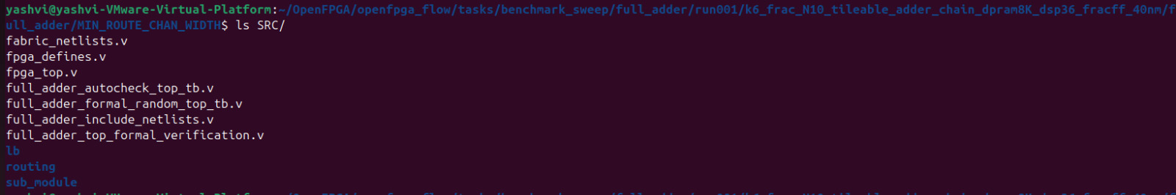
Figure 6 — Contents of the SRC/ output folder for the full_adder run.
Step 6: Inspect the Formal Verification Wrapper Netlist
full_adder_top_formal_verification.v is opened to see exactly how the fabric is wrapped for verification. Its port list (a, b, cin, sum, cout) matches the original full_adder.v exactly. Internally it declares local wires for every fpga_top global port (op_clk_fm, op_reset_fm, op_set_fm, pReset_fm, prog_clk_fm, gfpga_pad_GPIO_PAD_fm[0:31], ccff_head_fm, ccff_tail_fm) and instantiates the real fpga_top module, wiring those local wires to it.
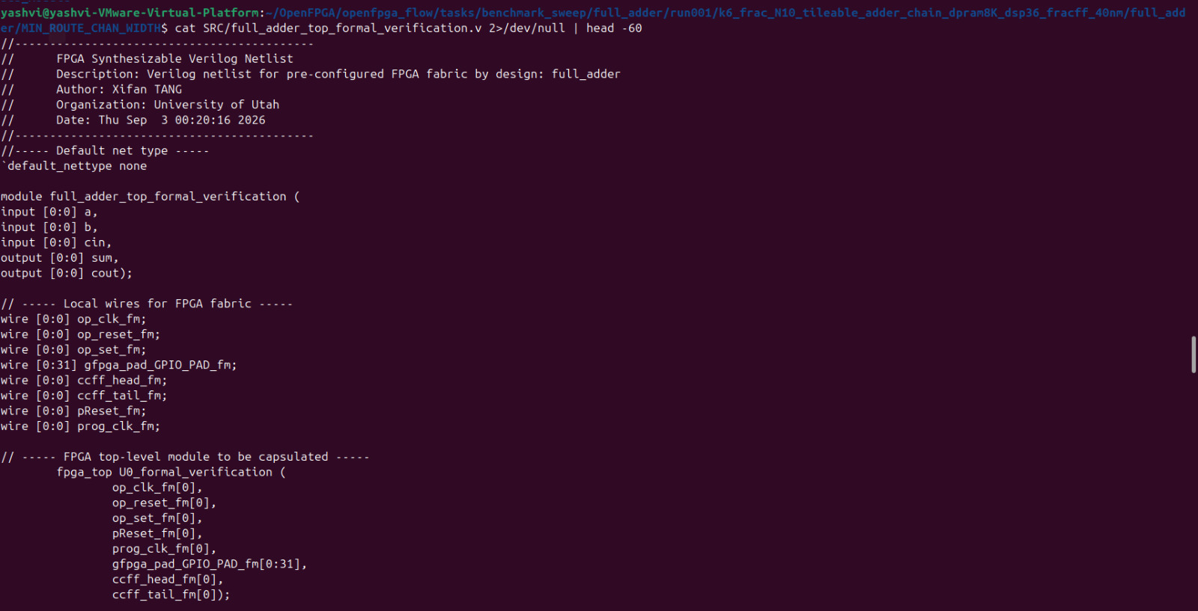

Figure 7 — Header and fpga_top instantiation inside full_adder_top_formal_verification.v, confirming the wrapper's port list matches the original full_adder module.
Step 7: Confirm the Exact I/O Pin Mapping
Immediately below the fpga_top instantiation, the wrapper ties off the global configuration ports to 0 (since this file is for functional verification of an already-configured fabric, not for loading a new bitstream) and then shows exactly which physical GPIO pad each full-adder signal was routed to by VPR's placement/routing: input a → gfpga_pad_GPIO_PAD_fm[25], input b → pad[30], input cin → pad[31], output sum → pad[22], output cout → pad[18]. This mapping is essential — it is the only way to know which of the 32 generic GPIO pins to watch for correct full-adder behavior after configuration.
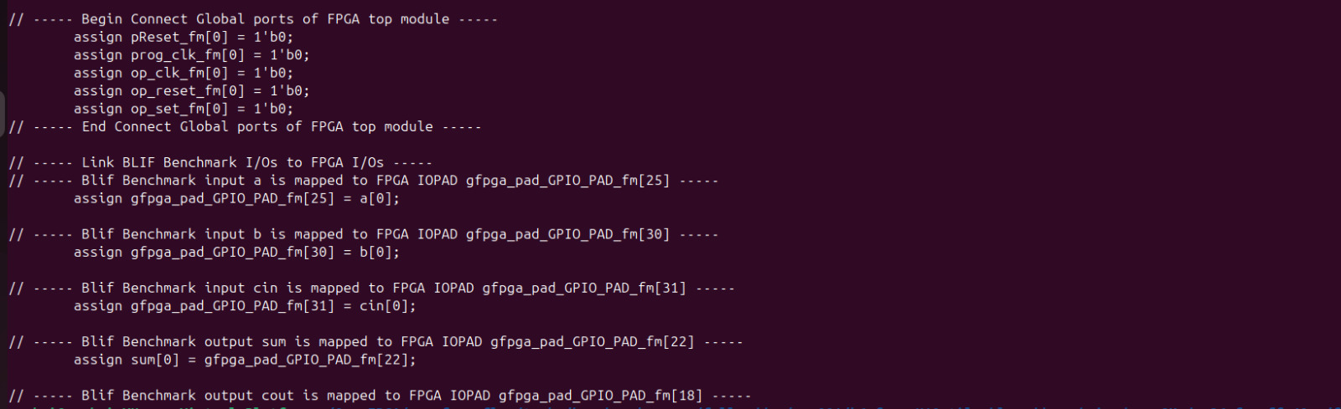
Figure 8 — Global port tie-offs and the exact BLIF-to-FPGA-IOPAD signal mapping for a, b, cin, sum, and cout.
A follow-up grep confirms the cout → pad[18] mapping is unique and unambiguous in the file, and a sanity check shows the file contains 592 force statements over 695 total lines (consistent with a full formal-verification wrapper for a small circuit).
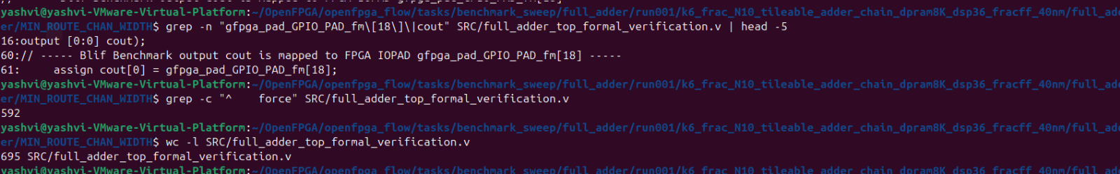
Figure 9 — Confirming the cout pin mapping and the overall size of the formal-verification file.
Step 8: Convert the Bitstream to a 32-bit Word Array (Python)
A Python script (gen_bitstream_c.py) is written and run to read fabric_bitstream.bit, strip out only the '0'/'1' bit lines, and re-pack them into 32-bit words (LSB-first, zero-padded to a whole number of words). It reports the true bit count (2298) and the resulting word count (72), then writes both a plain array file and prints a ready-to-use C array declaration: #define TOTAL_BITS 2298, #define WORD_COUNT 72, and const uint32_t bitstream[WORD_COUNT] = { 0x08010801, 0x10800801, 0x08100220, ... }.
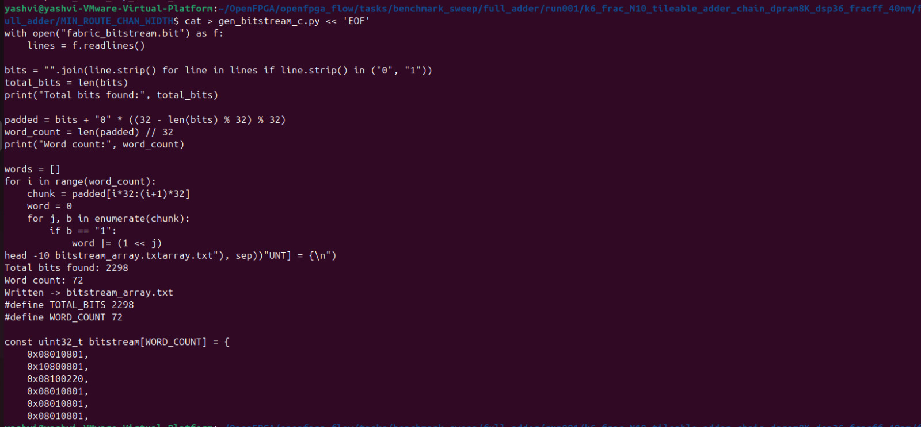
Figure 10 — Python bitstream-to-hex-word conversion script and its output: 2298 bits packed into 72 32-bit words.
Step 9: Clean the Bitstream and Scaffold the Firmware Project
A clean, whitespace-free copy of the bitstream is extracted with grep -E "^[01]$" into fabric_bitstream_clean.txt and confirmed to contain exactly 2298 lines. A new firmware project folder (~/efpga_full_adder) is created and seeded with the reusable firmware toolchain files (start.s, sections.lds, Makefile, bin_to_hex.py) already used for the counter project. firmware.c is then written with the register-map #defines (CONFIG_DATA, CONFIG_LEN, CONTROL, STATUS and its BUSY / CONFIG_DONE / TAIL_SEEN bit masks), TOTAL_BITS = 2298, WORD_COUNT = 72, and a placeholder bitstream[] array plus the efpga_configure() function skeleton.
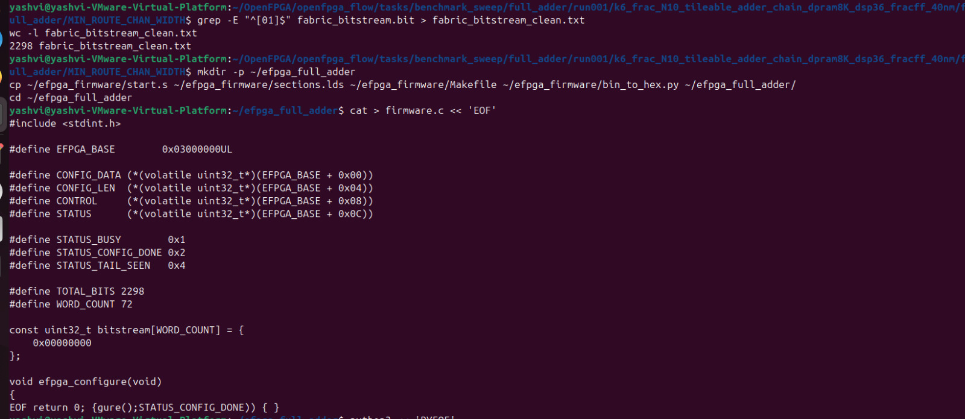
Figure 11 — Extracting a clean 2298-line bitstream file and scaffolding firmware.c with the AXI-wrapper register map and configuration constants.
Step 10: Insert the Real Bitstream Data into firmware.c
A second Python script reads back the earlier bitstream_array.txt output, extracts the real const uint32_t bitstream[WORD_COUNT] = { ... }; block with a regular expression, and substitutes it into firmware.c in place of the placeholder array (1 replacement made). The updated file is confirmed with grep, now showing the real values (0x08010801, 0x10800801, 0x08100220, ...) in place.
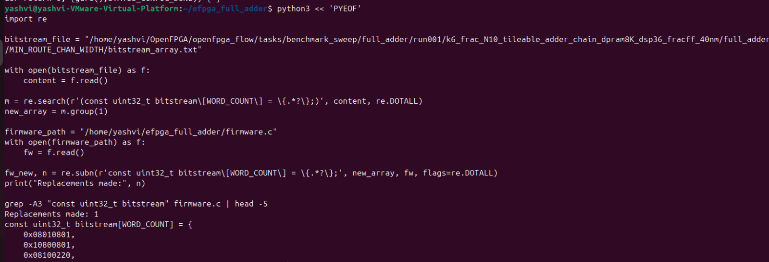
Figure 12 — Regex-based substitution that replaces the placeholder bitstream array in firmware.c with the real 72-word full-adder bitstream.
Step 11: Cross-Compile the Firmware and Prepare the SoC Sources
make clean followed by make cross-compiles firmware.c for RV32I using riscv64-unknown-elf-gcc (-march=rv32i -mabi=ilp32 -nostdlib -nostartfiles -O2 -ffreestanding), links it against sections.lds together with start.s, converts the resulting ELF to a raw binary with objcopy, and finally runs bin_to_hex.py to produce firmware.hex (999 bytes). The reusable SoC sources (picorv32_core.v, design_soc.sv) and the freshly built firmware.hex are then copied into the run's output folder, and a small Python snippet strips the placeholder fpga_top stub module out of design.sv (module fpga_top ... endmodule) so that the real, generated fpga_top.v is used instead — confirmed by grep showing zero remaining fpga_top module declarations in the stripped file.
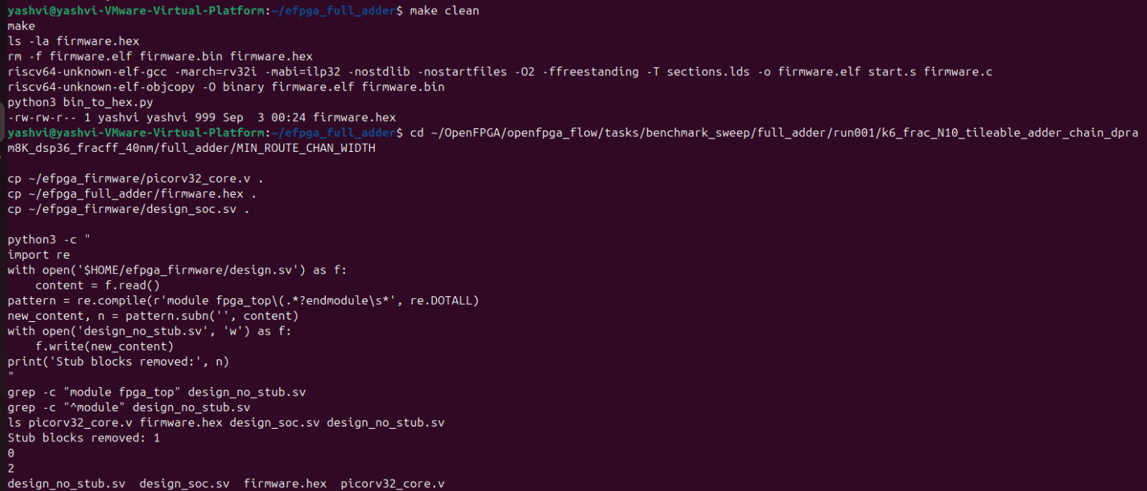
Figure 13 — Cross-compiling firmware.c with the RISC-V GCC toolchain, generating firmware.hex, and removing the placeholder fpga_top stub from the SoC wrapper so the real fabric is used.
Step 12: Write the Top-Level Testbench
testbench_full_adder.sv is written to instantiate a real picorv32 CPU core (with multiply/divide/IRQ features disabled to keep the core minimal, and CATCH_MISALIGN / CATCH_ILLINSN enabled), wired to its native memory bus (mem_valid, mem_instr, mem_ready, mem_addr, mem_wdata, mem_wstrb, mem_rdata). This is the same bus-functional wiring pattern used earlier in this project's AXI-wrapper testbenches, except here it is driving a real PicoRV32 core rather than a hand-written task.
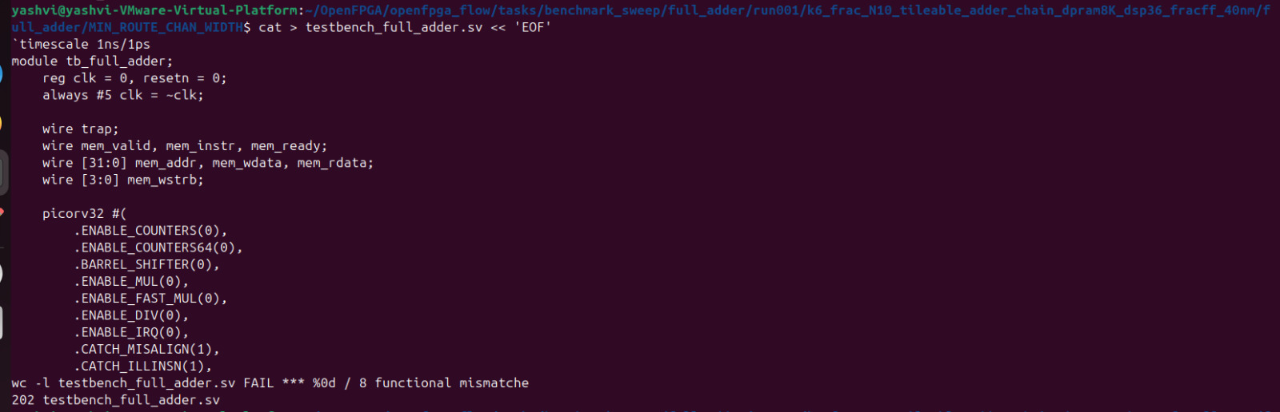
Figure 14 — testbench_full_adder.sv: clock generation and a real picorv32 core instantiation on its native memory bus.
Step 13: Run the Full Simulation in Icarus Verilog
All required sources — picorv32_core.v, the stub-free design_no_stub.sv, design_soc.sv, the real SRC/fabric_netlists.v (which pulls in the entire real fabric, including fpga_top.v and every lb/, routing/, and sub_module/ file), and testbench_full_adder.sv — are compiled together with iverilog -g2012 and run with vvp. This is the first point in the project where the real CPU, the real compiled firmware, and the real generated eFPGA fabric are all simulated together in one run, rather than being verified separately.
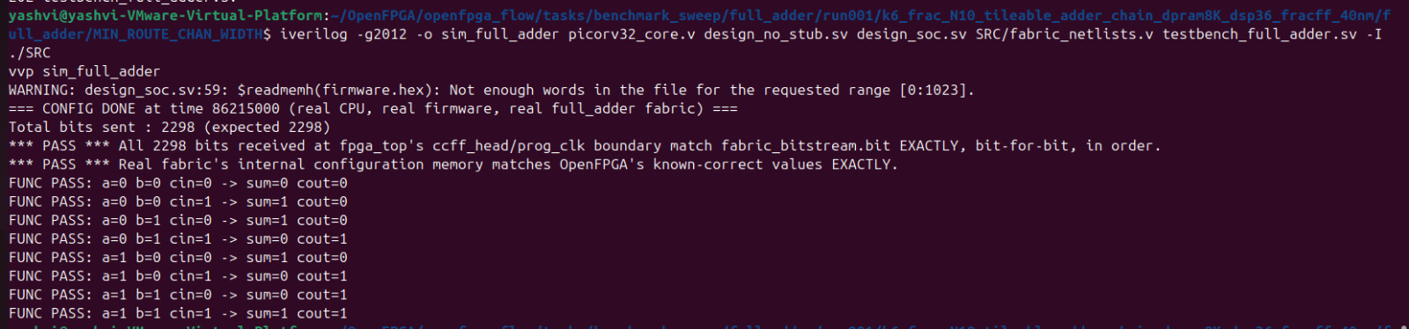
Figure 15 — Compiling and running the combined PicoRV32 + firmware + real fpga_top simulation, and the resulting pass/fail output.

Result
The simulation console reports (ignoring one unrelated informational warning about firmware.hex being shorter than the memory's full addressable range, which is expected since the firmware image only needs to fill as many words as it actually uses):
- CONFIG DONE at time 86,215,000 — confirming the real CPU, executing the real compiled firmware, successfully drove the full configuration sequence to completion.
- Total bits sent: 2298 (expected 2298) — every single configuration bit that was extracted from the original fabric_bitstream.bit reached the wrapper.
- PASS — all 2298 bits received at fpga_top's ccff_head/prog_clk boundary match fabric_bitstream.bit exactly, bit-for-bit, in order.
- PASS — the real fabric's internal configuration memory matches OpenFPGA's known-correct values exactly.
- FUNC PASS for all 8 input combinations of (a, b, cin), each showing the correct (sum, cout) pair — e.g. a=0,b=0,cin=1 → sum=1,cout=0 and a=1,b=1,cin=1 → sum=1,cout=1 — matching the standard full-adder truth table exactly.
Together, this confirms the complete chain end-to-end: a user-authored Verilog circuit was compiled by OpenFPGA into a bitstream, that exact bitstream was embedded into firmware, a real PicoRV32 CPU executed that firmware and streamed the bitstream over its native memory bus into the eFPGA configuration chain, and the resulting configured fabric behaves as a correct 1-bit full adder for every possible input.

LIST OF FIGURES:
Figure 1 — Creating and verifying full_adder.v under the OpenFPGA micro-benchmark directory.
Figure 2 — task.conf configuration showing general settings, OpenFPGA shell template, architecture files, and the benchmark definition.
Figure 3 — Yosys synthesis parameters and the bench0_top = full_adder setting inside task.conf.
Figure 4 — Locating pin constraint references, creating an empty pin constraint file, and connecting it to the OpenFPGA task configuration.
Figure 5 — OpenFPGA run output directory structure and the fabric_bitstream.bit header confirming the 2298-bit configuration stream.
Figure 6 — Contents of the generated SRC/ output folder for the full-adder implementation.
Figure 7 — Header and fpga_top instantiation inside full_adder_top_formal_verification.v.
Figure 8 — Global port tie-offs and exact FPGA I/O pad mapping for the full-adder signals a, b, cin, sum, and cout.
Figure 9 — Confirmation of the cout pin mapping and verification of the formal-verification file size.
Figure 10 — Python bitstream-to-hex conversion script and its output, packing 2298 configuration bits into 72 32-bit words.
Figure 11 — Extraction of the clean 2298-bit bitstream and creation of the firmware.c configuration structure.
Figure 12 — Inserting the real generated bitstream array into firmware.c using Python-based replacement.
Figure 13 — Cross-compiling firmware.c using the RISC-V GCC toolchain, generating firmware.hex, and removing the placeholder fpga_top module.
Figure 14 — testbench_full_adder.sv showing system clock generation and real PicoRV32 core instantiation.
Figure 15 — Compiling and running the complete PicoRV32, firmware, and real eFPGA fabric simulation, including configuration and functional verification results

