**SETTING UP PYTHON AND GIT**

1. **Install python 3.11**

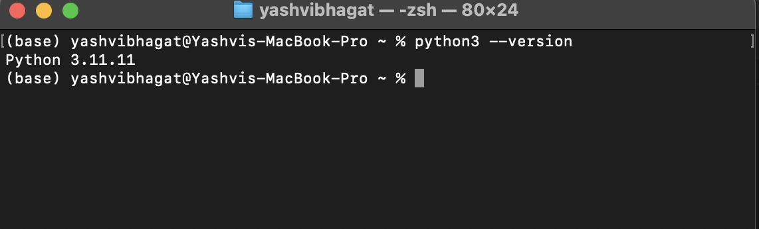

**2) Create a folder for your class files, make a python virtual environment called *venv* in this folder, activate it.**

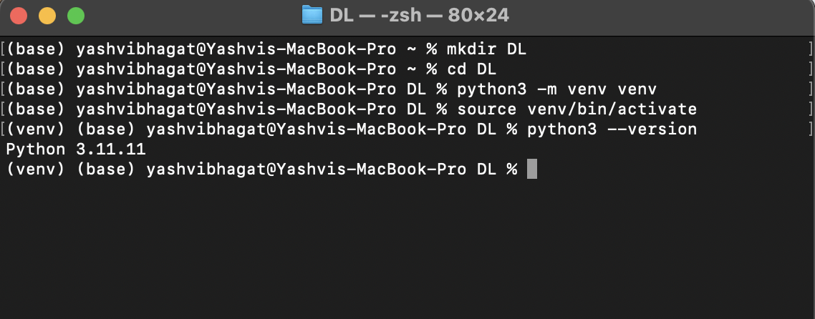

1. **Create a notebook called My First Notebook, execute a print statement to print your name and**

**attach screen capture**

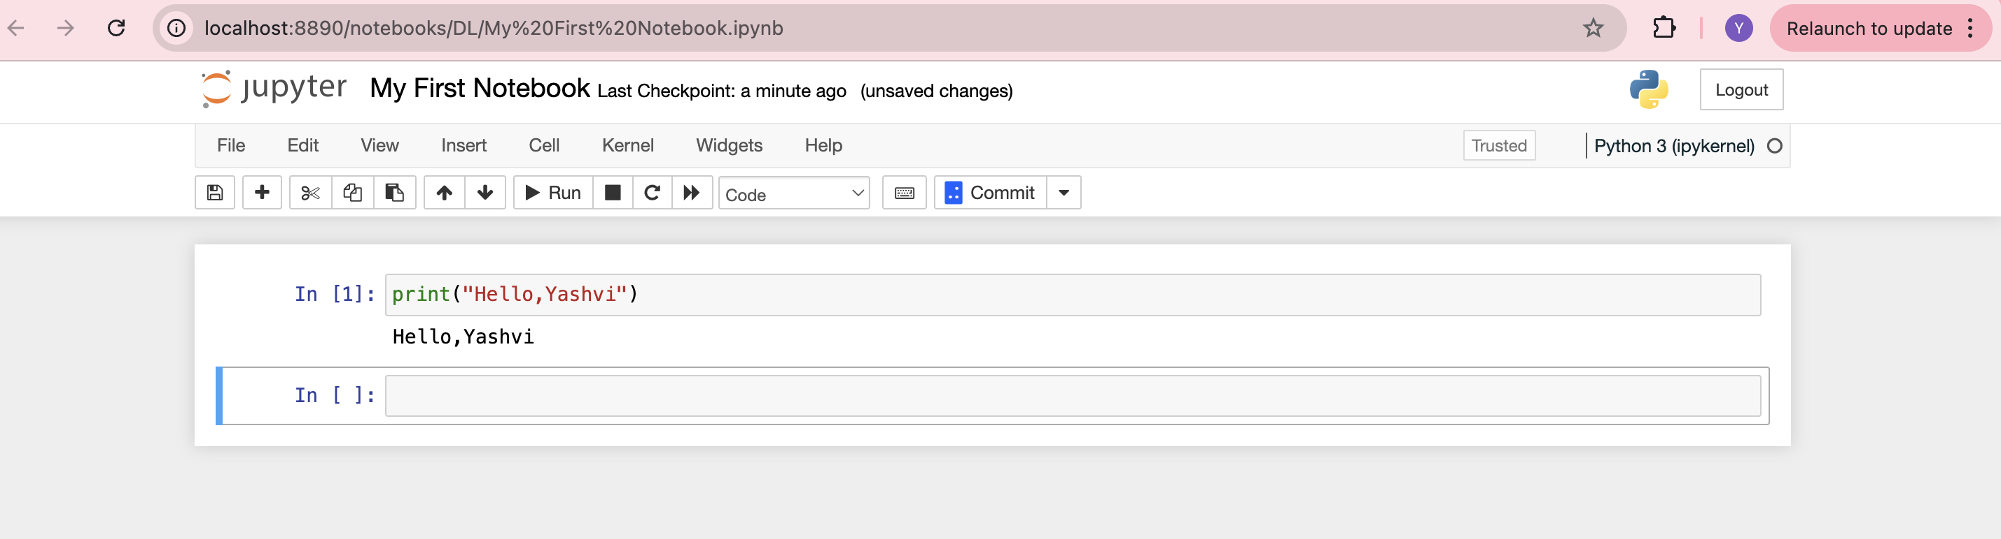

1. **show a screen capture with the IDE and the output.**

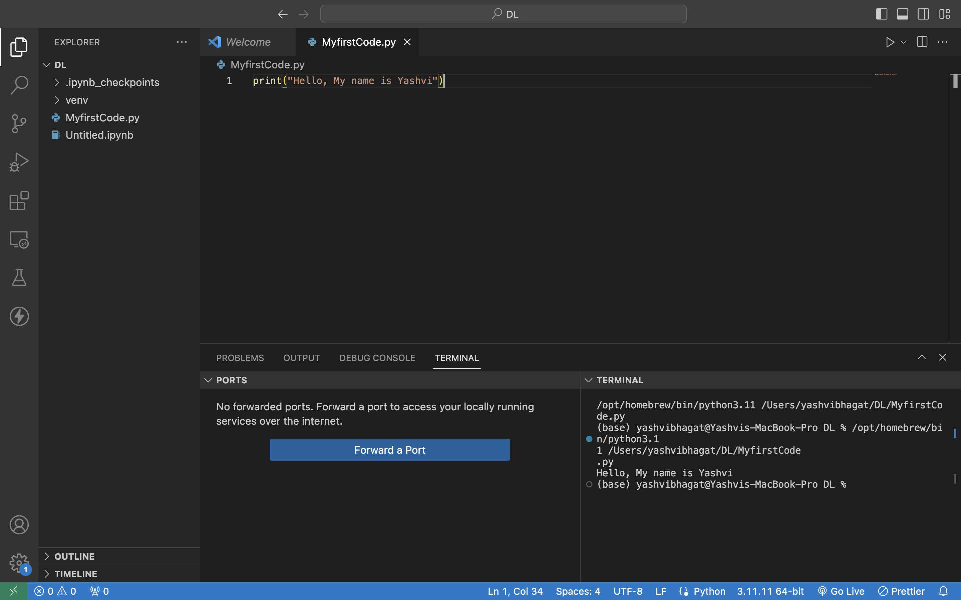

1. **Show a screen capture with your GitHub repository.**

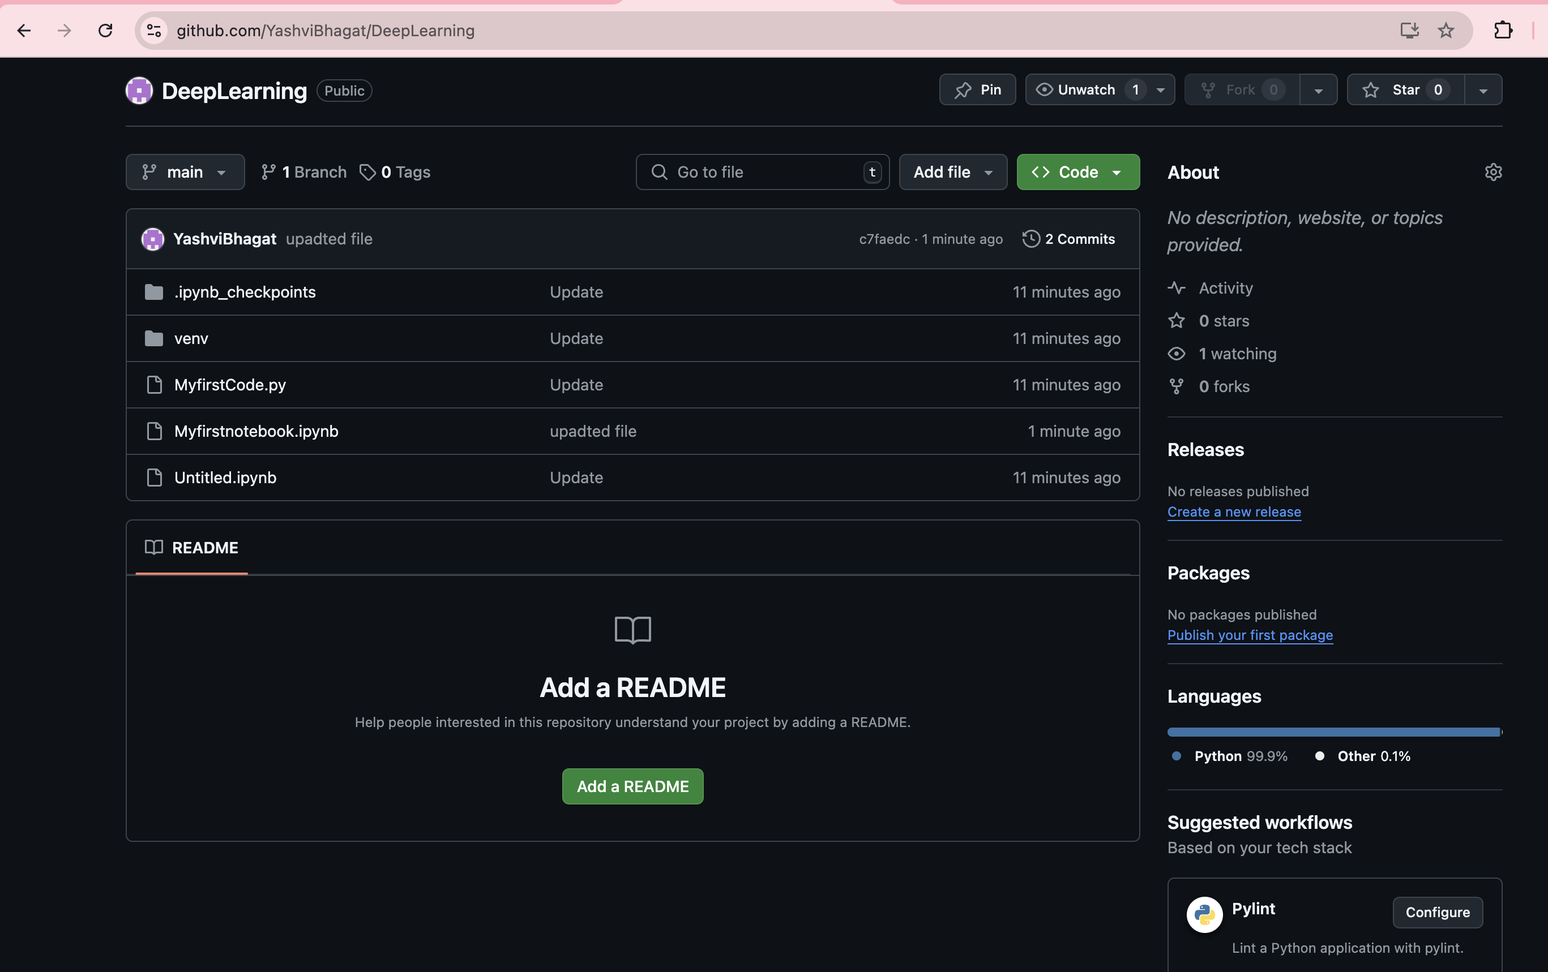

**GitHub link:** [**https://github.com/YashviBhagat/DeepLearning**](https://github.com/YashviBhagat/DeepLearning)