FILE 3 – VISUALIZATIONS & COMPARATIVE CHARTS
LAB 2 – Algorithm Performance Measurement and Benchmarking Tool
Design and Analysis of Algorithms Laboratory

Student Name | Yashvi Sahu
Roll No. | 2401201010
Course / Semester | BCA / 5th
Subject | Design and Analysis of Algorithms

Question 6 – Performance Visualization
The notebook generates three comparison charts: search algorithms, factorial implementations, and loop-based programs. The following are the original code and chart screenshots.
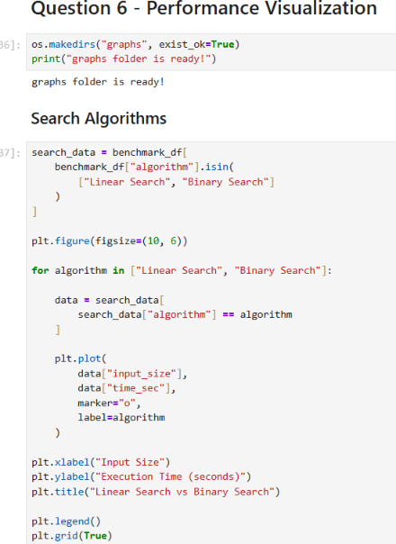
Q6 – Search visualization code
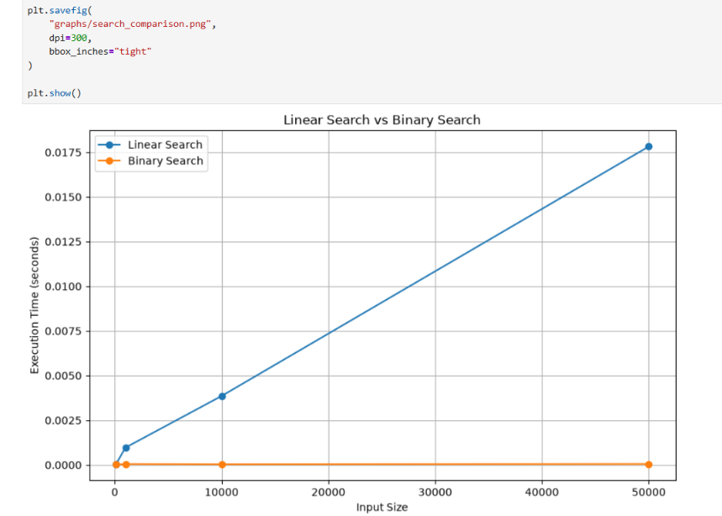
Q6 – Linear Search vs Binary Search chart
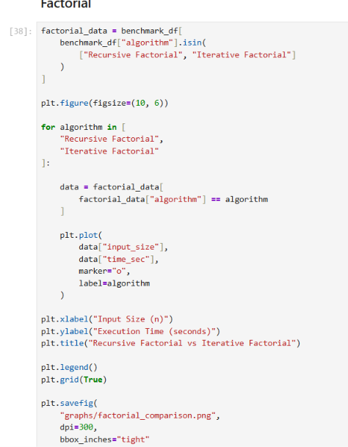
Q6 – Factorial visualization code
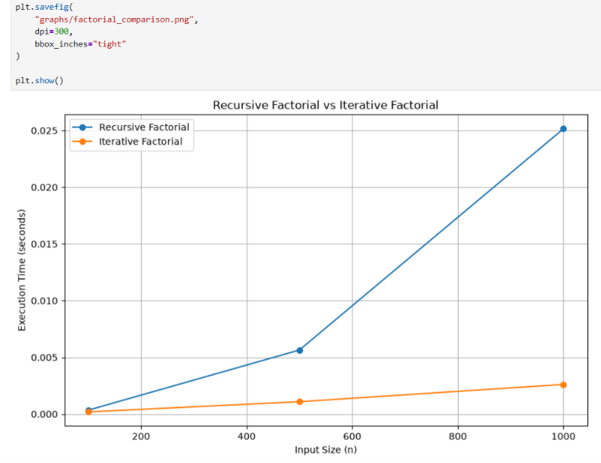
Q6 – Recursive Factorial vs Iterative Factorial chart
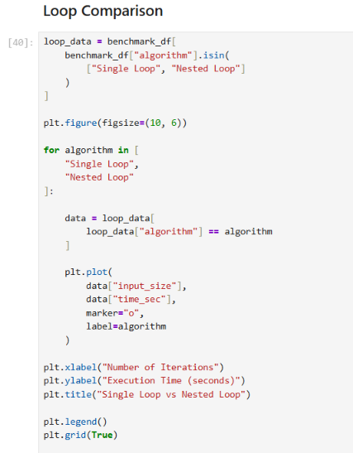
Q6 – Loop visualization code
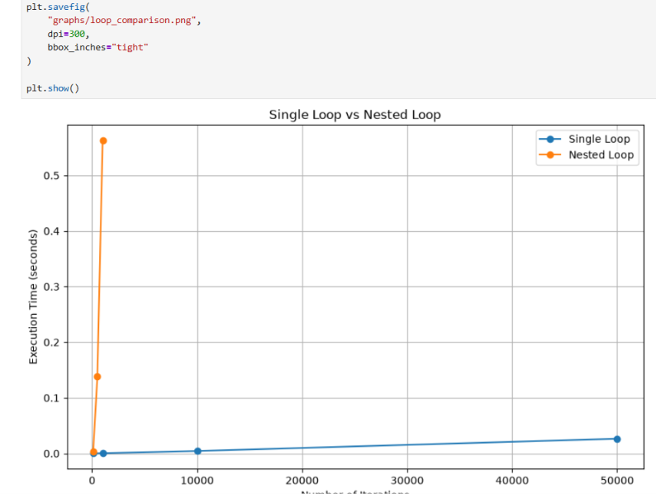
Q6 – Single Loop vs Nested Loop chart

Performance Observations
- Linear Search increases with input size, while Binary Search remains comparatively flat because its number of comparisons grows logarithmically.
- Recursive Factorial shows greater measured execution time than Iterative Factorial in the displayed experiment, consistent with recursive call overhead.
- Nested Loop grows much faster than Single Loop because the inner loop executes for every outer-loop iteration.
- The charts are based on the benchmark data generated in the notebook and saved by the project.

https://github.com/YashviSahu555/DAA-Lab-File-2

