FILE 4 – LAB 2 COMPLETE BENCHMARKING REPORT
LAB 2 – Algorithm Performance Measurement and Benchmarking Tool
Design and Analysis of Algorithms Laboratory

Student Name | Yashvi Sahu
Roll No. | 2401201010
Course / Semester | BCA / 5th
Subject | Design and Analysis of Algorithms

Question 7 – Benchmarking Report

1. Introduction
The purpose of this lab is to study algorithm performance experimentally by measuring execution time, peak memory usage and operation counts. Linear Search, Binary Search, loop-based programs and two factorial implementations were tested using Python.

2. Methodology
The implementations count comparisons or operations explicitly. Execution time is measured with time.perf_counter(), while peak memory usage is tracked with tracemalloc. The automated BenchmarkEngine repeats the same measurement process for multiple input sizes and exports the collected results to benchmark_results.csv.
- Search input sizes: 100, 1,000, 10,000 and 50,000.
- Single Loop input sizes include 100, 1,000, 10,000 and 50,000.
- Nested Loop uses smaller practical sizes because n² iterations become expensive quickly.
- Factorial measurements use moderate input sizes to keep recursive execution within practical Python limits.

3. Theoretical Complexity
Algorithm | Time | Space
Linear Search | O(n) | O(1)
Binary Search | O(log n) | O(1)
Recursive Factorial | O(n) | O(n)
Iterative Factorial | O(n) | O(1)
Single Loop | O(n) | O(1)
Nested Loop | O(n²) | O(1)

4. Experimental Findings
The combined Question 5 table reports the following average values from the submitted benchmark data:
Algorithm | Avg. Time (sec) | Avg. Memory (KB) | Avg. Operations
Binary Search | 0.000038 | 0.062500 | 11.750000
Iterative Factorial | 0.001295 | 1.183594 | 533.333333
Linear Search | 0.005668 | 0.035156 | 15275.000000
Nested Loop | 0.234774 | 48.407227 | 420000.000000
Recursive Factorial | 0.010380 | 8.867188 | 533.333333
Single Loop | 0.007807 | 0.041016 | 15275.000000

5. Search Algorithms
Linear Search examines elements sequentially and therefore its comparison count rises with the input size. Binary Search works on the sorted dataset and repeatedly halves the search interval, producing a much smaller comparison count. The search visualization reflects these different growth patterns.

6. Factorial Implementations
Both factorial implementations perform a linear number of multiplication steps. The recursive version additionally creates function-call stack frames, whereas the iterative version keeps the loop state in the current function. The measured chart shows higher execution time and memory values for the recursive implementation in the displayed experiment.

7. Loop-Based Programs
The Single Loop performs approximately n iterations. The Nested Loop performs approximately n² inner operations. Consequently, the nested implementation grows much more rapidly as the input increases. This difference is clearly visible in both the operation counts and the loop comparison chart.

8. Scalability and Efficiency Insights
- Algorithms with O(log n) growth scale more slowly with increasing input than algorithms with O(n) growth.
- An O(n²) loop structure becomes expensive quickly and therefore requires smaller practical test sizes.
- Two algorithms can have the same asymptotic time complexity while showing different measured timings because of implementation overhead.
- Recursive solutions can use more memory than iterative solutions because recursive calls occupy stack frames.

9. Conclusion
The experiment demonstrates the relationship between theoretical complexity and measured performance. The recorded operation counts and charts follow the expected growth trends: Binary Search grows logarithmically, Linear Search and the factorial implementations grow linearly, Single Loop grows linearly, and Nested Loop grows quadratically. Experimental timing and memory values provide practical evidence of these differences, while also showing that measured values can vary with the execution environment.

10. Evidence Screenshots
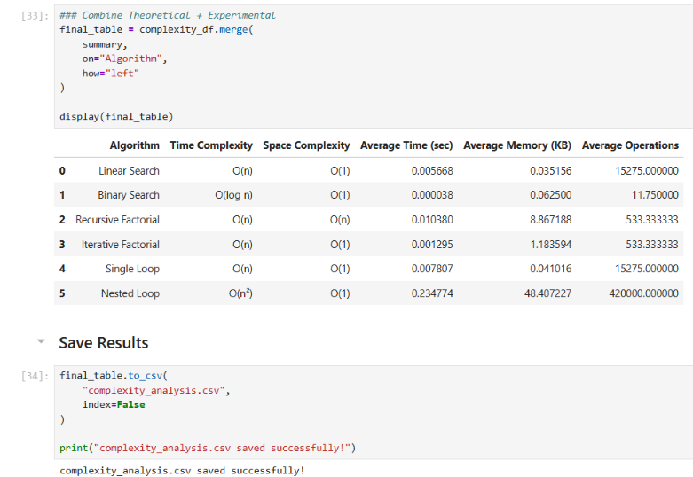
Combined theoretical and experimental table
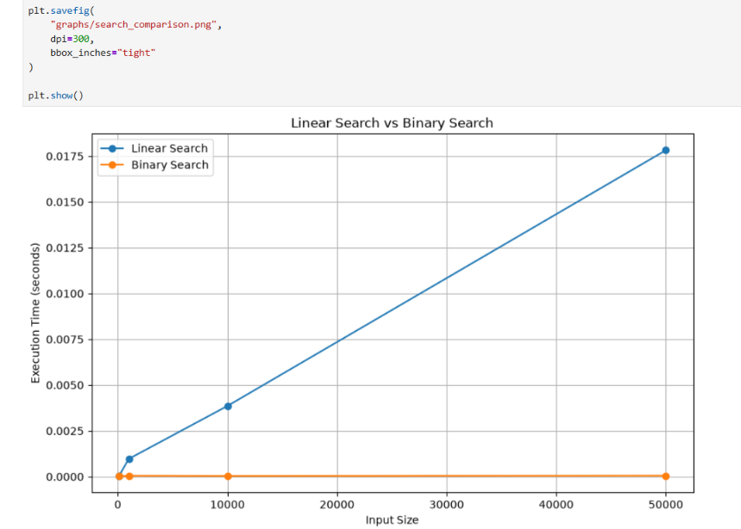
Search comparison chart
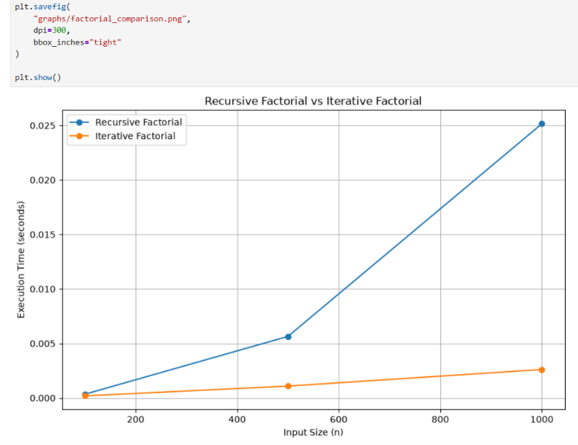
Factorial comparison chart
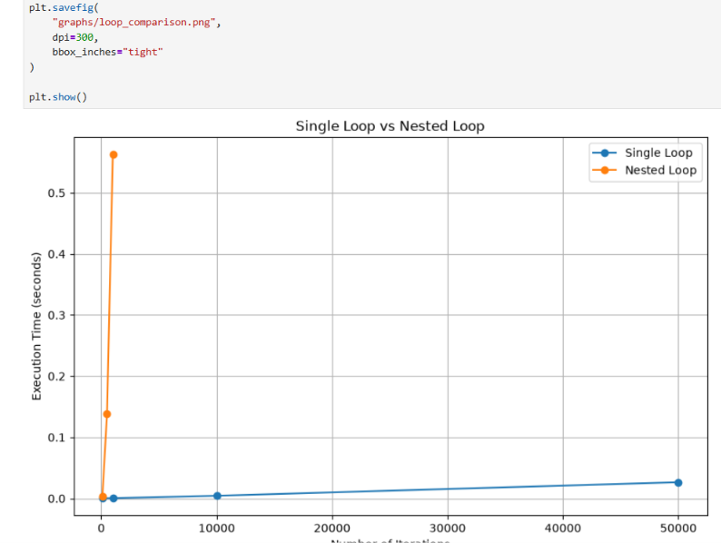
Loop comparison chart

https://github.com/YashviSahu555/DAA-Lab-File-2

