FILE 5 – FULL LAB FILE | QUESTIONS 1–7
LAB 2 – Algorithm Performance Measurement and Benchmarking Tool
Design and Analysis of Algorithms Laboratory

Student Name | Yashvi Sahu
Roll No. | 2401201010
Course / Semester | BCA / 5th
Subject | Design and Analysis of Algorithms

Question 1 – Project Setup
Project title: Algorithm Performance Measurement and Benchmarking Tool
Suggested project structure used for the lab:
Project Item | Purpose
app.py | Application / presentation layer
search_analysis.py | Search algorithm analysis
code_benchmark.py | Code benchmarking module
benchmark_engine.py | Reusable automated benchmarking engine
project_notebook.ipynb | Notebook containing the complete experiment
benchmark_results.csv | Experimental benchmark output
complexity_analysis.csv | Combined theoretical and experimental analysis
graphs/ | Generated comparison charts

The notebook uses Python libraries including time, tracemalloc, pandas, matplotlib and os/sys for the implementation and analysis.

Question 2 – Search Algorithm Analysis
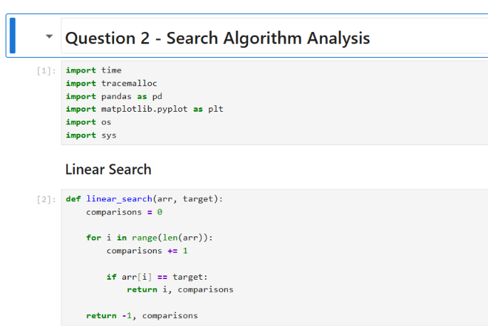
Q2 – Linear Search implementation
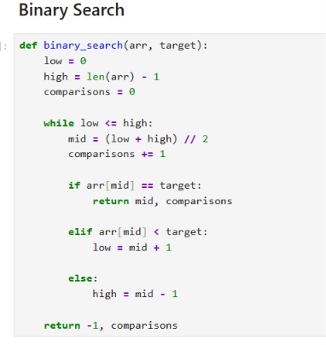
Q2 – Binary Search implementation
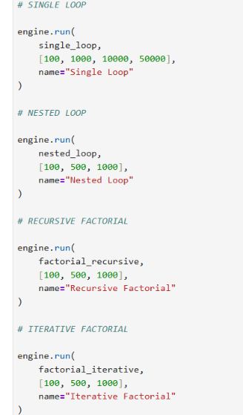
Q2 – Dataset generation and search-performance measurement
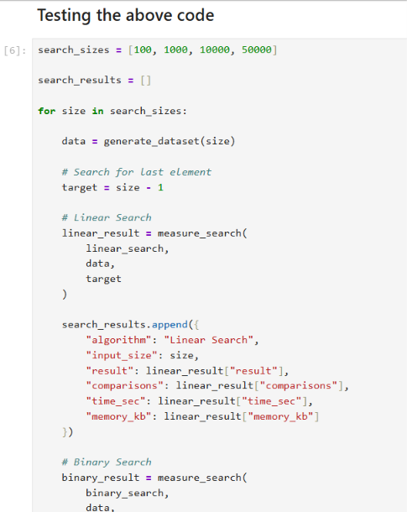
Q2 – Testing the search algorithms for multiple input sizes
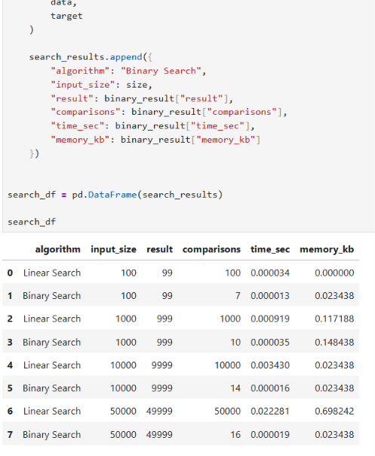
Q2 – Search results with comparisons, execution time and memory

Question 3 – Code Benchmarking Module
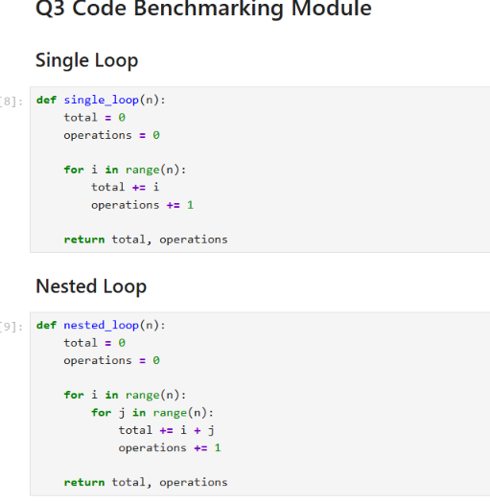
Q3 – Single Loop and Nested Loop
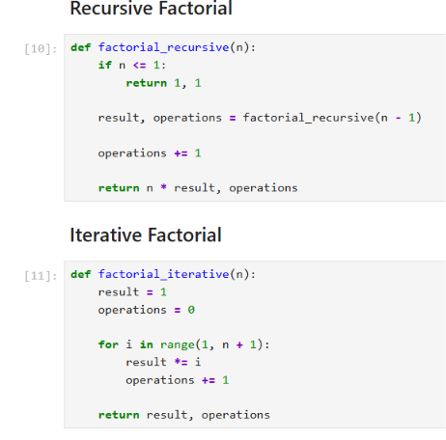
Q3 – Recursive and Iterative Factorial
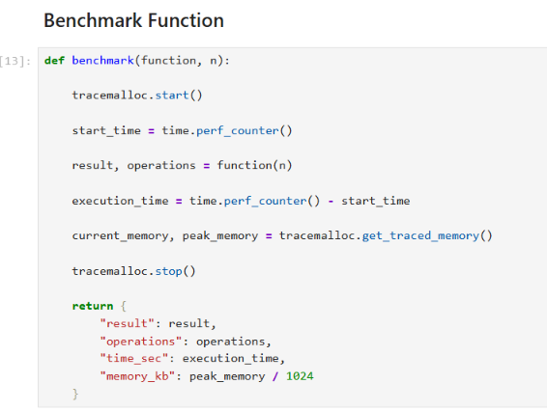
Q3 – Benchmark function
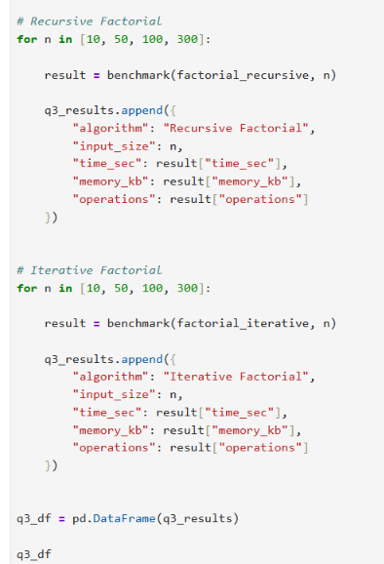
Q3 – Testing the benchmarking code
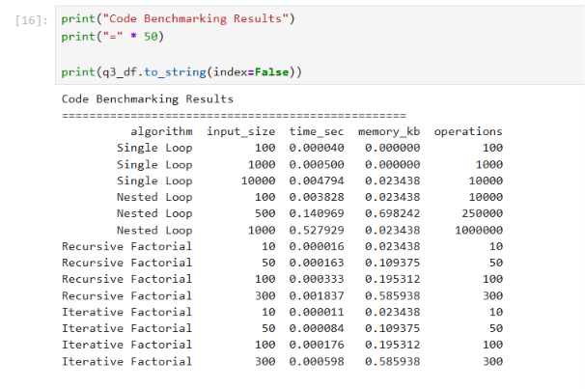
Q3 – Printed benchmarking results
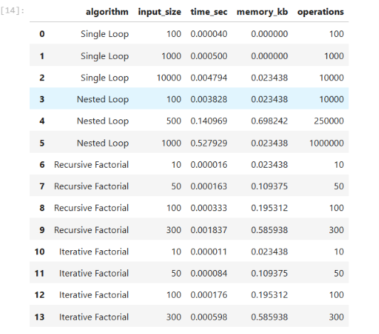
Q3 – Benchmarking results table

Question 4 – Automated Benchmarking Engine
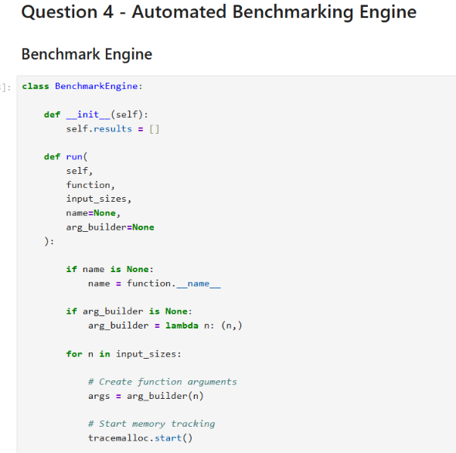
Q4 – BenchmarkEngine implementation, part 1
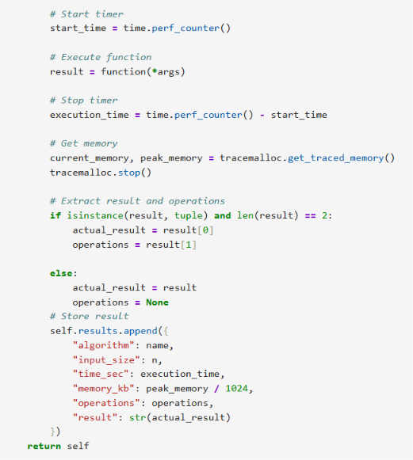
Q4 – BenchmarkEngine implementation, part 2
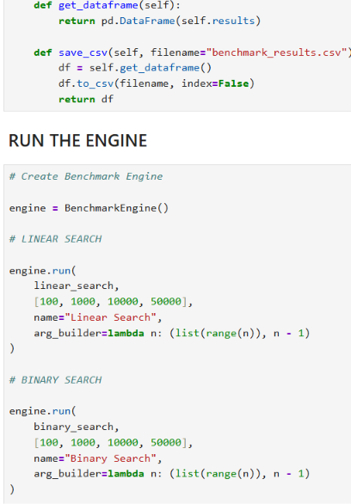
Q4 – Running the automated benchmarking engine
Q4 – Engine execution setup
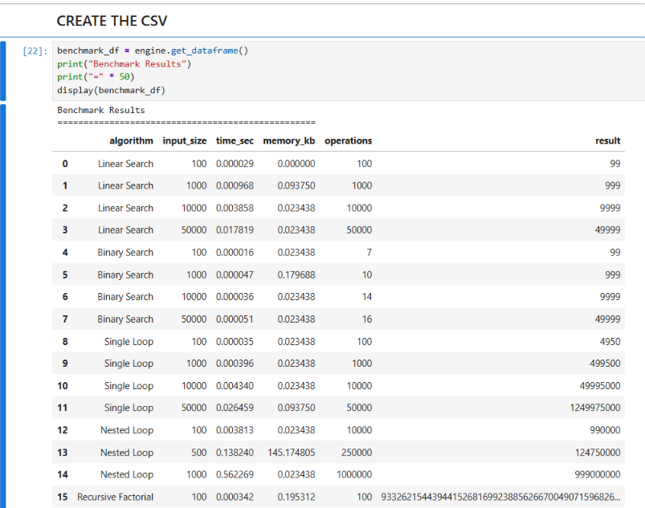
Q4 – Generated benchmark results
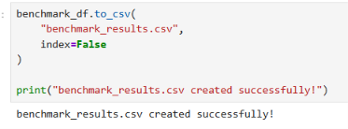
Q4 – benchmark_results.csv created successfully

Question 5 – Complexity Comparison
Algorithm | Time Complexity | Space Complexity
Linear Search | O(n) | O(1)
Binary Search | O(log n) | O(1)
Recursive Factorial | O(n) | O(n)
Iterative Factorial | O(n) | O(1)
Single Loop | O(n) | O(1)
Nested Loop | O(n²) | O(1)

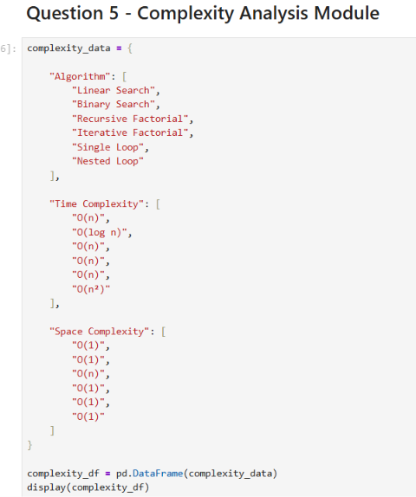
Q5 – Complexity analysis module
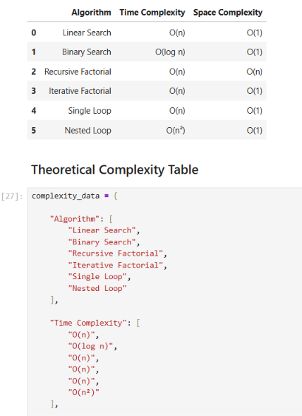
Q5 – Theoretical complexity table
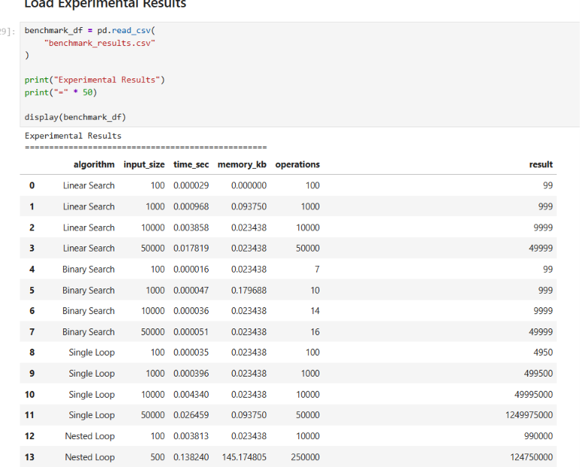
Q5 – Experimental benchmark results loaded from CSV
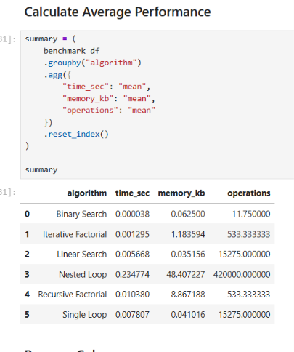
Q5 – Average performance calculation
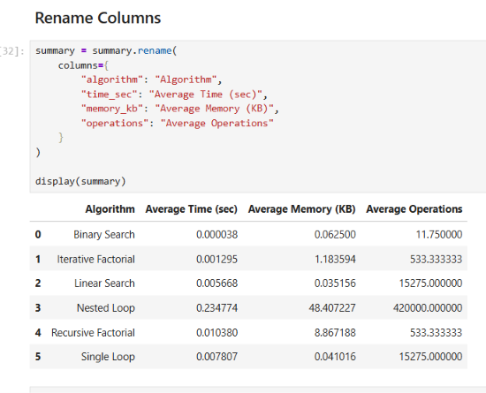
Q5 – Renamed average-performance columns
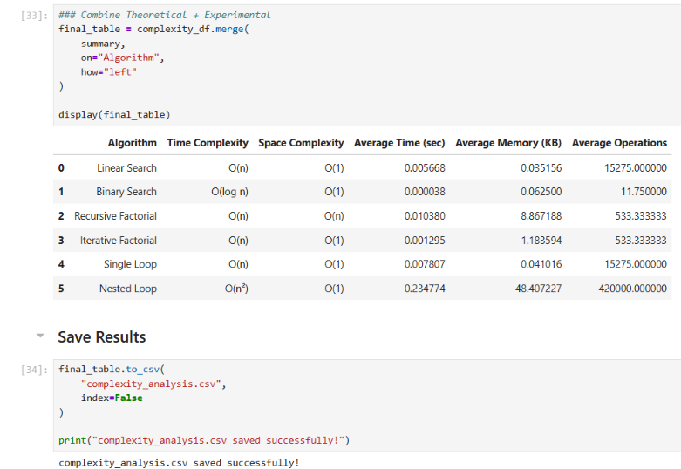
Q5 – Combined theoretical and experimental analysis table

Question 6 – Visualizations and Comparative Charts
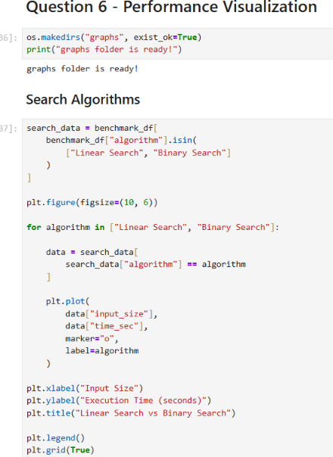
Q6 – Search visualization code
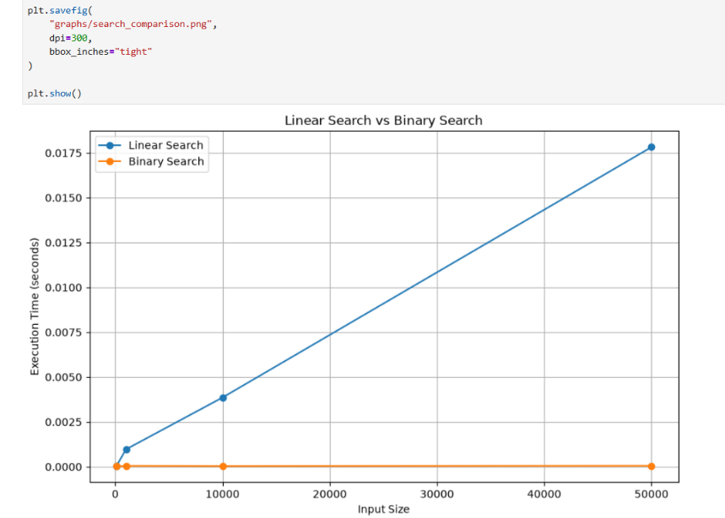
Q6 – Linear Search vs Binary Search chart
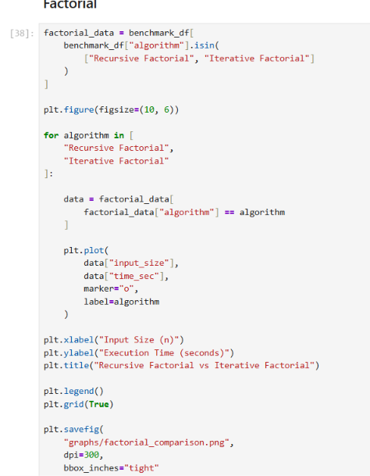
Q6 – Factorial visualization code
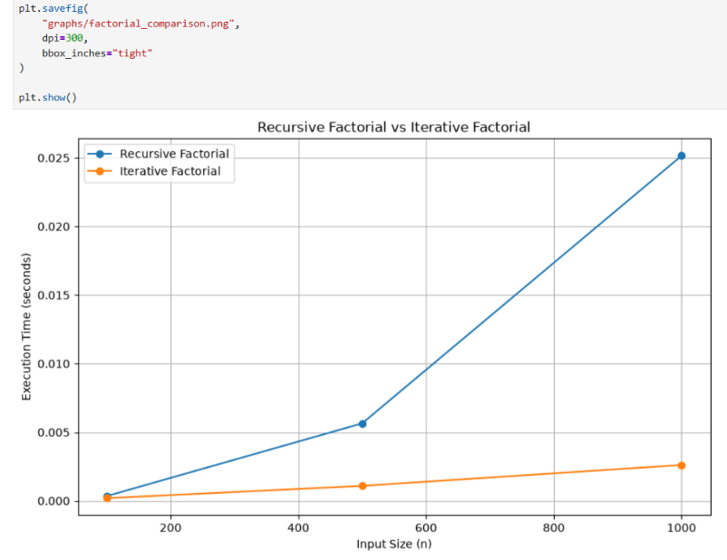
Q6 – Recursive Factorial vs Iterative Factorial chart
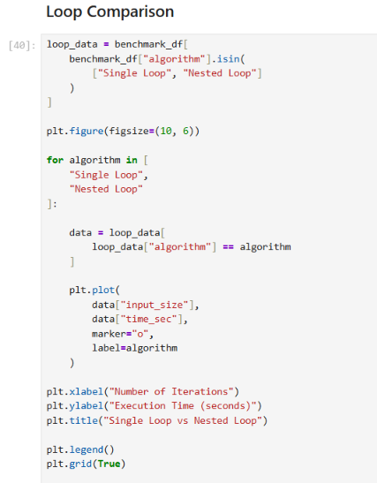
Q6 – Loop visualization code
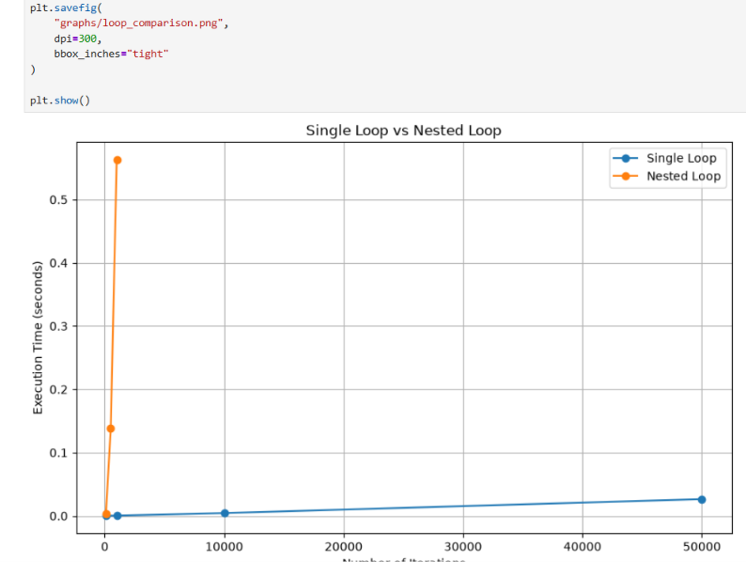
Q6 – Single Loop vs Nested Loop chart

Question 7 – Benchmarking Report
The benchmarking report below summarizes the observations from Questions 2–6.

Summary
The experiment measured execution time, peak memory usage and operation counts for six algorithm/program categories. The results demonstrate the practical effect of asymptotic complexity and implementation choices.

Search Comparison
Linear Search requires a number of comparisons that grows with n. Binary Search uses the sorted input to reduce the search interval by half at each step, producing O(log n) comparison growth.

Factorial Comparison
Recursive and iterative factorial both require O(n) multiplication steps. The recursive implementation additionally uses call-stack space, while the iterative version uses constant auxiliary space.

Loop Comparison
Single Loop has O(n) growth. Nested Loop has O(n²) growth and therefore becomes substantially more expensive as n increases.

Final Conclusion
The experimental results and generated graphs are consistent with the theoretical complexity classifications used in the lab. The benchmark engine provides a reusable way to collect comparable performance data for multiple input sizes.

Question 7 – Report Evidence
Final combined complexity-analysis table
Search visualization
Factorial visualization
Loop visualization

https://github.com/YashviSahu555/DAA-Lab-File-2

